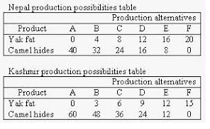

**Absolute Advantage**

**USA Production Possibilities**

|  |  |  |  |  |  |  |
| --- | --- | --- | --- | --- | --- | --- |
|  | **A** | **B** | **C** | **D** | **E** | **F** |
| **Skis** | **0** | **4** | **8** | **12** | **16** | **20** |
| **Golf Clubs** | **40** | **32** | **24** | **16** | **8** | **0** |

**Austria Production Possibilities**

|  |  |  |  |  |  |  |
| --- | --- | --- | --- | --- | --- | --- |
|  | **A** | **B** | **C** | **D** | **E** | **F** |
| **Skis** | **0** | **3** | **6** | **9** | **12** | **15** |
| **Golf Clubs** | **45** | **36** | **27** | **18** | **9** | **0** |

**Comparative Advantage**

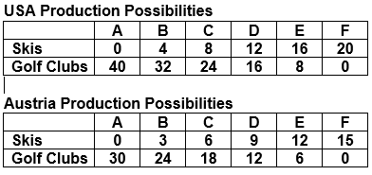

**USA Production Possibilities**

|  |  |  |  |  |  |  |
| --- | --- | --- | --- | --- | --- | --- |
|  | **A** | **B** | **C** | **D** | **E** | **F** |
| **Snowboards** | **0** | **4** | **8** | **12** | **16** | **20** |
| **Baseball Bats** | **40** | **32** | **24** | **16** | **8** | **0** |

**Austria Production Possibilities**

|  |  |  |  |  |  |  |
| --- | --- | --- | --- | --- | --- | --- |
|  | **A** | **B** | **C** | **D** | **E** | **F** |
| **Snowboards** | **0** | **2** | **3** | **6** | **8** | **10** |
| **Baseball Bats** | **30** | **24** | **18** | **12** | **6** | **0** |

**Absolute Advantage**

**USA Production Possibilities**

|  |  |  |  |  |  |  |
| --- | --- | --- | --- | --- | --- | --- |
|  | **A** | **B** | **C** | **D** | **E** | **F** |
| **Skis** | **0** | **4** | **8** | **12** | **16** | **20** |
| **Golf Clubs** | **40** | **32** | **24** | **16** | **8** | **0** |

**Austria Production Possibilities**

|  |  |  |  |  |  |  |
| --- | --- | --- | --- | --- | --- | --- |
|  | **A** | **B** | **C** | **D** | **E** | **F** |
| **Skis** | **0** | **3** | **6** | **9** | **12** | **15** |
| **Golf Clubs** | **30** | **24** | **18** | **12** | **6** | **0** |