Labor markets

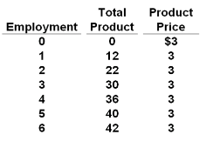

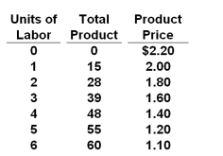

MP = ch TP / ch Ql

MRP = ch TR / ch Ql

MRC = ch TC / ch Ql

VMP = P x MP

**Comp / Comp W = 20**

|  |  |  |  |  |  |  |  |  |  |
| --- | --- | --- | --- | --- | --- | --- | --- | --- | --- |
| **Quantity of**  **Labor** | **TP**  **(quantity produced)** | **MP** | **Product Price** | **TR** | **MRP** | **Wage** | **TC**  **(total labor cost)** | **MRC** | **VMP**  **(PxMP)** |
| 0 | 0 | - | $ 2 | $ 0 | - | 20 | 0 | - | - |
| 1 | 40 | 40 | 2 | 80 | 80 | 20 | 20 | 20 | 80 |
| 2 | 70 | 30 | 2 | 140 | 60 | 20 | 40 | 20 | 60 |
| 3 | 90 | 20 | 2 | 180 | 40 | 20 | 60 | 20 | 40 |
| 4 | 100 | 10 | 2 | 200 | 20 | 20 | 80 | 20 | 20 |
| 5 | 100 | 0 | 2 | 200 | 0 | 20 | 100 | 20 | 0 |

**Comp / Comp W = 40**

|  |  |  |  |  |  |  |  |  |  |
| --- | --- | --- | --- | --- | --- | --- | --- | --- | --- |
| **Quantity of**  **Labor** | **TP**  **(quantity produced)** | **MP** | **Product Price** | **TR** | **MRP** | **Wage** | **TC**  **(total labor cost)** | **MRC** | **VMP**  **(PxMP)** |
| 0 | 0 | - | $ 2 | $ 0 | - | 40 | 0 | - | - |
| 1 | 40 | 40 | 2 | 80 | 80 | 40 | 40 | 40 | 80 |
| 2 | 70 | 30 | 2 | 140 | 60 | 40 | 80 | 40 | 60 |
| 3 | 90 | 20 | 2 | 180 | 40 | 40 | 120 | 40 | 40 |
| 4 | 100 | 10 | 2 | 200 | 20 | 40 | 160 | 40 | 20 |
| 5 | 100 | 0 | 2 | 200 | 0 | 40 | 200 | 40 | 0 |

**Comp / Comp W = 60**

|  |  |  |  |  |  |  |  |  |  |
| --- | --- | --- | --- | --- | --- | --- | --- | --- | --- |
| **Quantity of**  **Labor** | **TP**  **(quantity produced)** | **MP** | **Product Price** | **TR** | **MRP** | **Wage** | **TC**  **(total labor cost)** | **MRC** | **VMP**  **(PxMP)** |
| 0 | 0 | - | $ 2 | $ 0 | - | 60 | 0 | - | - |
| 1 | 40 | 40 | 2 | 80 | 80 | 60 | 60 | 60 | 80 |
| 2 | 70 | 30 | 2 | 140 | 60 | 60 | 120 | 60 | 60 |
| 3 | 90 | 20 | 2 | 180 | 40 | 60 | 180 | 60 | 40 |
| 4 | 100 | 10 | 2 | 200 | 20 | 60 | 240 | 60 | 20 |
| 5 | 100 | 0 | 2 | 200 | 0 | 60 | 300 | 60 | 0 |

|  |  |  |  |  |  |
| --- | --- | --- | --- | --- | --- |
| **Quantity of**  **Labor** | **TP**  **(quantity produced)** | **MP** | **Product Price** | **TR** | **MRP** |
| 0 | 0 | - | $ 2 |  |  |
| 1 | 40 | 40 | 2 |  |  |
| 2 | 70 | 30 | 2 |  |  |
| 3 | 90 | 20 | 2 |  |  |
| 4 | 100 | 10 | 2 |  |  |
| 5 | 100 | 0 | 2 |  |  |

|  |  |  |  |  |  |
| --- | --- | --- | --- | --- | --- |
| **Quantity of**  **Labor** | **TP**  **(quantity produced)** | **MP** | **Product Price** | **TR** | **MRP** |
| 0 | 0 | - | $ 2 | $ 0 | - |
| 1 | 40 | 40 | 2 | 80 | 80 |
| 2 | 70 | 30 | 2 | 140 | 60 |
| 3 | 90 | 20 | 2 | 180 | 40 |
| 4 | 100 | 10 | 2 | 200 | 20 |
| 5 | 100 | 0 | 2 | 200 | 0 |

|  |  |  |  |  |  |  |  |  |
| --- | --- | --- | --- | --- | --- | --- | --- | --- |
| **Quantity of**  **Labor** | **TP**  **(quantity produced)** | **MP** | **Product Price** | **TR** | **MRP** | **Wage** | **TC**  **(total labor cost)** | **MRC** |
| 0 | 0 | - | $ 2 | $ 0 | - | 20 |  | - |
| 1 | 40 | 40 | 2 | 80 | 80 | 20 |  |  |
| 2 | 70 | 30 | 2 | 140 | 60 | 20 |  |  |
| 3 | 90 | 20 | 2 | 180 | 40 | 20 |  |  |
| 4 | 100 | 10 | 2 | 200 | 20 | 20 |  |  |
| 5 | 100 | 0 | 2 | 200 | 0 | 20 |  |  |

|  |  |  |  |  |  |  |  |  |
| --- | --- | --- | --- | --- | --- | --- | --- | --- |
| **Quantity of**  **Labor** | **TP**  **(quantity produced)** | **MP** | **Product Price** | **TR** | **MRP** | **Wage** | **TC**  **(total labor cost)** | **MRC** |
| 0 | 0 | - | $ 2 | $ 0 | - | 20 | 0 | - |
| 1 | 40 | 40 | 2 | 80 | 80 | 20 | 20 | 20 |
| 2 | 70 | 30 | 2 | 140 | 60 | 20 | 40 | 20 |
| 3 | 90 | 20 | 2 | 180 | 40 | 20 | 60 | 20 |
| 4 | 100 | 10 | 2 | 200 | 20 | 20 | 80 | 20 |
| 5 | 100 | 0 | 2 | 200 | 0 | 20 | 100 | 20 |

|  |  |  |  |  |  |  |  |  |  |
| --- | --- | --- | --- | --- | --- | --- | --- | --- | --- |
| **Quantity of**  **Labor** | **TP**  **(quantity produced)** | **MP** | **Product Price** | **TR** | **MRP** | **Wage** | **TC**  **(total labor cost)** | **MRC** | **VMP**  **(PxMP)** |
| 0 | 0 | - | $ 2 | $ 0 | - | 20 | 0 | - | - |
| 1 | 40 |  | 2 | 80 | 80 | 20 | 20 | 20 |  |
| 2 | 70 |  | 2 | 140 | 60 | 20 | 40 | 20 |  |
| 3 | 90 |  | 2 | 180 | 40 | 20 | 60 | 20 |  |
| 4 | 100 |  | 2 | 200 | 20 | 20 | 80 | 20 |  |
| 5 | 100 |  | 2 | 200 | 0 | 20 | 100 | 20 |  |

**Comp / Imperfect Comp**

|  |  |  |  |  |  |  |  |  |  |
| --- | --- | --- | --- | --- | --- | --- | --- | --- | --- |
| **Quantity of**  **Labor** | **TP**  **(quantity produced)** | **MP** | **Product Price** | **TR** | **MRP** | **Wage** | **TC**  **(total labor cost)** | **MRC** | **VMP**  **(PxMP)** |
| 0 | 0 | - | $ 3.00 | $ 0 | - | 20 | 0 | - | - |
| 1 | 40 | 40 | 2.88 | 115 | 115 | 20 | 20 | 20 | 115 |
| 2 | 70 | 30 | 2.54 | 178 | 63 | 20 | 40 | 20 | 76.20 |
| 3 | 90 | 20 | 2.20 | 198 | 20 | 20 | 60 | 20 | 44 |
| 4 | 100 | 10 | 2.00 | 200 | 2 | 20 | 80 | 20 | 20 |

**Monopsony**

|  |  |  |  |  |  |  |  |  |  |
| --- | --- | --- | --- | --- | --- | --- | --- | --- | --- |
| **Quantity of**  **Labor** | **TP**  **(quantity produced)** | **MP** | **Product Price** | **TR** | **MRP** | **Wage** | **TC**  **(total labor cost)** | **MRC** | **VMP**  **(PxMP)** |
| 0 | 0 | - | $ 2 | $ 0 | - | 10 | 0 | - | - |
| 1 | 40 | 40 | 2 | 80 | 80 | 12.5 | 12.5 | 12.5 | 80 |
| 2 | 70 | 30 | 2 | 140 | 60 | 15 | 30 | 17.5 | 60 |
| 3 | 90 | 20 | 2 | 180 | 40 | 17.5 | 52.5 | **40** | 40 |
| 4 | 100 | 10 | 2 | 200 | 20 | 20 | 80 | 27.5 | 20 |
| 5 | 100 | 0 | 2 | 200 | 0 | 22.5 | 112.5 | 32.5 | 0 |

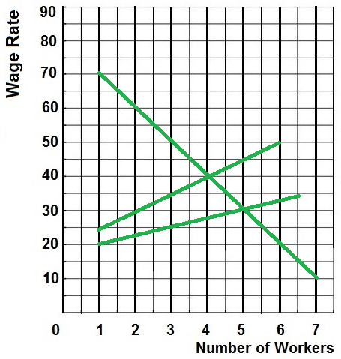

**Monopsony**

|  |  |  |  |  |  |  |  |  |  |
| --- | --- | --- | --- | --- | --- | --- | --- | --- | --- |
| **Quantity of**  **Labor** | **TP**  **(quantity produced)** | **MP** | **Product Price** | **TR** | **MRP** | **Wage** | **TC**  **(total labor cost)** | **MRC** | **VMP**  **(PxMP)** |
| 0 | 0 | - | $ 1 | $ 0 | - | 2 | 0 | - | - |
| 1 | 9 | 9 | 1 | 9 | 9 | 3 | 3 | 3 | 9 |
| 2 | 17 | 8 | 1 | 17 | 8 | 4 | 8 | 5 | 8 |
| 3 | 24 | 7 | 1 | 24 | 7 | 5 | 15 | 7 | 7 |
| 4 | 30 | 6 | 1 | 30 | 6 | 6 | 24 | 9 | 6 |
| 5 | 35 | 5 | 1 | 35 | 5 | 7 | 35 | 11 | 5 |

**Monopsony calc MRC**

|  |  |  |  |  |  |  |  |  |  |
| --- | --- | --- | --- | --- | --- | --- | --- | --- | --- |
| **Quantity of**  **Labor** | **TP**  **(quantity produced)** | **MP** | **Product Price** | **TR** | **MRP** | **Wage** | **TC**  **(total labor cost)** | **MRC** | **VMP**  **(PxMP)** |
| 0 | 0 | - | $ 1 | $ 0 | - | 2 |  | - | - |
| 1 | 9 | 9 | 1 | 9 | 9 | 3 |  |  | 9 |
| 2 | 17 | 8 | 1 | 17 | 8 | 4 |  |  | 8 |
| 3 | 24 | 7 | 1 | 24 | 7 | 5 |  |  | 7 |
| 4 | 30 | 6 | 1 | 30 | 6 | 6 |  |  | 6 |
| 5 | 35 | 5 | 1 | 35 | 5 | 7 |  |  | 5 |

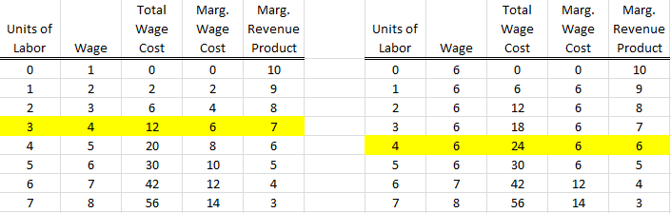

Yp: 