|  |  |  |  |  |  |  |  |
| --- | --- | --- | --- | --- | --- | --- | --- |
| **Quantity** | **TC** | **TVC** | **TFC** | **ATC** | **AVC** | **AFC** | **MC** |
| 0 | 20 | 0 | 20 | - | - | - | - |
| 1 | 40 | 20 | 20 | 40 | 20 | 20 | 20 |
| 2 | 50 | 30 | 20 | 25 | 15 | 10 | 10 |
| 3 | 70 | 50 | 20 | 23 | 16.6 | 6.6 | 20 |
| 4 | 100 | 80 | 20 | 25 | 20 | 5 | 30 |
| 5 | 140 | 120 | 20 | 28 | 24 | 4 | 40 |

|  |  |  |  |  |
| --- | --- | --- | --- | --- |
| **Quantity** | **TC** | **Price** | **MR** | **MC** |
| 0 | 20 | 35 |  |  |
| 1 | 40 | 35 |  |  |
| 2 | 50 | 35 |  |  |
| 3 | 70 | 35 |  |  |
| 4 | 100 | 35 |  |  |
| 5 | 140 | 35 |  |  |

|  |  |  |  |  |  |
| --- | --- | --- | --- | --- | --- |
| **Quantity** | **TC** | **MC** | **Price** | **TR** | **MR** |
| 0 | 20 |  | 35 |  |  |
| 1 | 40 |  | 35 |  |  |
| 2 | 50 |  | 35 |  |  |
| 3 | 70 |  | 35 |  |  |
| 4 | 100 |  | 35 |  |  |
| 5 | 140 |  | 35 |  |  |

|  |  |  |  |  |  |
| --- | --- | --- | --- | --- | --- |
| **Quantity** | **TC** | **MC** | **Price** | **TR** | **MR** |
| 0 | 20 | - | 35 | 0 | 35 |
| 1 | 40 | 20 | 35 | 35 | 35 |
| 2 | 50 | 10 | 35 | 70 | 35 |
| 3 | 70 | 20 | 35 | 105 | 35 |
| 4 | 100 | 30 | 35 | 140 | 35 |
| 5 | 140 | 40 | 35 | 175 | 35 |

|  |  |  |  |  |  |  |  |
| --- | --- | --- | --- | --- | --- | --- | --- |
| **Quantity** | **TC** | **TVC** | **TFC** | **ATC** | **AVC** | **AFC** | **MC** |
| 0 | 200 | 0 | 200 | - | - | - | - |
| 10 | 400 | 200 | 200 | 400 | 200 | 200 | 200 |
| 20 | 500 | 300 | 200 | 250 | 150 | 100 | 100 |
| 30 | 700 | 500 | 200 | 233 | 167 | 67 | 200 |
| 40 | 1000 | 800 | 200 | 250 | 200 | 50 | 300 |
| 50 | 1400 | 1200 | 200 | 280 | 240 | 40 | 400 |

**Total Fixed Costs = $ 20 Total Fixed Costs = $ 30**

|  |  |  |  |  |  |  |
| --- | --- | --- | --- | --- | --- | --- |
| **Quantity** | **TC** | **TVC** | **MC** | **TC** | **TVC** | **MC** |
| 0 | 20 | 0 | - | 30 | 0 | - |
| 1 | 40 | 20 | 20 | 50 | 20 | 20 |
| 2 | 50 | 30 | 10 | 60 | 30 | 10 |
| 3 | 70 | 50 | 20 | 80 | 50 | 20 |
| 4 | 100 | 80 | 30 | 110 | 80 | 30 |
| 5 | 140 | 120 | 40 | 150 | 120 | 40 |



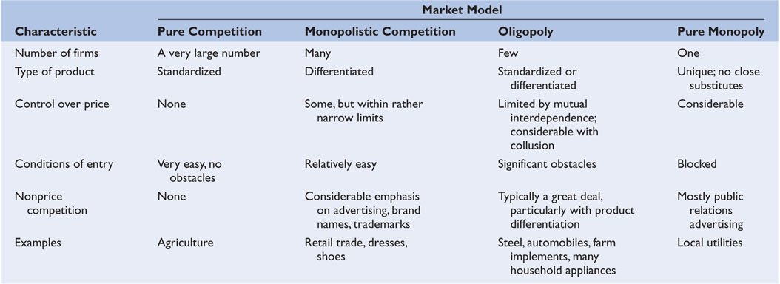

**PRODUCT MARKET MODELS**

|  |  |  |  |  |
| --- | --- | --- | --- | --- |
|  |  |  |  |  |
| **CHARACTERISTIC** | **Pure Competition** | **Monopolistic Competition** | **Oligopoly** | **Monopoly** |
| **Number of firms** | Very many | Many | Few | One |
| **Type of product** | Standardized  (Homogenous) | Differentiated | Standardized or differentiated | Unique, no close substitutes |
| **Control over price** | None  (price takers) | Some, depends on product differentiation | A lot with collusion, limited with mutual interdependence | A lot |
| **Barriers to entry** | Very easy,  no barriers | Relatively easy | Significant barriers | Blocked |
| **Nonprice competition** | None | Very much | Very much with differentiated products | Would expect none, but some public relations advertising |
| **Examples** | Agriculture (like wheat, soybean, corn); stock market | Restaurants, hotels, pubs, retail trade (pharmacies, gas stations, grocery stores) | Steel, automobiles, farm implements, smart phones, video streaming, airlines, health insurance | Local public utilities (electricity, natural gas, water) |

**TR**

**MR = -----------**

**Q**

|  |  |  |  |  |  |
| --- | --- | --- | --- | --- | --- |
| **Quantity** | **TC** | **MC** | **Price** | **TR** | **MR** |
| 0 | 20 |  | 20 |  |  |
| 1 | 40 |  | 20 |  |  |
| 2 | 50 |  | 20 |  |  |
| 3 | 70 |  | 20 |  |  |
| 4 | 100 |  | 20 |  |  |
| 5 | 140 |  | 20 |  |  |

|  |  |  |  |  |  |
| --- | --- | --- | --- | --- | --- |
| **Quantity** | **TC** | **MC** | **Price** | **TR** | **MR** |
| 0 | 20 | - | 20 | 0 | 20 |
| 1 | 40 | 20 | 20 | 20 | 20 |
| 2 | 50 | 10 | 20 | 40 | 20 |
| 3 | 70 | 20 | 20 | 60 | 20 |
| 4 | 100 | 30 | 20 | 80 | 20 |
| 5 | 140 | 40 | 20 | 100 | 35 |

**v**