**2017 Tax Schedules – Individual Taxpayers**

|  |  |
| --- | --- |
| **If Taxable Income is Between:** | **The Tax Due is:** |
| 0 - $9,325 | 10% of taxable income |
| $9,326 - $37,950 | $932.50 + 15% of the amount over $9,325 |
| $37,951 - $91,900 | $5,226.25 + 25% of the amount over $37,950 |
| $91,901 - $191,650 | $18,713.75 + 28% of the amount over $91,900 |
| $191,651 - $416,700 | $46,643.75 + 33% of the amount over $191,650 |
| $416,701 - $418,400 | $120,910.25 + 35% of the amount over $416,700 |
| $418,401 + | $121,505.25 + 39.6% of the amount over $418,400 |

**2017 Tax Schedules – Individual Taxpayers**

|  |  |
| --- | --- |
| **If Taxable Income is Between:** | **The Tax Due is:** |
| 0 - $9,325 | 10% of taxable income |
| $9,326 - $37,950 | $932.50 + 15% of the amount over $9,325 |
| $37,951 - $91,900 | $5,226.25 + 25% of the amount over $37,950 |
| $91,901 - $191,650 | $18,713.75 + 28% of the amount over $91,900 |
| $191,651 - $416,700 | $46,643.75 + 33% of the amount over $191,650 |
| $416,701 - $418,400 | $120,910.25 + 35% of the amount over $416,700 |
| $418,401 + | $121,505.25 + 39.6% of the amount over $418,400 |

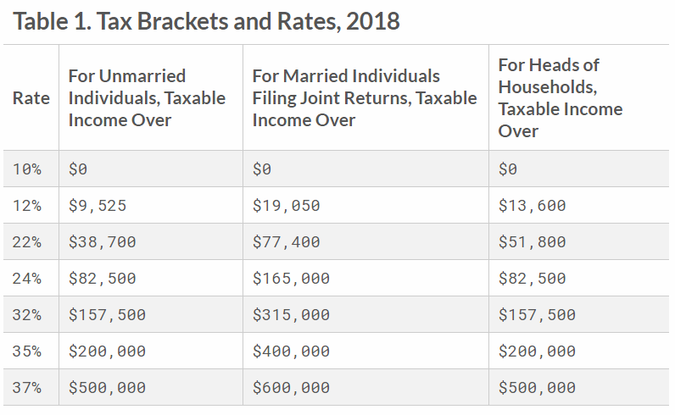

**2018 Tax Schedules – Individual Taxpayers**

|  |  |
| --- | --- |
| **If Taxable Income is Between:** | **The Tax Due is:** |
| 0 - $9,525 | 10% of taxable income |
| $9,526 - $38,700 | $932.50 + 12% of the amount over $9,525 |
| $37,951 - $82,500 | $5,226.25 + 22% of the amount over $38,700 |
| $82,501 - $157,500 | $18,713.75 + 24% of the amount over $91,900 |
| $157,501 - $200,000 | $46,643.75 + 32% of the amount over $191,650 |
| $200,001 - $500,000 | $120,910.25 + 35% of the amount over $416,700 |
| $500,001 + | $121,505.25 + 37% of the amount over $418,400 |