How Banks Create Money

Major Point: An initial increase in funds available to the banking industry results in a MULTIPLE increase in the money supply.

Three Step Process per Round:

- An increase in demand deposits or other liabilities of a bank increases the bank’s reserves.
- Bank can make loans equal to its excess reserves. Loans made by increasing demand deposits.
- The loan check is spent, deposited in a different bank, and CLEARS. First bank now has no excess reserves, but second does and can therefore make a loan.
Given: Required Reserve Ration = 20%

FNB = First National Bank
SNB = Second National Bank
TNB = Third National Bank

ER = excess reserves
All banks initially have no excess reserves
Banks make loans equal to their excess reserves

$10 cash is deposited in a checking (DD) account at FNB

Show: The CHANGES in the balance sheets of each bank as a result of this $10 cash deposit and the increased loan making ability of the banks.

One

Step 1: $10 deposited in FNB

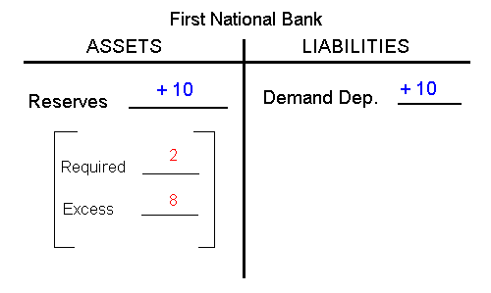

Step 2: FNB makes loan equal to its excess reserves

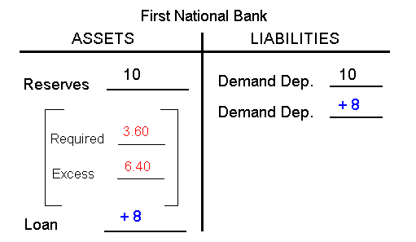

Step 3: Loan is spent, deposited in SNB, and the check clears

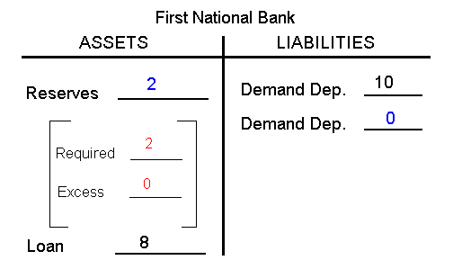

Round Two

Step 1: Check from round one deposited in SNB

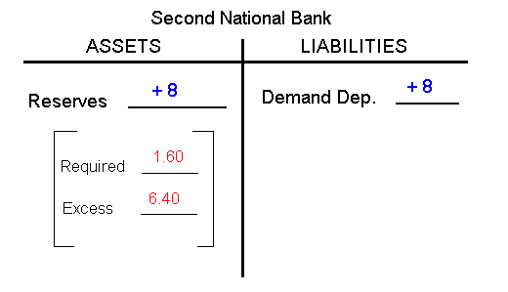

Step 2: SNB makes loan equal to its excess reserves
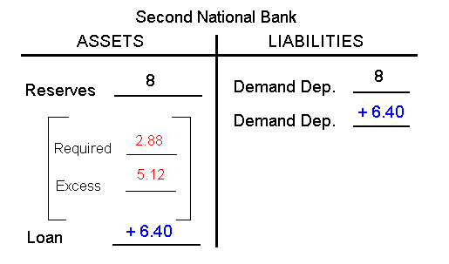

Step 3: Loan is spent, deposited in TNB, and the check clears
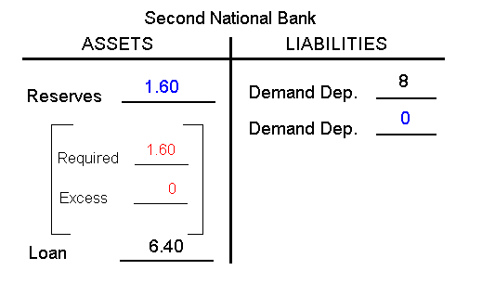
Round Three

Step 1: Check from round two deposited in TNB

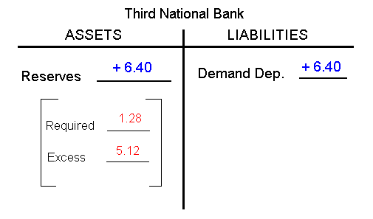
Money Supply Changes:

How much money was created in round one? ____$ 8____

How much money was created in round two? ____$ 6.40_

How much money can be created in round three? ____$ 5.12_

Deposit Expansion Multiplier = 1 / Required Reserve Ratio
(also called Money multiplier)

Money Multiplier = total increase in money supply / initial excess reserves

What is the money multiplier? _____5______

What is the maximum total increase in the money
supply that can occur as a result of the initial $10
cash deposit? ____$ 40_____

What are the limitations on this money creation process?

_____1) banks may hold ER _______________________

_____2) people may hold money_________________________

_____3) the required reserve ratio_______________________

