The countries of Macrostan and Micrastan have the production possibilities tables for sheep and hogs shown in the tables below. Without trade Macro would produce at Alternative D and Micra would also produce Alternative D. Note that the costs of producing sheep and hogs are constant in both countries.

MACROSTAN’S PRODUCTION POSSIBILITIES TABLE
Product | Alternative
(lbs) | A | B | C | D | E | F
Sheep | 25 | 20 | 15 | 10 | 5 | 0
Hogs | 0 | 5 | 10 | 15 | 16 | 25

MICRASTAN’S PRODUCTION POSSIBILITIES TABLE
Product | Alternative
(lbs) | A | B | C | D | E | F
Sheep | 20 | 16 | 12 | 8 | 4 | 0
Hogs | 0 | 3 | 6 | 9 | 12 | 15

(a) In Macro, the cost of producing:
5 units of sheep is ______ hog units.
1 unit of sheep is ______ hog units.
(b) In Micra, the cost of producing:
4 units of sheep is ______ hog units.
1 unit of sheep is ______ hog units.
(c) Which country has the comparative advantage in sheep production and which country has the comparative advantage in hog production?
(d) If each nation specializes in the product where it has a comparative advantage and trades with the other, what will be the limits to the terms of trade for each sheep unit?
(e) If the nations do not specialize and trade but remain at alternative D in Macrostan and D in Micrastan, the combined production of Macro and Micrastan will be how many sheep and how many hogs?
(f) However, if the two nations specialize, the combined production of Macro and Micrastan will be how many sheep and how many hogs?
(g) What will be the total gain of sheep and hogs if the countries specialize and trade?

18. What are the economic effects of a depreciation of the dollar on foreign exchange markets?

19. What are the economic effects of an appreciation of the dollar in foreign exchange markets?

26. If tariffs contribute to inefficiency in the international allocation of resources and lower output and income, why have nations enacted tariffs?

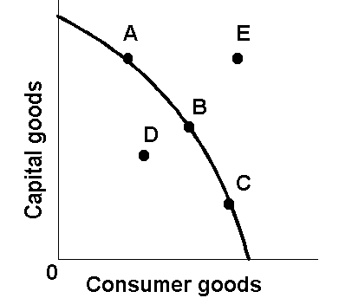

Refer to the above domestic production possibilities curve for Abernorelco. The gain to Abernorelco from specialization and international trade is represented by a move from:
A) A to B. B) C to A. C) C to D. D) B to E.

