Chapter 16 REVIEW

1. Use the diagram below to answer the questions.

a. Define ECONOMIC GROWTH:

b. What CAUSES economic growth?

c. Is this type of economic growth an increase in POTENTIAL GDP or ACHIEVING the potential?

2. Use the diagram below to answer the questions.
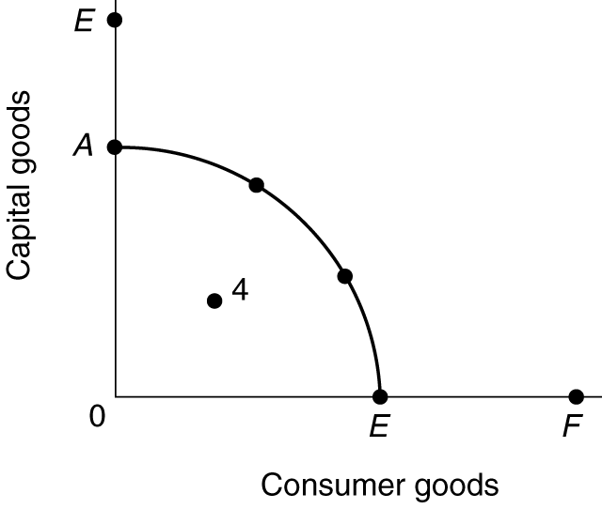

a. If the economy’s production possibilities curve is shown by curve AE, then draw in a new curve which indicates positive economic growth.

b. Is this type of economic growth an increase in POTENTIAL GDP or ACHIEVING the potential?

3. Use the diagram below to answer the questions.

a. What would cause the AS curve to shift to the right?

b. Is this type of economic growth an increase in POTENTIAL GDP or ACHIEVING the potential?
4. What are the two (three) definitions of economic growth used in class? State which definition is an increase in POTENTIAL GDP and which is ACHIEVING the potential?

5. Use the diagram below to answer the questions.

a. If the economy illustrated by production possibilities curve AE is producing at point 4, what economic problem does this represent for this economy?

b. Assume that the economy moves from point 4 to a point on the curve. Draw an arrow to show the change.

c. Is this type of economic growth an increase in POTENTIAL GDP or ACHIEVING the potential?

6. Use the diagram below to answer the questions.

a. What would cause the AD curve to shift to the right?

b. Is this type of economic growth an increase in POTENTIAL GDP or ACHIEVING the potential?

7. Suppose an economy’s real GDP is $125 billion in year one and $130 billion in year two. What is the growth rate of its GDP?

Chapter 16 (questions with answers)

1. State two (three) definitions of economic growth.

2. Suppose an economy's real GDP is $50,000 in year 1 and $55,000 in year 2.

a. What is the growth rate of its GDP?

b. Assume that population was 100 in year 1 and 105 in year 2. What is the growth rate in GDP per capita?

3. Explain why even small changes in the rate of economic growth are significant. Use the "rule of 70" to demonstrate the point.

4. Which is more important — increasing inputs of resources or increasing the productivity of those inputs — as the main source of economic growth in the United States? Explain.

5. Summarize the historical growth record of the United States over the past 50 years in terms of real GDP growth and in terms of real GDP per capita growth.

ANSWERS:

- State two (three) definitions of economic growth.

Economic growth can first be defined and measured as an increase in real GDP occurring over a period of time. This could be caused by an (1) increase in the potential GDP [increase in the ability to produce] or (2) simply achieving the potential GDP [producing more].

(3) Economic growth can also be defined and measured as an increase in real GDP per capita occurring over a period of time. Economic growth is usually calculated as an annual percentage rate of growth.

2. Suppose an economy's real GDP is $50,000 in year 1 and $55,000 in year 2.

a. $5,000/$50,000 or 10% in year 1.
b.The per capita growth can be calculated as follows:
$500 per capita in year 1 ($50,000/100);
$523.81 per capita in year 2 ($55,000/105).

3. Explain why even small changes in the rate of economic growth are significant. Use the "rule of 70" to demonstrate the point.

Small changes in the rate of growth can be very meaningful, especially for a country where a fraction of a percent change in the growth rate may mean the difference between starvation and hunger. Over a period of time small changes are cumulative in the same way that compound interest payments are cumulative on a bank account. Using the rule of 70 to estimate the time it takes to double GDP, we can see that a country whose growth rate is 5% takes 14 years to double its GDP, but a country whose growth rate is 3% may take nearly 10 years longer to double its GDP or about 23.3 years. If these countries continued to grow at their respective 5% and 3% rates, in 28 years the first country's GDP would be quadrupled, whereas in the second country, it would take nearly 47 years to quadruple its GDP from the current year.

4. Which is more important — increasing inputs of resources or increasing the productivity of those inputs — as the main source of economic growth in the United States? Explain.

Both resource quantity and resource productivity contribute significantly to increased economic growth in the United States. About a third of the increase in economic growth comes from increases in resource input and about two-thirds from increases in resource productivity. Clearly, it is not the quantity of resources that is most important but the quality of resources and how they are used for production.

5. Summarize the historical growth record of the United States over the past 50 years in terms of real GDP growth and in terms of real GDP per capita growth.

The real GDP has increased about 3.5% per year between 1950 and 2000. Real GDP per capita rose more slowly because population has grown along with GDP. Still the GDP per capita growth has expanded at about 2.3% per year since 1950.

