11-1 Why is the aggregate demand curve downsloping? Specify how your explanation differs from the rationale behind the downsloping demand curve for a single product.

The aggregate demand (AD) curve shows that as the price level drops, purchases of real domestic output increase. The AD curve slopes downward for three reasons. The first is the interest-rate effect. We assume the supply of money to be fixed. When the price level increases, more money is needed to make purchases and pay for inputs. With the money supply fixed, the increased demand for it will drive up its price, the rate of interest. These higher rates will decrease the buying of goods with borrowed money, thus decreasing the amount of real output demanded.

The second reason is the wealth or real balances effect. As the price level rises, the real value—the purchasing power—of money and other accumulated financial assets (bonds, for instance) will decrease. People will therefore become poorer in real terms and decrease the quantity demanded of real output.

The third reason is the foreign purchases effect. As the United States’ price level rises relative to other countries, Americans will buy more abroad in preference to their own output. At the same time foreigners, finding American goods and services relatively more expensive, will decrease their buying of American exports. Thus, with increased imports and decreased exports, American net exports decrease and so, therefore, does the quantity demanded of American real output.

These reasons for the downsloping AD curve have nothing to do with the reasons for the downsloping single-product demand curve. In the case of the dropping price of a single product, the consumer with a constant money income substitutes more of the now relatively cheaper product for those whose prices have not changed. Also, the consumer has become richer in real terms, because of the lower price of the one product, and can buy more of it and all other products. But with the AD curve, moving down the curve means all prices are dropping—the price level is dropping. Therefore, the single-product substitution effect does not apply. Also, whereas when dealing with the demand for a single product the consumer’s income is assumed to be fixed, the AD curve specifically excludes this assumption. Movement down the AD curve indicates lower prices but, with regard to the circular flow of economic activity, it also indicates lower incomes. If prices are dropping, so must the receipts or revenues or incomes of the sellers. Thus, a decline in the price level does not necessarily imply an increase in the nominal income of the economy as a whole.

11-2 Explain the shape of the aggregate supply curve, accounting for the differences between the horizontal, intermediate, and vertical ranges of the curve.

In the horizontal range of the aggregate supply (AS) curve, the economy is in a severe recession, so that there is a large GDP gap—much excess capacity—because of deficient aggregate demand (AD). In these circumstances, AD can increase without pulling the price level upward.

In the intermediate, or upsloping, range of the AS curve, the economy is clearly in the recovery phase of the business cycle and the price level moves up more and more as AD increases. The economy as a whole nears the full employment level of output, as some firms, some industries, are at or close enough to their capacity production that they believe they can—or are forced to—raise their prices to equate the quantity they supply with increasing demand. Moreover, some essential inputs are fully employed—some skilled labor, certain raw materials—and firms must bid against each other in order to increase their production. Thus, costs—and prices—start to rise in the economy, pushing up the price level as full employment is reached.

In the vertical range of the AS curve, absolute full capacity has been reached; the economy, by definition, cannot produce any more (not until, through economic growth, the potential output of the economy has increased). Since the economy has attained its potential, any further increase in AD cannot be met by an increase in output. Therefore, the increase in AD results only in pure demand-pull inflation.

11-3 (Optional Section Question) Explain carefully: “A change in the price level shifts the aggregate expenditures curve, but not the aggregate demand curve.”

A change in the price level does not shift the aggregate demand curve. It simply represents a movement along the curve, because there is an inverse relationship between the price level and aggregate quantity demanded.

However, a change in the price level will shift the aggregate expenditures curve, which responds to the wealth, interest-rate, and foreign purchases effects occurring with a change in price level. When the price level declines, aggregate expenditures will rise, and when the price level rises, aggregate expenditures will fall. The aggregate expenditures model assumes a constant price level, so it is expressed in “real” terms. Figure 11-2 graphically illustrates the relationship between the two models.

11-4 (Key Question) Suppose that aggregate demand and supply for a hypothetical economy are as shown on top of next page:
Amount of  real domestic  output demanded,  billions |  | Price level  (price index) | Amount of  real domestic  output supplied,  billions
$100  200  300  400  500 |  | 300  250  200  150  150 | $400  400  300  200  100

a. Use these sets of data to graph the aggregate demand and supply curves. What will be the equilibrium price level and level of real domestic output in this hypothetical economy? Is the equilibrium real output also the absolute full-capacity real output? Explain.

b. Why will a price level of 150 not be an equilibrium price level in this economy? Why not 250?

c. Suppose that buyers desire to purchase $200 billion of extra real domestic output at each price level. What factors might cause this change in aggregate demand? What is the new equilibrium price level and level of real output? Over which range of the aggregate supply curve—horizontal, intermediate, or vertical—has equilibrium changed?

(a) See the graph. Equilibrium price level = 200. Equilibrium real output = $300 billion. No, the full-capacity level of GDP is $400 billion, where the AS curve becomes vertical

(b) At a price level of 150, real GDP supplied is a maximum of $200 billion, less than the real GDP demanded of $400 billion. The shortage of real output will drive the price level up. At a price level of 250, real GDP supplied is $400 billion, which is more than the real GDP demanded of $200 billion. The surplus of real output will drive down the price level. Equilibrium occurs at the price level at which AS and AD intersect.

See the graph. Increases in consumer, investment, government, or net export spending might shift the AD curve rightward. New equilibrium price level = 250. New equilibrium GDP = $400 billion. The intermediate range.

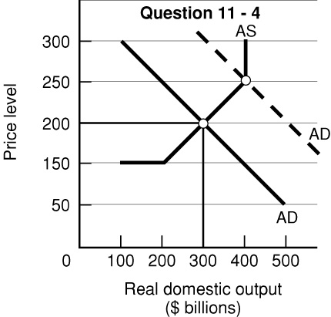

11-5 (Key Question) Suppose that the hypothetical economy in question 4 had the following relationship between its real domestic output and the input quantities necessary for producing that level of output:

a. What is the level of productivity in this economy?

b. What is the per unit cost of production if the price of each input is $2?

c. Assume that the input price increases from $2 to $3 with no accompanying change in productivity. What is the new per unit cost of production? In what direction did the $1 increase in input price push the aggregate supply curve? What effect would this shift in aggregate supply have upon the price level and the level of real output?

d. Suppose that the increase in input price had not occurred but instead that productivity had increased by 100 percent. What would be the new per unit cost of production? What effect would this change in per unit production cost have on the aggregate supply curve? What effect would this shift in aggregate supply have on the price level and the level of real output?
Input  quantity |  | Real domestic  output
150.0  112.5  75.0 |  | 400  300  200

(a) $\text{Productivity }=2\text{.}\text{67}\left({\text{300}}/{\text{112}}\text{.}5\right)\text{.}$
- $$\text{Pre-unit cost of production }=\$\text{.}\text{75}\left(\$2×\text{112}\text{.}5/{\text{300}}\right)\text{.}$$
- $\text{New per unit production cost }=\$1\text{.}\text{13}\text{.}$ The AS curve would shift leftward. The price level
would rise and real output would decrease.

(d) $\text{New per unit cost of production }=\$0\text{.}\text{375}\left(\$2×\text{112}\text{.}5/{\text{600}}\right)\text{.}$
AS curve shifts to the right; price level declines and real output increases.

11-6 Will an increase in the U.S. price level relative to price levels in other nations shift the U.S. aggregate demand curve? If so, in what direction? Explain. Will a decline in the dollar price of foreign currencies shift the U.S. aggregate supply curve rightward or simply move the economy along an existing aggregate supply curve? Explain.

An increase in the American price level does not shift the American AD curve. What does happen is that because of the foreign purchases effect, there will be a decline in American net exports and, consequently, movement up along the American AD curve, resulting in a decline in the aggregate quantity demanded of American real output.

A decline in the dollar price of foreign currencies will decrease the price of imported inputs, thereby decreasing the per unit cost of producing American real output. This will shift the American AS curve to the right (and not merely move the economy along an existing AS curve).

11-7 (Key Question) What effects would each of the following have on aggregate demand or aggregate supply? In each case use a diagram to show the expected effects on the equilibrium price level and level of real output. Assume all other things remain constant.

a. A widespread fear of depression on the part of consumers

b. A large purchase of wheat by Russia

c. A $1 increase in the excise tax on cigarettes

d. A reduction in interest rates at each price level

e. A cut in Federal spending for health care

f. The expectation of a rapid rise in the price level

g. The complete disintegration of OPEC, causing oil prices to fall by one-half

h. A 10 percent reduction in personal income tax rates

i. An increase in labor productivity

j. A 12 percent increase in nominal wages

k. Depreciation in the international value of the dollar

l. A sharp decline in the national incomes of our western European trading partners

m. A decline in the percentage of the American labor force which is unionized

(a) AD curve left

(b) AD curve right

(c) AS curve left

(d) AD curve right

(e) AD curve left

(f) AD curve right

(g) AS curve right

(h) AD curve right

(i) AS curve right

(j) AS curve left

(k) AD curve right; AS curve left

(l) AD curve left

(m) AS curve right.

11-8 What is the relationship between the production possibilities curve discussed in Chapter 2 and the aggregate supply curve discussed in this chapter?

A given AS curve shows how much will be produced at each and every price level up to the full employment output level. Beyond this point, the economy at present does not have the resources and technology to produce more. A movement to the right of the AS curve is brought about, in effect, by the same factors that cause a production possibilities curve to shift to the right.

11-9 (Key Question) Other things being equal, what effect will each of the following have on the equilibrium price level and level of real output:

a. An increase in aggregate demand in the vertical range of aggregate supply

b. An increase in aggregate supply (assume prices and wages are flexible)

d. An equal increase in both aggregate demand and aggregate supply

d. A reduction in aggregate demand in the horizontal range of aggregate supply

e. An increase in aggregate demand and a decrease in aggregate supply

f. A decrease in aggregate demand in the intermediate range of aggregate supply (assume prices and wages are inflexible downward)

(a) Price level rises and no change in real output

(b) Price level drops and real output increases

(c) Price level does not change, but real output rises

(d) Price level does not change, but real output declines

(e) Price level increases, but the change in real output is indeterminate

(f) Price level does not change, but real output declines

11-10 (Optional Section Question) Suppose that the price level is constant and investment spending increases sharply. How would you show this increase in the aggregate expenditures model? What would be the outcome? How would you show this rise in investment in the aggregate demand-aggregate supply model? What range of the aggregate supply curve is involved?

An increase in investment spending represents an increase in aggregate expenditures and an upward shift in the aggregate expenditures curve. The outcome would be a new, greater equilibrium output level. This rise in output would be equal to a multiple of the initial change in investment spending based on the multiplier effect. The multiplier is 1/MPS in this model.

Because we are assuming the price level is constant with increased aggregate demand, the shift in aggregate demand occurs in the horizontal range of the aggregate supply curve. It would be a rightward shift of aggregate demand, and the new equilibrium output would fall to the right of the original equilibrium by the full extent of the shift in aggregate demand.

11-11 (Optional Section Question) Explain how an upsloping aggregate supply curve might weaken the multiplier.

An upward sloping aggregate supply curve weakens the effect of the multiplier because any increase in aggregate demand will have both a price and an output effect. For example, if aggregate demand grows by $110 million, this could represent an increase of $100 million in real output and $10 million in higher prices if the inflation rate averages 10 percent. The multiplier is weakened because some of the increase in aggregate demand is absorbed by the higher prices and real output does not change by the full extent of the change in aggregate demand.
  - In the accompanying diagram assume that the aggregate demand curve shifts from AD1 in year 1 to AD2 in year 2, only to fall back to AD1 in year 3. Locate the new year 3 equilibrium position on the assumption that prices and wages are (a) completely flexible and (b) completely rigid downward. Which of the two equilibrium positions is more desirable? Which is more realistic? Explain why the price level might be ratcheted upward when aggregate demand increases. Be sure to refer to both efficiency wages and menu costs in your answer.

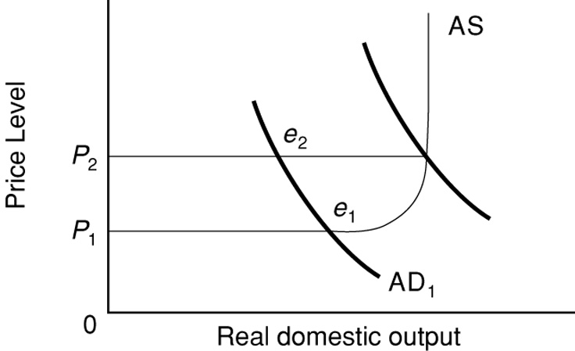

(a) With prices and wages completely flexible, the year 3 price and output equilibrium is identical to the year 1 equilibrium at e1, with price again at P1.

(b) With prices and wages completely rigid, the year 3 price remains at the higher year 2 price of P2 and output is less than in either year 1 or 2. The year 3 equilibrium position is at e2.

e1 is far more desirable because of higher output and less inflation.

e2 is more realistic and denotes the stagflation of the early 1980s.

When AD increases, product prices, resource prices and per unit production costs move upward easily, they do not so easily come down. There are a number of reasons for the inflexibility of wages and prices in the downward direction. Wage contracts may prevent wage cuts for the duration of the contract. Some employers may not wish to cut wages because they fear a drop in morale and worker productivity. Current wages may be “efficiency wages” which elicit maximum work effort and thus minimize labor cost per unit of output. Employers may have invested in worker training and fear loss of valuable workers if wages are cut. Minimum wage laws also contribute to the downward inflexibility of wages. Product prices may not fall as a result of decreased demand because of “menu costs”—the costs of changing prices. Finally, cutting product price could set off an unwanted price war.

11-13 “Unemployment can be caused by a leftward shift of aggregate demand or a leftward shift of aggregate supply.” Do you agree? Explain. In each case specify price-level effects.

Assuming the economy was not operating in the vertical range of the AS curve, the statement is true. In either case, the new point of intersection is to the left of the previous position, denoting a decrease in real domestic output and, therefore, assuming no change in productivity, necessarily an increase in unemployment.

However, assuming complete flexibility of prices and wages, the decrease in AD will result in a lower price level, whereas the decrease in AS will result in a higher price level. From the point of view of price stability, therefore, the decrease in AD is preferable. If the economy were in the horizontal range initially, there would be no price changes in either case.

11-14 (Last Word) What are the alternative views on why unemployment in Europe has recently been so high? Discuss the policy implications of each view.

There are two views on this question. One is that there is a high natural rate of unemployment in each of the European countries in question. This view holds that there are high levels of frictional and structural unemployment which accompany the full-employment level of output. Any increase in aggregate demand would cause demand-pull inflation. The sources of the high frictional and structural unemployment are government policies and union contracts, which increase the costs of hiring and reduce the costs of not having a job. For example, there are high minimum wages; generous welfare benefits; restrictions against firing, which discourage firms from employing workers; thirty to forty days of paid vacation per year; high worker absenteeism, which reduces productivity; and high employer costs of health, pension, disability, and other benefits.

The second explanation disagrees with the first and sees the major problem as being deficient aggregate demand. Those economists who hold this view point to government policies that are aimed at preventing inflation and not at increasing aggregate demand. In this view, the European economies are operating in the horizontal range of their aggregate supply curves and, increases in aggregate demand would not be inflationary but would, instead, increase output and employment.

