William Rainey Harper College

MACROECONOMICS

IN THE GLOBAL ECONOMY
Fall 2009

YELLOW PAGES
Activities will be done in class. Bring to class everyday.

http://www.harpercollege.edu/mhealy/eco212/machome.htm

COURSE DESCRIPTION
Almost every day we hear news reports of economic problems and successes from around the world. All over the world, countries are undertaking economic reforms (often called STRUCTURAL ADJUSTMENT POLICIES) that their leaders believe will provide their citizens with lower unemployment and higher living standards.
This course will cover the area of economics commonly defined as macroeconomics. The main goal of macroeconomics is to gain a better understanding of the causes of, and remedies for, UNEMPLOYMENT and INFLATION, as well as the factors that affect ECONOMIC GROWTH.
We will study these macroeconomic issues in an international context to try to understand the economic reforms many countries are undertaking.

Unit 1 - WHAT IS ECONOMICS and GLOBALIZATION ?
NOTE: Some of the answers in the back of the study guide are WRONG. Corrected answers and page references can be found on the textbook's website.
Chapter 1 - The 5Es of Economics
- Reading Assignments:
  - Chapter 1 ALL (including the appendix "Graphs and Their Meaning")
  - PLUS:
    - Efficient Allocation pp. 56-57
    - Personal Distribution of Income pp. 73-74
    - The online lecture is VERY IMPORTANT: The 5Es of Economics
- Study Guide
  - Chapter 1:
    - Multiple Choice: # 1-7, 10-12, 14-24
    - Problems: # 4, 5
  - Appendix to Chapter 1:
    - Multiple Choice: # 1, 2, 6, 11, 12 15, 16, 17
    - Problems: # 1a, 1b, 2a, 4
- Worked Problems: 1.1 and 1.2 @ http://www.mcconnell18e.com
- Web Quiz at http://www.mcconnell18e.com: ALL questions
- End-of-Chapter Key Questions: # 1-5, 1-7, 1-10, 1-11, 1-14, appendix 1-7
[the answers to the key questions can be found on our Blackboard site]
Chapter 2 - Economic Systems and Globalization
- Reading Assignments:
  - Chapter 2 ALL
  - PLUS
    - pages 2-13 from Chapter 23W of the 16th edition of our textbook found online at:
http://highered.mcgraw-hill.com/sites/dl/free/0072875577/141636/Webchapter23.pdf:
      - State Ownership and Central Planning: 23W-2 to 23W-3
      - Problems with Central Planning 23W-3 to 23W-5
      - The Collapse of the Soviet Economy 23W-5 to 23W-6
      - The Russian Transition to a Market System 23W-6 to 23W-9
      - Market Reforms in China 23W-10 to 23W-11
      - Outcome and Prospects 23W-11 to 23W-13
      - Conclusion 23W-13
    - The Last Word - "Fair Trade Products" pp. 106-107
    - Last Word: "Shuffling the Deck": p. 41
    - The Last Word - "Economic Growth in China": p. 163
    - Global Competition, p. 108
    - The Last Word - "Petition of the Candlemakers, 1845": p. 407
    - http://www.harpercollege.edu/mhealy/eco212i/lectures/command/econsys.htm
- Study Guide
  - Multiple Choice: # 1-3, 6, 7, 9, 11, 12, 13, 19-25
  - Problems: # 1, 4
- Web Quiz Chapter 2 at http://www.mcconnell18e.com: ALL
Chapter 3 - The Efficiency of Markets: Supply and Demand
- Reading Assignments:
  - Chapter 3 pp. 45-58 only
  - Chapter 3 appendix: pp. 66-70
  - PLUS: http://www.harpercollege.edu/mhealy/eco211/lectures/s%26d/sdeff.htm
- Study Guide
  - Chapter 3:
    - Multiple Choice: # 1-28
    - Problems: # 1-6, 8
  - Chapter 3 Appendix:
    - Multiple Choice: 1-8, 11-15
    - Problems: 1, 2
- Web Quiz at http://www.mcconnell18e.com: ALL questions
- End-of-Chapter Key Questions: # 3-3, 3-6, 3-8, 3-9, 3-14
[the answers to the key questions can be found on our Blackboard site]
Chapters 5 and 20 - TRADE: Specialization and Exchange
- Reading Assignments:
  - ALL of chapter 5
  - PLUS
    - Chapter 20 pp. 391-397, 401-406 (ignore supply and demand graphs)
    - Recent U.S. Trade Deficits pp. 425-428
    - "The mystical power of free trade"
http://www.cnn.com/ALLPOLITICS/time/1999/12/06/free.trade.html
    - http://news.bbc.co.uk/1/shared/spl/hi/pop_ups/03/business_trade_and_poor_countries/html/1.stm
- Study Guide
  - Multiple Choice:
    - Chapter 5: #1, 2, 4, 5, 7-19, 24, 25
    - Chapter 18: # 1-12, 18-25
  - Problems:
    - Chapter 5: # 1, 2, 3, 4
  - Chapter 18: # 1 a-d,
- Worked Problems 5.1 and 20.1 at http://www.mcconnell18e.com
- Web Quizzes at http://www.mcconnell18e.com
  - Chapter 5: 1,2,4-10
  - Chapter 20: 1-3, 6-8
- End-of-Chapter Key Questions: # 5-4, 5-6, 5-9, 20-4
Chapter 4 - The Public Sector (Government): Role and Finance
- Reading Assignments:
  - Chapter 3: Application: Government Set Prices pp. 59-62
  - Chapter 4 only pp. 78-88
- Study Guide
  - Multiple Choice:
    - Chapter 3: #29, 30
    - Chapter 3 Appendix: #9, 10
    - Chapter 4: # 9-17, 19-25
  - Problems:
    - Chapter 3: #7
    - Chapter 4: # 2, 4
- Worked Problems at http://www.mcconnell18e.com: #4.1
- Chapter 4 Web Quiz at http://www.mcconnell18e.com: #2, 3, 6, 7, 9, 10
- End-of-Chapter Key Questions: # 4-9, 4-10, 4-15
[the answers to the key questions can be found on our Blackboard site]
The 5Es of Economics: Fill in the banks.
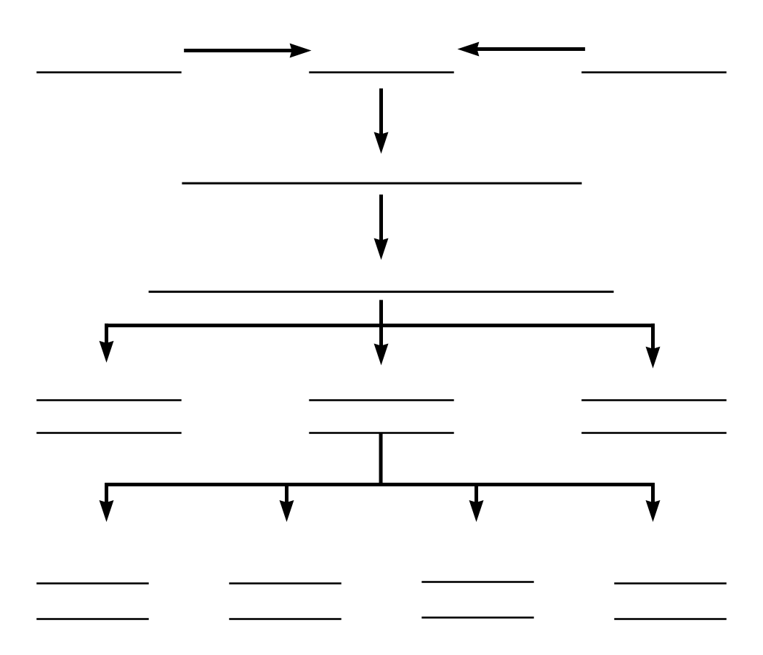

Adapted from Economics: The Options for Dealing with Scarcity by Frank D. Tinari. Scott, Foresman and Company, Glenville, Illinois, 1986

Which of the 5 Es of Economics BEST explains the statements that follow:
- Economic Growth
- Allocative Efficiency
- Productive Efficiency
  - not using more resources than necessary
  - using resources where they are best suited
  - using the appropriate technology
- Equity
- Full Employment
- Shortage of Super Bowl Tickets
- Coke lays off 6000 employees and still produces the same amount
- Free trade
- More resources
- Producing more music downloads and fewer CDs
- Law of Diminishing Marginal Utility
- Using all available resources
- Discrimination
- "President Obama Example"
- improved technology
- Due to an economic recession many companies lay off workers
- A "fair" distribution of goods and services
- Food price controls
- Secretaries type letters and truck drivers drive trucks
- Due to government price supports farmers grow too much grain

- Kodak Cuts Jobs - see article below
  - October 24, 2001 Posted: 1728 GMT
[http://edition.cnn.com/2001/BUSINESS/10/24/kodak/index.html
NEW YORK (CNNmoney) -- Eastman Kodak Co. posted a sharp drop in third-quarter profits Wednesday and warned the current quarter won't be much better, adding it will cut up to 4,000 more jobs. . . .Film and photography companies have been struggling with the adjustment to a shift to digital photography as the market for traditional film continues to shrink.

Which of the 5Es explains this news article? Explain.

Not all Lay-offs are Good for Society
WHY ARE THERE LAY-OFFS?
- Productive Efficiency
  - Improved Productive efficiency allows business to produce the SAME AMOUNT OF OUTPUT with fewer workers.
  - These lay-offs are GOOD for society because they reduce scarcity because more products are produced by the laid-off workers.

- Allocative Efficiency
  - Allocative efficiency means the economy uses its limited resources to produce what people want.
  - Resources are not wasted producing products that people do not want
  - Some lay-offs occur in industries that were producing products that people no longer wanted.
  - These lay-offs are GOOD for society because they reduce scarcity because society gets more utility from its resources.

- Recession
  - Some lay-offs are the result of an economic recession when unemployment rises and people buy fewer products
  - These lay-offs are NOT GOOD for society because they result in MORE SCARCITY because fewer products are produced with society’s resources.

Resource Quiz
Each of the following is either a/n:
a. consumer good
b. consumer service
c. land
d. capital
e. labor
f. entrepreneur

 | Your answer: |  | Your answer:
medical checkup |  | taxi ride
factory |  | automobile
highway |  | autoworker
candy bar |  | John DeLorean
coal |  | ice cream cone
coke |  | haircut
iron ore |  | waiter
Steve Jobs/Steve Wasnik |  | Ted Turner
forest |  | crude oil
lumber |  | gasoline
class lecture |  | stockings

Production Possibilities
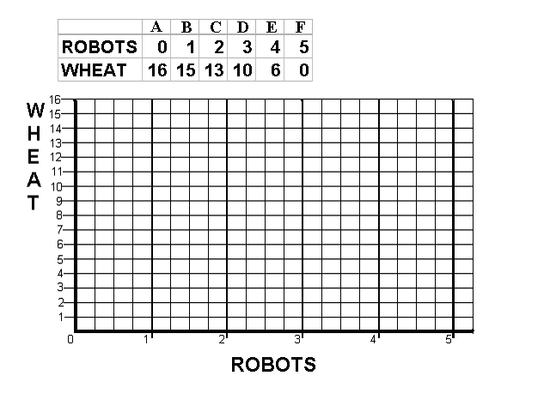
- What is the Law of Increasing Costs?

__________________________________________________________________________________________
__________________________________________________________________________________________

__________________________________________________________________________________________

- Calculate the Opportunity Cost of Producing the first robot:

the first robot = __________wheat; second robot = __________wheat;

3rd = ________wheat; 4th = ________wheat; 5th = ________wheat.

- Mark a point “N” on your production possibilities graph that represents
PRODUCTIVE INEFFICIENCY or UNEMPLOYMENT.

Mark a point “M” that represents a combination of wheat and robots that is
Currently IMPOSSIBLE to produce with given resources and technology.

- On the graph above, sketch in a new PPC that would represent economic growth.

5. If we know that robots are Capital goods and wheat is a Consumer good, which combination of robots and wheat, B, C, D or E, would result in more growth in the future?
Benefit Cost Analysis

Definition: The selection of all possible alternatives where the marginal benefits are
greater than the marginal costs.

select ALL possible options up to where MB = MC

this implies ignoring sunk (fixed) costs
select all where: MB > MC
up to where: MB = MC
but never where: MB < MC
Purpose: to make the best decision possible

Example 1 – How many guards should be hired?

# total marginal amount lost total benefit marginal
guards cost cost in shoplifting (amount caught) benefit

0 $ 0 -- $ 1000 $ 0 --

1 $ 200 $ 500 $ 500

2 $ 400 $ 200 $ 800

3 $ 800 $ 50 $ 950

Example 2 - How many bridges should be built?

# total marginal total marginal
bridges cost costs benefits benefits

0 $ 0 -- $ 0 --

1 $ 50 M $ 100 M

2 $ 120 M $ 120 M

CHAPTER 3 DEMAND AND SUPPLY

An individual’s demand for Moore’s Pizza:

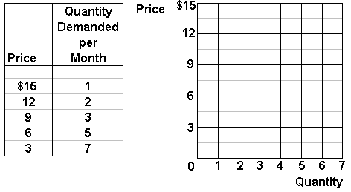
In the graph above, plot this individual’s demand curve for Moore’s pizza.

The supply of Moore’s pizza:

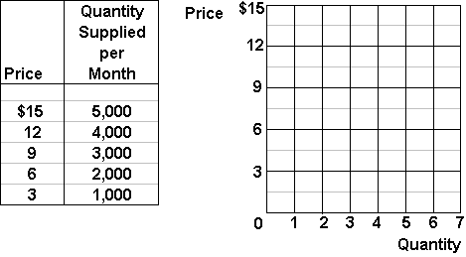
In the graph above, plot the supply curve for Moore’s pizza.

Market Equilibrium:

Assume that there are 1000 people with identical demand curves for Moore’s
Pizza, plot the market demand and supply curves for Moore’s pizza:

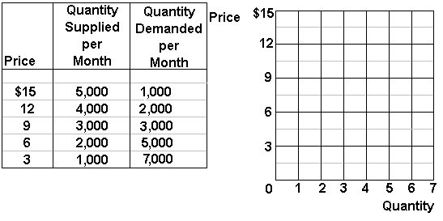

What is the equilibrium price of Moore’s pizza? ___________________

What is the equilibrium quantity? ___________________

Market Disequilibrium:

If Moore charged $12 per pizza:

How many pizzas would be demanded? ____________________

How many pizzas would be supplied? ____________________

There would be a surplus/shortage (circle one) of ________________ pizzas.

If Moore charged $6 per pizza:

How many pizzas would be demanded? ____________________

How many pizzas would be supplied? ____________________

There would be a surplus/shortage (circle one) of ________________ pizzas.

The non-price determinants of demand | The non-price determinants of supply
Pe -- expected price  Pog -- price of other goods  1) substitute goods  2) complementary goods  3) independent goods  I -- income  1) normal goods  2) inferior goods  N -- number of POTENTIAL consumers  T -- tastes and preferences | Pe -- expected price  Pog -- price of other goods PROD.BY SAME FIRM  Pres -- price of resources  T --technology  T --taxes and subsidies  N -- number of sellers

Increase in Demand
Decrease in Demand
Increase in Supply
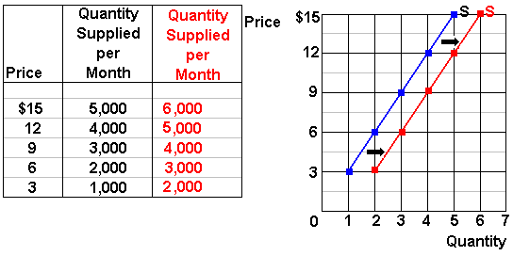
Decrease in Supply
List the Five Non-Price Determinants of Demand:  ______, ______, ______, ______, ______ | List the Six Non-Price Determinants of Supply:  ______, _______, ______, ______, ______, ______
Fill in the blanks with either or  Pe -- expected price  Pe in the future ____D today  Pe in the future ____ D today  Pog -- price of other goods  1) substitute goods  P Maxwell House coffee ____ D Folgers coffee  P of one product ____ D of its substitutes  2) complementary goods  P of wieners ____ D of buns  P of one product ____D of its compliment  I -- income  1) normal goods  Income ____ D for normal goods  Income ____ D for normal goods  2) inferior goods  Income ____ D for inferior goods  Income ____ D for inferior goods  Npot -- number of POTENTIAL consumers  Npot ____ D  Npot ____ D  T -- tastes and preferences  Tastes for a product ____ D for that product  Tastes for a product ____ D for that product | Fill in the blanks with either or  Pe -- expected price  Pe in the future ____ S today  Pe in the future ____ S today  Pog -- price of other goods also produced by the same firm  P soybeans ____ S corn  P soybeans ____ S corn  Pres -- price of resources  P autoworkers wages costs of producing cars ____ S cars  Pres costs ____ S  Pres costs ____ S  Tech --technology  Improved technology costs ____ S  Tax --taxes and subsidies  Taxes costs ____ S  Taxes costs ____ S  Subsidies costs ____ S  Subsidies costs ____ S  N -- number of producers/sellers  Nproducers ____ S  Nproducers ____ S

The Non-Price Determinants of Demand and Supply
Non-Price Determinants of Demand  Pe, Pog, I, Npot, T | Non-Price Determinants of Supply  Pe, Pog, Pres, Tech, Tax, Nprod
Pe -- expected price  Pe in the future D today  Pe in the future D today  Pog -- price of other goods  1) substitute goods  P Maxwell House coffee D Folgers coffee  P of one product D of its substitute  2) complementary goods  P of wieners D of buns  P of one product D of its compliment  I -- income  1) normal goods  Income D for normal goods  Income D for normal goods  2) inferior goods  Income D for inferior goods  Income D for inferior goods  Npot -- number of POTENTIAL consumers  Npot D  Npot D  T -- tastes and preferences  Tastes for a product D for that product  Tastes for a product D for that product | Pe -- expected price  Pe in the future S today  Pe in the future S today  Pog -- price of other goods also produced by the same firm  P soybeans S corn  P soybeans S corn  Pres -- price of resources  P autoworkers wages costs of producing cars S cars  Pres costs S  Pres costs S  Tech --technology  Improved technology costs S  Tax --taxes and subsidies  Taxes costs S  Taxes costs S  Subsidies costs S  Subsidies costs S  N -- number of producers/sellers  Nproducers S  Nproducers S

Change in Demand vs. Change in Quantity Demanded
Matching: Which of the follow tables/graphs shows:

1. a decrease in demand __________
2. a change in quantity demanded ___________
3. an increase in demand _________
A
B
C

Change in Supply vs. Change in Quantity Supplied
Matching: Which of the follow tables/graphs shows:
1. a decrease in supply __________
2. a change in quantity supplied ___________
3. an increase in supply _________
A
B
C

INSTRUCTIONS
Use supply and demand curves to illustrate how each of the following changes will affect the price and quantity of the stated product, ceterus paribus.
Before you guess, answer the following questions:
(1) Which determinant has changed?
(2) Will it affect supply or demand?
(3) Will supply or demand increase or decrease?
(4) GRAPH IT! What happens to price and quantity?
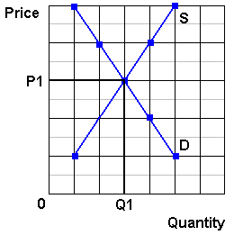
1. Computers  Consumer incomes increase | (1) Which determinant has changed?  (2) Will it affect supply or demand?  (3) Will supply or demand increase or decrease?  (4) GRAPH IT! What happens to price and quantity?
2. Calculators  Improved technology reduces the costs of production | (1) Which determinant has changed?  (2) Will it affect supply or demand?  (3) Will supply or demand increase or decrease?  (4) GRAPH IT! What happens to price and quantity?
3. Sony Play Station  Computer prices drop | (1) Which determinant has changed?  (2) Will it affect supply or demand?  (3) Will supply or demand increase or decrease?  (4) GRAPH IT! What happens to price and quantity? (or maybe)
4. Nikon Cameras  Price of film developing decreases | (1) Which determinant has changed?  (2) Will it affect supply or demand?  (3) Will supply or demand increase or decrease?  (4) GRAPH IT! What happens to price and quantity?
5. Cigarettes  Reduced gov't farm subsidies increase the costs of production | (1) Which determinant has changed?  (2) Will it affect supply or demand?  (3) Will supply or demand increase or decrease?  (4) GRAPH IT! What happens to price and quantity?
6. Coffee  a report links coffee drinking to heart attacks | (1) Which determinant has changed?  (2) Will it affect supply or demand?  (3) Will supply or demand increase or decrease?  (4) GRAPH IT! What happens to price and quantity?
7. Wood furniture  Lumber prices rise | (1) Which determinant has changed?  (2) Will it affect supply or demand?  (3) Will supply or demand increase or decrease?  (4) GRAPH IT! What happens to price and quantity?
8. Steel Furniture  Wood furniture prices increase | (1) Which determinant has changed?  (2) Will it affect supply or demand?  (3) Will supply or demand increase or decrease?  (4) GRAPH IT! What happens to price and quantity?
9. Computers  5 new firms enter the industry | (1) Which determinant has changed?  (2) Will it affect supply or demand?  (3) Will supply or demand increase or decrease?  (4) GRAPH IT! What happens to price and quantity?
10. Cigarettes  Gov't announces a large tax increase will begin in 1 week | (1) Which determinant has changed?  (2) Will it affect supply or demand?  (3) Will supply or demand increase or decrease?  (4) GRAPH IT! What happens to price and quantity?
11. Gasoline  Gasoline taxes increase | (1) Which determinant has changed?  (2) Will it affect supply or demand?  (3) Will supply or demand increase or decrease?  (4) GRAPH IT! What happens to price and quantity?
12. Soybeans  The price of corn rises | (1) Which determinant has changed?  (2) Will it affect supply or demand?  (3) Will supply or demand increase or decrease?  (4) GRAPH IT! What happens to price and quantity?

THE EFFICIENCY OF MARKETS
Why are Markets Efficient?
Businesses will produce the profit maximizing quantity. This is the equilibrium quantity where Qd=Qs (see graph below on the left). This is WHAT WE GET.

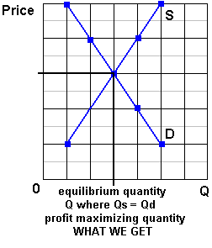 | 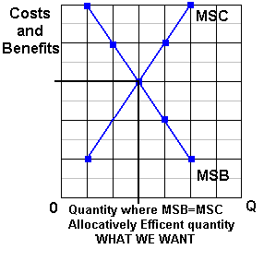
Society wants the allocatively efficient quantity. This is the quantity where MSB=MSC (see graph above on the right). This is WHAT WE WANT.
If there are no negative externalities (spillover costs) the S = MSC, and if there are no positive externalities (spillover benefits) the D = MSB, THEREFORE: WHAT WE GET = WHAT WE WANT and self-interested, profit maximizing, businesses will end up doing what is best for society - achieving allocative efficiency - as if there is some "invisible hand " guiding their decisions.
SUMMARY:
- Businesses will produce the profit maximizing or market equilibrium quantity - the quantity where Qd=Qs; (WHAT WE GET)

- Society wants the allocatively efficient quantity - the quantity where MSB=MSC ; (WHAT WE WANT)

- WHAT WE GET = WHAT WE WANT if:
  - Market Demand = Marginal Social Benefits (D=MSB)
(and this is true if there are no positive externalities [spillover benefits])
  - Market Supply = Marginal Social Costs (S=MSC)
(and this is true if there are no negative externalities [spillover costs))
  - THEREFORE if there are no negative externalities (spillover costs) and no positive externalities (spillover benefits) competitive markets (capitalism) achieves allocative efficiency
WHAT WE GET = WHAT WE WANT
This is the "invisible hand" of capitalism. Even though businesses are not trying to be efficient, when they are selfish and try to maximize their profits, THEY WILL BE EFFICIENT.
In a market economy with no positive externalities (spillover benefits) and no negative externalities (spillover costs):
the profit maximizing or market equilibrium quantity
(what we get)
WILL BE THE SAME AS
the allocative efficient quantity
(what we want)

The mystical power of free trade

Some people find it hard to believe it really works, but it does

By Michael Kinsley
http://www.cnn.com/ALLPOLITICS/time/1999/12/06/free.trade.html
December 6, 1999
Web posted at: 1:27 p.m. EST (1827 GMT)
Free trade is always a hard sell. In all of social science, the proposition that comes closest to being scientific, in terms of being theoretically provable and true in real life, is that a society benefits from allowing its citizens to buy what they wish--even from foreigners. But people resist this conclusion, sometimes violently, as in Seattle last week. Why?
A couple of reasons. First, the principle of free trade may be true, but it's not obviously true. In fact, it's counterintuitive. If a factory shuts down because of a flood of cheap foreign products, how is that good? If middle-class Americans find themselves competing with foreigners being paid practically nothing and living in squalor, how can this send Americans' standard of living up and not down? If another nation is willing to pollute its air and water in order to produce goods for sale in the global economy, how can America join that economy and still hope to keep its own air and water clean?
There are answers to these questions, but they take a bit of background and a bit of persuading. Students of economics are led step by step through layers of reasoning until the moment they see the light. Skeptics think that the whole routine is like induction into a religious cult and that free trade is more like an article of religious faith than a sound policy recommendation. These skeptics are wrong, but their skepticism is understandable.
The other reason it's hard to sell free trade is that any given example tends to benefit a lot of people in small ways that are hard to identify and tends to harm a few people a lot in ways that are vividly evident. When that factory shuts down, the unemployed workers know they've suffered a loss, and they know why. And it's a big enough loss to stir them politically. It will affect their vote at least, if not cause them to march in the streets.
By contrast, budget-conscious clothes shoppers (maybe those same workers) who are able to save a few bucks on a new sweater are not likely to realize they are enjoying a bargain as a result of global trade or to take to the streets to defend their right to a cheap sweater. Or suppose the U.S. slaps a tariff on foreign sweaters and the foreign country retaliates by raising a tariff on something we're selling them--the people who would lose their jobs aren't even identifiable for sure, though for sure they exist. Likewise the people who lose jobs because shoppers who have to pay more for sweaters have less money to spend on other things.
It's by considering all these things--the risk of losing your job one way minus the risk of losing it another, the extra money you make if your industry is shielded from foreign competition minus the extra money you pay for goods and services that are protected--that you reach the conclusion that on average, free trade benefits us all. Yes, there are various economic theories about circumstances in which all this may not be true, but their authors win prizes precisely because the circumstances are unusual. In general, the numbers work irrespective of what policies other countries follow. They just get worse if one country's trade restrictions lead other countries to impose more of the same. Trouble is, who's got time for all that math?
Still, a half-century of general prosperity in the U.S. has created a climate of toleration, if not enthusiasm, for the free-trade gospel--mostly, indeed, as a gospel of our civic religion rather than out of anyone's buying the math. Alarm about imports tends to ebb and flow with the economy--less in good times, more in bad. So how, in the best times ever, did the World Trade Organization become the global bogeyman? No earnest college kid ever hitched across the country to carry a picket sign against the General Agreement on Tariffs and Trade, the WTO's predecessor, although its function was similar. It took decades for the CIA, the Trilateral Commission and the Council on Foreign Relations to achieve their places in the pantheon of political paranoia. The WTO has joined them in just four years. And it is despised across the entire political spectrum, whereas these other groups symbolize evil only to one political extreme or the other.
Part of the explanation is the special nature of our current prosperity, which is widening the income gap rather than narrowing it, as in the past. Part is the growth of global economic forces that are actually impinging on national sovereignty, even though it's the paranoid hysterics who say so. But the WTO isn't responsible for either of these trends, both of which are probably inevitable and neither of which undermines the basic case for free trade or for an organization empowered to promote trade through binding arbitration of trade disputes.
Maybe it's the name. If you call yourself the World Trade Organization, you can't complain much if people dial your 800 number and gripe about world trade. If a bunch of heads of government plan a triumphalist self-celebration in Seattle, you can't blame party poopers for showing up to horn in on the publicity. But really, the WTO is O.K. Do the math. Or take it on faith.

QUIZ

Do you think like an economist?
- The purpose of economic activity is:
A. to improve consumer well being
B. to create jobs
- Work is a:
A. cost
B. benefit
- Imports are a
A. benefit
B. cost
- Exports are a
A. cost
B. benefit
- The objective of trade is to
A. get goods cheaply
B. create jobs

Assume there is an attorney who is an excellent auto mechanic and his/her car needs repair.
The attorney could fix it in one hour. An auto mechanic could fix it in two hours. (Note: the auto mechanic is not as good at fixing cars, or at doing law, as the attorney – the attorney is better at both)
Let's say the auto mechanic charges $50 an hour and the attorney charges $200 per hour.
Should the attorney fix the car himself/herself or should they bring it to the auto mechanic?

Why?
Absolute Advantage
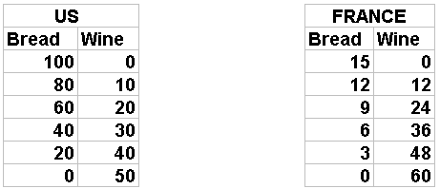
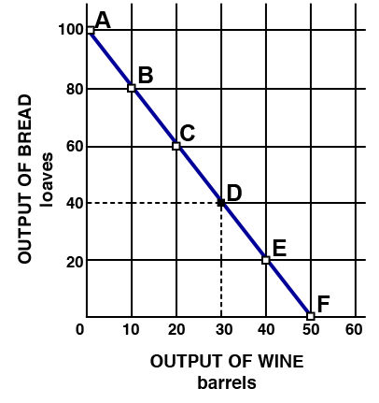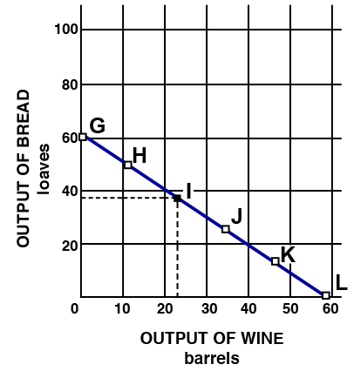

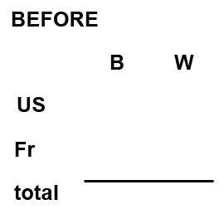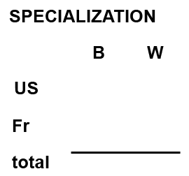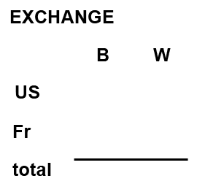
Comparative Advantage
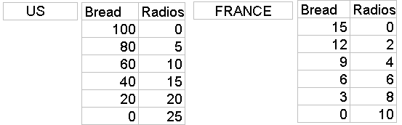
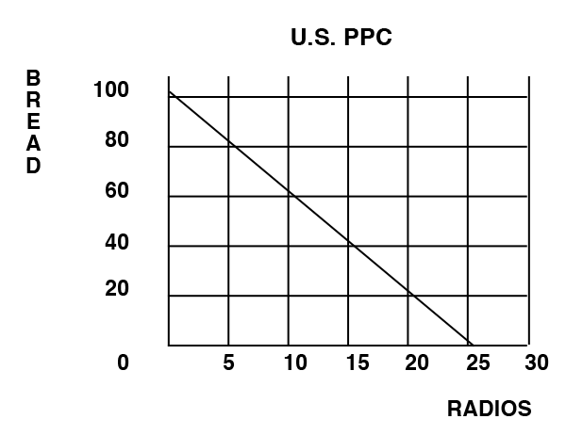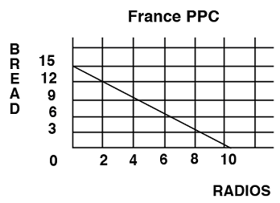

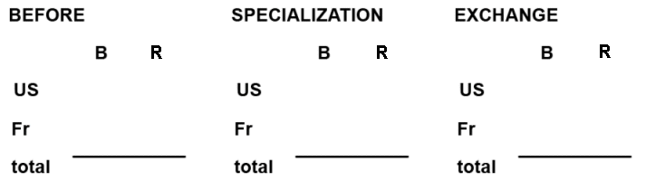
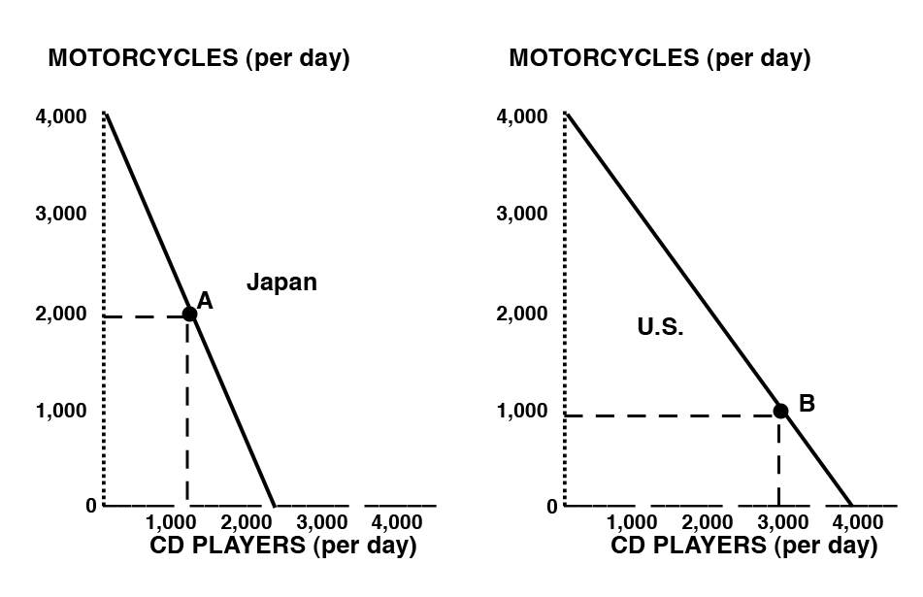
1. Who has a comparative advantage in motorcycles?
2. Who has a comparative advantage in CD players?
3. Assume that before specialization and trade Japan is at point A and the U.S. is at point B. If each country specializes 100% according to their comparative advantage, what are the gains from specialization and trade?

Should the US use trade restrictions to protect American jobs?
READ:
Could your job go to China?
While U.S. employment leaps ...
September 7, 2001 Posted: 12:07 PM EDT (1607 GMT)
[http://www.cnn.com/2001/CAREER/trends/09/06/china.trade.jobs/index.html]
By Porter Anderson
CNN Career
(CNN) -- Just as Friday's new Labor Department report shows the United States unemployment rate soaring in August to 4.9 percent from 4.6 percent, a newly released, federally funded study reveals that a significant number of production jobs are shifting from the American workplace to China.

Labor Department statistics suggest that U.S. employers cut far more jobs in August than private economists had anticipated -- 113,000 non-farm positions. And this is after American layoffs passed the 1-million mark in July.

But what concerns Stephanie Luce, Ph.D., about her research data is not just her figure of at least 34,900 jobs -- and maybe twice that -- moving from the States to China in a seven-month period as a result of warming Washington-Beijing trade relations.

"What makes it worse," she says, "is that some of these are higher-wage jobs, the type jobs that U.S. cities have been fighting to win. And now they're leaving. Many of those jobs were held by people who'd been working in them for many years, and in some cases their whole lifetimes."

QUESTIONS:
AFTER READING, WHAT DO YOU THINK?
Should the US use trade restrictions to protect American jobs?
- What is YOUR answer to this question? YES / NO
- How would most economists answer this question? YES / NO
- According to economic studies which of the following is true for countries that restrict trade?
  - The benefits of trade restrictions are much greater than their costs
  - The costs of trade restrictions are much greater than the benefits

- If YOU answered NO to the first question, how do you reconcile your answer with the news article above? OR what could be done instead of trade restrictions?
Ch. 4 -- The Economic Functions of Government and the 5 Es

NEGATIVE EXTERNALITIES

Define Negative Externalities (Spillover costs):

Examples of Negative Externalities (Spillover costs):

Use the graph below to answer the questions that follow.

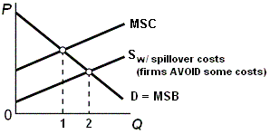

What is the allocatively efficient quantity?

What is the profit maximizing quantity?

Which quantity will be produced without government involvement?

Is there an OVER allocation or an UNDERallocation of resources?
What is the goal of government involvement? [When spillover costs are associated with a product like gasoline what should the government try to do to the QUANTITY -- INCREASE OR DECREASE it?]
What are the possible government policies to achieve this goal?
On your graph show the effect of an increase in the excise tax on gasoline
What happens to the quantity and allocative efficiency when the government taxes a product whose production has negative externalities (spillover costs)?
POSITIVE EXTERNALITIES

Define Positive Externalities (Spillover benefits):

Examples of Positive Externalities (Spillover benefits):

Use the graph below to answer the questions that follow.

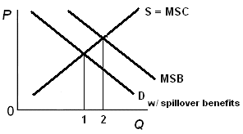

What is the allocatively efficient quantity?

What is the profit maximizing quantity?

Which quantity will be produced without government involvement?

Is there an OVER allocation or an UNDERallocation of resources?

What is the goal of government involvement? [When spillover benefits are associated with a product like education what should the government try to do to the QUANTITY -- INCREASE OR DECREASE it?]

What are the possible government policies to achieve this goal?

On your graph show the effect of an increase supply on the market for education.
What happens to quantity and allocative efficiency when the government subsidizes a product whose production has positive externalities (spillover benefits)?

