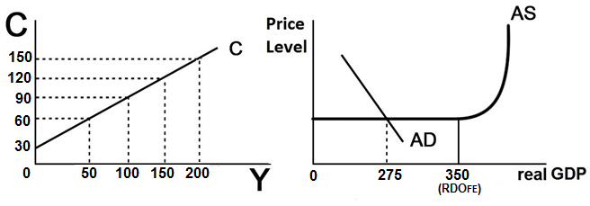

**1. Use the figure above to answer this question. What increase in government purchases is needed to achieve full employment (increase real GDP from 275 to 350)?**1. 10  
2. 20  
3. 30  
4. 50  
5. 75

**2. Use the figure above to answer this question. What decrease in taxes is needed to achieve full employment (increase real GDP from 275 to 350)?**1. 10  
2. 20  
3. 30  
4. 50  
5. 75

**3. Use the figure above to answer this question. If we do not want to increase the budget deficit, what increase in government purchases AND increase in taxes would be needed to achieve full employment (increase real GDP from 275 to 350)? Increase BOTH G and T by:**1. 10  
2. 20  
3. 30  
4. 50  
5. 75

**4. The AD-AS graph shows that as AD increases there is no change in the price level (no inflation). If there was inflation then what increase in government spending would be needed to achieve full employment (increase real GDP by 75)?**1. less than 30  
2. 30  
3. more than 30  
4. we cannot tell