**What happens to the value of the US $ and the Mexican peso if the following happens?**

**Show the changes on the foreign exchange market graphs.**

1. **If US incomes grow relative to Mexico’s:**

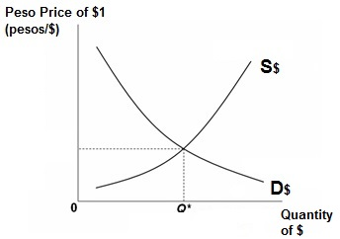 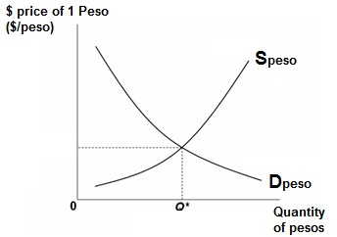

CIRCLE ONE: $ will appreciate or depreciate CIRCLE ONE: Peso will appreciate or depreciate

1. **If Mexican incomes grow relative to those in the US:**

 

CIRCLE ONE: $ will appreciate or depreciate CIRCLE ONE: Peso will appreciate or depreciate

1. **If US interest rates increase relative to Mexico’s:**

 

CIRCLE ONE: $ will appreciate or depreciate CIRCLE ONE: Peso will appreciate or depreciate

1. **If Mexican interest rates increase relative to those in the US:**

 

CIRCLE ONE: $ will appreciate or depreciate CIRCLE ONE: Peso will appreciate or depreciate

1. **American tastes turn more favorable towards Mexican beer:**

 

CIRCLE ONE: $ will appreciate or depreciate CIRCLE ONE: Peso will appreciate or depreciate

1. **Mexican tastes turn more favorable towards American beer:**

 

CIRCLE ONE: $ will appreciate or depreciate CIRCLE ONE: Peso will appreciate or depreciate

1. **If prices rise quickly in Mexico compared to those in the US:**

 

CIRCLE ONE: $ will appreciate or depreciate CIRCLE ONE: Peso will appreciate or depreciate

1. **If prices rise quickly in the US compared to those in Mexico:**

 

CIRCLE ONE: $ will appreciate or depreciate CIRCLE ONE: Peso will appreciate or depreciate