**DETERMINANTS of EXCHANGE RATES: The Foreign Exchange Market**

When Americans buy foreign products or make financial investments overseas we demand foreign currency and supply dollars

When foreigners buy American products or make financial investments in the U.S. they demand dollars and supply their currency

DETERMINANTS: Why would Americans demand foreign currency and supply dollars?

To buy more foreign products: PPINT

* Lower prices overseas, higher prices in the US (Pog subs)
* Increase in US incomes (I = Income)
* Increase in tastes for foreign goods (T = tastes)

To invest financially overseas:

* Higher interest rates overseas, lower interest rates in the US

DETERMINANTS: Why would foreigners demand dollars and supply their currency?

To buy more US products: PPINT

* Lower prices in US, higher prices in their country (Pog subs)
* Increase in their incomes (I – Income)
* Increase in tastes for US goods (T=tastes))

To invest financially overseas:

* Higher interest rates in US, lower interest rates in their country

REMEMBER:

- The demand for $ by Mexicans is the same as the supply of pesos. They supply pesos when they buy $.

- The demand for pesos by Americans is the same as the supply of $. We supply $ when we buy pesos.

What happens to the value of the US $ and the Mexican peso if the following happens? Show the changes on the foreign exchange market graphs.

1. **If US incomes grow relative to Mexico’s:**

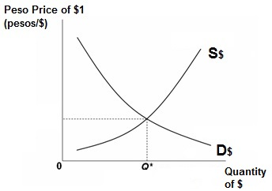 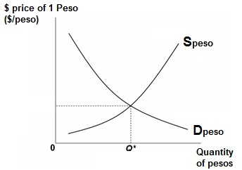

CIRCLE ONE: $ will appreciate or depreciate CIRCLE ONE: Peso will appreciate or depreciate

1. **If Mexican incomes grow relative to those in the US:**

 

CIRCLE ONE: $ will appreciate or depreciate CIRCLE ONE: Peso will appreciate or depreciate

1. **If US interest rates increase relative to Mexico’s:**

 

CIRCLE ONE: $ will appreciate or depreciate CIRCLE ONE: Peso will appreciate or depreciate

1. **If Mexican interest rates increase relative to those in the US:**

 

CIRCLE ONE: $ will appreciate or depreciate CIRCLE ONE: Peso will appreciate or depreciate

1. **American tastes turn more favorable towards Mexican beer:**

 

CIRCLE ONE: $ will appreciate or depreciate CIRCLE ONE: Peso will appreciate or depreciate

1. **Mexican tastes turn more favorable towards American beer:**

 

CIRCLE ONE: $ will appreciate or depreciate CIRCLE ONE: Peso will appreciate or depreciate

1. **If prices rise quickly in Mexico compared to those in the US:**

 

CIRCLE ONE: $ will appreciate or depreciate CIRCLE ONE: Peso will appreciate or depreciate

1. **If prices rise quickly in the US compared to those in Mexico:**

 

CIRCLE ONE: $ will appreciate or depreciate CIRCLE ONE: Peso will appreciate or depreciate

**Answers**

What happens to the value of the US $ and the Mexican peso if the following happens? Show the changes on the foreign exchange market graphs.

1. **If US incomes grow relative to Mexico’s:**

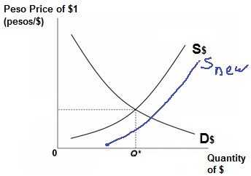 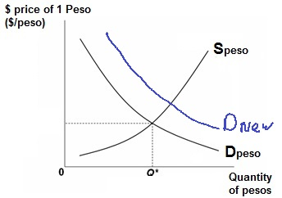

CIRCLE ONE: $ will appreciate or **depreciate** CIRCLE ONE: Peso will **appreciate** or depreciate

1. **If Mexican incomes grow relative to those in the US:**

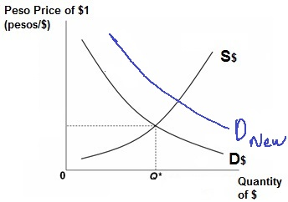 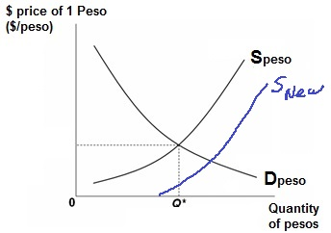

CIRCLE ONE: $ will **appreciate** or depreciate CIRCLE ONE: Peso will appreciate or **depreciate**

1. **If US interest rates increase relative to those in Mexico:**

 

CIRCLE ONE: $ will **appreciate** or depreciate CIRCLE ONE: Peso will appreciate or **depreciate**

**Mexicans demand more $ to invest in the US Mexicans supply more pesos to buy $ to invest   
 in US**

**OR**

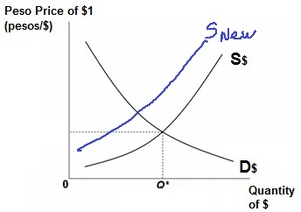 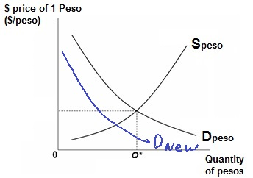

CIRCLE ONE: $ will **appreciate** or depreciate CIRCLE ONE: Peso will appreciate or **depreciate  
 Americans supply fewer $ because they now Americans demand fewer pesos because they now  
 invest less in Mexico . invest less in Mexico.**

1. **If Mexican interest rates increase relative to those in the US:**

 

CIRCLE ONE: $ will appreciate or **depreciate** CIRCLE ONE: Peso will **appreciate** or depreciate  
 **Americans supply more $ to buy pesos to invest Americans demand more pesos to invest in Mex.  
 in Mexico**

**OR**

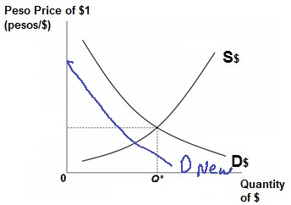 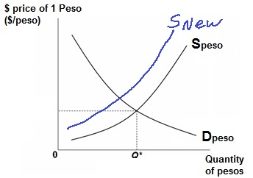

CIRCLE ONE: $ will appreciate or **depreciate** CIRCLE ONE: Peso will **appreciate** or depreciate  
 **Mexicans demand fewer $ because they Mexicans supply fewer pesos because they now   
 now invest less in the US invest less in the US**

1. **American tastes turn more favorable towards Mexican beer:**

 

CIRCLE ONE: $ will appreciate or **depreciate** CIRCLE ONE: Peso will **appreciate** or depreciate

1. **Mexican tastes turn more favorable towards American beer:**

 

CIRCLE ONE: $ will appreciate or depreciate CIRCLE ONE: Peso will appreciate or depreciate

1. **If prices rise more quickly in Mexico compared to those in the US:**

 

CIRCLE ONE: $ will **appreciate** or depreciate CIRCLE ONE: Peso will appreciate or **depreciate  
 Mexicans demand more $ to buy the now Mexicans supply more pesos to buy dollars to   
 cheaper US goods buy the cheaper US goods.**

**OR**

 

CIRCLE ONE: $ will **appreciate** or depreciate CIRCLE ONE: Peso will appreciate or **depreciate  
 Americans supply fewer $ because they now Americans demand fewer pesos because they   
 buy fewer Mexican goods buy fewer Mexican goods.**

1. **If prices rise more quickly in the US compared to those in Mexico:**

 

CIRCLE ONE: $ will appreciate or **depreciate** CIRCLE ONE: Peso will **appreciate** or depreciate  
 **Mexicans will demand fewer $ because they Mexicans will supply fewer pesos because they  
 will buy fewer US goods. will buy fewer US goods**

**OR**

 

CIRCLE ONE: $ will appreciate or **depreciate** CIRCLE ONE: Peso will **appreciate** or depreciate  
 **Americans will supply more $ because they Americans will demand more pesos because they  
 will buy more Mexican goods. will buy more Mexican goods.**