**Answers**

What happens to the value of the US $ and the Mexican peso if the following happens? Show the changes on the foreign exchange market graphs.

1. **If US incomes grow relative to Mexico’s:**

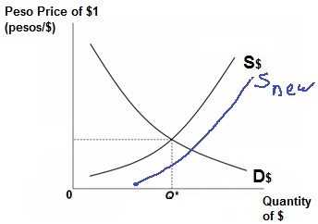 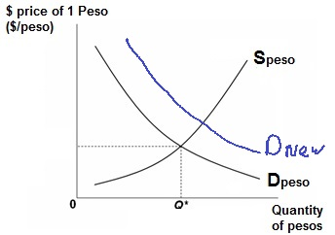

CIRCLE ONE: $ will appreciate or **depreciate** CIRCLE ONE: Peso will **appreciate** or depreciate

1. **If Mexican incomes grow relative to those in the US:**

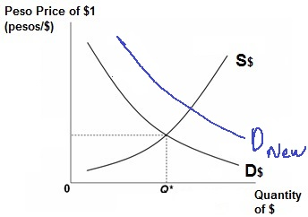 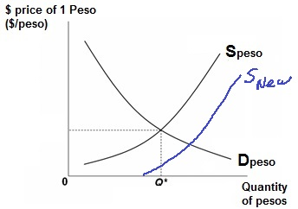

CIRCLE ONE: $ will **appreciate** or depreciate CIRCLE ONE: Peso will appreciate or **depreciate**

1. **If US interest rates increase relative to those in Mexico:**

 

CIRCLE ONE: $ will **appreciate** or depreciate CIRCLE ONE: Peso will appreciate or **depreciate**

**Mexicans demand more $ to invest in the US Mexicans supply more pesos to buy $ to invest   
 in US**

**OR**

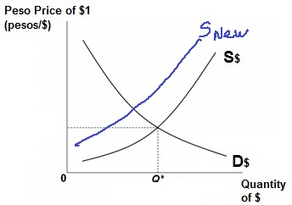 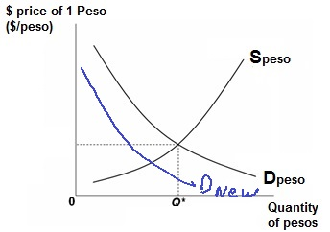

CIRCLE ONE: $ will **appreciate** or depreciate CIRCLE ONE: Peso will appreciate or **depreciate  
 Americans supply fewer $ because they now Americans demand fewer pesos because they now  
 invest less in Mexico . invest less in Mexico.**

1. **If Mexican interest rates increase relative to those in the US:**

 

CIRCLE ONE: $ will appreciate or **depreciate** CIRCLE ONE: Peso will **appreciate** or depreciate  
 **Americans supply more $ to buy pesos to invest Americans demand more pesos to invest in Mex.  
 in Mexico**

**OR**

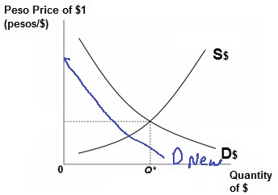 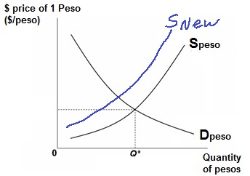

CIRCLE ONE: $ will appreciate or **depreciate** CIRCLE ONE: Peso will **appreciate** or depreciate  
 **Mexicans demand fewer $ because they Mexicans supply fewer pesos because they now   
 now invest less in the US invest less in the US**

1. **American tastes turn more favorable towards Mexican beer:**

 

CIRCLE ONE: $ will appreciate or **depreciate** CIRCLE ONE: Peso will **appreciate** or depreciate

1. **Mexican tastes turn more favorable towards American beer:**

 

CIRCLE ONE: $ will appreciate or depreciate CIRCLE ONE: Peso will appreciate or depreciate

1. **If prices rise more quickly in Mexico compared to those in the US:**

 

CIRCLE ONE: $ will **appreciate** or depreciate CIRCLE ONE: Peso will appreciate or **depreciate  
 Mexicans demand more $ to buy the now Mexicans supply more pesos to buy dollars to   
 cheaper US goods buy the cheaper US goods.**

**OR**

 

CIRCLE ONE: $ will **appreciate** or depreciate CIRCLE ONE: Peso will appreciate or **depreciate  
 Americans supply fewer $ because they now Americans demand fewer pesos because they   
 buy fewer Mexican goods buy fewer Mexican goods.**

1. **If prices rise more quickly in the US compared to those in Mexico:**

 

CIRCLE ONE: $ will appreciate or **depreciate** CIRCLE ONE: Peso will **appreciate** or depreciate  
 **Mexicans will demand fewer $ because they Mexicans will supply fewer pesos because they  
 will buy fewer US goods. will buy fewer US goods**

**OR**

 

CIRCLE ONE: $ will appreciate or **depreciate** CIRCLE ONE: Peso will **appreciate** or depreciate  
 **Americans will supply more $ because they Americans will demand more pesos because they  
 will buy more Mexican goods. will buy more Mexican goods.**