**GIVEN THE FOLLOWING INFORMATION: 16a**

**FED TOOL - What did the Fed do?** (must be given)

Assume the Fed BUYS $100 billion in securities FROM BANKS.

**Required Reserve Ratio** (RR)? (must be given): __20 %__

**Formulas:**

MS = ER x Money Multiplier  
Required Reserves = RR x Demand Dep.  
Excess Reserves = Total Reserves - Required Reserves  
Money Multiplier = 1/RR

**SHOW CHANGES ON BALANCE SHEETS:**

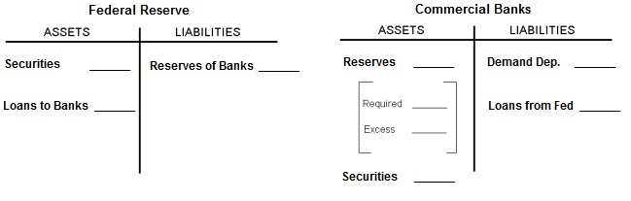

**WHAT HAPPENS TO THE MONEY SUPPLY (MS)?**

**SHOW CHANGES ON GRAPHS:**

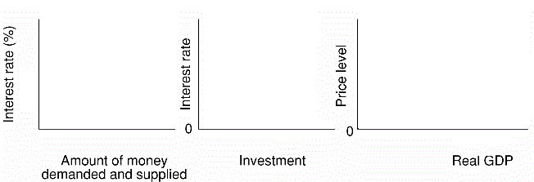

**WHAT HAPPENS TO: UE _________________; IN _________________; EG _________________.**

**GIVEN THE FOLLOWING INFORMATION: 16a**

**FED TOOL - What did the Fed do?** (must be given)

Assume the Fed BUYS $100 billion in securities FROM THE PUBLIC.

**Required Reserve Ratio** (RR)? (must be given): __20 %__

**Formulas:**

MS = ER x Money Multiplier  
Required Reserves = RR x Demand Dep.  
Excess Reserves = Total Reserves – Required Reserves  
Money Multiplier = 1/RR

**SHOW CHANGES ON BALANCE SHEETS:**



**WHAT HAPPENS TO THE MONEY SUPPLY (MS)?**

**SHOW CHANGES ON GRAPHS:**



**WHAT HAPPENS TO: UE _________________; IN _________________; EG _________________.**

**GIVEN THE FOLLOWING INFORMATION: 16a**

**FED TOOL – What did the Fed do?** (must be given)

Assume the Fed LOWERS THE DISCOUNT RATE which causes commercial banks to borrow $100 billion in loans from the Federal Reserve.

**Required Reserve Ratio** (RR)? (must be given): __20 %__

**Formulas:**

MS = ER x Money Multiplier  
Required Reserves = RR x Demand Dep.  
Excess Reserves = Total Reserves - Required Reserves  
Money Multiplier = 1/RR

**SHOW CHANGES ON BALANCE SHEETS:**



**WHAT HAPPENS TO THE MONEY SUPPLY (MS)?**

**SHOW CHANGES ON GRAPHS:**



**WHAT HAPPENS TO: UE _________________; IN _________________; EG _________________.**

**GIVEN THE FOLLOWING INFORMATION: 16a**

**FED TOOL - What did the Fed do** (must be given)?

Assume the Fed RAISES THE DISCOUNT RATE which causes commercial banks to repay $100 billion in loans owed to the Federal Reserve.

**Required Reserve Ratio** (RR; must be given): __20 %__

**Formulas:**MS = ER x Money Multiplier  
Required Reserves = RR x Demand Dep.  
Excess Reserves = Total Reserves - Required Reserves  
Money Multiplier = 1/RR

**SHOW CHANGES ON BALANCE SHEETS:**



**WHAT HAPPENS TO THE MONEY SUPPLY (MS)?**

**SHOW CHANGES ON GRAPHS:**



**WHAT HAPPENS TO: UE _________________; IN _________________; EG _________________.**