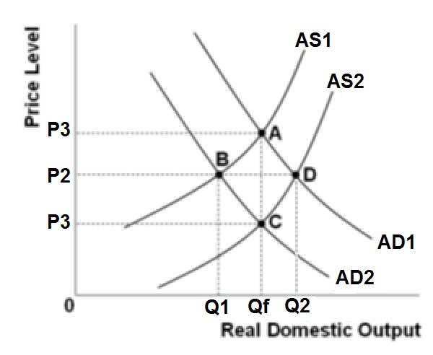

Refer to the above graph. Assume that the economy is initially at equilibrium at point *A*. If there is a recession in the economy because AD1 shifts to AD2, and wages and prices are flexible, then in the long run the price level will be:   
A. *P2*, and real output will be *Qf*  
B. *P3*, and real output will be *Qf*  
C. *P1*, and real output will be *Qf*  
D. *P2*, and real output will be *Q1*

Refer to the above graph. Assume that the economy is initially at equilibrium at point *C*. If there is an increase in AD from AD2 to AD1 shifts to, and wages and prices are flexible, then in the long run the price level will be:   
A. *P2*, and real output will be *Qf*  
B. *P3*, and real output will be *Qf*  
C. *P1*, and real output will be *Qf*  
D. *P2*, and real output will be *Q1*

Refer to the above graph. If Qf is potential GDP, wages and prices are flexible, then the long-run aggregate supply curve will be:   
A. AS2  
B. AS1  
C. a vertical line at *Qf*  
D. a vertical line at *Q1*

E. a vertical line at Q2