**Using the AS/AD Model**

We learn the AS/AD Model so that we have a tool that will help us better understand what causes changes in **UE, IN, and EG**.

The tool works this way, get the cause and effect order correct (what CAUSES what?):  
FIRST: there is a change in one of the DETERMINANTS (see unit 2 yellow pages 2-4)  
SECOND: this causes the GRAPH to SHIFT  
THIRD: which causes a change in the PL and RDO  
FOURTH: finally, a change in the PL and RDO indicates a change in UE, IN, and EG.

Begin by drawing a graph showing AS1, AD1, RDO1, PL1 and RDOFE. UE and IN data is provided at the end of these problems to help you (see page 30).

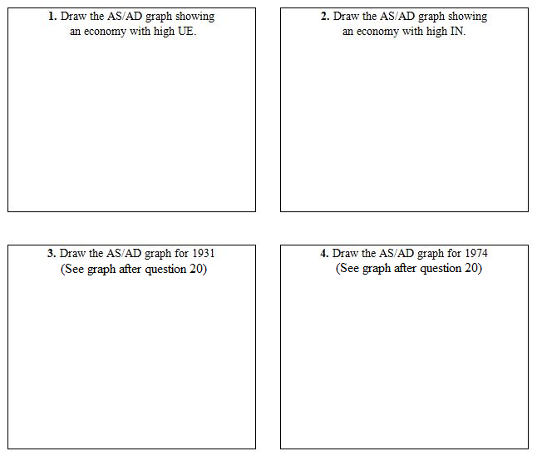

Read the following very short news article then:

1. Find and CIRCLE the determinants of Aggregate Demand (AD) and/or Aggregate Supply (AS) that have changed.

2. Show the effects of these changes on an AS/AD graph.

3. Show the effects on the equilibrium Price Level (PL) and Real Domestic Output (RDO).

4. State what happens to UE, IN, and EG.

**5.** Red flag: U.S. economy may have hit the pause button, by Patrick Gillespie,   April 6, 2016  
<http://money.cnn.com/2016/04/06/news/economy/us-economy-growth-forecast-first-quarter/index.html?category=economy>

Economists have dramatically cut their forecasts for U.S. economic growth in the first quarter of 2016. Falling car sales, equipment purchases by businesses and a downward revision to consumer spending have darkened the view.

**6.** The US Economy Has Reached A Turning Point, The Economist, Oct. 5, 2014  
<http://www.businessinsider.com/the-us-economy-has-reached-a-turning-point-2014-10>

The economy powered ahead. . . . [G]rowth was boosted by improvements across all sectors, including consumer spending, residential and non-residential fixed investment, net exports and government spending. . . . Lower energy prices will also provide a lift, reducing business costs. . . .

**7.** The Economy Is Bad, but 1982 Was Worse, By DAVID LEONHARDT, JAN. 20, 2009  
<http://www.nytimes.com/2009/01/21/business/economy/21leonhardt.html>

So suffice it to say that the serious recent declines in retail sales, business spending and employment make it highly unusual that the economy will improve anytime soon. . . . [I]t is hard to judge the staggering stimulus numbers being thrown around Washington. whether [the Obama administration is] running the risk of being too timid or too aggressive.

**8.** 1980-82 Early 1980s Recession  
<http://vm136.lib.berkeley.edu/BANC/ROHO/projects/debt/1980srecession.html>

Between 1980 and 1982 the U.S. economy experienced a deep recession, the primary cause of which was the disinflationary monetary policy adopted by the Federal Reserve. The recession coincided with U.S. President Ronald Reagan’s steep cuts in domestic spending. [Another] cause of the early 1980s recession was the Iranian Revolution of 1979, which sparked a second large round of oil price increases.

**9.** U.S. Economy Slowed Sharply at End of 2005, By EDUARDO PORTER and VIKAS BAJAJ : January 28, 2006 <http://www.nytimes.com/2006/01/28/business/28econ.html?_r=1>

Consumer spending slowed abruptly as purchases of motor vehicles collapsed after automakers phased out the generous incentive programs that had lifted sales through the summer. As consumers cut back on spending, business investment also slowed as companies curtailed spending on cars and trucks. Military spending also fell unexpectedly, while a surging import bill put a drag on overall growth.

**10.** A Review Of Past Recessions By Dan Barufaldi  
<http://www.investopedia.com/articles/economics/08/past-recessions.asp>

The Roosevelt Recession: (May 1937 - June 1938). Reasons and Causes: The stock market crashed in late 1937.

**11.** A Review Of Past Recessions By Dan Barufaldi  
<http://www.investopedia.com/articles/economics/08/past-recessions.asp>

The Union Recession: (February 1945 - October 1945) Reasons and Causes: The tail-end of World War II . . . War production had virtually ceased and veterans were just beginning to re-enter the workforce. It was also known as the "Union Recession" as unions were beginning to reassert themselves. Minimum wages were on the rise and credit was tight.

**12.** A Review Of Past Recessions By Dan Barufaldi  
<http://www.investopedia.com/articles/economics/08/past-recessions.asp>

The Post-Korean War Recession: (July 1953 - May 1954) Reasons and causes: After an inflationary period that followed the Korean War, more dollars were directed at national security. The Federal Reserve tightened monetary policy to curb inflation in 1952.

**13**. A Review Of Past Recessions By Dan Barufaldi  
<http://www.investopedia.com/articles/economics/08/past-recessions.asp>

The Eisenhower Recession: (August 1957 - April 1958) Reasons and Causes: . . . The sharp world-wide recession and the strong U.S. dollar contributed to a foreign trade deficit.

**14**. A Review Of Past Recessions By Dan Barufaldi  
<http://www.investopedia.com/articles/economics/08/past-recessions.asp>

The Oil Crisis Recession: (November 1973 - March 1975) Reasons and Causes: This long, deep recession was brought on by the quadrupling of oil prices and high government spending on the Vietnam War. This led to "stagflation" and high unemployment. Unemployment finally reached 9% in May of 1975.

**15.** A Review Of Past Recessions By Dan Barufaldi  
<http://www.investopedia.com/articles/economics/08/past-recessions.asp>

The Iran/Energy Crisis Recession: (July 1981 - November 1982) Reasons and Causes: This long and deep recession was caused by the regime change in Iran; the world's second largest producer of oil at the time . . . forcing [oil] prices higher. The U.S. government enforced a tighter monetary policy to control rampant inflation, which had been carried over from the previous two oil and energy crises.

**16**. A U.S. Economy Snap Shot, Part 1: The Growth Story In 2015 Jan 6, 2016 <http://www.forbes.com/sites/greatspeculations/2016/01/06/a-u-s-economy-snap-shot-part-1-the-growth-story-in-2015/#575d433b72a8>

Consumer demand, which is the chief engine of the U.S. economy and accountable for nearly 70% of economic activity, rose about 3% in the third quarter year over year. This may be due to the improvement in consumer sentiment which in turn stems from an improved labor market.

**17.**...And the Band Played On: The U.S. Economy in 1999 by Christopher J. Waller  
<http://cber.uky.edu/Downloads/waller00.htm>

The year began with remarkable news that the U.S. economy had grown at a staggering rate of 5.9 percent in the fourth quarter of 1998. . . . The Federal Reserve had cut the federal funds rate (the interest rate under its control) three times from 5.5 percent to 4.75 percent during the fall of 1998 . . .

**18**. ...And the Band Played On: The U.S. Economy in 1999 by Christopher J. Waller  
<http://cber.uky.edu/Downloads/waller00.htm>

One of the most startling developments of the year was the report that in the first quarter of 1999, the U.S. saving rate became negative — an event that had not occurred in nearly 40 years. . . Also, the more wealth one has, the less one needs to save for the future. The substantial increases in financial wealth incurred via the U.S. stock market have led people to reduce current saving.

**19**. ...And the Band Played On: The U.S. Economy in 1999 by Christopher J. Waller  
<http://cber.uky.edu/Downloads/waller00.htm>

The biggest surprise regarding the U.S. economy over the last three years has been the continued expansion of the economy at very high rates of growth with almost no inflation. These high rates of growth are particularly surprising since the U.S. labor market is tighter now than at any time in the last 30 years. . . . The Fed to its credit knows that increases in productivity of workers and capital cause more output to be supplied to the market.

**20.** Why December Is Looking Likelier for the Fed to Raise Interest Rates, By KEVIN GRANVILLE UPDATED December 7, 2015  
<http://www.nytimes.com/interactive/2015/business/economy/fed-interest-rates.html>

One of these days, the Federal Reserve tells us, it will decide to raise interest rates.