Spring 2012



ECO 212 – Macroeconomics

Yellow Pages

ANSWERS

Unit 3

Mark Healy
William Rainey Harper College
E-Mail: mhealy@harpercollege.edu
Office: J-262
Phone: 847-925-6352

Consumption and Saving Functions

Y C S APC MPC APS MPS _____________________________________________________________________________________

0 40 - 40 -- -- -- --
_ _ _ _ _ _ _ _ _ _ _ _ _ _ _ _ _ _ _ _ _ _ _ _ _ _ _ _ _ _ _ _ _ _ _ _ _ _ _ _ _ _ _ _ _ _ _ _ _ _ _ _ _ _ _ _

100 120 - 20 1.2 .8 -0.2 .2
_ _ _ _ _ _ _ _ _ _ _ _ _ _ _ _ _ _ _ _ _ _ _ _ _ _ _ _ _ _ _ _ _ _ _ _ _ _ _ _ _ _ _ _ _ _ _ _ _ _ _ _ _ _ _ _ _

200 200 0 1 .8 0 .2
_ _ _ _ _ _ _ _ _ _ _ _ _ _ _ _ _ _ _ _ _ _ _ _ _ _ _ _ _ _ _ _ _ _ _ _ _ _ _ _ _ _ _ _ _ _ _ _ _ _ _ _ _ _ _ _ _

- 280 20 .93 .8 .07 .2
_ _ _ _ _ _ _ _ _ _ _ _ _ _ _ _ _ _ _ _ _ _ _ _ _ _ _ _ _ _ _ _ _ _ _ _ _ _ _ _ _ _ _ _ _ _ _ _ _ _ _ _ _ _ _ _ _

- 360 40 .90 .8 .10 .2
_ _ _ _ _ _ _ _ _ _ _ _ _ _ _ _ _ _ _ _ _ _ _ _ _ _ _ _ _ _ _ _ _ _ _ _ _ _ _ _ _ _ _ _ _ _ _ _ _ _ _ _ _ _ _ _ _

- 440 60 .88 .8 .12 .2
_ _ _ _ _ _ _ _ _ _ _ _ _ _ _ _ _ _ _ _ _ _ _ _ _ _ _ _ _ _ _ _ _ _ _ _ _ _ _ _ _ _ _ _ _ _ _ _ _ _ _ _ _ _ _ _ _

- 520 80 .87 .8 .13 .2
_ _ _ _ _ _ _ _ _ _ _ _ _ _ _ _ _ _ _ _ _ _ _ _ _ _ _ _ _ _ _ _ _ _ _ _ _ _ _ _ _ _ _ _ _ _ _ _ _ _ _ _ _ _ _ _ _

- 600 100 .86 .8 .14 .2
_ _ _ _ _ _ _ _ _ _ _ _ _ _ _ _ _ _ _ _ _ _ _ _ _ _ _ _ _ _ _ _ _ _ _ _ _ _ _ _ _ _ _ _ _ _ _ _ _ _ _ _ _ _ _ _ _

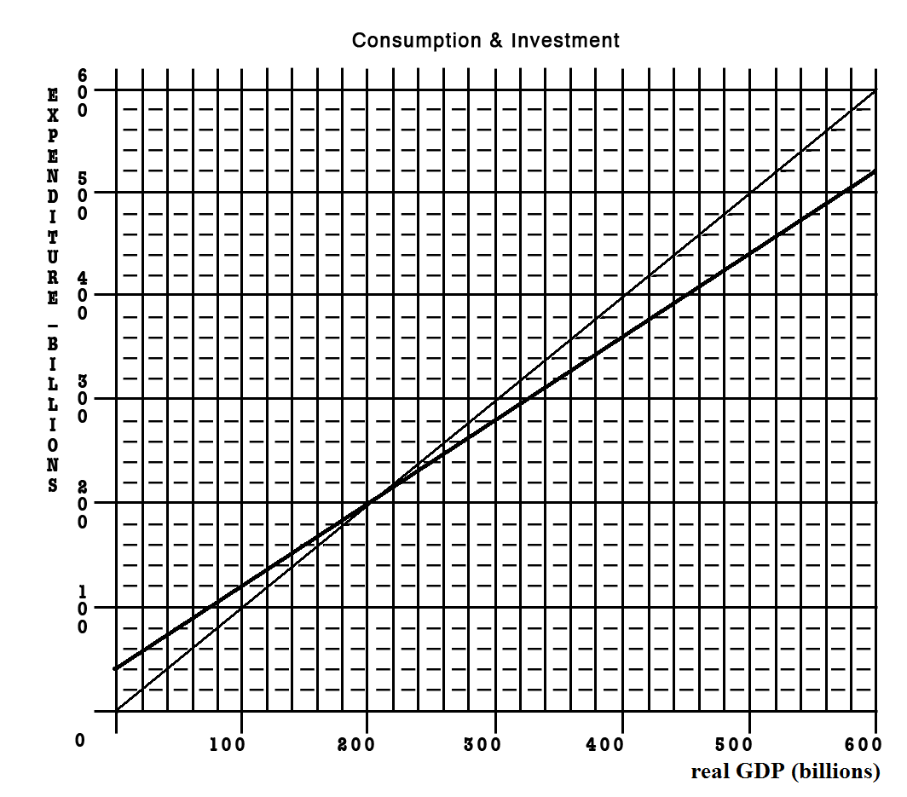
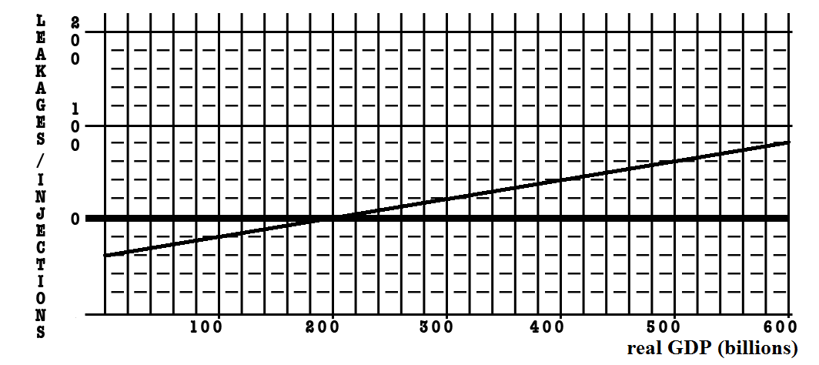

Given the graphs below, calculate the change in government spending that is needed for this economy to achieve full employment.

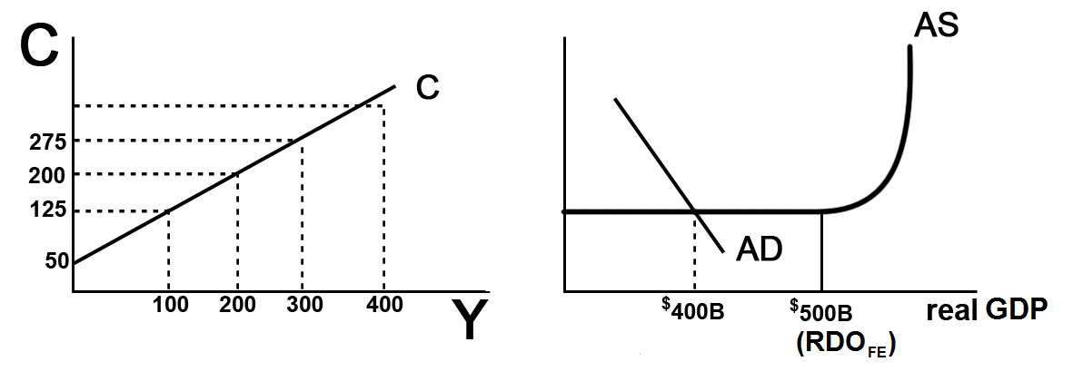
- MPC = ___change in C / change in income = 75/100 = .75___

- MPS = __change in S / change in income - .25/100 = .25_OR MPC+MPS=1__

- initial GDP = __$400_____ full employment GDP = ____$500____

- multiplier = __1/MPS = 1/.25 = 4__

- What change in government spending is needed to achieve full employment?

Change in GDP = change in G x multiplier
100 = change in G x 4
Change in G - $25

- What happens to the size of the multiplier with the addition of Taxes and Imports?

It gets smaller

- What would happen to your answer in #5 if we included Taxes and Imports?

We would need a larger change in government spending

- Notice that as this economy approaches full employment, there is no inflation. What happens to the size of the multiplier if there is inflation?

If there is inflation the multiplier is smaller

- What would happen to your answer in #5 if there was some inflation?

If there is inflation the change in government spending needed to achieve full employment would have to be larger

- What is the lump-sum tax multiplier?
-3;
the lump-sum tax multiplier is always one less than the simple multiplier and negative_
or = -MPC/MPS = _.75/.25 = -3

- What change in taxes is needed to achieve full employment? ________________

Change in GDP = change in taxes x lump-sum tax multiplier
$100 billion = change in taxes x -3
change in taxes = -$33 billion

~~~~~~~~~~~~~~~~~~~~~~~~~~~~~~~~~~~~~~~~~~~~~~~~~~~~~~~~~~~~~~~~~~
If the MPC = .6 and government spending decreases by $100 B, what happens to equilibrium GDP?

Change in GDP = change in spending x multiplier
Multiplier – 1/MPS
MPC + MPS = 1
MPC + MPS = 1
.6 + MPC = 1
MPS = .4
Multiplier = 1/MPS = 1/1-MPC = 1/.4 = 2.5
Change in GDP = change in spending x multiplier
Change in equilibrium GDP = -$100 x 2.5 = - $250

ANSWERS - Quick Quiz – Chapter 10: MPC, APC, MPS, APS
1. The most important determinant of consumption and saving is the:
1. level of bank credit.
2. level of income.
3. interest rate.
4. price level.
2. The MPC can be defined as that fraction of a:
1. change in income that is not spent.
2. change in income that is spent.
3. given total income that is not consumed.
4. given total income that is consumed.
3. The APC can be defined as the fraction of a:
1. change in income that is not spent.
2. change in income that is spent.
3. specific level of total income that is not consumed.
4. specific level of total income that is consumed.
4. Dissaving means:
1. the same thing as disinvesting.
2. that households are spending more than their current incomes.
3. that saving and investment are equal.
4. that disposable income is less than zero.
5. Refer to the above data. The marginal propensity to consume is:
1. .25.
2. .75.
3. .20.
4. .80.

6. Refer to the above data. If disposable income was $325, we would expect consumption to be:
1. $315.
2. $305.
3. $20.
4. $290.
7. Refer to the above diagram. The marginal propensity to consume is:
1. .4
2. .6
3. .5
4. .8

ANSWERS - Quick Quiz: The Multiplier Effect
1. If the MPC is .70 and investment increases by $3 billion, the equilibrium GDP will:
1. increase by $10 billion.
2. increase by $2.10 billion.
3. decrease by $4.29 billion.
4. increase by $4.29 billion.
2. If the MPC is .6, the multiplier will be:
1. 4.0
2. 6.0
3. 2.5
4. 1.67
3. The multiplier is:
1. 1/APS.
2. 1/APC.
3. 1/MPC.
4. 1/MPS.
4. The multiplier effect indicates that:
1. a decline in the interest rate will cause a proportionately larger increase in investment.
2. a change in spending will change aggregate income by a larger amount.
3. a change in spending will increase aggregate income by the same amount.
4. an increase in total income will generate a larger change in aggregate expenditures.
5. If a $500 billion increase in investment spending increases income by $500 billion in the first round of the multiplier process and by $450 in the second round, income will eventually increase by:
1. $2500 billion.
2. $3000 billion.
3. $4000 billion.
4. $5000 billion.
6. The actual multiplier effect in the U.S. economy is less than the multiplier effect in the text examples because:
1. the real-world MPS is larger than the MPS in the examples.
2. in addition to saving, households use some of any increase in income to buy imported goods and to pay additional taxes.
3. the gap between the nominal interest rate and the real interest rate widens as the economy expands or contracts.
4. the MPC in the United States is greater than 1.

7. Refer to the above diagram. The simple multiplier for this economy is:
1. 1.0
2. 1.5
3. 2.0
4. 2.5
ANSWERS - Quick Quiz: Fiscal Policy
1. Discretionary fiscal policy refers to:
1. any change in government spending or taxes that destabilizes the economy.
2. the authority that the President has to change personal income tax rates.
3. changes in taxes and government expenditures made by Congress to stabilize the economy.
4. the changes in taxes and transfers that occur as GDP changes.
2. Countercyclical discretionary fiscal policy calls for:
1. surpluses during recessions and deficits during periods of demand-pull inflation.
2. deficits during recessions and surpluses during periods of demand-pull inflation.
3. surpluses during both recessions and periods of demand-pull inflation.
4. deficits during both recessions and periods of demand-pull inflation

3. Contractionary fiscal policy is so named because it:
1. involves a contraction of the nation's money supply.
2. necessarily reduces the size of government.
3. is aimed at reducing aggregate demand and thus achieving price stability.
4. is expressly designed to contract real GDP.

4. An appropriate fiscal policy for a severe recession is:
1. a decrease in government spending.
2. a decrease in tax rates.
3. appreciation of the dollar.
4. an increase in interest rates.

5. A contractionary fiscal policy is shown as a:
1. rightward shift in the economy's aggregate demand curve.
2. rightward shift in the economy's aggregate supply curve.
3. movement along an existing aggregate demand curve.
4. leftward shift in the economy's aggregate demand curve.

6. If the MPS in an economy is .1, government could shift the aggregate demand curve rightward by $40 billion by:
1. increasing government spending by $4 billion.
2. increasing government spending by $40 billion.
3. decreasing taxes by $4 billion.
4. increasing taxes by $4 billion.

7. Which of the following represents the most expansionary fiscal policy?
1. a $10 billion tax cut
2. a $10 billion increase in government spending
3. a $10 billion tax increase
4. a $10 billion decrease in government spending
8. A specific reduction in government spending will dampen demand-pull inflation by a greater amount, the:
1. smaller is the economy's MPC.
2. flatter is the economy's aggregate supply curve.
3. smaller is the economy's MPS.
4. less the economy's built-in stability.
9. Suppose the price level is fixed (i.e. no inflation), the MPC is .8, and the GDP gap is a negative $100 billion (equilibrium GDP is $100 billion less than the full employment level). To achieve full-employment output (exactly), government should:
1. increase government expenditures by $100 billion.
2. increase government expenditures by $20 billion.
3. reduce taxes by $20 billion.
4. reduce taxes by $100 billion.
10. Suppose the price level is NOT fixed (i.e. there IS inflation), the MPC is .8, and the GDP gap is a negative $100 billion (equilibrium GDP is $100 billion less than the full employment level). To achieve full-employment output, government should:
1. do nothing.
2. increase government expenditures by $20 billion.
3. increase government expenditures by more than $20 billion
4. reduce taxes by $20 billion.
5. reduce taxes by $100 billion.
11. Refer to the above data. If a lump-sum tax (the same tax amount at each level of GDP) of $40 is now imposed in this economy, the consumption schedule will be:
1.
2.
3.
4.

ANSWERS - Quick Quiz: Fiscal Policy – Other Issues

1. The standardized budget refers to:
1. the inflationary impact that the automatic stabilizers have in a full-employment economy.
2. that portion of a full-employment GDP that is not consumed in the year it is produced.
3. the size of the Federal government's budgetary surplus or deficit when the economy is operating at full employment.
4. the number of workers who are underemployed when the level of unemployment is 4 to 5 percent.

2. If the economy has a standardized budget surplus, this means that:
1. the public sector is exerting an expansionary impact on the economy.
2. tax revenues would exceed government expenditures if full employment were achieved.
3. the actual budget is necessarily also in surplus.
4. the economy is actually operating at full employment.

3. Suppose the government purposely changes the economy's standardized budget from a deficit of 3 percent of real GDP to a surplus of 1 percent of real GDP. The government is engaging in a(n):
1. expansionary fiscal policy.
2. contractionary fiscal policy.
3. neutral fiscal policy.
4. high-interest rate policy.

(1) The composite index of leading indicators turns downward for three consecutive months, suggesting the possibility of a recession;
(2) Economists reach agreement that the economy is moving into a recession;
(3) A tax cut is proposed in Congress;
(4) The tax cut is passed by Congress and signed by the President;
(5) Consumption spending begins to rise, aggregate demand increases, and the economy begins to recover.

4. Refer to the above information. The operational lag of fiscal policy is reflected in event(s):
1. (1) and (2)
2. (2) and (3)
3. (3) and (4)
4. (4) and (5)
5. Which of the following best describes the idea of a political business cycle?
1. Politicians are more willing to cut taxes and increase government spending than they are to do the reverse.
2. Fiscal policy will result in alternating budget deficits and surpluses.
3. Politicians will use fiscal policy to cause output, real incomes, and employment to be rising prior to elections.
4. Despite good intentions, various timing lags will cause fiscal policy to reinforce the business cycle.
6. Assume the government purposely incurs a budget deficit that is financed by borrowing. As a result, interest rates rise and the amount of private investment spending declines. This illustrates:
1. the equation-of-exchange effect.
2. the paradox of thrift.
3. the crowding-out effect.
4. the wealth effect.
7. The crowding-out effect is:
1. strongest when the economy is at full employment.
2. strongest when the economy is in a deep recession.
3. weakest when there is demand-pull inflation.
4. equally strong, regardless of the state of the macroeconomy.
8. Which of the following fiscal policy actions is most likely to increase aggregate supply?
1. An increase in personal income tax rates.
2. A reduction in interest rates that encourages consumers to purchase more durable goods.
3. An increase in transfer payments to unemployed workers.
4. An increase in government spending on infrastructure that increases private sector productivity.
ANSWERS - Quick Quiz: - The Public Deficits and Debt
1. The amount by which government expenditures exceed revenues during a particular year is the:
1. public debt.
2. budget deficit.
3. full-employment.
4. GDP gap.
2. Since 2002, the United States has had:
1. large Federal budget surpluses.
2. large Federal budget deficits.
3. modest trade surpluses.
4. a rising natural rate of unemployment.

3. The true size of Federal budget deficits may be understated because:
1. a portion of government spending is public investment.
2. inflation reduces the real value of the public debt.
3. Social Security surpluses are included as government tax revenues in measuring the budget deficit.
4. foreign holdings of the debt have recently increased.

4. The tax cut passed by Congress and the Bush administration in 2001 was motivated primarily by:
1. the recession that began in March 2001.
2. the terrorist attacks on September 11, 2001.
3. the desire to distribute income and wealth more equally.
D. projections that actual budget surpluses would rise to $5 trillion by 2010.

5. The U.S. public debt:
1. refers to the debts of all units of government—Federal, state, and local.
2. consists of the total debt of U.S. households, businesses, and government.
3. refers to the collective amount that U.S. citizens and businesses owe to foreigners.
4. consists of the historical accumulation of all Federal government deficits less surpluses.

6. Which of the following is not a significant contributor to the U.S. public debt?
1. war financing
2. tax cuts and expenditure increases in the 1980s
3. recessions
4. demand-pull inflation

7. What percentage of the public debt is held by foreign individuals and institutions?
1. 50 percent
2. 18 percent
3. 42 percent
4. 25 percent
8. To say that "the U.S. public debt is also a public credit" is to say that:
1. only interest payments on the public debt are an economic burden.
2. official figures understate the size of the public debt.
3. the bulk of the public debt is owned by U.S. citizens and institutions.
4. the public debt is equal to the land and buildings assets owned by the Federal government.
9. Payment of interest on the U.S. public debt:
1. increases the current domestic standard of living in the United States.
2. has no effect on the distribution of income.
3. is thought to decrease income inequality.
4. is thought to increase income inequality.
10. The most likely way the public debt burdens future generations, if at all, is by:
1. reducing the current level of investment.
2. causing future unemployment.
3. causing deflation.
4. reducing real interest rates.
11. The real burden of an increase in the public debt:
1. may be very small or conceivably zero when the economy is in a severe depression.
2. will be smaller when full employment exists than when the economy has large quantities of idle resources.
3. can be shifted to future generations if the debt is internally financed.
4. can best be measured by the dollar increase in the size of the debt.
12. Which of the following is not considered a legitimate concern of a large public debt?
1. Bankruptcy of the Federal government
2. Disincentives created by higher taxes
3. Crowding-out of private investment
4. Increased income inequality

REVIEW EXERCISES - Chapters 10 and 13 - Fiscal Policy

Level of output and income  (GDP = DI) | Consumption | Saving | APC | APS | MPC | MPS
$480 | $488 | –$8 | 1.02 | –0.2 | 0.8 | 0.2
520 | 520 | 0 | 1.00 | 0.0 | 0.8 | 0.2
560 | 552 | 8 | 0.99 | 0.1 | 0.8 | 0.2
600 | 584 | 16 | 0.99 | 0.3 | 0.8 | 0.2
640 | 616 | 24 | 0.96 | 0.4 | 0.8 | 0.2
680 | 648 | 32 | 0.95 | 0.5 | 0.8 | 0.2
720 | 680 | 40 | 0.94 | 0.6 | 0.8 | 0.2
760 | 712 | 48 | 0.94 | 0.6 | 0.8 | 0.2
800 | 744 | 56 | 0.93 | 0.7 | 0.8 | 0.2

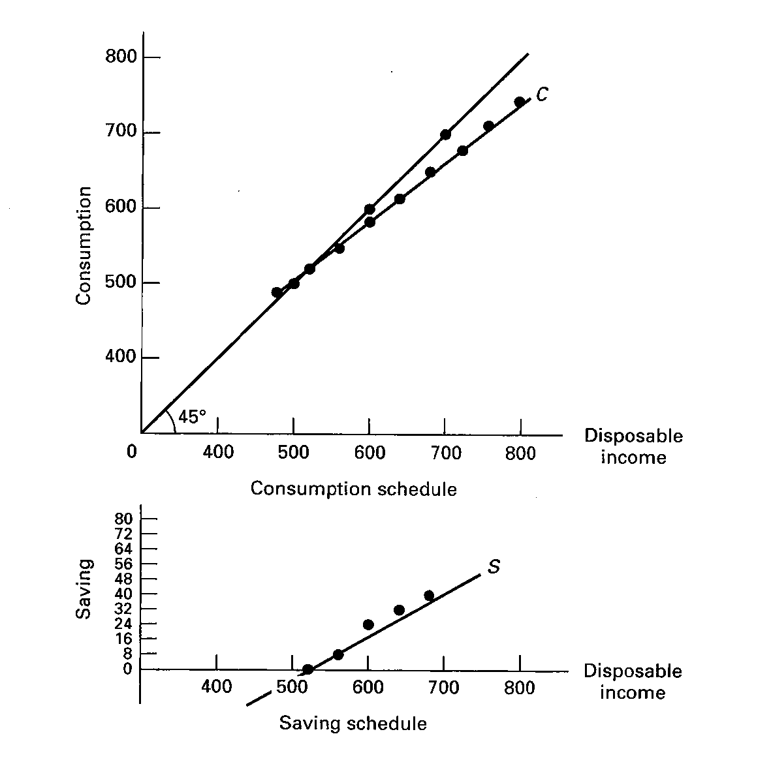

Quick Quiz: What is Money? – Chapter 14

1. When a consumer wants to compare the price of one product with another, money is primarily functioning as a:
1. Store of value
2. Unit of account
3. Medium of exchange

2. What function is money serving when you buy a ticket to a movie?
1. A store of value
2. A unit of account
3. A medium of exchange

3. Cathy Rogers deposits $200 in currency in her checking account at a bank. This deposit is treated as:
1. A subtraction of $200 from the M1 money supply because the $200 in currency is no longer in circulation
2. An addition of $200 to the M1 money supply because of the creation of a checkable deposit of $200
3. An addition of $200 to the M1 money supply because the bank holds $200 in currency and the checking account has been increased by $200
4. No change in the M1 money supply because the $200 in currency has been converted to a $200 increase in checkable deposits

4. Checkable deposits are included in:
1. M1 but not in M2
2. M2 but not in M1
3. both M1 and M2
4. neither M1 nor M2
5. What "backs" the money supply?
1. The U.S. government's ability to keep the value of money relatively stable
2. The amount of gold the U.S. government has on deposit at its banks
3. The fact that currency is issued as Federal Reserve Notes
4. The fact that the intrinsic value of coins in circulation is greater than their face value

Quick Quiz: The Fed – Chapter 14
1. The Federal Reserve Banks are owned by the:
1. Federal government
2. Board of Governors
3. United States Treasury
4. Member banks
2. How long is the term of office for members appointed to serve on the Board of Governors of the Federal Reserve System?
1. 2 years
2. 4 years
3. 7 years
4. 14 years
3. The Federal Open Market Committee (FOMC) of the Federal Reserve System is primarily for:
1. Maintaining cash reserves that can be used to settle international transactions
2. Supervising banks to make sure that markets are open to all and remain competitive
3. Issuing currency and acting as the fiscal agent for the Federal government
4. Setting the Fed's monetary policy and directing the purchase and sale of government securities
4. The main function of the Federal Reserve System is to:
1. Serve as the fiscal agent for the Federal government
2. Supervise the operation of member banks
3. Clear checks from member banks
4. Control the money supply
5. Economic studies conducted in industrially advanced countries suggest there is:
1. A positive relationship between the degree of independence of the central bank and the size of the average annual rate of inflation
2. An inverse relationship between the degree of independence of the central bank and the size of the average annual rate of inflation
3. No relationship between the degree of independence of the central bank and the size of the average annual rate of inflation
4. A positive relationship between the degree of independence of the central bank and the size of the central bank

Quick Quiz: The Money Market – Chapter 14 lecture (Chapter 16 textbook)
1. The asset demand for money and the rate of interest are:
1. Inversely related
2. Directly related
3. Unrelated
4. Both stable
2. The total quantity of money demanded is determined by:
1. Subtracting the asset demand for money from the transactions demand for money
2. Adding the transactions demand for money to the asset demand for money
3. Subtracting the transactions demand for money from nominal GDP
4. Adding the asset demand for money to nominal GDP
3. Refer to the above graph, in which D_{t} is the transactions demand for money, D_{m} is the total demand for money, and S_{m} is the supply of money. The transactions demand for money in this money market is:
1. $125 2. $175
3. $250 4. $325
4. Refer to the above graph, in which D_{t} is the transactions demand for money, D_{m} is the total demand for money, and S_{m} is the supply of money. If the interest rate was 4 percent, the asset demand for money would be:
1. $125
2. $175
3. $200
4. $225

5. Refer to the above graph. If the supply of money was $250 billion, the interest rate would be:
1. 1 percent
2. 2 percent
3. 3 percent
4. 4 percent

6. An increase in the money supply is likely to decrease:
1. Prices
2. Nominal income
3. Money demand
4. Interest rates

How Banks Create Money
Major Point: An initial increase in funds available to the banking industry results in a MULTIPLE increase in the money supply.
Three Step Process per Round:
- An increase in demand deposits or other liabilities of a bank increases the bank’s reserves.
- Bank can make loans equal to its excess reserves. Loans made by increasing demand deposits.
- The loan check is spent, deposited in a different bank, and CLEARS. First bank now has no excess reserves, but second does and can therefore make a loan.

Given:
Required Reserve Ratio = 20%
FNB = First National Bank
SNB = Second National Bank
TNB = Third National Bank
ER = excess reserves
All banks initially have no excess reserves
Banks make loans equal to their excess reserves
$10 cash is deposited in a checking (DD) account at FNB
SHOW: The CHANGES in the balance sheets of each bank as a result of this $10 cash deposit and the increased loan making ability of the banks.
Round One

Step 1: $10 deposited in FNB
Step 2: FNB makes loan equal to its excess reserves

Step 3: Loan is spent, deposited in SNB, and the check clears

Round Two
Step 1: Check from round one deposited in SNB
Step 2: SNB makes loan equal to its excess reserves
Step 3: Loan is spent, deposited in TNB, and the check clears
Round Three
Step 1: Check from round two deposited in TNB
Money Supply Changes:

How much money was created in round one? ____$ 8____
How much money was created in round two? ____$ 6.40_
How much money can be created in round three? ____$ 5.12_
Money Multiplier = 1/Required Reserve Ratio
(also called Deposit Expansion multiplier)
Total increase in money supply = Money Multiplier x initial excess reserves
What is the money multiplier? _____5______
What is the maximum total increase in the money supply that can occur as a result of the initial $10 cash deposit? ____$ 40_____

What are the limitations on this money creation process?
_____1) banks may hold ER _______________________
_____2) people may hold money_________________________
_____3) the required reserve ratio_______________________
Chapter 14 Money Creation Yellow Page Work Sheet Explanation
WORKSHEET
The following worksheet should teach you :
1. How a Cash Deposit at a bank effects:
a. the bank's balance sheet
b. M1 (the money supply) - HINT: there is no effect
2. How Money is Created when a bank grants a loan
a. Know the balance sheet changes when the loan is granted (see below)
b. Know the balance sheet changes when the check is cleared (see below)
3. How much money can be created by the banking system when there is an increase in excess reserves
Banks create money during their normal operations of accepting deposits and making loans. In this example we'll use M1 as our definition of money. (M1 = currency in our pockets and balances in our checking accounts.) When a bank makes a loan it creates money. For example when I got a loan to buy my boat, my credit union called an told me that the loan was approved and that I should come in and get the check. I told them to just deposit it in my checking account. So they did. they turned on their computers, typed in my account number, and added the loan to my checking account balance. I now had more money (M1). The bank created this money when they gave me the loan.
To learn how banks create money during their normal activities of accepting deposits and making loans lets assume that a $10 bill is deposited in the First National Bank (FNB). We will use the balance sheets of banks to see the effects. Our balance sheets will only show the CHANGES made to them. Our study guide has problems where they show actual (but hypothetical) amounts in the bank's T-account.
Major Point: An initial increase in funds available to the banking industry results in a MULTIPLE increase in the money supply.
There is a Three Step Process per Round:
- An increase in demand deposits or other liabilities of a bank increases the bank’s reserves.
- Bank can make loans equal to its excess reserves. Loans made by increasing demand deposits.
- The loan check is spent, deposited in a different bank, and CLEARS. First bank now has no excess reserves, but second does and can therefore make a loan.
Formulas:
Total Reserves = Cash in vault + Deposits at Fed.
Required Reserves = RR x Liabilities
- Liabilities are the Demand Deposits or DD
- RR is the Required Reserve ration set by the Fed
- NOTE: a common error is that students calculate the Required Reserves by: RR x Reserves. DON'T DO THIS!. To calculate the Required Reserves: RR x Liabilities
- total reserves are also called "actual reserves"
Excess Reserves = Total Reserves - Required Reserves
Excess Reserves are used by banks to:
- make loans
- pay back depositors when they remove their funds from their accounts (like write a check)
Change in Money Supply = initial Excess Reserves x Money Multiplier
Money Multiplier = 1 / RR
These two formulas are very important!
Given:
Required Reserve Ratio = 20%
FNB = First National Bank
SNB = Second National Bank
TNB = Third National Bank
ER = excess reserves
DD = Demand Deposits (checking account deposits = liabilities)
All banks initially have no excess reserves
Banks make loans equal to their excess reserves
$10 cash is deposited in a checking (DD) account at FNB
Show:
The CHANGES in the balance sheets of each bank as a result of this $10 cash deposit and the increased loan making ability of the banks.

Round One
Step 1: $10 deposited in FNB
The $10 bill becomes cash in the bank's vault so it becomes part of the bank's reserves. the deposit in the customer's checking account is a liability to the bank. Note that the balance sheet still balances.
Now calculate the changes in the bank's excess reserves:
Total Reserves = cash in vault + Deposits at Fed = 10
Required Reserves = RR x Liabilities = .20 x 10 = 2
Excess Reserves = Total Reserves - Required Reserves = 10 - 2 = 8
Step 2: FNB makes loan equal to its excess reserves
We will assume that when the bank makes a loan for $8 (the amount of its excess reserves above) it credits the borrower's checking account. THIS IS NEWLY CREATED MONEY !
Note that the balance sheet still balances: the $8 loan is an asset to the bank and the $8 credited to the borrower's checking account (DD) is an additional liability.
Now calculate the changes in the bank's excess reserves:
Total Reserves = cash in vault + Deposits at Fed. = 10
Required Reserves = RR x Liabilities = .20 x 18 = 3.60
Excess Reserves = Total Reserves - Required Reserves = 10 - 3.60 = 6.40
You may notice that the FNB still has excess reserves BUT Excess Reserves are used by banks to:
- make loans
- buy government securities AND
- pay back depositors when they remove their funds from their accounts (like write a check)
and since the FNB just made a loan it can figure that the borrower will probably spend it, so they better keep some excess reserves available to pay back depositor's when they remove their funds from their accounts (like write a check)

Step 3: Loan is spent, deposited in SNB, and the check clears
Sure enough, the borrower did spend the loan by writing a check which was deposited in the SNB.
When the check clears, the FNB sends the SNB $8 of its reserves. So the reserves of the FNB go down by $8 to $2, and the reserves at the SNB go up by $8. Since all banks either directly or indirectly have deposits at the Fed, checks can clear rapidly simply by having the fed transfer the funds ($8 from the account of the FNB to the account of the SNB).
Now calculate the changes in the bank's (FNB) excess reserves:
Total Reserves = cash in vault + Deposits at Fed. = 2
Required Reserves = RR x Liabilities = .20 x 10 = 2
Excess Reserves = Total Reserves - Required Reserves = 2 - 2 = 0
(With no more excess reserves, the FNB cannot make any more loans.)
Round Two
Step 1: Check from round one deposited in SNB
Now the SNB has $8 more reserves (this was transferred from the FNB to cover the check from a depositor of that bank.) and therefore $6.40 in additional excess reserves. It also has $8 in additional liabilities, when an $8 check from a customer of the FNB is spent and then deposited in the SNB.
To calculate the changes in the bank's excess reserves:
Total Reserves = cash in vault + Deposits at Fed. = 8
Required Reserves = RR x Liabilities = .20 x 8 = 1.60
Excess Reserves = Total Reserves - Required Reserves = 8 - 1.60 = 6.40
Step 2: SNB makes loan equal to its excess reserves
And the process continues . . . . The SNB can now make a loan equal to its new excess reserves ($6.40). This will be NEW MONEY, increasing the Money Supply.
You may notice that the FNB still has excess reserves BUT Excess Reserves are used by banks to:
- make loans
- buy government securities AND
- pay back depositors when they remove their funds from their accounts (like write a check)
and since the FNB just made a loan it can figure that the borrower will probably spend it, so they better keep some excess reserves available to pay back depositor's when they remove their funds from their accounts (like write a check)
Step 3: Loan is spent, deposited in TNB, and the check clears
The loan is spent and after covering the check (transferring reserves to the bank where the check was deposited - the TNB) the SNB has no additional excess reserves.,
Round Three
Step 1: Check from round two deposited in TNB
But the TNB now has new excess reserves.
The $ 6.40 loan from the SNB was spent and then deposited in the TNB (DD + $6.40). when the check clears the SNB transfers $ 6.40 from its reserves to the TNB. With these new reserves and new liabilities, the TNB now has $5.12 in new excess reserves.
To calculate the changes in the bank's excess reserves:
Total Reserves = cash in vault + Deposits at Fed. = 6.40
Required Reserves = RR x Liabilities = .20 x 6.40 = 1.28
Excess Reserves = Total Reserves - Required Reserves = 6.40 - 1.28 = 5.12
The TNB can now make a loan equal to $5.12. this would be NEW MONEY.
SUMMARY: Money Supply Changes:
1. How much money was created in round one? ____$ 8____
2. How much money was created in round two? ____$ 6.40_
3. How much money can be created in round three? ____$ 5.12_
If the process continued with each additional bank making loans equal to its excess reserves, the maximum possible change in the money supply will be:
Total Change in Money Supply = initial excess reserves X money multiplier
4. What is the money multiplier? _____5______
money multiplier = 1/RR - 1/.2 = 5
5. What is the maximum total increase in the money supply that can occur as a result of the initial $10 cash deposit? ____$ 40_____
Change in the MS = ER x money multiplier = $8 x 5 = $40
6. What are the limitations on this money creation process?
The formula above gives us the MAXIMUM possible change in the money supply. The chapter’s discussion of bank credit is in terms of the maximum money-creating potential that would probably not ever be reached due to these modifications introduced at the end of this chapter:
_____1) banks may hold ER _______________________
_____2) people may hold money_________________________
_____3) the required reserve ratio_______________________

Quick Quiz: Money Creation – Chapter 15

1. The fractional reserve system of banking started when goldsmiths began:
1. Accepting deposits of gold for safe storage
2. Charging people who deposited their gold
3. Using deposited gold to produce products for sale to others
4. Issuing paper receipts in excess of the amount of gold held

2. The primary reason for legal reserve requirements that require commercial banks to keep required reserves on deposit at Federal Reserve Banks is to:
1. Add to the liquidity of the commercial bank
2. Allow the Fed to control the amount of bank lending
3. Protect the deposits in the commercial bank against losses
4. Provide the means by which checks drawn on a commercial bank and deposited in other commercial banks can be collected

3. A commercial bank has actual reserves of $50,000 and checkable deposits of $200,000, and the required reserve ratio is 20%. The excess reserves of the bank are:
1. $10,000
2. $20,000
3. $40,000
4. $50,000

Use this information for the next two questions: Assume that the required reserve ratio is 25 percent. If a commercial bank has $1 million cash in its vault, $2 million in short-term government securities, $3 million on deposit at a Federal Reserve Bank, and $6 million in checkable deposits

4. Refer to the above information. This bank can safely expand its loans by a maximum of:
1. $1 million
2. $2.5 million
3. $5 million
4. $8 million

5. Refer to the above information. If the original bank balance sheet was for the commercial banking system, rather than a single bank, loans and deposits could have been expanded by a maximum of:
1. $2.5 million
2. $5 million
3. $8 million
4. $10 million

6. When a check is cleared against a bank, it will lose:
1. Cash and securities
2. Checkable deposits and reserves
3. Reserves and capital stock
4. Loans and demand deposits

7. Refer to the above information for a single bank. The required (legal) reserve ratio is 25%. This bank can safely expand its loans by a maximum of:
1. $0
2. $50
3. $100
4. $200
8. Refer to the above information. The required (legal) reserve ratio is 25%. If the original bank balance sheet was for the commercial banking system, rather than a single bank, loans and deposits could have been expanded by a maximum of:
1. $0
2. $50
3. $100
4. $200
MONEY CREATION -- REVIEW
1. Why are financial institutions required to keep reserves?
ANSWER: Reserves are required to constrain the amount of bank lending (money creation) that can occur. Without required reserves, theoretically banks would have unlimited power to lend and thereby, expand the money supply without any limit.
2. Explain what is meant by fractional reserve banking.
ANSWER: Fractional reserve banking is the system that exists in the United States whereby financial institutions are required to keep only a fraction of their customer deposits in reserve. They may lend out or invest the remainder in qualified securities. This system allows banks to "create" money through the loans that they make.
3. Answer the next question based on the following consolidated balance sheet for the commercial banking system. Assume the required reserve ratio is 30 percent. All figures are in millions of dollars.
ASSETS | LIABILITIES
  Reserves | $200
  Securities | 500
  Loans | 100
  Property | 500
  Deposits | $600
  Capital Stock | 700
(a) What is the amount of excess reserves in this commercial banking system?
(b) What is the maximum amount that the money supply can be expanded?
(c) If the reserve ratio fell to 25 percent, what is now the maximum amount that the money supply can be expanded?
ANSWER:
(a) Required reserves are $600 million x .30 = $180 million. Actual reserves are $200 million, so excess reserves are $20 million.
(b) The monetary multiplier is 1/.3 or 3.33. Maximum expansion of the money supply is $20 million x 3.33, or 66.67 million.
(c) If the reserve ratio was 25%, then excess reserves would be $50 million [$200 million - (.25 x $600 million)]. The monetary multiplier would be 1/.25 or 4, so the maximum expansion of the money supply is $200 million [4 x $50 million].
4. Answer the next question based on the following consolidated balance sheet for the commercial banking system. Assume the required reserve ratio is 20 percent. All figures are in billions of dollars.
ASSETS | LIABILITIES
  Reserves | $60
  Securities | 140
  Loans | 100
  Property | 400
  Deposits | $200
  Capital Stock | 500
(a) What is the amount of excess reserves in this commercial banking system?
(b) What is the maximum amount that the money supply can be expanded?
(c) If the reserve ratio fell to 10 percent, what is now the maximum amount that the money supply can be expanded?
ANSWER:
(a) Required reserves are $200 billion x .20 = $40 billion. Actual reserves are $60 billion, so excess reserves are $20 billion.
(b) The monetary multiplier is 1/.20 or 5. Maximum expansion of the money supply is $20 billion x 5, or $100 billion.
(c) If the reserve ratio was 10%, then excess reserves would be $40 billion [$60 billion - (.10 x $200 billion)]. The monetary multiplier would be 1/.10 or 10, so the maximum expansion of the money supply is $400 billion [10 x $40 billion].

Monetary Policy – Chapter 16
1. The reserves of commercial banks are a(n):
1. Asset to commercial banks and an asset to the Federal Reserve Banks
2. Asset to commercial banks and a security to the Federal Reserve Banks
3. Asset to commercial banks and a liability to the Federal Reserve Banks
4. Liability to commercial banks and an asset to the Federal Reserve Banks

2. The Board of Governors of the Federal Reserve System can increase commercial bank reserves (i.e. increase the money supply) by:
1. Increasing the discount rate
2. Increasing the reserve ratio
3. sell fewer reserves to bank through the term auction facility
4. Buying government securities in the open market

3. Assume the required reserve ratio is 20 percent. If the Federal Reserve buys $100 million in government securities directly from commercial banks, then the money supply will potentially:
1. decrease by $100
2. increase by $100
3. decrease by $500
4. increase by $500

4. Assume the required reserve ratio is 20 percent. If the Federal Reserve buys $100 million in government securities from the public, then the money supply will immediately:
1. Increase by $100 million, and the maximum money-lending potential of the commercial banking system will increase by $100 million
2. Increase by $100 million, and the maximum money-lending potential of the commercial banking system will increase by $500 million
3. Increase by $100 million, and the maximum money-lending potential of the commercial banking system will increase by $400 million
4. Decrease, because the securities are an asset to the commercial banks and a liability to the Federal Reserve

5. The most frequently used monetary device for achieving price stability is:
1. Open-market operations
2. The discount rate
3. The reserve ratio
4. Term auction facility

6. If the Board of Governors of the Federal Reserve System increases the legal (required) reserve ratio, this change will:
1. Increase the excess reserves of member banks and thus increase the money supply
2. Increase the excess reserves of member banks and thus decrease the money supply
3. Decrease the excess reserves of member banks and thus decrease the money supply
4. Decrease the excess reserves of member banks and thus increase the money supply

7. A television report states: "The Federal Reserve will lower the discount rate for the fourth time this year." This report indicates that the Federal Reserve is most likely trying to:
1. Reduce inflation
2. Save the banking industry
3. Stimulate the economy
4. Improve the savings rate

8. In recent years, the Fed often communicated its intentions to restrict or expand monetary policy by announcing a change in targets for the:
1. Exchange rate
2. Federal funds rate
3. Prime interest rate
4. Consumer price index

9. Refer to the above graphs, in which the numbers in parentheses near the AD₁, AD₂, and AD₃ labels indicate the level of investment spending associated with each curve, respectively. All numbers are in billions of dollars. The interest rate and the level of investment spending in the economy are at point D on the investment demand curve. To achieve the long-run goal of a noninflationary full-employment output Qf in the economy, the Fed should:
1. Decrease aggregate demand by increasing the interest rate from 2 to 4 percent
2. Decrease aggregate demand by increasing the interest rate from 4 to 6 percent
3. Increase aggregate demand by decreasing the interest rate from 4 to 2 percent
4. Increase the level of investment spending from $120 billion to $150 billion
10. Which of the following best describes what occurs when monetary authorities sell government securities?
1. There is a decrease in the size of commercial banks' excess reserves, the money supply increases, and interest rates fall, thereby causing a decrease in investment spending and real GDP
2. There is a decrease in the size of commercial banks' excess reserves, the money supply decreases, and the interest rates rise, thereby causing a decrease in investment spending and real GDP
3. There is a decrease in the size of commercial banks' excess reserves, the money supply decreases, and interest rates rise, thereby causing an increase in investment spending and real GDP
4. There is an increase in the size of commercial bank reserves, the money supply increases, and interest rates fall, thereby causing an increase in investment spending and real GDP

11. Refer to the above diagrams, in which the numbers in parentheses near the AD₁, AD₂, and AD₃ labels indicate the level of investment spending associated with each curve. All figures are in billions. The economy is at equilibrium at the intersection of the aggregate supply curve and aggregate demand curve AD₃. What policy should the Fed pursue to achieve a noninflationary full-employment level of real GDP?
1. Increase the money supply from $75 to $150 billion
2. Increase the money supply from $150 to $225 billion
3. Decrease the money supply from $225 to $150 billion
4. Make no change in the money supply

12. Assume that the MPC is .75. If the Federal Reserve increases the money supply and investment spending increases by $8 billion, then aggregate demand is likely to:
1. Increase by $6 billion
2. Increase by $8 billion
3. Increase by $32 billion
4. Decrease by $8 billion
13. The strengths of monetary policy compared to fiscal policy are generally thought to include all of the following except:
1. greater Speed
2. greater Flexibility
3. greater Impact on taxation
4. greater Political acceptance
14. A Federal Reserve official notes: "A restrictive money policy can force a contraction of the money supply, but an expansionary money policy may not achieve an expansion of the economy." The official has described the problem of the:
1. Inflexibility of monetary policy tools
2. Change in taxes on monetary policy
3. Cyclical asymmetry of monetary policy
4. Political acceptability of monetary policy

Chapter 16
Review Questions: ANSWERS

1. What are the two types of demand that make up total demand for money?

The first type of demand for money is transaction demand or demand for money as a medium of exchange. Households in part demand money because it is convenient for purchasing goods and services and valuable to have on hand because some purchases are unplanned. The level of nominal GDP is also a determinant of the total transactions demand for money. The larger the monetary value of goods and services in an economy, the larger the transaction demand for money. This increase in demand occurs in both cases when prices rise and real output increases.
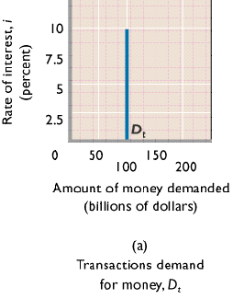

The second type of demand for money is asset demand due to money’s function as a store of value. It’s attractive to hold some of one’s assets as money because it is the most liquid of all assets. Money is also relatively attractive to hold if other assets, like bonds, are expected to decline in value. On the flipside, money receives little or no interest, which can make it less attractive than other assets. Ultimately, what determines asset demand is the interest rate, which is inversely related to money demand.
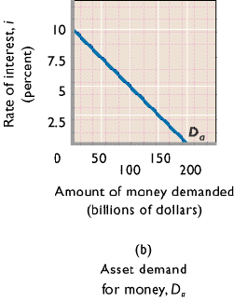

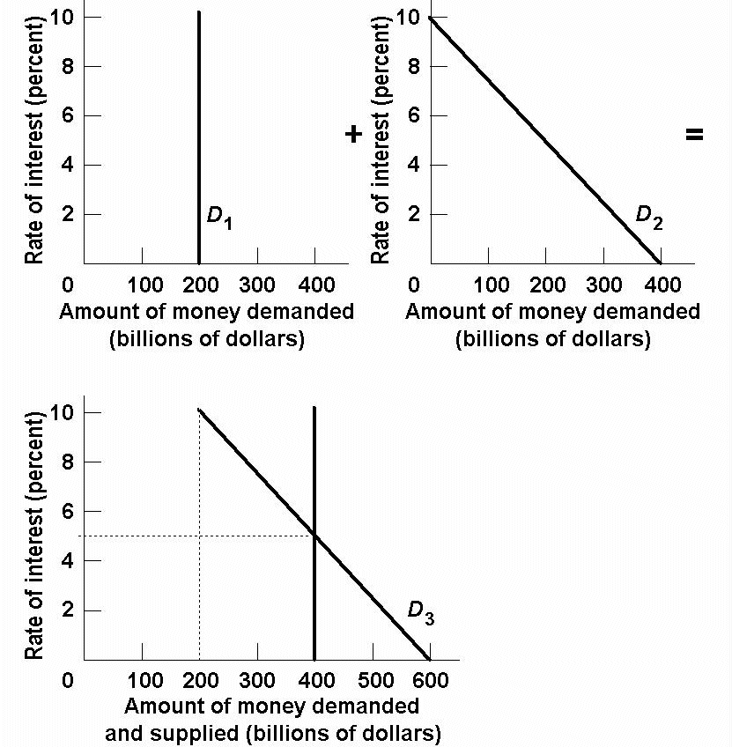

2. Analyze what would happen to the equilibrium rate of interest in the money market if the supply of money were increased while the demand schedule remained the same.

Because the quantity of money demanded is inversely related to the interest rate, an increase in the supply of money would result in a higher equilibrium quantity of money being demanded at a lower equilibrium rate of interest.

3. What are the four principal tools of monetary policy? Explain how they can be used.

ANSWER:
The Federal Reserve Banks use three principal tools (techniques or instruments) to control the reserves of banks and the size of the money supply.
(1) The Federal Reserve can buy or sell government securities in the open market to change the lending ability of the banking system:
(a) buying government securities in the open market from either banks or the public increases the excess reserves of banks;
(b) selling government securities in the open market to either banks or the public decreases the excess reserves of banks.
(2) The Fed can raise or lower the reserve ratio:
(a) raising the reserve ratio decreases the excess reserves of banks and the size of the monetary (checkable-deposit) multiplier;
(b) lowering the reserve ratio increases the excess reserves of banks and the size of the monetary multiplier.
(3) The Fed can also raise or lower the discount rate:
(a) raising the discount rate discourages banks from borrowing reserves from the Fed;
(b) lowering the discount rate encourages banks to borrow from the Fed.
(4) The Federal Reserve uses its term auction facility to make reserves available to banks. The Fed holds two auctions each month since December of 2007. These loans of reserves borrowed by auction-winning banks have the same effect on reserves and the size of the monetary multiplier as the borrowing of reserves at the discount rate:
(a) the Fed can increase banks’ excess reserves and the size of the monetary multiplier by making more funds available through its term auction facility;
(b) The Fed can decrease banks’ excess reserves and the size of the monetary multiplier by reducing the amount of reserves auctioned off every two weeks under the term auction facility.

- Answer the next question based on the following consolidated balance sheet for the commercial banking system. Assume the required reserve ratio is 25%. All figures are in billions of dollars.
Assets | Liabilities + Net Worth
Reserves $100  Securities 200  Loans 100  Property 600 | Checkable deposits $300  Stock shares 700

(a) What is the amount of excess reserves in this commercial banking system?
(b) What is the maximum amount that the money supply can be expanded?
(c) If the reserve ratio fell to 25%, what is now the maximum amount that the money supply can be expanded?

ANSWERS
(a) Required reserves are $300 billion × .25 = $75 billion. Actual reserves are $100 billion, so excess reserves are $25 billion.
(b) The monetary multiplier is 1/.25 or 4. Maximum expansion of the money supply is $25 billion × 4, or $100 billion.
(c) If the reserve ratio was 20%, then excess reserves would be $40 billion [$100 billion – (.20 × $300 billion)]. The monetary multiplier would be 1/.20 or 5, so the maximum expansion of the money supply is $200 billion [5 × $40 billion].

5. What is the difference between the Federal Reserve Banks’ purchases of securities from the commercial banking system and those from the public? Give an example.

Assume that the commercial banks are “loaned up.” Purchases of bonds by the Fed from commercial banks increase actual reserves and excess reserves of the commercial banks by the full amount of the bond purchase. Purchases of bonds by the Fed from the public increase actual reserves, but also increase checkable deposits. Some of the checkable deposits must be kept as legal reserves, so the commercial banking system has fewer excess reserves to lend out. Despite this difference the end result is the same amount of increase in the money supply.
For example, if the Fed buys a $1000 bond from commercial banks, the banks have $1000 in excess reserves to lend. If the reserve ratio is 20%, then the commercial banks can increase the money supply by $5000. If the Fed buys a $1000 bond from the public, then $1000 in checkable deposits is created. The bank can lend the excess reserves, which in this case will be $800 because 20% of $1000 must be kept as legal reserves. The $800 in excess reserves increases the money supply by $4000. Adding this $4000 in bank lending to the $1000 in new checkable deposits results in a total increase in the money supply of $5000.

6. The following are simplified balance sheets for the commercial banking system and the Federal Reserve System. Perform each of the following three transactions, a, b, and c, making appropriate changes in columns (1) through (3) in each balance sheet. Do not cumulate your answers. Also, answer these three questions for each part: (a) What change, if any, took place in the money supply as a direct result of this transaction? (b) What change, if any, occurred in commercial bank reserves? (c) What change occurred in the money-creating potential of the commercial banking system if the reserve ratio is 20%? All figures are in billions of dollars.

(1) Suppose a drop in the discount rate causes commercial banks to borrow an additional $3 billion from the Fed. Show the new sheet figures in column 1.
(2) The Fed buys $2 billion of government bonds from the public. Show the new sheet figures in column 2.
(3) The Fed buys $2 billion of government bonds from commercial banks. Show the new sheet figures in column 3

Consolidated Balance Sheet: Commercial Banking System
 | (1) | (2) | (3)
Assets:  Reserves $ 50  Securities 75  Loans 75  Liabilities:  Checkable deposits 190  Loans from FRBs 10 | ($53)  75  75  190  (13) | ($52)  75  75  (192)  10 | ($52)  (73)  75  190  10

Consolidated Balance Sheet: Federal Reserve Banks
 | (1) | (2) | (3)
Assets:  Securities $90  Loans to CBs 10  Liabilities:  Reserves of CBs 50  Treasury deposits 10  Federal Reserve notes 40 | $90  (13)  (53)  10  40 | ($92)  10  (52)  10  40 | ($92)  10  (52)  10  40

(1) a. No direct change in the money supply; b. bank reserves up by $3 billion; c. money-creating potential up by $15 billion.

(2) a. Money supply up by $2 billion; b. bank reserves up by $2 billion;
c. money-creating potential up by 5 × $1.6 = $8 billion.

(3) a. No direct change in the money supply; b. bank reserves up by $2 billion; c. money-creating potential up by 5 × $2 = $10 billion.

7. Use the graphs below to answer the following questions assuming the nominal GDP in the economy is given.
(a) Look at graph A and suppose the supply of money increases from 100 to 200. What will be the equilibrium rate of interest?

(b) Look at graph B which shows an investment-demand curve for this economy. Given the answer to part (a) above, how much will investors plan to spend on capital goods?

(c) What will happen to aggregate demand?

(d) Now trace what will happen in parts (a)–(c) if the money supply increases to $300.

ANSWERS

(a) 6%
(b) $120
(c) Aggregate demand will increase by a multiple of the increase in investment depending on the size of the multiplier.
(d) 3%; $170; Aggregate demand will increase by a multiple of the decrease in investment depending on the size of the multiplier.

GRAPHS

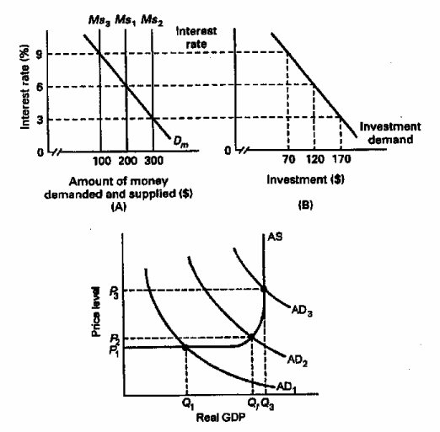
8. Suppose the economy is experiencing inflation. What would be the interpretation of how a restrictive monetary policy would address this problem?

With a restrictive monetary policy, the Federal Reserve sells bonds, raises the reserve ratio, or raises the discount rate. As a consequence of these actions, excess reserves decrease, which in turn decreases the money supply. When this happens, interest rates rise, investment spending decreases and aggregate demand decreases. The end result is a fall in real GDP by a multiple of the decrease in investment

9. Explain two strengths of monetary policy for achieving economic stability.

Monetary policy is relatively speedy and flexible relative to fiscal policy because the decision-making body is smaller and the decisions to change monetary policy can be implemented immediately. A second strength is that monetary policy is largely removed from political pressure since the members of the Board of Governors are appointed to 14-year terms. Unpopular, but necessary, changes can thus be made which might not be possible with fiscal policy where the decision makers are elected officials who may be reluctant to make unpopular decisions.

10. One of the advantages of monetary policy is its speed and flexibility, but there are limitations. Explain.

Monetary policy is not subject to an administration lag because once the decision is made action can be taken quickly. The major timing problems are recognition lags that occur because it sometimes take time to recognize or understand that there is a problem that needs to be addressed by a change in monetary policy. Also, there is an operational lag that occurs between the time that the problem is recognized and the monetary policy takes effect. It may take 3 to 6 months for interest rate changes to have the anticipated effect on the economy.

