Fall 2012
Unit 3 - MACROECONOMIC POLICY
Chapters 10 and 13 - Fiscal Policy
- Reading Assignments:
  - Chapter 10: ALL
  - Chapter 13: ALL
  - PLUS Review Ch. 18 pp. 374-378 "Taxation and Aggregate Supply"
- Study Guide
  - Chapter 10:
    - Multiple Choice: ALL
    - Problems: ALL
  - Chapter 13:
    - Multiple Choice: # ALL
    - Problems: # 1, 2, 4, 5
- Worked Problems 10.1 and 10.2 at http://highered.mcgraw-hill.com/sites/0077337727/student_view0/chapter10/worked_problems.html
- Web Quizzes
  - Chapter 10: ALL at http://highered.mcgraw-hill.com/sites/0077337727/student_view0/chapter10/quiz.html
  - Chapter 13: ALL at http://highered.mcgraw-hill.com/sites/0077337727/student_view0/chapter13/quiz.html
- End-of-Chapter Questions and Problems:
  - Chapter 10: Questions ALL; Problems # 1, 2, 5, 9, 10
  - Chapter 13: Questions # 2, 4, 5, 6, 8, 9, 11, 12; Problems 1, 5

Chapters 14 and 15 - Money and How Banks Create It
- Reading Assignments:
  - Chapter 14: ALL
  - Chapter 15: ALL
  - Chapter 16: Interest Rates pp. 315-317
- Study Guide
  - Chapter 14
    - Multiple Choice: # 1-5, 7, 9, 11, 13, 15-25
  - Chapter 15
    - Multiple Choice: # 1, 3-25
    - Problems: # 1-4
  - Chapter 16
    - Multiple Choice: # 3-8
    - Problem # 1
- Worked Problems
  - Chapter 15: 15.1 and 15.2 at http://highered.mcgraw-hill.com/sites/0077337727/student_view0/chapter15/worked_problems.html
- Web Quizzes
  - Chapter 14: 1-4, 6-8, 10 at http://highered.mcgraw-hill.com/sites/0077337727/student_view0/chapter14/quiz.html
  - Chapter 15: ALL at http://highered.mcgraw-hill.com/sites/0077337727/student_view0/chapter15/quiz.html
- End-of-Chapter Questions and Problems:
  - Chapter 14: Questions # 1, 5, 6, 8, 10; Problem # 2, 4
  - Chapter 15: Questions # 2-7, 9; Problems # 2-7
  - Chapter 16: Question # 1; Problem #1
Chapter 16 - Monetary Policy
- Reading Assignment: ALL of Chapter 16
- Study Guide – Chapter 16
  - Multiple Choice: # 1, 9, 12-30
  - Problems: # 3-6
- Worked Problem 16.3 at http://highered.mcgraw-hill.com/sites/0077337727/student_view0/chapter16/worked_problems.html
- Web Quiz: Chapter 16 # 1-9 at http://highered.mcgraw-hill.com/sites/0077337727/student_view0/chapter16/quiz.html
- End-of-Chapter Questions and Problems: Question # 2-4, 6-8; Problems # 1, 3, 7(?)
Consumption and Saving Functions

Y C S APC MPC APS MPS ____________________________________________________________________________________________

0 40 - 40 -- -- -- --
_ _ _ _ _ _ _ _ _ _ _ _ _ _ _ _ _ _ _ _ _ _ _ _ _ _ _ _ _ _ _ _ _ _ _ _ _ _ _ _ _ _ _ _ _ _ _ _ _ _ _ _ _ _ _ _ _ _ _ _ _

100 120 - 20
_ _ _ _ _ _ _ _ _ _ _ _ _ _ _ _ _ _ _ _ _ _ _ _ _ _ _ _ _ _ _ _ _ _ _ _ _ _ _ _ _ _ _ _ _ _ _ _ _ _ _ _ _ _ _ _ _ _ _ _ _ _

200 200 0
_ _ _ _ _ _ _ _ _ _ _ _ _ _ _ _ _ _ _ _ _ _ _ _ _ _ _ _ _ _ _ _ _ _ _ _ _ _ _ _ _ _ _ _ _ _ _ _ _ _ _ _ _ _ _ _ _ _ _ _ _ _

- 280
_ _ _ _ _ _ _ _ _ _ _ _ _ _ _ _ _ _ _ _ _ _ _ _ _ _ _ _ _ _ _ _ _ _ _ _ _ _ _ _ _ _ _ _ _ _ _ _ _ _ _ _ _ _ _ _ _ _ _ _ _ _

- 360
_ _ _ _ _ _ _ _ _ _ _ _ _ _ _ _ _ _ _ _ _ _ _ _ _ _ _ _ _ _ _ _ _ _ _ _ _ _ _ _ _ _ _ _ _ _ _ _ _ _ _ _ _ _ _ _ _ _ _ _ _ _

- 440
_ _ _ _ _ _ _ _ _ _ _ _ _ _ _ _ _ _ _ _ _ _ _ _ _ _ _ _ _ _ _ _ _ _ _ _ _ _ _ _ _ _ _ _ _ _ _ _ _ _ _ _ _ _ _ _ _ _ _ _ _ _

- 520
_ _ _ _ _ _ _ _ _ _ _ _ _ _ _ _ _ _ _ _ _ _ _ _ _ _ _ _ _ _ _ _ _ _ _ _ _ _ _ _ _ _ _ _ _ _ _ _ _ _ _ _ _ _ _ _ _ _ _ _ _ _

- 600
_ _ _ _ _ _ _ _ _ _ _ _ _ _ _ _ _ _ _ _ _ _ _ _ _ _ _ _ _ _ _ _ _ _ _ _ _ _ _ _ _ _ _ _ _ _ _ _ _ _ _ _ _ _ _ _ _ _ _ _ _ _

Chapter 10
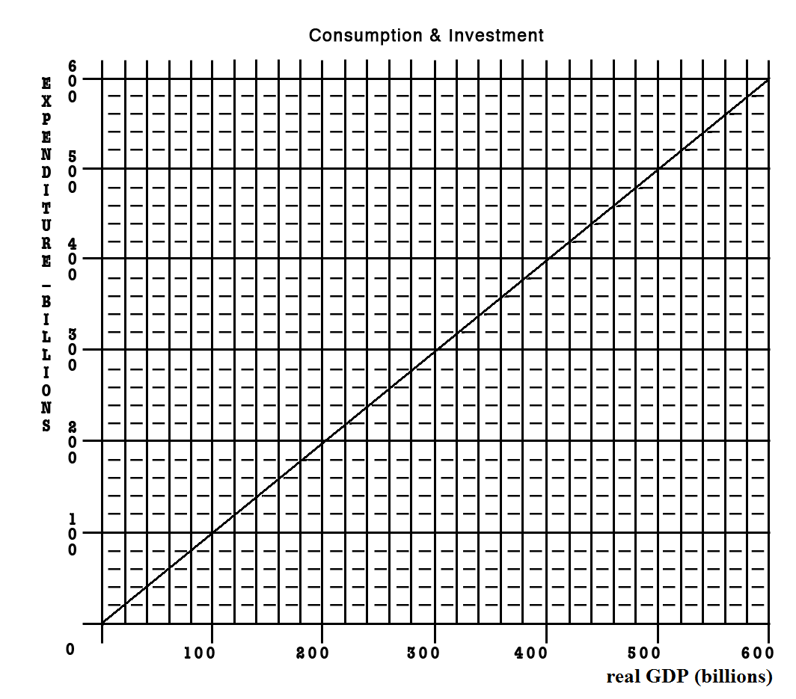
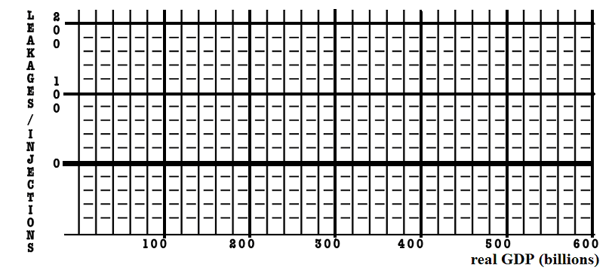
Given the graphs below, calculate the change in government spending that is needed for this economy to achieve full employment.

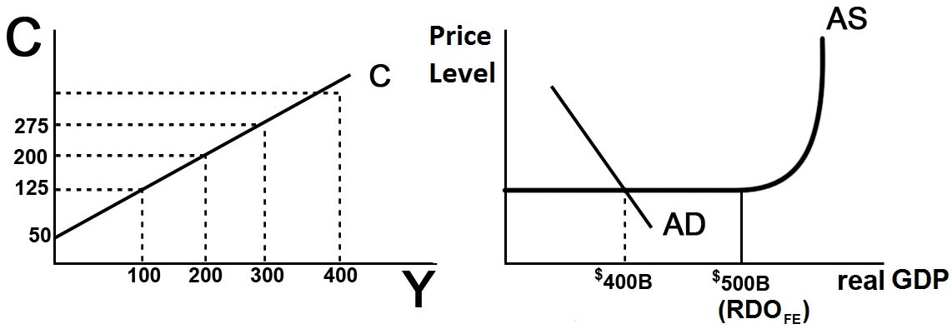
- MPC = _____________

- MPS = _____________

- initial GDP = ___________ full employment GDP = ____________

- multiplier = ____________

- What change in government spending needed to achieve full employment?

- What happens to the size of the multiplier with the addition of Taxes and Imports?

- What would happen to your answer in #5 if we included Taxes and Imports?

- Notice that as this economy approaches full employment, there is no inflation. What happens to the size of the multiplier if there is inflation?

- What would happen to your answer in #5 if there was some inflation?

- What is the lump-sum tax multiplier? ___________________

- What change in taxes is needed to achieve full employment? ________________

~~~~~~~~~~~~~~~~~~~~~~~~~~~~~~~~~~~~~~~~~~~~~~~~~~~~~~~~~~~~~~~~~~~~~~~~
~~~~~~~~~~~~~~~~~~~~~~~~~~~~~~~~~~~~~~~~~~~~~~~~~~~~~~~~~~~~~~~~~~~~~~~~

If the MPC = .6 and government spending decreases by $100 B, what happens to equilibrium GDP?

The Multiplier Effect
The Philadelphia Inquirer, November 6, 1998

Plentiful gains seen from GOP

The publicity for the city may be priceless. The visitors' spending could reach $300 million.
By Howard Goodman
INQUIRER STAFF WRITER
When the elephants thunder into Philadelphia in 2000, the vibrations are expected to shake an incredibly bountiful money tree, showering dollars all over the region.
The economic impact of the Republican National Convention will almost certainly exceed $125 million in direct spending on hotel rooms, meals and the like, along with at least $175 million in spinoff benefits (emphasis added), David L. Cohen said yesterday. Cohen, Mayor Rendell's former chief of staff, is cochairman of Philadelphia 2000, the committee formed to woo a political convention.
The estimate is based on a Federal Reserve Board study of the economic blessings felt in Chicago from the 1996 Democratic convention, with a little extra figured in for four years' worth of inflation, Cohen said.
"There is no convention you can host that has a greater economic impact than a national political convention," he said. "Most people agree the only thing you can host that has a greater economic impact is the Olympics."
. . . . .
In San Diego, where the Republicans last met, business leaders still bask in the 1996 convention's glow. "We look at the convention as a weeklong television commercial for your city as a destination," Salvatore Giametta, a spokesman for the San Diego Convention and Visitors Bureau, said in an interview this summer.
. . . . .
According to the Greater San Diego Area Chamber of Commerce, the four-day convention attracted 30,000 visitors who spent $26 million on hotel rooms. But there has been no follow-up study to show the convention's broader effect on the San Diego economy.
Despite the lack of data, San Diego "absolutely" would host a convention again, Giametta said. "We think it was good for the tourism industry without a doubt."
Brian Ford, an accountant for Philadelphia 2000, said that insisting on a study to prove that Philadelphia will benefit mightily from the GOP meeting "is like saying you need a study to show that a car works."
. . . . .
Chapter 10 and 13 REVIEW:

MULTIPLIERS
MULTIPLIER | PAGE | LARGER OR SMALLER THAN  THE SIMPLE MULTIPLIER? - WHY?
SIMPLE | pp. 204-208 "The Multiplier Effect" | multiplier = 1 / mps
Complex multiplier | pp. 207-208  "How Large is the Actual Multiplier Effect?" | smaller because there are more leakages: (1) saving, (2) spending on imports, and (3) taxes
Multiplier w/ changes  in the price level | pp. 244-248 "Increases in AD: Demand-Pull Inflation" and Decreases in AD: Recession and Cyclical Unemployment” | smaller
G spending multiplier | p. 258 "Increased Government Spending"  p. 260 "Decreased Government Spending" | same as simple
Tax multiplier | p. 259 "Tax Reductions"  p. 261 "Increased Taxes" | one less than the simple multiplier, but negative  tax multiplier =MPC / MPS
Bal. Budget multiplier | p. 259, 261 "Combined Gov/t Spending . . . " | always equals 1, WHY?
Multiplier w/ crowding out  (expansionary FP only) | pp. 268, 273 "Crowding-Out Effect" | smaller
Multiplier with supply-side effects | pp. 269 "Current Thinking on Fiscal Policy" | larger

Quick Quiz – Chapter 10: MPC, APC, MPS, APS
1. The most important determinant of consumption and saving is the:
1. level of bank credit.
2. level of income.
3. interest rate.
4. price level.
2. The MPC can be defined as that fraction of a:
1. change in income that is not spent.
2. change in income that is spent.
3. given total income that is not consumed.
4. given total income that is consumed.
3. The APC can be defined as the fraction of a:
1. change in income that is not spent.
2. change in income that is spent.
3. specific level of total income that is not consumed.
4. specific level of total income that is consumed.
4. Dissaving means:
1. the same thing as disinvesting.
2. that households are spending more than their current incomes.
3. that saving and investment are equal.
4. that disposable income is less than zero.
5. Refer to the above data. The marginal propensity to consume is:
1. .25.
2. .75.
3. .20.
4. .80.

6. Refer to the above data. If disposable income was $325, we would expect consumption to be:
1. $315.
2. $305.
3. $20.
4. $290.
7. Refer to the above diagram. The marginal propensity to consume is:
1. .4.
2. .6.
3. .5.
4. .8.

Quick Quiz: The Multiplier Effect
1. If the MPC is .70 and investment increases by $3 billion, the equilibrium GDP will:
1. increase by $10 billion.
2. increase by $2.10 billion.
3. decrease by $4.29 billion.
4. increase by $4.29 billion.
2. If the MPC is .6, the multiplier will be:
1. 4.0.
2. 6.0.
3. 2.5.
4. 1.67.
3. The simple multiplier is:
1. 1/APS.
2. 1/APC.
3. 1/MPC.
4. 1/MPS.
4. The multiplier effect indicates that:
1. a decline in the interest rate will cause a proportionately larger increase in investment.
2. a change in spending will change aggregate income by a larger amount.
3. a change in spending will increase aggregate income by the same amount.
4. an increase in total income will generate a larger change in aggregate expenditures.
5. If a $500 billion increase in investment spending increases income by $500 billion in the first round of the multiplier process and by $450 in the second round, income will eventually increase by:
1. $2500 billion.
2. $3000 billion.
3. $4000 billion.
4. $5000 billion.
6. The actual multiplier effect in the U.S. economy is less than the multiplier effect in the text examples because:
1. the real-world MPS is larger than the MPS in the examples.
2. in addition to saving, households use some of any increase in income to buy imported goods and to pay additional taxes.
3. the gap between the nominal interest rate and the real interest rate widens as the economy expands or contracts.
4. the MPC in the United States is greater than 1.

7. Refer to the above diagram. The simple multiplier for this economy is:
1. 1.0
2. 1.5
3. 2.0
4. 2.5

Quick Quiz: Fiscal Policy
1. Discretionary fiscal policy refers to:
1. any change in government spending or taxes that destabilizes the economy.
2. the authority that the President has to change personal income tax rates.
3. changes in taxes and government expenditures made by Congress to stabilize the economy.
4. the changes in taxes and transfers that occur as GDP changes.
2. Countercyclical discretionary fiscal policy calls for:
1. surpluses during recessions and deficits during periods of demand-pull inflation.
2. deficits during recessions and surpluses during periods of demand-pull inflation.
3. surpluses during both recessions and periods of demand-pull inflation.
4. deficits during both recessions and periods of demand-pull inflation

3. Contractionary fiscal policy is so named because it:
1. involves a contraction of the nation's money supply.
2. necessarily reduces the size of government.
3. is aimed at reducing aggregate demand and thus achieving price stability.
4. is expressly designed to contract real GDP.

4. An appropriate fiscal policy for a severe recession is:
1. a decrease in government spending.
2. a decrease in tax rates.
3. appreciation of the dollar.
4. an increase in interest rates.

5. A contractionary fiscal policy is shown as a:
1. rightward shift in the economy's aggregate demand curve.
2. rightward shift in the economy's aggregate supply curve.
3. movement along an existing aggregate demand curve.
4. leftward shift in the economy's aggregate demand curve.

6. If the MPS in an economy is .1, government could shift the aggregate demand curve rightward by $40 billion by:
1. increasing government spending by $4 billion.
2. increasing government spending by $40 billion.
3. decreasing taxes by $4 billion.
4. increasing taxes by $4 billion.

7. Which of the following represents the most expansionary fiscal policy?
1. a $10 billion tax cut
2. a $10 billion increase in government spending
3. a $10 billion tax increase
4. a $10 billion decrease in government spending
8. A specific reduction in government spending will dampen demand-pull inflation by a greater amount, the:
1. smaller is the economy's MPC.
2. flatter is the economy's aggregate supply curve.
3. smaller is the economy's MPS.
4. less the economy's built-in stability.
9. Suppose the price level is fixed (i.e. no inflation), the MPC is .8, and the GDP gap is a negative $100 billion (equilibrium GDP is $100 billion less than the full employment level). To achieve full-employment output (exactly), government should:
1. increase government expenditures by $100 billion.
2. increase government expenditures by $20 billion.
3. reduce taxes by $20 billion.
4. reduce taxes by $100 billion.
10. Suppose the price level is NOT fixed (i.e. there IS inflation), the MPC is .8, and the GDP gap is a negative $100 billion (equilibrium GDP is $100 billion less than the full employment level). To achieve full-employment output, government should:
1. do nothing.
2. increase government expenditures by $20 billion.
3. increase government expenditures by more than $20 billion
4. reduce taxes by $20 billion.
5. reduce taxes by $100 billion.
11. Refer to the above data. If a lump-sum tax (the same tax amount at each level of GDP) of $40 is now imposed in this economy, the consumption schedule will be:
1.
2.
3.
4.

Quick Quiz: Fiscal Policy – Other Issues

1. The standardized budget refers to:
1. the inflationary impact that the automatic stabilizers have in a full-employment economy.
2. that portion of a full-employment GDP that is not consumed in the year it is produced.
3. the size of the Federal government's budgetary surplus or deficit when the economy is operating at full employment.
4. the number of workers who are underemployed when the level of unemployment is 4 to 5 percent.

2. If the economy has a standardized budget surplus, this means that:
1. the public sector is exerting an expansionary impact on the economy.
2. tax revenues would exceed government expenditures if full employment were achieved.
3. the actual budget is necessarily also in surplus.
4. the economy is actually operating at full employment.

3. Suppose the government purposely changes the economy's standardized budget from a deficit of 3 percent of real GDP to a surplus of 1 percent of real GDP. The government is engaging in a(n):
1. expansionary fiscal policy.
2. contractionary fiscal policy.
3. neutral fiscal policy.
4. high-interest rate policy.

(1) The composite index of leading indicators turns downward for three consecutive months, suggesting the possibility of a recession;
(2) Economists reach agreement that the economy is moving into a recession;
(3) A tax cut is proposed in Congress;
(4) The tax cut is passed by Congress and signed by the President;
(5) Consumption spending begins to rise, aggregate demand increases, and the economy begins to recover.

4. Refer to the above information. The operational lag of fiscal policy is reflected in event(s):
1. (1) and (2).
2. (2) and (3).
3. (3) and (4).
4. (4) and (5).
5. Which of the following best describes the idea of a political business cycle?
1. Politicians are more willing to cut taxes and increase government spending than they are to do the reverse.
2. Fiscal policy will result in alternating budget deficits and surpluses.
3. Politicians will use fiscal policy to cause output, real incomes, and employment to be rising prior to elections.
4. Despite good intentions, various timing lags will cause fiscal policy to reinforce the business cycle.
6. Assume the government purposely incurs a budget deficit that is financed by borrowing. As a result, interest rates rise and the amount of private investment spending declines. This illustrates:
1. the equation-of-exchange effect.
2. the paradox of thrift.
3. the crowding-out effect.
4. the wealth effect.
7. The crowding-out effect is:
1. strongest when the economy is at full employment.
2. strongest when the economy is in a deep recession.
3. weakest when there is demand-pull inflation.
4. equally strong, regardless of the state of the macroeconomy.
8. Which of the following fiscal policy actions is most likely to increase aggregate supply?
1. An increase in personal income tax rates.
2. A reduction in interest rates that encourages consumers to purchase more durable goods.
3. An increase in transfer payments to unemployed workers.
4. An increase in government spending on infrastructure that increases private sector productivity.

Quick Quiz: The Public Deficits and Debt
1. The amount by which government expenditures exceed revenues during a particular year is the:
1. public debt.
2. budget deficit.
3. full-employment.
4. GDP gap.

2. Since 2002, the United States has had:
1. large Federal budget surpluses.
2. large Federal budget deficits.
3. modest trade surpluses.
4. a rising natural rate of unemployment.

3. The true size of Federal budget deficits may be understated because:
1. a portion of government spending is public investment.
2. inflation reduces the real value of the public debt.
3. Social Security surpluses are included as government tax revenues in measuring the budget deficit.
4. foreign holdings of the debt have recently increased.

4. The tax cut passed by Congress and the Bush administration in 2001 was motivated primarily by:
1. the recession that began in March 2001.
2. the terrorist attacks on September 11, 2001.
3. the desire to distribute income and wealth more equally.
4. projections that actual budget surpluses would rise to $5 trillion by 2010.

5. The U.S. public debt:
1. refers to the debts of all units of government—Federal, state, and local.
2. consists of the total debt of U.S. households, businesses, and government.
3. refers to the collective amount that U.S. citizens and businesses owe to foreigners.
4. consists of the historical accumulation of all Federal government deficits less surpluses.

6. Which of the following is not a significant contributor to the U.S. public debt?
1. war financing
2. tax cuts and expenditure increases in the 1980s
3. recessions
4. demand-pull inflation

7. What percentage of the public debt is held by foreign individuals and institutions?
1. 50 percent
2. 18 percent
3. 42 percent
4. 25 percent
8. To say that "the U.S. public debt is also a public credit" is to say that:
1. only interest payments on the public debt are an economic burden.
2. official figures understate the size of the public debt.
3. the bulk of the public debt is owned by U.S. citizens and institutions.
4. the public debt is equal to the land and buildings assets owned by the Federal government.
9. Payment of interest on the U.S. public debt:
1. increases the current domestic standard of living in the United States.
2. has no effect on the distribution of income.
3. is thought to decrease income inequality.
4. is thought to increase income inequality.
10. The most likely way the public debt burdens future generations, if at all, is by:
1. reducing the current level of investment.
2. causing future unemployment.
3. causing deflation.
4. reducing real interest rates.

11. The real burden of an increase in the public debt:
1. may be very small or conceivably zero when the economy is in a severe depression.
2. will be smaller when full employment exists than when the economy has large quantities of idle resources.
3. can be shifted to future generations if the debt is internally financed.
4. can best be measured by the dollar increase in the size of the debt.
12. Which of the following is not considered a legitimate concern of a large public debt?
1. Bankruptcy of the Federal government
2. Disincentives created by higher taxes
3. Crowding-out of private investment
4. Increased income inequality

REVIEW EXERCISES - Chapters 10 and 13 - Fiscal Policy

1. Complete the accompanying table.
Level of output and income  (GDP = DI) | Consumption | Saving | APC | APS | MPC | MPS
$480 | $_____ | –$8 | _____ | _____ | _____ | _____
520 | _____ | 0 | _____ | _____ | _____ | _____
560 | _____ | 8 | _____ | _____ | _____ | _____
600 | _____ | 16 | _____ | _____ | _____ | _____
640 | _____ | 24 | _____ | _____ | _____ | _____
680 | _____ | 32 | _____ | _____ | _____ | _____
720 | _____ | 40 | _____ | _____ | _____ | _____
760 | _____ | 48 | _____ | _____ | _____ | _____
800 | _____ | 56 | _____ | _____ | _____ | _____

2. Using the data above, show the consumption and saving schedules graphically.

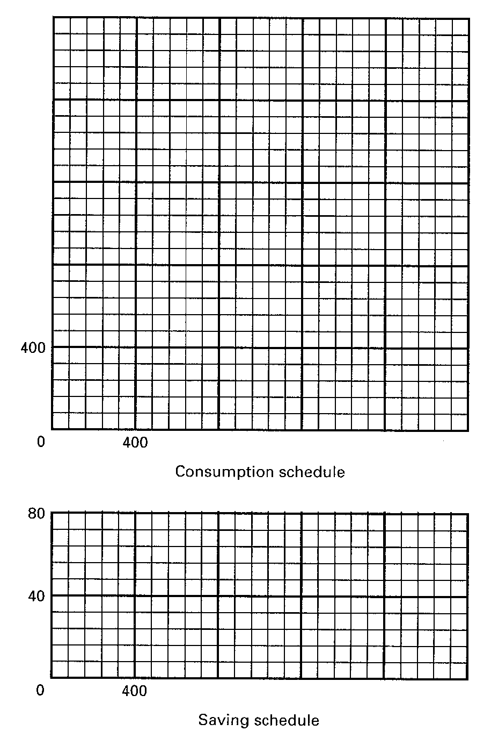
Quick Quiz: What is Money? – Chapter 14

1. When a consumer wants to compare the price of one product with another, money is primarily functioning as a:
1. Store of value
2. Unit of account
3. Medium of exchange

2. What function is money serving when you buy a ticket to a movie?
1. A store of value
2. A unit of account
3. A medium of exchange

3. Cathy Rogers deposits $200 in currency in her checking account at a bank. This deposit is treated as:
1. A subtraction of $200 from the M1 money supply because the $200 in currency is no longer in circulation
2. An addition of $200 to the M1 money supply because of the creation of a checkable deposit of $200
3. An addition of $200 to the M1 money supply because the bank holds $200 in currency and the checking account has been increased by $200
4. No change in the M1 money supply because the $200 in currency has been converted to a $200 increase in checkable deposits

4. Checkable deposits are included in:
1. M1 but not in M2
2. M2 but not in M1
3. both M1 and M2
4. neither M1 nor M2
5. What "backs" the money supply?
1. The U.S. government's ability to keep the value of money relatively stable
2. The amount of gold the U.S. government has on deposit at its banks
3. The fact that currency is issued as Federal Reserve Notes
4. The fact that the intrinsic value of coins in circulation is greater than their face value

Quick Quiz: The Fed – Chapter 14
1. The Federal Reserve Banks are owned by the:
1. Federal government
2. Board of Governors
3. United States Treasury
4. Member banks
2. How long is the term of office for members appointed to serve on the Board of Governors of the Federal Reserve System?
1. 2 years
2. 4 years
3. 7 years
4. 14 years
3. The Federal Open Market Committee (FOMC) of the Federal Reserve System is primarily for:
1. Maintaining cash reserves that can be used to settle international transactions
2. Supervising banks to make sure that markets are open to all and remain competitive
3. Issuing currency and acting as the fiscal agent for the Federal government
4. Setting the Fed's monetary policy and directing the purchase and sale of government securities
4. The main function of the Federal Reserve System is to:
1. Serve as the fiscal agent for the Federal government
2. Supervise the operation of member banks
3. Clear checks from member banks
4. Control the money supply
5. Economic studies conducted in industrially advanced countries suggest there is:
1. A positive relationship between the degree of independence of the central bank and the size of the average annual rate of inflation
2. An inverse relationship between the degree of independence of the central bank and the size of the average annual rate of inflation
3. No relationship between the degree of independence of the central bank and the size of the average annual rate of inflation
D. A positive relationship between the degree of independence of the central bank and the size of the central bank

Quick Quiz: The Money Market – Chapter 14 lecture (Chapter 16 textbook)
1. The asset demand for money and the rate of interest are:
1. Inversely related
2. Directly related
3. Unrelated
4. Both stable
2. The total quantity of money demanded is determined by:
1. Subtracting the asset demand for money from the transactions demand for money
2. Adding the transactions demand for money to the asset demand for money
3. Subtracting the transactions demand for money from nominal GDP
4. Adding the asset demand for money to nominal GDP
3. Refer to the above graph, in which D_{t} is the transactions demand for money, D_{m} is the total demand for money, and S_{m} is the supply of money. The transactions demand for money in this money market is:
1. $125 2. $175
3. $250 4. $325
4. Refer to the above graph, in which D_{t} is the transactions demand for money, D_{m} is the total demand for money, and S_{m} is the supply of money. If the interest rate was 4 percent, the asset demand for money would be:
1. $125
2. $175
3. $200
4. $225

5. Refer to the above graph. If the supply of money was $250 billion, the interest rate would be:
1. 1 percent
2. 2 percent
3. 3 percent
4. 4 percent

6. An increase in the money supply is likely to decrease:
1. Prices
2. Nominal income
3. Money demand
4. Interest rates

Total Change in Money Supply = Initial excess reserves x Money Multiplier
- Total Reserves = Cash in vault + Deposits at Fed
- Required Reserves = RR x Liabilities
- Excess Reserves = Total Reserves - Required Reserves
- Money Multiplier = 1 / RR

How Banks Create Money
Major Point: An initial increase in funds available to the banking industry results in a MULTIPLE increase in the money supply.
Three Step Process per Round:
- An increase in demand deposits or other liabilities of a bank increases the bank’s reserves.
- Bank can make loans equal to its excess reserves. Loans made by increasing demand deposits.
- The loan check is spent, deposited in a different bank, and CLEARS. First bank now has no excess reserves, but second does and can therefore make a loan.
Given:
Required Reserve Ratio = 20%
FNB = First National Bank
SNB = Second National Bank
TNB = Third National Bank
ER = excess reserves
All banks initially have no excess reserves
Banks make loans equal to their excess reserves
$10 cash is deposited in a checking (DD) account at FNB
SHOW: The CHANGES in the balance sheets of each bank as a result of this $10 cash deposit and the increased loan making ability of the banks.

FORMULAS

Total Change in Money Supply = Initial excess reserves x Money Multiplier
  - Total Reserves = Cash in vault + Deposits at Fed
  - Required Reserves = RR x Liabilities
  - Excess Reserves = Total Reserves - Required Reserves
  - Money Multiplier = 1 / RR
Round One
Step 1: $10 deposited in FNB

Step 2: FNB makes loan equal to its excess reserves

Step 3: Loan is spent, deposited in SNB, and the check clears

Round Two
Step 1: Check from round one deposited in SNB
Step 2: SNB makes loan equal to its excess reserves
Step 3: Loan is spent, deposited in TNB, and the check clears
Round Three
Step 1: Check from round two deposited in TNB

Money Supply Changes:

How much money was created in round one? ____________
How much money was created in round two? ____________
How much money can be created in round three? ____________
Money Multiplier = 1/Required Reserve Ratio
(also called Deposit Expansion multiplier)
Total increase in money supply = Money Multiplier x initial excess reserves
What is the money multiplier? _____________
What is the maximum total increase in the money supply that can occur as a result of the initial $10 cash deposit? _____________
What are the limitations on this money creation process?
________________________________________________________
________________________________________________________
________________________________________________________
Quick Quiz: Money Creation – Chapter 15

1. The fractional reserve system of banking started when goldsmiths began:
1. Accepting deposits of gold for safe storage
2. Charging people who deposited their gold
3. Using deposited gold to produce products for sale to others
4. Issuing paper receipts in excess of the amount of gold held

2. The primary reason for legal reserve requirements that require commercial banks to keep required reserves on deposit at Federal Reserve Banks is to:
1. Add to the liquidity of the commercial bank
2. Allow the Fed to control the amount of bank lending
3. Protect the deposits in the commercial bank against losses
4. Provide the means by which checks drawn on a commercial bank and deposited in other commercial banks can be collected

3. A commercial bank has actual reserves of $50,000 and checkable deposits of $200,000, and the required reserve ratio is 20%. The excess reserves of the bank are:
1. $10,000
2. $20,000
3. $40,000
4. $50,000

Use this information for the next two questions: Assume that the required reserve ratio is 25 percent. If a commercial bank has $1 million cash in its vault, $2 million in short-term government securities, $3 million on deposit at a Federal Reserve Bank, and $6 million in checkable deposits

4. Refer to the above information. This bank can safely expand its loans by a maximum of:
1. $1 million
2. $2.5 million
3. $5 million
4. $8 million

5. Refer to the above information. If the original bank balance sheet was for the commercial banking system, rather than a single bank, loans and deposits could have been expanded by a maximum of:
1. $2.5million
2. $5 million
3. $8 million
4. $10 million

6. When a check is cleared against a bank, it will lose:
1. Cash and securities
2. Checkable deposits and reserves
3. Reserves and capital stock
4. Loans and demand deposits

7. Refer to the above information for a single bank. The required (legal) reserve ratio is 25%. This bank can safely expand its loans by a maximum of:
1. $0
2. $50
3. $100
4. $200
8. Refer to the above information. The required (legal) reserve ratio is 25%. If the original bank balance sheet was for the commercial banking system, rather than a single bank, loans and deposits could have been expanded by a maximum of:
1. $0
2. $50
3. $100
4. $200
MONEY CREATION -- REVIEW
1. Why are financial institutions required to keep reserves?
2. Explain what is meant by fractional reserve banking.
3. Answer the next question based on the following consolidated balance sheet for the commercial banking system. Assume the required reserve ratio is 30 percent. All figures are in millions of dollars.
ASSETS | LIABILITIES
  Reserves | $200
  Securities | 500
  Loans | 100
  Property | 500
  Deposits | $600
  Capital Stock | 700
(a) What is the amount of excess reserves in this commercial banking system?
(b) What is the maximum amount that the money supply can be expanded?
(c) If the reserve ratio fell to 25 percent, what is now the maximum amount that the money supply can be expanded?

4. Answer the next question based on the following consolidated balance sheet for the commercial banking system. Assume the required reserve ratio is 20 percent. All figures are in billions of dollars.
ASSETS | LIABILITIES
  Reserves | $60
  Securities | 140
  Loans | 100
  Property | 400
  Deposits | $200
  Capital Stock | 500
(a) What is the amount of excess reserves in this commercial banking system?
(b) What is the maximum amount that the money supply can be expanded?
(c) If the reserve ratio fell to 10 percent, what is now the maximum amount that the money supply can be expanded?

Formulas

Total Change in Money Supply = Initial excess reserves x Money Multiplier
- Total Reserves = Cash in vault + Deposits at Fed
- Required Reserves = RR x Liabilities
- Excess Reserves = Total Reserves - Required Reserves
- Money Multiplier = 1 / RR

Balance Sheet of Banks
ASSETS | LIABILITIES & NET WORTH
- cash in the vault  - deposits at the Fed.  - loans made to customers  - government securities (bonds) bought by the banks  - Other (the building, computers, land, etc.) | - Checking deposits of customers (call Demand Deposits (DD)  - Savings Accounts and CDs of customers  - Loans borrowed by the bank from the Fed or other banks  - Net Worth

Balance Sheet of the Fed
ASSETS |  | || | LIABILITIES
Securities |  | || | Reserves of banks
Loans to banks |  | || | Treasury deposits
other |  | || | Federal Res. Notes
 |  | || | other

SUMMARY: "Easy" or expansionary monetary policy
1. Occurs when the Fed tries to increase money supply by expanding excess reserves in order to stimulate the economy.
2. GOAL: to reduce unemployment
3. The Fed will enact one or more of the following measures.
a. The Fed will buy securities.
b. The Fed may reduce reserve ratio, although this is rarely changed because of its powerful impact.
c. The Fed could reduce the discount rate, although this has little direct impact on the money supply.
d. The Fed could auction off more reserves.
4. Expansionary or easy money policy: The Fed takes steps to increase excess reserves, banks can make more loans increasing the money supply, which lowers the interest rate and increases investment which, in turn, increases GDP by a multiple amount of the change in investment.
Keynesian Cause-Effect Chain of Monetary Policy:
FED  TOOLS ER MS Int. RatesI AD
  real GDP UE
  PL ΙΝ
BUY OMO
DR
RR
LEND MORE RESERVES VIA THE TERM AUCTION FACILITY(DR)

The numbers on the graphs above indicate the correct order of the causes and effects.

"Tight" or contractionary monetary policy
1. Occurs when Fed tries to decrease money supply by decreasing excess reserves in order to slow spending in the economy during an inflationary period.
2. GOAL: to reduce inflation
3. The Fed will enact one or more of the following policies:
a. The Fed will sell securities.
b. The Fed may raise the reserve ratio, although this is rarely changed because of its powerful impact.
c. The Fed could raise the discount rate, although it has little direct impact on money supply.
d. The Fed could auction off fewer reserves.

4. Contractionary or tight money policy is the reverse of an easy policy: Excess reserves fall, the money supply decreases, which raises interest rate, which decreases investment, which, in turn, decreases GDP by a multiple amount of the change in investment.
Keynesian Cause-Effect Chain of Monetary Policy:
FED  TOOLS ER MS Int. RatesI AD
  real GDP UE
  PL ΙΝ
SELL OMO
DR
RR
LEND FEWER RESERVES VIA THE TERM AUCTION FACILITY (DR)
The numbers on the graphs above indicate the correct order of the causes and effects.

Monetary Policy – Chapter 16

1. The reserves of commercial banks are a(n):
1. Asset to commercial banks and an asset to the Federal Reserve Banks
2. Asset to commercial banks and a security to the Federal Reserve Banks
3. Asset to commercial banks and a liability to the Federal Reserve Banks
4. Liability to commercial banks and an asset to the Federal Reserve Banks

2. The Board of Governors of the Federal Reserve System can increase commercial bank reserves (i.e. increase the money supply) by:
1. Increasing the discount rate
2. Increasing the reserve ratio
3. sell fewer reserves to bank through the term auction facility
4. Buying government securities in the open market

3. Assume the required reserve ratio is 20 percent. If the Federal Reserve buys $100 million in government securities directly from commercial bank, then the money supply will potentially:
1. decrease by $100
2. increase by $100
3. decrease by $500
4. increase by $500

4. Assume the required reserve ratio is 20 percent. If the Federal Reserve buys $100 million in government securities from the public, then the money supply will immediately:
1. Increase by $100 million, and the maximum money-lending potential of the commercial banking system will increase by $100 million
2. Increase by $100 million, and the maximum money-lending potential of the commercial banking system will increase by $500 million
3. Increase by $100 million, and the maximum money-lending potential of the commercial banking system will increase by $400 million
D. Decrease, because the securities are an asset to the commercial banks and a liability to the Federal Reserve

5. The most frequently used monetary device for achieving price stability is:
1. Open-market operations
2. The discount rate
3. The reserve ratio
4. Term auction facility

6. If the Board of Governors of the Federal Reserve System increases the legal (required) reserve ratio, this change will:
1. Increase the excess reserves of member banks and thus increase the money supply
2. Increase the excess reserves of member banks and thus decrease the money supply
3. Decrease the excess reserves of member banks and thus decrease the money supply
4. Decrease the excess reserves of member banks and thus increase the money supply
7. A television report states: "The Federal Reserve will lower the discount rate for the fourth time this year." This report indicates that the Federal Reserve is most likely trying to:
1. Reduce inflation
2. Save the banking industry
3. Stimulate the economy
4. Improve the savings rate

8. In recent years, the Fed often communicated its intentions to restrict or expand monetary policy by announcing a change in targets for the:
1. Exchange rate
2. Federal funds rate
3. Prime interest rate
4. Consumer price index

9. Refer to the above graphs, in which the numbers in parentheses near the AD₁, AD₂, and AD₃ labels indicate the level of investment spending associated with each curve, respectively. All numbers are in billions of dollars. The interest rate and the level of investment spending in the economy are at point D on the investment demand curve. To achieve the long-run goal of a noninflationary full-employment output Qf in the economy, the Fed should:
1. Decrease aggregate demand by increasing the interest rate from 2 to 4 percent
2. Decrease aggregate demand by increasing the interest rate from 4 to 6 percent
3. Increase aggregate demand by decreasing the interest rate from 4 to 2 percent
4. Increase the level of investment spending from $120 billion to $150 billion

10. Which of the following best describes what occurs when monetary authorities sell government securities?
1. There is a decrease in the size of commercial banks' excess reserves, the money supply increases, and interest rates fall, thereby causing a decrease in investment spending and real GDP
2. There is a decrease in the size of commercial banks' excess reserves, the money supply decreases, and the interest rates rise, thereby causing a decrease in investment spending and real GDP
3. There is a decrease in the size of commercial banks' excess reserves, the money supply decreases, and interest rates rise, thereby causing an increase in investment spending and real GDP
4. There is an increase in the size of commercial bank reserves, the money supply increases, and interest rates fall, thereby causing an increase in investment spending and real GDP

11. Refer to the above diagrams, in which the numbers in parentheses near the AD₁, AD₂, and AD₃ labels indicate the level of investment spending associated with each curve. All figures are in billions. The economy is at equilibrium at the intersection of the aggregate supply curve and aggregate demand curve AD₃. What policy should the Fed pursue to achieve a noninflationary full-employment level of real GDP?
1. Increase the money supply from $75 to $150 billion
2. Increase the money supply from $150 to $225 billion
3. Decrease the money supply from $225 to $150 billion
4. Make no change in the money supply

12. Assume that the MPC is .75. If the Federal Reserve increases the money supply and investment spending increases by $8 billion, then aggregate demand is likely to:
1. Increase by $6 billion
2. Increase by $8 billion
3. Increase by $32 billion
4. Decrease by $8 billion
13. The strengths of monetary policy compared to fiscal policy are generally thought to include all of the following except:
1. greater speed
2. greater flexibility
3. greater impact on taxation
4. greater political acceptance
14. A Federal Reserve official notes: "A restrictive money policy can force a contraction of the money supply, but an expansionary money policy may not achieve an expansion of the economy." The official has described the problem of the:
1. Inflexibility of monetary policy tools
2. Change in taxes on monetary policy
3. Cyclical asymmetry of monetary policy
4. Political acceptability of monetary policy
Chapter 16
Review Questions

1. What are the two types of demand that make up total demand for money?

2. Analyze what would happen to the equilibrium rate of interest in the money market if the supply of money were increased while the demand schedule remained the same.

3. What are the four principal tools of monetary policy? Explain how they can be used to affect banks’ excess reserves and the money supply.

4. Answer the next question based on the following consolidated balance sheet for the commercial banking system. Assume the required reserve ratio is 25%. All figures are in billions of dollars.

Assets | Liabilities + Net Worth
Reserves $100  Securities 200  Loans 100  Property 600 | Checkable deposits $300  Stock shares 700

(a) What is the amount of excess reserves in this commercial banking system?
(b) What is the maximum amount that the money supply can be expanded?
(c) If the reserve ratio fell to 25%, what is now the maximum amount that the money supply can be expanded?

5. What is the difference between the Federal Reserve Banks’ purchases of securities from the commercial banking system and those from the public? Give an example.

6. The following are simplified balance sheets for the commercial banking system and the Federal Reserve System. Perform each of the following three transactions, a, b, and c, making appropriate changes in columns (1) through (3) in each balance sheet. Do not cumulate your answers. Also, answer these three questions for each part: (a) What change, if any, took place in the money supply as a direct result of this transaction? (b) What change, if any, occurred in commercial bank reserves? (c) What change occurred in the money-creating potential of the commercial banking system if the reserve ratio is 20%? All figures are in billions of dollars.
Consolidated Balance Sheet: Commercial Banking System
 | (1) | (2) | (3)
Assets:  Reserves $ 50  Securities 75  Loans 75  Liabilities:  Checkable deposits 190  Loans from FRBs 10 | $_____  _____  _____  _____  _____ | $_____  _____  _____  _____  _____ | $_____  _____  _____  _____  _____

Consolidated Balance Sheet: Federal Reserve Banks
 | (1) | (2) | (3)
Assets:  Securities $90  Loans to CBs 10  Liabilities:  Reserves of CBs 50  Treasury deposits 10  Federal Reserve notes 40 | $_____  _____  _____  _____  _____ | $_____  _____  _____  _____  _____ | $_____  _____  _____  _____  _____

(1) Suppose a drop in the discount rate causes commercial banks to borrow an additional $3 billion from the Fed. Show the new sheet figures in column 1.

(2) The Fed buys $2 billion of government bonds from the public. Show the new sheet figures in column 2.

(3) The Fed buys $2 billion of government bonds from commercial banks. Show the new sheet figures in column 3

7. Use the below graphs to answer the following questions assuming the nominal GDP in the economy is given.
(a) Look at graph A and suppose the supply of money increases from 100 to 200. What will be the equilibrium rate of interest?

(b) Look at graph B which shows an investment-demand curve for this economy. Given the answer to part (a) above, how much will investors plan to spend on capital goods?

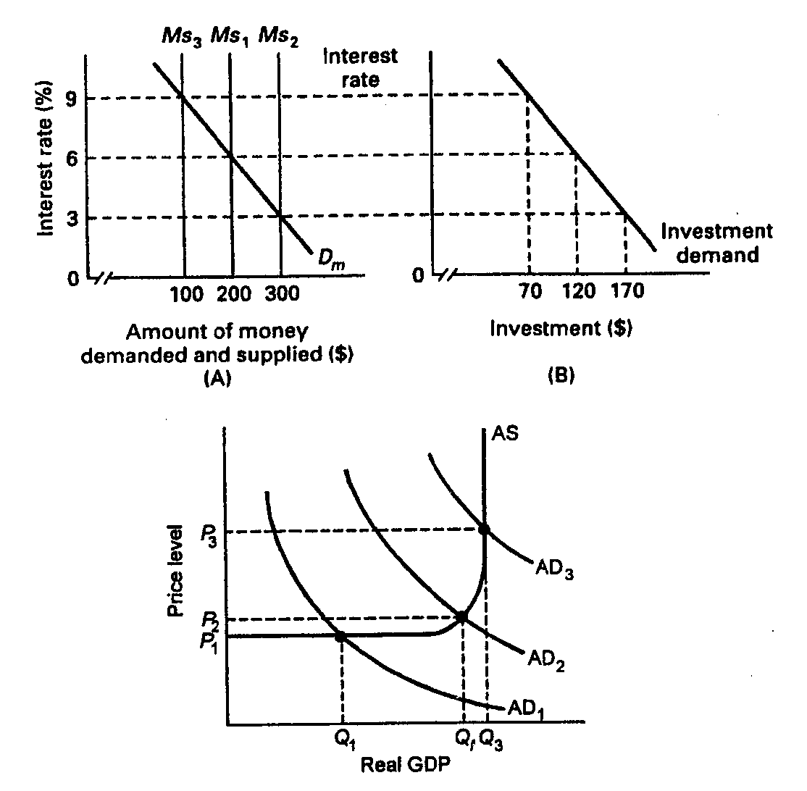
(c) What will happen to aggregate demand?
(d) Now trace what will happen in parts (a)–(c) if the money supply increases to $300.

8. Suppose the economy is experiencing inflation. What would be the interpretation of how a restrictive monetary policy would address this problem?

9. Explain two strengths of monetary policy for achieving economic stability.

10. One of the advantages of monetary policy is its speed and flexibility, but there are limitations. Explain.

