Unit 3 - MACROECONOMIC POLICY
Chapters 10 and 13 - Fiscal Policy
- Reading Assignments:
  - ALL of chapter 10
  - ALL of chapter 13
  - PLUS pp. 367-368 "Taxation and Aggregate Supply"
- Study Guide
  - Chapter 10:
    - Multiple Choice: ALL
    - Problems: # 1, 4, 5
  - Chapter 13:
    - Multiple Choice: # 1-5, 10, 11-25
    - Problems: # 4, 5
- Worked Problems 10.1 and 10.2 at http://www.mcconnell18e.com
- Web Quizzes at http://www.mcconnell18e.com
  - Chapter 10: ALL
  - Chapter 13: # 1, 2, 4-10
- Key Questions
  - Chapter 8: # 1a and 4
  - Chapter 11: # 1, 2, 4, 5, and 6
- End-of-Chapter Key Questions: # 10-5a, 10-9, 13-2, 13-3, 13-8, 13-10, 13-13
[the answers to the key questions can be found on our Blackboard site]
Chapters 14 and 15 - Money and How Banks Create It
- Reading Assignments:
  - ALL of Chapter 14 and pp. 308-310 from chapter 16
  - ALL of Chapter 15
- Study Guide
  - Chapter 14
    - Multiple Choice: # 1-5, 7, 9, 11, 13, 15-23
  - Chapter 15
    - Multiple Choice: # 1, 3-25
    - Problems: # 1-4
- Worked Problems 15.1 and 15.2 at http://www.mcconnell18e.com
- Web Quizzes at http://www.mcconnell18e.com
  - Chapter 14: 1-4, 6-8, 10
  - Chapter 15: ALL
- End-of-Chapter Key Questions: # 14-4, 14-8, 15-2, 15-4, 15-8, 15-13
[the answers to the key questions can be found on our Blackboard site]
Chapter 16 - Monetary Policy
- Reading Assignment: ALL of chapter 16
- Study Guide
  - Multiple Choice: # 1, 3, 4, 7, 8, 14 (tricky), 15-30
  - Problems: # 3, 4, 5 (the graph is slightly off).
- Worked Problem 16.3 at http://www.mcconnell18e.com
- Web Quiz chapter 16 at http://www.mcconnell18e.com: # 2, 4-9
- End-of-Chapter Key Questions: # 16-1, 16-2, 16-5
[the answers to the key questions can be found on our Blackboard site]
Consumption and Saving Functions

Y C S APC MPC APS MPS ____________________________________________________________________________________________

0 40 - 40 -- -- -- --
_ _ _ _ _ _ _ _ _ _ _ _ _ _ _ _ _ _ _ _ _ _ _ _ _ _ _ _ _ _ _ _ _ _ _ _ _ _ _ _ _ _ _ _ _ _ _ _ _ _ _ _ _ _ _ _ _ _ _ _ _

100 120 - 20
_ _ _ _ _ _ _ _ _ _ _ _ _ _ _ _ _ _ _ _ _ _ _ _ _ _ _ _ _ _ _ _ _ _ _ _ _ _ _ _ _ _ _ _ _ _ _ _ _ _ _ _ _ _ _ _ _ _ _ _ _ _

200 200 0
_ _ _ _ _ _ _ _ _ _ _ _ _ _ _ _ _ _ _ _ _ _ _ _ _ _ _ _ _ _ _ _ _ _ _ _ _ _ _ _ _ _ _ _ _ _ _ _ _ _ _ _ _ _ _ _ _ _ _ _ _ _

- 280
_ _ _ _ _ _ _ _ _ _ _ _ _ _ _ _ _ _ _ _ _ _ _ _ _ _ _ _ _ _ _ _ _ _ _ _ _ _ _ _ _ _ _ _ _ _ _ _ _ _ _ _ _ _ _ _ _ _ _ _ _ _

- 360
_ _ _ _ _ _ _ _ _ _ _ _ _ _ _ _ _ _ _ _ _ _ _ _ _ _ _ _ _ _ _ _ _ _ _ _ _ _ _ _ _ _ _ _ _ _ _ _ _ _ _ _ _ _ _ _ _ _ _ _ _ _

- 440
_ _ _ _ _ _ _ _ _ _ _ _ _ _ _ _ _ _ _ _ _ _ _ _ _ _ _ _ _ _ _ _ _ _ _ _ _ _ _ _ _ _ _ _ _ _ _ _ _ _ _ _ _ _ _ _ _ _ _ _ _ _

- 520
_ _ _ _ _ _ _ _ _ _ _ _ _ _ _ _ _ _ _ _ _ _ _ _ _ _ _ _ _ _ _ _ _ _ _ _ _ _ _ _ _ _ _ _ _ _ _ _ _ _ _ _ _ _ _ _ _ _ _ _ _ _

- 600
_ _ _ _ _ _ _ _ _ _ _ _ _ _ _ _ _ _ _ _ _ _ _ _ _ _ _ _ _ _ _ _ _ _ _ _ _ _ _ _ _ _ _ _ _ _ _ _ _ _ _ _ _ _ _ _ _ _ _ _ _ _

Chapter 10
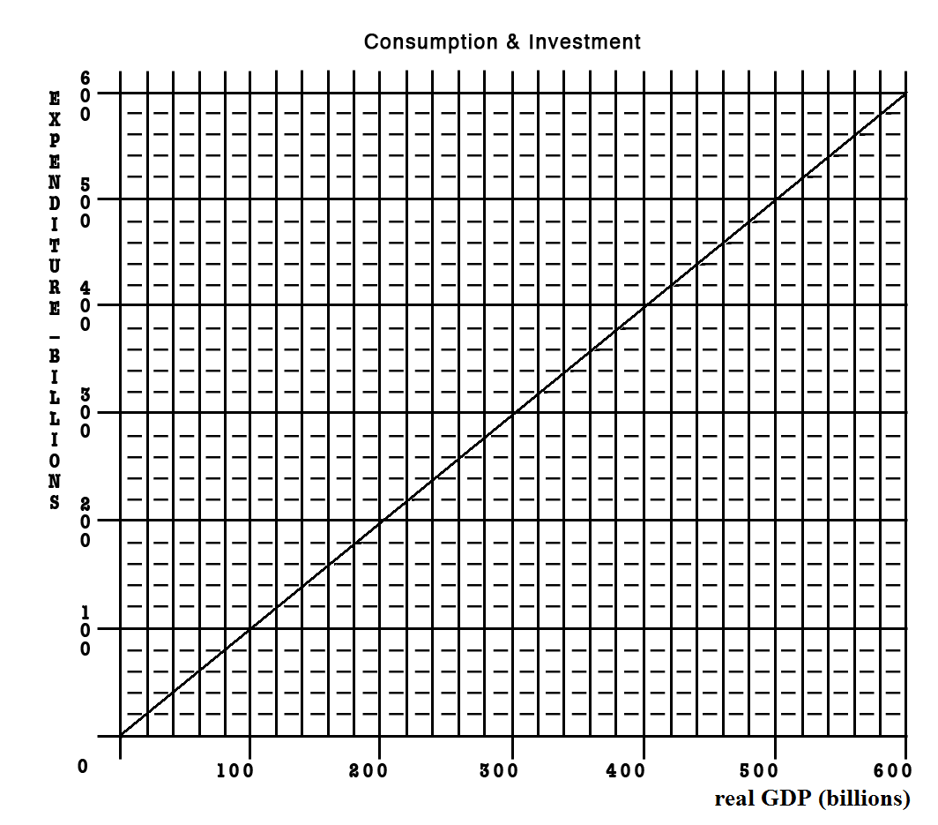
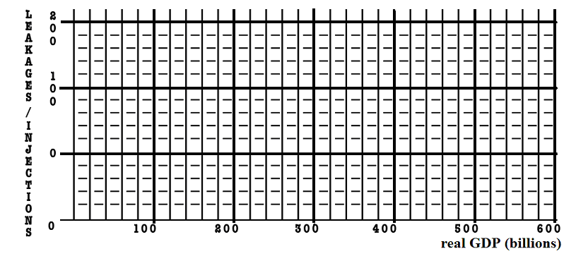
Given the graphs below, calculate the change in government spending that is needed for this economy to achieve full employment.

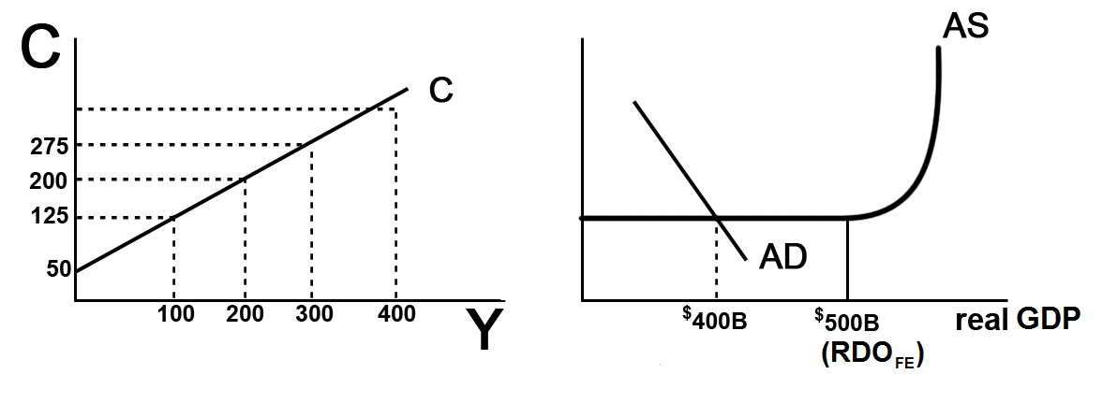
- MPC = _____________

- MPS = _____________

- initial GDP = ___________ full employment GDP = ____________

- multiplier = ____________

- What change in government spending needed to achieve full employment?

- What happens to the size of the multiplier with the addition of Taxes and Imports?

- What would happen to your answer in #5 if we included Taxes and Imports?

- Notice that as this economy approaches full employment, there is no inflation. What happens to the size of the multiplier if there is inflation?

- What would happen to your answer in #5 if there was some inflation?

- What is the lump-sum tax multiplier? ___________________

- What change in taxes is needed to achieve full employment? ________________

~~~~~~~~~~~~~~~~~~~~~~~~~~~~~~~~~~~~~~~~~~~~~~~~~~~~~~~~~~~~~~~~~~~~~~~~

If the MPC = .6 and government spending decreases by $100 B, what happens to equilibrium GDP?

The Philadelphia Inquirer, November 6, 1998

Plentiful gains seen from GOP

The publicity for the city may be priceless. The visitors' spending could reach $300 million.
By Howard Goodman
INQUIRER STAFF WRITER
When the elephants thunder into Philadelphia in 2000, the vibrations are expected to shake an incredibly bountiful money tree, showering dollars all over the region.
The economic impact of the Republican National Convention will almost certainly exceed $125 million in direct spending on hotel rooms, meals and the like, along with at least $175 million in spinoff benefits (emphasis added), David L. Cohen said yesterday. Cohen, Mayor Rendell's former chief of staff, is cochairman of Philadelphia 2000, the committee formed to woo a political convention.
The estimate is based on a Federal Reserve Board study of the economic blessings felt in Chicago from the 1996 Democratic convention, with a little extra figured in for four years' worth of inflation, Cohen said.
"There is no convention you can host that has a greater economic impact than a national political convention," he said. "Most people agree the only thing you can host that has a greater economic impact is the Olympics."
. . . . .
In San Diego, where the Republicans last met, business leaders still bask in the 1996 convention's glow. "We look at the convention as a weeklong television commercial for your city as a destination," Salvatore Giametta, a spokesman for the San Diego Convention and Visitors Bureau, said in an interview this summer.
. . . . .
According to the Greater San Diego Area Chamber of Commerce, the four-day convention attracted 30,000 visitors who spent $26 million on hotel rooms. But there has been no follow-up study to show the convention's broader effect on the San Diego economy.
Despite the lack of data, San Diego "absolutely" would host a convention again, Giametta said. "We think it was good for the tourism industry without a doubt."
Brian Ford, an accountant for Philadelphia 2000, said that insisting on a study to prove that Philadelphia will benefit mightily from the GOP meeting "is like saying you need a study to show that a car works."
. . . . .
Chapter 10 and 13 REVIEW:

MULTIPLIERS
MULTIPLIER | PAGE | LARGER OR SMALLER THAN  THE SIMPLE MULTIPLIER? - WHY?
SIMPLE | pp. 200-203 "The Multiplier Effect" | multiplier = 1 / mps
Complex multiplier | pp. 203-205  "How Large is the Actual Multiplier Effect?" | smaller because there are more leakages: (1) saving, (2) spending on imports, and (3) taxes
Multiplier w/ changes  in the price level | pp. 255-256 "Increased Government Spending" | smaller
G spending multiplier | p. 255 "Increased Government Spending"  p. 257 "Decreased Government Spending" | same as simple
Tax multiplier | p. 256 "Tax Reductions"  p. 258 "Increased Taxes" | one less than the simple multiplier, but negative  tax multiplier =MPC / MPS
Bal. Budget multiplier | p. 256, 258 "Combined Gov/t Spending . . . " | always equals 1, WHY?
Multiplier w/ crowding out  (expansionary FP only) | pp. 265, 269 "Crowding-Out Effect" | smaller
Multiplier with supply-side effects | pp. 265-266 "Current Thinking on Fiscal Policy" | larger

ECO 212 - Chapters 10 and 13 - Fiscal Policy
REVIEW EXERCISES

1. Complete the accompanying table.
Level of output and income  (GDP = DI) | Consumption | Saving | APC | APS | MPC | MPS
$480 | $_____ | –$8 | _____ | _____ | _____ | _____
520 | _____ | 0 | _____ | _____ | _____ | _____
560 | _____ | 8 | _____ | _____ | _____ | _____
600 | _____ | 16 | _____ | _____ | _____ | _____
640 | _____ | 24 | _____ | _____ | _____ | _____
680 | _____ | 32 | _____ | _____ | _____ | _____
720 | _____ | 40 | _____ | _____ | _____ | _____
760 | _____ | 48 | _____ | _____ | _____ | _____
800 | _____ | 56 | _____ | _____ | _____ | _____

2. Using the data above, show the consumption and saving schedules graphically.

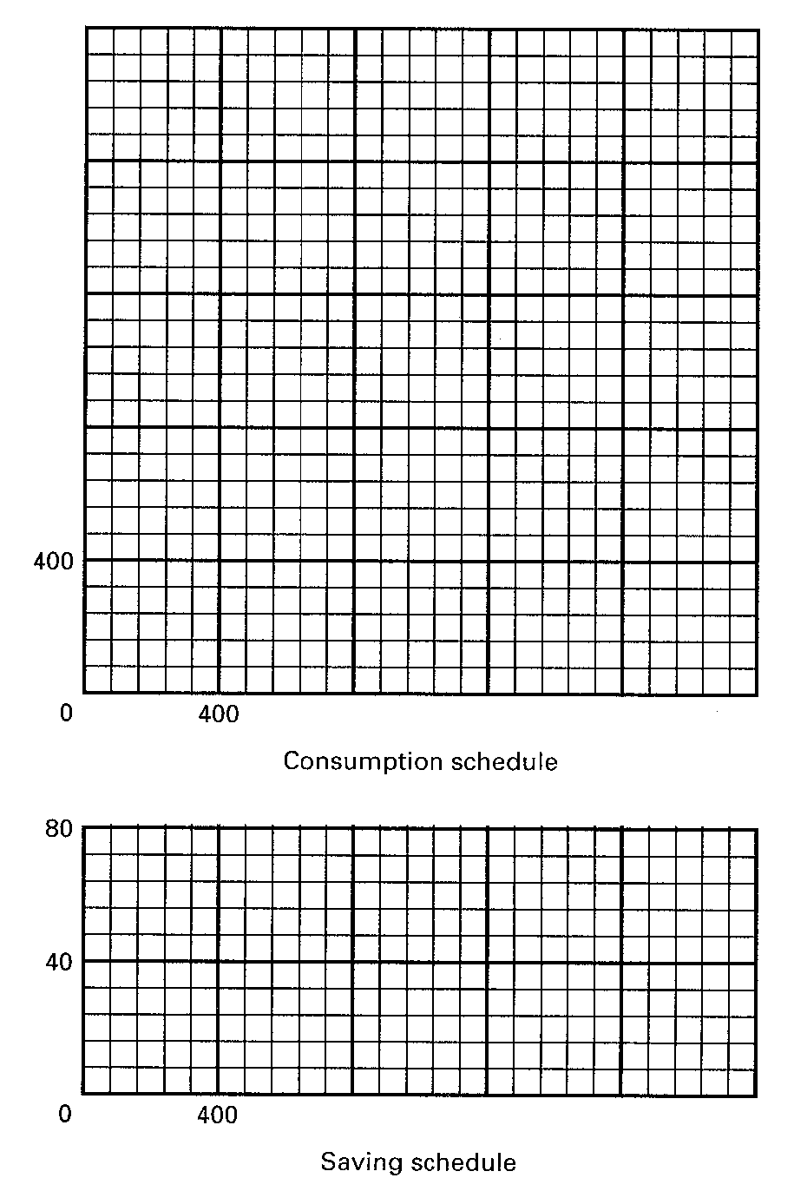

Total Change in Money Supply = Initial excess reserves x Money Multiplier
- Total Reserves = Cash in vault + Deposits at Fed
- Required Reserves = RR x Liabilities
- Excess Reserves = Total Reserves - Required Reserves
- Money Multiplier = 1 / RR

How Banks Create Money
Major Point: An initial increase in funds available to the banking industry results in a MULTIPLE increase in the money supply.
Three Step Process per Round:
- An increase in demand deposits or other liabilities of a bank increases the bank’s reserves.
- Bank can make loans equal to its excess reserves. Loans made by increasing demand deposits.
- The loan check is spent, deposited in a different bank, and CLEARS. First bank now has no excess reserves, but second does and can therefore make a loan.
Given:
Required Reserve Ratio = 20%
FNB = First National Bank
SNB = Second National Bank
TNB = Third National Bank
ER = excess reserves
All banks initially have no excess reserves
Banks make loans equal to their excess reserves
$10 cash is deposited in a checking (DD) account at FNB
Show:
The CHANGES in the balance sheets of each bank as a result of this $10 cash deposit and the increased loan making ability of the banks.

FORMULAS

Total Change in Money Supply = Initial excess reserves x Money Multiplier
  - Total Reserves = Cash in vault + Deposits at Fed
  - Required Reserves = RR x Liabilities
  - Excess Reserves = Total Reserves - Required Reserves
  - Money Multiplier = 1 / RR
Round One
Step 1: $10 deposited in FNB

Step 2: FNB makes loan equal to its excess reserves

Step 3: Loan is spent, deposited in SNB, and the check clears

Round Two
Step 1: Check from round one deposited in SNB
Step 2: SNB makes loan equal to its excess reserves
Step 3: Loan is spent, deposited in TNB, and the check clears
Round Three
Step 1: Check from round two deposited in TNB

Money Supply Changes:
How much money was created in round one? ____________
How much money was created in round two? ____________
How much money can be created in round three? ____________
Deposit Expansion Multiplier = 1 / Required Reserve Ratio
(also called Money multiplier)
Money Multiplier = total increase in money supply / initial excess reserves
What is the money multiplier? _____________
What is the maximum total increase in the money supply that can occur as a result of the initial $10 cash deposit? _____________
What are the limitations on this money creation process?
________________________________________________________
________________________________________________________
________________________________________________________
MONEY CREATION -- REVIEW
1. Why are financial institutions required to keep reserves?
2. Explain what is meant by fractional reserve banking.
3. Answer the next question based on the following consolidated balance sheet for the commercial banking system. Assume the required reserve ratio is 30 percent. All figures are in millions of dollars.
ASSETS | LIABILITIES
  Reserves | $200
  Securities | 500
  Loans | 100
  Property | 500
  Deposits | $600
  Capital Stock | 700
(a) What is the amount of excess reserves in this commercial banking system?
(b) What is the maximum amount that the money supply can be expanded?
(c) If the reserve ratio fell to 25 percent, what is now the maximum amount that the money supply can be expanded?

4. Answer the next question based on the following consolidated balance sheet for the commercial banking system. Assume the required reserve ratio is 20 percent. All figures are in billions of dollars.
ASSETS | LIABILITIES
  Reserves | $60
  Securities | 140
  Loans | 100
  Property | 400
  Deposits | $200
  Capital Stock | 500
(a) What is the amount of excess reserves in this commercial banking system?
(b) What is the maximum amount that the money supply can be expanded?
(c) If the reserve ratio fell to 10 percent, what is now the maximum amount that the money supply can be expanded?

Formulas

Total Change in Money Supply = Initial excess reserves x Money Multiplier
- Total Reserves = Cash in vault + Deposits at Fed
- Required Reserves = RR x Liabilities
- Excess Reserves = Total Reserves - Required Reserves
- Money Multiplier = 1 / RR

Balance Sheet of Banks
ASSETS | LIABILITIES & NET WORTH
- cash in the vault  - deposits at the Fed.  - loans made to customers  - government securities (bonds) bought by the banks  - Other (the building, computers, land, etc.) | - Checking deposits of customers (call Demand Deposits (DD)  - Savings Accounts and CDs of customers  - Loans borrowed by the bank from the Fed or other banks  - Net Worth

Balance Sheet of the Fed
ASSETS |  | || | LIABILITIES
Securities |  | || | Reserves of banks
Loans to banks |  | || | Treasury deposits
other |  | || | Federal Res. Notes
 |  | || | other

SUMMARY: "Easy" or expansionary monetary policy
1. Occurs when the Fed tries to increase money supply by expanding excess reserves in order to stimulate the economy.
2. GOAL: to reduce unemployment
3. The Fed will enact one or more of the following measures.
a. The Fed will buy securities.
b. The Fed may reduce reserve ratio, although this is rarely changed because of its powerful impact.
c. The Fed could reduce the discount rate, although this has little direct impact on the money supply.
d. The Fed could auction off more reserves.
4. Expansionary or easy money policy: The Fed takes steps to increase excess reserves, banks can make more loans increasing the money supply, which lowers the interest rate and increases investment which, in turn, increases GDP by a multiple amount of the change in investment.
Keynesian Cause-Effect Chain of Monetary Policy:
FED  TOOLS ER MS Int. RatesI AD
  real GDP UE
  PL ΙΝ
SELL OMO
DR
RR
LEND MORE RESERVES VIA THE TERM AUCTION FACILITY(DR)

The numbers on the graphs above indicate the correct order of the causes and effects.

"Tight" or contractionary monetary policy
1. Occurs when Fed tries to decrease money supply by decreasing excess reserves in order to slow spending in the economy during an inflationary period.
2. GOAL: to reduce inflation
3. The Fed will enact one or more of the following policies:
a. The Fed will sell securities.
b. The Fed may raise the reserve ratio, although this is rarely changed because of its powerful impact.
c. The Fed could raise the discount rate, although it has little direct impact on money supply.
d. The Fed could auction off fewer reserves.

4. Contractionary or tight money policy is the reverse of an easy policy: Excess reserves fall, the money supply decreases, which raises interest rate, which decreases investment, which, in turn, decreases GDP by a multiple amount of the change in investment.
Keynesian Cause-Effect Chain of Monetary Policy:
FED  TOOLS ER MS Int. RatesI AD
  real GDP UE
  PL ΙΝ
SELL OMO
DR
RR
LEND FEWER RESERVES VIA THE TERM AUCTION FACILITY (DR)
The numbers on the graphs above indicate the correct order of the causes and effects.
Chapter 16
Review Questions

1. What are the two types of demand that make up total demand for money?

2. Analyze what would happen to the equilibrium rate of interest in the money market if the supply of money were increased while the demand schedule remained the same.

3. What are the four principal tools of monetary policy? Explain how they can be used to affect banks’ excess reserves and the money supply.

4. Answer the next question based on the following consolidated balance sheet for the commercial banking system. Assume the required reserve ratio is 25%. All figures are in billions of dollars.

Assets | Liabilities + Net Worth
Reserves $100  Securities 200  Loans 100  Property 600 | Checkable deposits $300  Stock shares 700

(a) What is the amount of excess reserves in this commercial banking system?
(b) What is the maximum amount that the money supply can be expanded?
(c) If the reserve ratio fell to 25%, what is now the maximum amount that the money supply can be expanded?

5. What is the difference between the Federal Reserve Banks’ purchases of securities from the commercial banking system and those from the public? Give an example.

6. The following are simplified balance sheets for the commercial banking system and the Federal Reserve System. Perform each of the following three transactions, a, b, and c, making appropriate changes in columns (1) through (3) in each balance sheet. Do not cumulate your answers. Also, answer these three questions for each part: (a) What change, if any, took place in the money supply as a direct result of this transaction? (b) What change, if any, occurred in commercial bank reserves? (c) What change occurred in the money-creating potential of the commercial banking system if the reserve ratio is 20%? All figures are in billions of dollars.
Consolidated Balance Sheet: Commercial Banking System
 | (1) | (2) | (3)
Assets:  Reserves $ 50  Securities 75  Loans 75  Liabilities:  Checkable deposits 190  Loans from FRBs 10 | $_____  _____  _____  _____  _____ | $_____  _____  _____  _____  _____ | $_____  _____  _____  _____  _____

Consolidated Balance Sheet: Federal Reserve Banks
 | (1) | (2) | (3)
Assets:  Securities $90  Loans to CBs 10  Liabilities:  Reserves of CBs 50  Treasury deposits 10  Federal Reserve notes 40 | $_____  _____  _____  _____  _____ | $_____  _____  _____  _____  _____ | $_____  _____  _____  _____  _____

(1) Suppose a drop in the discount rate causes commercial banks to borrow an additional $3 billion from the Fed. Show the new sheet figures in column 1.

(2) The Fed buys $2 billion of government bonds from the public. Show the new sheet figures in column 2.

(3) The Fed buys $2 billion of government bonds from commercial banks. Show the new sheet figures in column 3

7. Use the below graphs to answer the following questions assuming the nominal GDP in the economy is given.
(a) Look at graph A and suppose the supply of money increases from 100 to 200. What will be the equilibrium rate of interest?

(b) Look at graph B which shows an investment-demand curve for this economy. Given the answer to part (a) above, how much will investors plan to spend on capital goods?

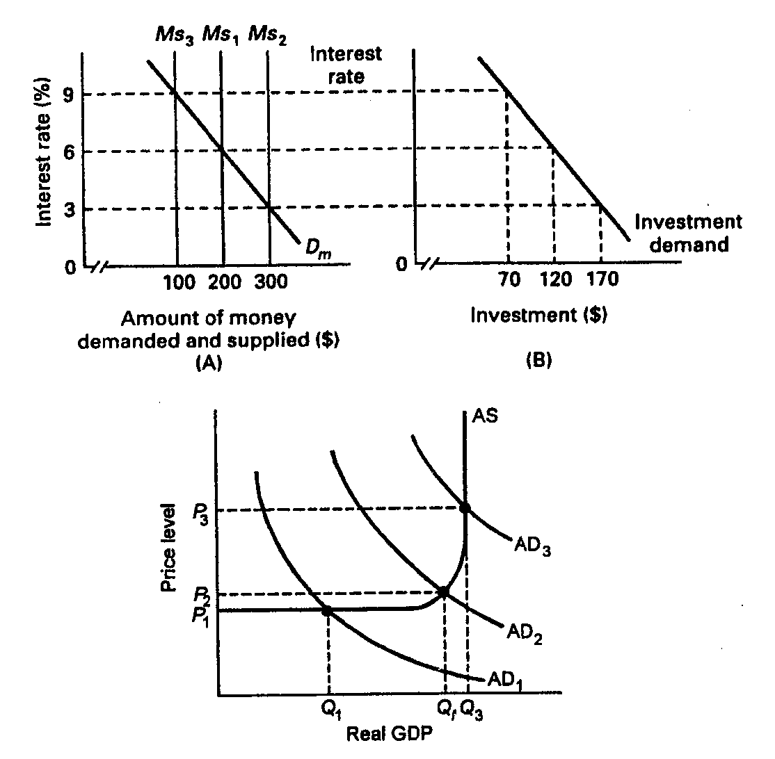
(c) What will happen to aggregate demand?
(d) Now trace what will happen in parts (a)–(c) if the money supply increases to $300.

8. Suppose the economy is experiencing inflation. What would be the interpretation of how a restrictive monetary policy would address this problem?

9. Explain two strengths of monetary policy for achieving economic stability.

10. One of the advantages of monetary policy is its speed and flexibility, but there are limitations. Explain.

