

ECO 212 – Macroeconomics

Yellow Pages

ANSWERS

Unit 3

Mark Healy
William Rainey Harper College
E-Mail: mhealy@harpercollege.edu
Office: J-262
Phone: 847-925-6352

Consumption and Saving Functions

Y C S APC MPC APS MPS _____________________________________________________________________________________

0 40 - 40 -- -- -- --
_ _ _ _ _ _ _ _ _ _ _ _ _ _ _ _ _ _ _ _ _ _ _ _ _ _ _ _ _ _ _ _ _ _ _ _ _ _ _ _ _ _ _ _ _ _ _ _ _ _ _ _ _ _ _ _

100 120 - 20 1.2 .8 -0.2 .2
_ _ _ _ _ _ _ _ _ _ _ _ _ _ _ _ _ _ _ _ _ _ _ _ _ _ _ _ _ _ _ _ _ _ _ _ _ _ _ _ _ _ _ _ _ _ _ _ _ _ _ _ _ _ _ _ _

200 200 0 1 .8 0 .2
_ _ _ _ _ _ _ _ _ _ _ _ _ _ _ _ _ _ _ _ _ _ _ _ _ _ _ _ _ _ _ _ _ _ _ _ _ _ _ _ _ _ _ _ _ _ _ _ _ _ _ _ _ _ _ _ _

- 280 20 .93 .8 .07 .2
_ _ _ _ _ _ _ _ _ _ _ _ _ _ _ _ _ _ _ _ _ _ _ _ _ _ _ _ _ _ _ _ _ _ _ _ _ _ _ _ _ _ _ _ _ _ _ _ _ _ _ _ _ _ _ _ _

- 360 40 .90 .8 .10 .2
_ _ _ _ _ _ _ _ _ _ _ _ _ _ _ _ _ _ _ _ _ _ _ _ _ _ _ _ _ _ _ _ _ _ _ _ _ _ _ _ _ _ _ _ _ _ _ _ _ _ _ _ _ _ _ _ _

- 440 60 .88 .8 .12 .2
_ _ _ _ _ _ _ _ _ _ _ _ _ _ _ _ _ _ _ _ _ _ _ _ _ _ _ _ _ _ _ _ _ _ _ _ _ _ _ _ _ _ _ _ _ _ _ _ _ _ _ _ _ _ _ _ _

- 520 80 .87 .8 .13 .2
_ _ _ _ _ _ _ _ _ _ _ _ _ _ _ _ _ _ _ _ _ _ _ _ _ _ _ _ _ _ _ _ _ _ _ _ _ _ _ _ _ _ _ _ _ _ _ _ _ _ _ _ _ _ _ _ _

- 600 100 .86 .8 .14 .2
_ _ _ _ _ _ _ _ _ _ _ _ _ _ _ _ _ _ _ _ _ _ _ _ _ _ _ _ _ _ _ _ _ _ _ _ _ _ _ _ _ _ _ _ _ _ _ _ _ _ _ _ _ _ _ _ _

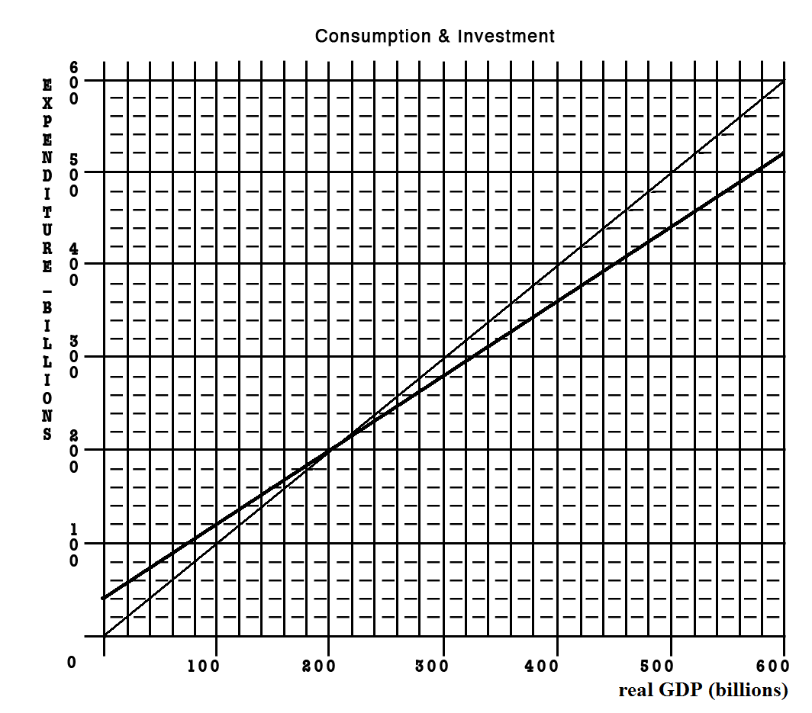
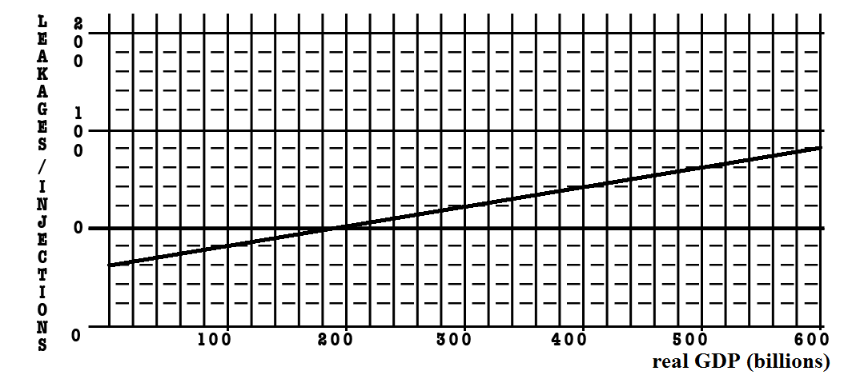

Given the graphs below, calculate the change in government spending that is needed for this economy to achieve full employment.

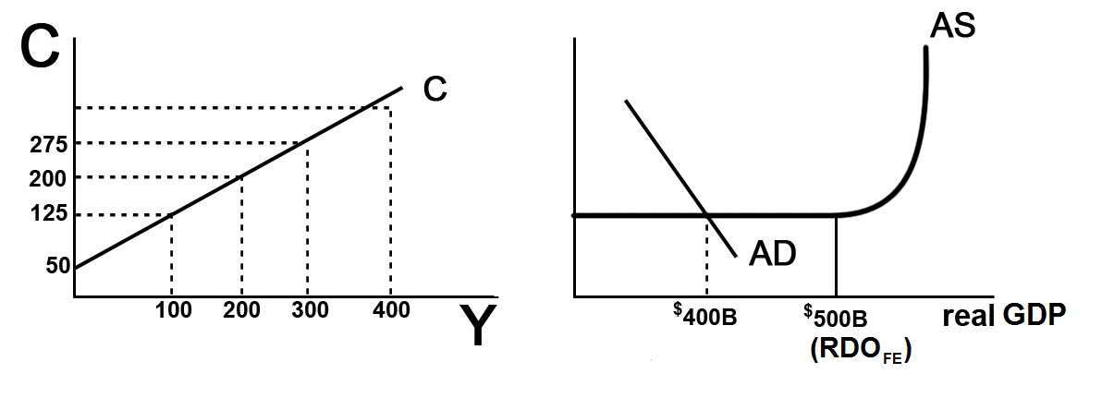
- MPC = ___change in C / change in income = 75/100 = .75___

- MPS = __change in S / change in income - .25/100 = .25_OR MPC+MPS=1__

- initial GDP = __$400_____ full employment GDP = ____$500____

- multiplier = __1/MPS = 1/.25 = 4__

- What change in government spending is needed to achieve full employment?

Change in GDP = change in G x multiplier
100 = change in G x 4
Change in G - $25

- What happens to the size of the multiplier with the addition of Taxes and Imports?

It gets smaller

- What would happen to your answer in #5 if we included Taxes and Imports?

We would need a larger change in government spending

- Notice that as this economy approaches full employment, there is no inflation. What happens to the size of the multiplier if there is inflation?

If there is inflation the multiplier is smaller

- What would happen to your answer in #5 if there was some inflation?

If there is inflation the change in government spending needed to achieve full employment would have to be larger

- What is the lump-sum tax multiplier?
-3;
the lump-sum tax multiplier is always one less than the simple multiplier and negative_
or = -MPC/MPS = _.75/.25 = -3

- What change in taxes is needed to achieve full employment? ________________

Change in GDP = change in taxes x lump-sum tax multiplier
$100 billion = change in taxes x -3
change in taxes = -$33 billion

~~~~~~~~~~~~~~~~~~~~~~~~~~~~~~~~~~~~~~~~~~~~~~~~~~~~~~~~~~~~~~~~~~

If the MPC = .6 and government spending decreases by $100 B, what happens to equilibrium GDP?

Change in GDP = change in spending x multiplier
Multiplier – 1/MPS
MPC + MPS = 1
MPC + MPS = 1
.6 + MPC = 1
MPS = .4
Multiplier = 1/MPS = 1/1-MPC = 1/.4 = 2.5
Change in GDP = change in spending x multiplier
Change in equilibrium GDP = -$100 x 2.5 = - $250

YELLOW PAGE
ECO 212 - Chapters 10 and 13 - Fiscal Policy
REVIEW EXERCISES

Level of output and income  (GDP = DI) | Consumption | Saving | APC | APS | MPC | MPS
$480 | $488 | –$8 | 1.02 | –0.2 | 0.8 | 0.2
520 | 520 | 0 | 1.00 | 0.0 | 0.8 | 0.2
560 | 552 | 8 | 0.99 | 0.1 | 0.8 | 0.2
600 | 584 | 16 | 0.99 | 0.3 | 0.8 | 0.2
640 | 616 | 24 | 0.96 | 0.4 | 0.8 | 0.2
680 | 648 | 32 | 0.95 | 0.5 | 0.8 | 0.2
720 | 680 | 40 | 0.94 | 0.6 | 0.8 | 0.2
760 | 712 | 48 | 0.94 | 0.6 | 0.8 | 0.2
800 | 744 | 56 | 0.93 | 0.7 | 0.8 | 0.2

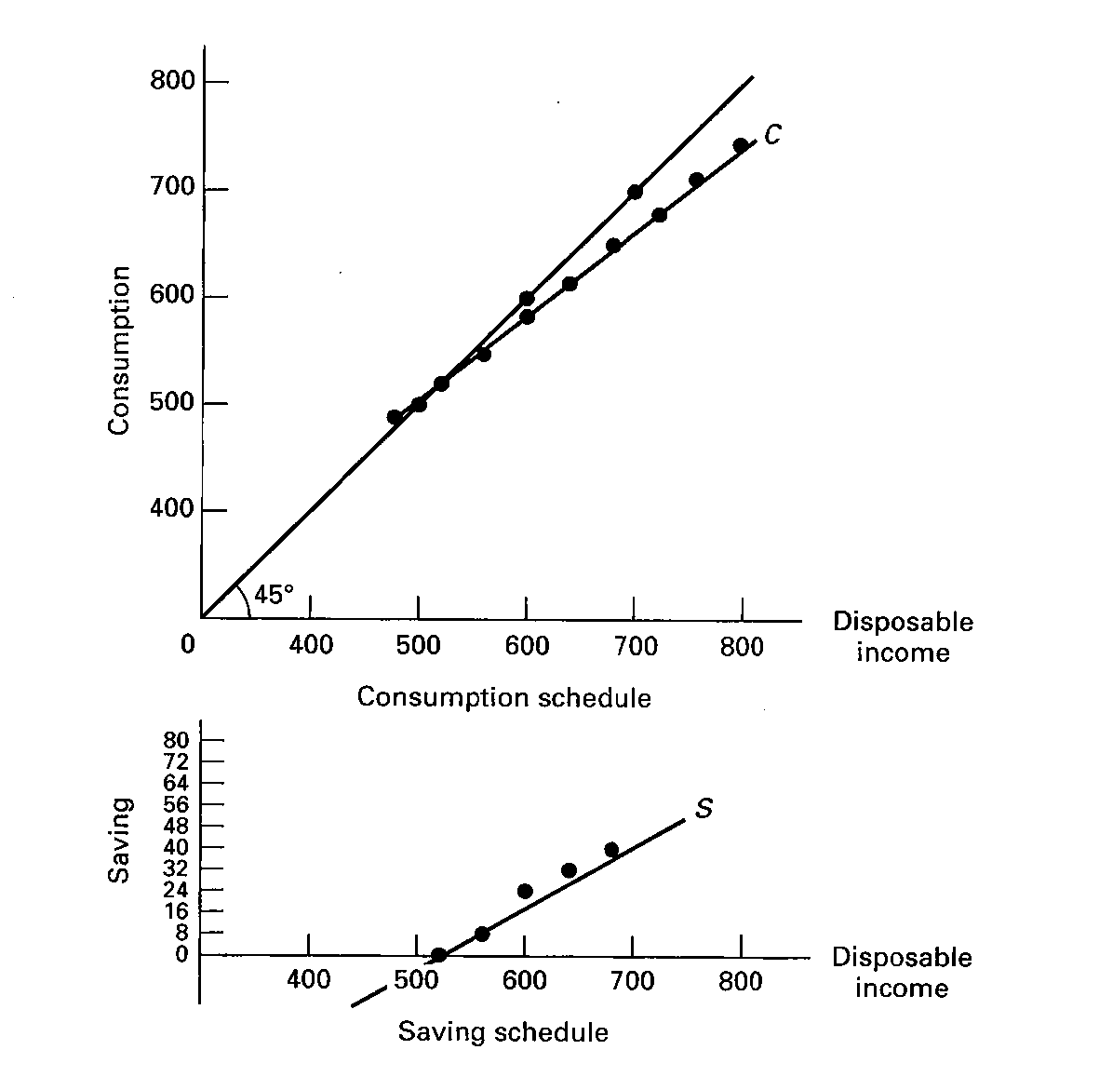

How Banks Create Money
Major Point: An initial increase in funds available to the banking industry results in a MULTIPLE increase in the money supply.
Three Step Process per Round:
- An increase in demand deposits or other liabilities of a bank increases the bank’s reserves.
- Bank can make loans equal to its excess reserves. Loans made by increasing demand deposits.
- The loan check is spent, deposited in a different bank, and CLEARS. First bank now has no excess reserves, but second does and can therefore make a loan.

Given:
Required Reserve Ratio = 20%
FNB = First National Bank
SNB = Second National Bank
TNB = Third National Bank
ER = excess reserves
All banks initially have no excess reserves
Banks make loans equal to their excess reserves
$10 cash is deposited in a checking (DD) account at FNB
Show:
The CHANGES in the balance sheets of each bank as a result of this $10 cash deposit and the increased loan making ability of the banks.
Round One
Step 1: $10 deposited in FNB
Step 2: FNB makes loan equal to its excess reserves

Step 3: Loan is spent, deposited in SNB, and the check clears

Round Two
Step 1: Check from round one deposited in SNB
Step 2: SNB makes loan equal to its excess reserves
Step 3: Loan is spent, deposited in TNB, and the check clears
Round Three
Step 1: Check from round two deposited in TNB
Money Supply Changes:
How much money was created in round one? ____$ 8____
How much money was created in round two? ____$ 6.40_
How much money can be created in round three? ____$ 5.12_
Deposit Expansion Multiplier = 1 / Required Reserve Ratio
(also called Money multiplier)
Money Multiplier = total increase in money supply / initial excess reserves
What is the money multiplier? _____5______
What is the maximum total increase in the money supply that can occur as a result of the initial $10 cash deposit? ____$ 40_____

What are the limitations on this money creation process?
_____1) banks may hold ER _______________________
_____2) people may hold money_________________________
_____3) the required reserve ratio_______________________
Chapter 14 Money Creation Yellow Page Work Sheet Explanation
WORKSHEET
The following worksheet should teach you :
1. How a Cash Deposit at a bank effects:
a. the bank's balance sheet
b. M1 (the money supply) - HINT: there is no effect
2. How Money is Created when a bank grants a loan
a. Know the balance sheet changes when the loan is granted (see below)
b. Know the balance sheet changes when the check is cleared (see below)
3. How much money can be created by the banking system when there is an increase in excess reserves
Banks create money during their normal operations of accepting deposits and making loans. In this example we'll use M1 as our definition of money. (M1 = currency in our pockets and balances in our checking accounts.) When a bank makes a loan it creates money. For example when I got a loan to buy my boat, my credit union called an told me that the loan was approved and that I should come in and get the check. I told them to just deposit it in my checking account. So they did. they turned on their computers, typed in my account number, and added the loan to my checking account balance. I now had more money (M1). The bank created this money when they gave me the loan.
To learn how banks create money during their normal activities of accepting deposits and making loans lets assume that a $10 bill is deposited in the First National Bank (FNB). We will use the balance sheets of banks to see the effects. Our balance sheets will only show the CHANGES made to them. Our study guide has problems where they show actual (but hypothetical) amounts in the bank's T-account.
Major Point: An initial increase in funds available to the banking industry results in a MULTIPLE increase in the money supply.
There is a Three Step Process per Round:
- An increase in demand deposits or other liabilities of a bank increases the bank’s reserves.
- Bank can make loans equal to its excess reserves. Loans made by increasing demand deposits.
- The loan check is spent, deposited in a different bank, and CLEARS. First bank now has no excess reserves, but second does and can therefore make a loan.
Formulas:
Total Reserves = Cash in vault + Deposits at Fed.
Required Reserves = RR x Liabilities
- Liabilities are the Demand Deposits or DD
- RR is the Required Reserve ration set by the Fed
- NOTE: a common error is that students calculate the Required Reserves by: RR x Reserves. DON'T DO THIS!. To calculate the Required Reserves: RR x Liabilities
- total reserves are also called "actual reserves"
Excess Reserves = Total Reserves - Required Reserves
Excess Reserves are used by banks to:
- make loans
- pay back depositors when they remove their funds from their accounts (like write a check)
Change in Money Supply = initial Excess Reserves x Money Multiplier
Money Multiplier = 1 / RR
These two formulas are very important!
Given:
Required Reserve Ratio = 20%
FNB = First National Bank
SNB = Second National Bank
TNB = Third National Bank
ER = excess reserves
DD = Demand Deposits (checking account deposits = liabilities)
All banks initially have no excess reserves
Banks make loans equal to their excess reserves
$10 cash is deposited in a checking (DD) account at FNB
Show:
The CHANGES in the balance sheets of each bank as a result of this $10 cash deposit and the increased loan making ability of the banks.

Round One
Step 1: $10 deposited in FNB
The $10 bill becomes cash in the bank's vault so it becomes part of the bank's reserves. the deposit in the customer's checking account is a liability to the bank. Note that the balance sheet still balances.
Now calculate the changes in the bank's excess reserves:
Total Reserves = cash in vault + Deposits at Fed = 10
Required Reserves = RR x Liabilities = .20 x 10 = 2
Excess Reserves = Total Reserves - Required Reserves = 10 - 2 = 8
Step 2: FNB makes loan equal to its excess reserves
We will assume that when the bank makes a loan for $8 (the amount of its excess reserves above) it credits the borrower's checking account. THIS IS NEWLY CREATED MONEY !
Note that the balance sheet still balances: the $8 loan is an asset to the bank and the $8 credited to the borrower's checking account (DD) is an additional liability.
Now calculate the changes in the bank's excess reserves:
Total Reserves = cash in vault + Deposits at Fed. = 10
Required Reserves = RR x Liabilities = .20 x 18 = 3.60
Excess Reserves = Total Reserves - Required Reserves = 10 - 3.60 = 6.40
You may notice that the FNB still has excess reserves BUT Excess Reserves are used by banks to:
- make loans
- buy government securities AND
- pay back depositors when they remove their funds from their accounts (like write a check)
and since the FNB just made a loan it can figure that the borrower will probably spend it, so they better keep some excess reserves available to pay back depositor's when they remove their funds from their accounts (like write a check)

Step 3: Loan is spent, deposited in SNB, and the check clears
Sure enough, the borrower did spend the loan by writing a check which was deposited in the SNB.
When the check clears, the FNB sends the SNB $8 of its reserves. So the reserves of the FNB go down by $8 to $2, and the reserves at the SNB go up by $8. Since all banks either directly or indirectly have deposits at the Fed, checks can clear rapidly simply by having the fed transfer the funds ($8 from the account of the FNB to the account of the SNB).
Now calculate the changes in the bank's (FNB) excess reserves:
Total Reserves = cash in vault + Deposits at Fed. = 2
Required Reserves = RR x Liabilities = .20 x 10 = 2
Excess Reserves = Total Reserves - Required Reserves = 2 - 2 = 0
(With no more excess reserves, the FNB cannot make any more loans.)
Round Two
Step 1: Check from round one deposited in SNB
Now the SNB has $8 more reserves (this was transferred from the FNB to cover the check from a depositor of that bank.) and therefore $6.40 in additional excess reserves. It also has $8 in additional liabilities, when an $8 check from a customer of the FNB is spent and then deposited in the SNB.
To calculate the changes in the bank's excess reserves:
Total Reserves = cash in vault + Deposits at Fed. = 8
Required Reserves = RR x Liabilities = .20 x 8 = 1.60
Excess Reserves = Total Reserves - Required Reserves = 8 - 1.60 = 6.40
Step 2: SNB makes loan equal to its excess reserves
And the process continues . . . . The SNB can now make a loan equal to its new excess reserves ($6.40). This will be NEW MONEY, increasing the Money Supply.
You may notice that the FNB still has excess reserves BUT Excess Reserves are used by banks to:
- make loans
- buy government securities AND
- pay back depositors when they remove their funds from their accounts (like write a check)
and since the FNB just made a loan it can figure that the borrower will probably spend it, so they better keep some excess reserves available to pay back depositor's when they remove their funds from their accounts (like write a check)
Step 3: Loan is spent, deposited in TNB, and the check clears
The loan is spent and after covering the check (transferring reserves to the bank where the check was deposited - the TNB) the SNB has no additional excess reserves.,
Round Three
Step 1: Check from round two deposited in TNB
But the TNB now has new excess reserves.
The $ 6.40 loan from the SNB was spent and then deposited in the TNB (DD + $6.40). when the check clears the SNB transfers $ 6.40 from its reserves to the TNB. With these new reserves and new liabilities, the TNB now has $5.12 in new excess reserves.
To calculate the changes in the bank's excess reserves:
Total Reserves = cash in vault + Deposits at Fed. = 6.40
Required Reserves = RR x Liabilities = .20 x 6.40 = 1.28
Excess Reserves = Total Reserves - Required Reserves = 6.40 - 1.28 = 5.12
The TNB can now make a loan equal to $5.12. this would be NEW MONEY.
SUMMARY: Money Supply Changes:
1. How much money was created in round one? ____$ 8____
2. How much money was created in round two? ____$ 6.40_
3. How much money can be created in round three? ____$ 5.12_
If the process continued with each additional bank making loans equal to its excess reserves, the maximum possible change in the money supply will be:
Total Change in Money Supply = initial excess reserves X money multiplier
4. What is the money multiplier? _____5______
money multiplier = 1/RR - 1/.2 = 5
5. What is the maximum total increase in the money supply that can occur as a result of the initial $10 cash deposit? ____$ 40_____
Change in the MS = ER x money multiplier = $8 x 5 = $40
6. What are the limitations on this money creation process?
The formula above gives us the MAXIMUM possible change in the money supply. The chapter’s discussion of bank credit is in terms of the maximum money-creating potential that would probably not ever be reached due to these modifications introduced at the end of this chapter:
_____1) banks may hold ER _______________________
_____2) people may hold money_________________________
_____3) the required reserve ratio_______________________
MONEY CREATION -- REVIEW
questions with answers
1. Why are financial institutions required to keep reserves?
ANSWER: Reserves are required to constrain the amount of bank lending (money creation) that can occur. Without required reserves, theoretically banks would have unlimited power to lend and thereby, expand the money supply without any limit.
2. Explain what is meant by fractional reserve banking.
ANSWER: Fractional reserve banking is the system that exists in the United States whereby financial institutions are required to keep only a fraction of their customer deposits in reserve. They may lend out or invest the remainder in qualified securities. This system allows banks to "create" money through the loans that they make.
3. Answer the next question based on the following consolidated balance sheet for the commercial banking system. Assume the required reserve ratio is 30 percent. All figures are in millions of dollars.
ASSETS | LIABILITIES
  Reserves | $200
  Securities | 500
  Loans | 100
  Property | 500
  Deposits | $600
  Capital Stock | 700
(a) What is the amount of excess reserves in this commercial banking system?
(b) What is the maximum amount that the money supply can be expanded?
(c) If the reserve ratio fell to 25 percent, what is now the maximum amount that the money supply can be expanded?
ANSWER:
(a) Required reserves are $600 million x .30 = $180 million. Actual reserves are $200 million, so excess reserves are $20 million.
(b) The monetary multiplier is 1/.3 or 3.33. Maximum expansion of the money supply is $20 million x 3.33, or 66.67 million.
(c) If the reserve ratio was 25%, then excess reserves would be $50 million [$200 million - (.25 x $600 million)]. The monetary multiplier would be 1/.25 or 4, so the maximum expansion of the money supply is $200 million [4 x $50 million].
4. Answer the next question based on the following consolidated balance sheet for the commercial banking system. Assume the required reserve ratio is 20 percent. All figures are in billions of dollars.
ASSETS | LIABILITIES
  Reserves | $60
  Securities | 140
  Loans | 100
  Property | 400
  Deposits | $200
  Capital Stock | 500
(a) What is the amount of excess reserves in this commercial banking system?
(b) What is the maximum amount that the money supply can be expanded?
(c) If the reserve ratio fell to 10 percent, what is now the maximum amount that the money supply can be expanded?
ANSWER:
(a) Required reserves are $200 billion x .20 = $40 billion. Actual reserves are $60 billion, so excess reserves are $20 billion.
(b) The monetary multiplier is 1/.20 or 5. Maximum expansion of the money supply is $20 billion x 5, or $100 billion.
(c) If the reserve ratio was 10%, then excess reserves would be $40 billion [$60 billion - (.10 x $200 billion)]. The monetary multiplier would be 1/.10 or 10, so the maximum expansion of the money supply is $400 billion [10 x $40 billion].

Chapter 16
Review Questions: ANSWERS

1. What are the two types of demand that make up total demand for money?

The first type of demand for money is transaction demand or demand for money as a medium of exchange. Households in part demand money because it is convenient for purchasing goods and services and valuable to have on hand because some purchases are unplanned. The level of nominal GDP is also a determinant of the total transactions demand for money. The larger the monetary value of goods and services in an economy, the larger the transaction demand for money. This increase in demand occurs in both cases when prices rise and real output increases.
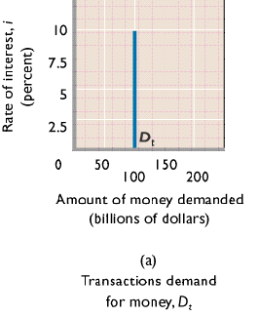

The second type of demand for money is asset demand due to money’s function as a store of value. It’s attractive to hold some of one’s assets as money because it is the most liquid of all assets. Money is also relatively attractive to hold if other assets, like bonds, are expected to decline in value. On the flipside, money receives little or no interest, which can make it less attractive than other assets. Ultimately, what determines asset demand is the interest rate, which is inversely related to money demand.
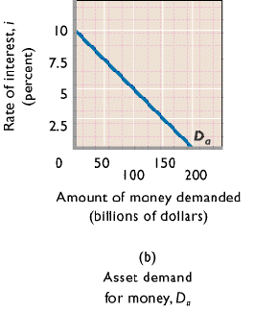

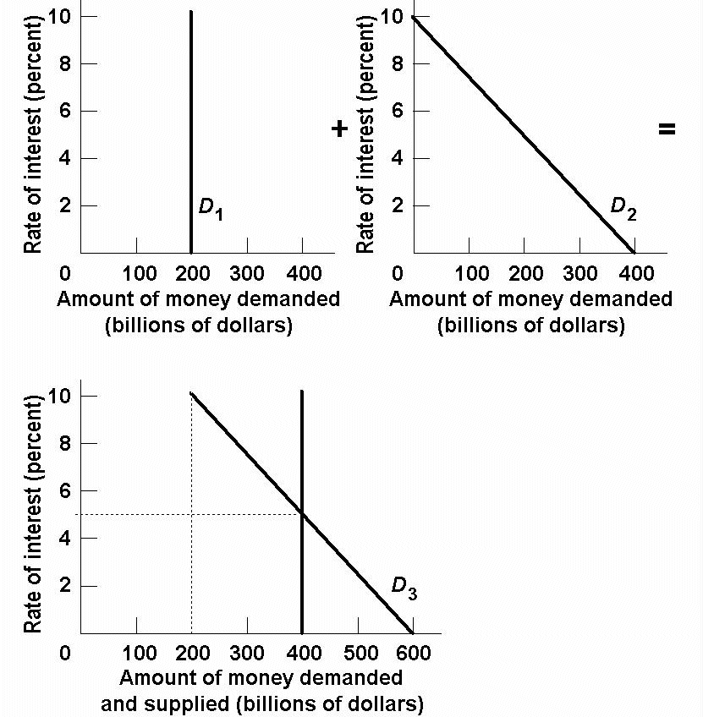

2. Analyze what would happen to the equilibrium rate of interest in the money market if the supply of money were increased while the demand schedule remained the same.

Because the quantity of money demanded is inversely related to the interest rate, an increase in the supply of money would result in a higher equilibrium quantity of money being demanded at a lower equilibrium rate of interest.

3. What are the four principal tools of monetary policy? Explain how they can be used.

ANSWER:
The Federal Reserve Banks use three principal tools (techniques or instruments) to control the reserves of banks and the size of the money supply.
(1) The Federal Reserve can buy or sell government securities in the open market to change the lending ability of the banking system:
(a) buying government securities in the open market from either banks or the public increases the excess reserves of banks;
(b) selling government securities in the open market to either banks or the public decreases the excess reserves of banks.
(2) The Fed can raise or lower the reserve ratio:
(a) raising the reserve ratio decreases the excess reserves of banks and the size of the monetary (checkable-deposit) multiplier;
(b) lowering the reserve ratio increases the excess reserves of banks and the size of the monetary multiplier.
(3) The Fed can also raise or lower the discount rate:
(a) raising the discount rate discourages banks from borrowing reserves from the Fed;
(b) lowering the discount rate encourages banks to borrow from the Fed.
(4) The Federal Reserve uses its term auction facility to make reserves available to banks. The Fed holds two auctions each month since December of 2007. These loans of reserves borrowed by auction-winning banks have the same effect on reserves and the size of the monetary multiplier as the borrowing of reserves at the discount rate:
(a) the Fed can increase banks’ excess reserves and the size of the monetary multiplier by making more funds available through its term auction facility;
(b) The Fed can decrease banks’ excess reserves and the size of the monetary multiplier by reducing the amount of reserves auctioned off every two weeks under the term auction facility.

- Answer the next question based on the following consolidated balance sheet for the commercial banking system. Assume the required reserve ratio is 25%. All figures are in billions of dollars.
Assets | Liabilities + Net Worth
Reserves $100  Securities 200  Loans 100  Property 600 | Checkable deposits $300  Stock shares 700

(a) What is the amount of excess reserves in this commercial banking system?
(b) What is the maximum amount that the money supply can be expanded?
(c) If the reserve ratio fell to 25%, what is now the maximum amount that the money supply can be expanded?

ANSWERS
(a) Required reserves are $300 billion × .25 = $75 billion. Actual reserves are $100 billion, so excess reserves are $25 billion.
(b) The monetary multiplier is 1/.25 or 4. Maximum expansion of the money supply is $25 billion × 4, or $100 billion.
(c) If the reserve ratio was 20%, then excess reserves would be $40 billion [$100 billion – (.20 × $300 billion)]. The monetary multiplier would be 1/.20 or 5, so the maximum expansion of the money supply is $200 billion [5 × $40 billion].

5. What is the difference between the Federal Reserve Banks’ purchases of securities from the commercial banking system and those from the public? Give an example.

Assume that the commercial banks are “loaned up.” Purchases of bonds by the Fed from commercial banks increase actual reserves and excess reserves of the commercial banks by the full amount of the bond purchase. Purchases of bonds by the Fed from the public increase actual reserves, but also increase checkable deposits. Some of the checkable deposits must be kept as legal reserves, so the commercial banking system has fewer excess reserves to lend out. Despite this difference the end result is the same amount of increase in the money supply.
For example, if the Fed buys a $1000 bond from commercial banks, the banks have $1000 in excess reserves to lend. If the reserve ratio is 20%, then the commercial banks can increase the money supply by $5000. If the Fed buys a $1000 bond from the public, then $1000 in checkable deposits is created. The bank can lend the excess reserves, which in this case will be $800 because 20% of $1000 must be kept as legal reserves. The $800 in excess reserves increases the money supply by $4000. Adding this $4000 in bank lending to the $1000 in new checkable deposits results in a total increase in the money supply of $5000.

6. The following are simplified balance sheets for the commercial banking system and the Federal Reserve System. Perform each of the following three transactions, a, b, and c, making appropriate changes in columns (1) through (3) in each balance sheet. Do not cumulate your answers. Also, answer these three questions for each part: (a) What change, if any, took place in the money supply as a direct result of this transaction? (b) What change, if any, occurred in commercial bank reserves? (c) What change occurred in the money-creating potential of the commercial banking system if the reserve ratio is 20%? All figures are in billions of dollars.

(1) Suppose a drop in the discount rate causes commercial banks to borrow an additional $3 billion from the Fed. Show the new sheet figures in column 1.
(2) The Fed buys $2 billion of government bonds from the public. Show the new sheet figures in column 2.
(3) The Fed buys $2 billion of government bonds from commercial banks. Show the new sheet figures in column 3

Consolidated Balance Sheet: Commercial Banking System
 | (1) | (2) | (3)
Assets:  Reserves $ 50  Securities 75  Loans 75  Liabilities:  Checkable deposits 190  Loans from FRBs 10 | ($53)  75  75  190  (13) | ($52)  75  75  (192)  10 | ($52)  (73)  75  190  10

Consolidated Balance Sheet: Federal Reserve Banks
 | (1) | (2) | (3)
Assets:  Securities $90  Loans to CBs 10  Liabilities:  Reserves of CBs 50  Treasury deposits 10  Federal Reserve notes 40 | $90  (13)  (53)  10  40 | ($92)  10  (52)  10  40 | ($92)  10  (52)  10  40

(1) a. No direct change in the money supply; b. bank reserves up by $3 billion; c. money-creating potential up by $15 billion.

(2) a. Money supply up by $2 billion; b. bank reserves up by $2 billion;
c. money-creating potential up by 5 × $1.6 = $8 billion.

(3) a. No direct change in the money supply; b. bank reserves up by $2 billion; c. money-creating potential up by 5 × $2 = $10 billion.

7. Use the graphs below to answer the following questions assuming the nominal GDP in the economy is given.
(a) Look at graph A and suppose the supply of money increases from 100 to 200. What will be the equilibrium rate of interest?

(b) Look at graph B which shows an investment-demand curve for this economy. Given the answer to part (a) above, how much will investors plan to spend on capital goods?

(c) What will happen to aggregate demand?

(d) Now trace what will happen in parts (a)–(c) if the money supply increases to $300.

ANSWERS

(a) 6%
(b) $120
(c) Aggregate demand will increase by a multiple of the increase in investment depending on the size of the multiplier.
(d) 3%; $170; Aggregate demand will increase by a multiple of the decrease in investment depending on the size of the multiplier.

GRAPHS

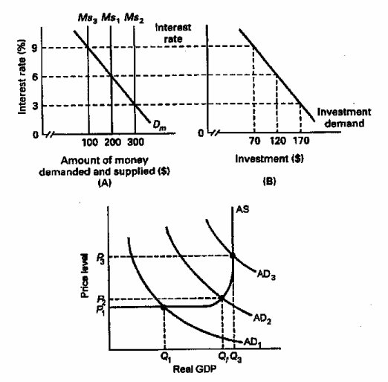
8. Suppose the economy is experiencing inflation. What would be the interpretation of how a restrictive monetary policy would address this problem?

With a restrictive monetary policy, the Federal Reserve sells bonds, raises the reserve ratio, or raises the discount rate. As a consequence of these actions, excess reserves decrease, which in turn decreases the money supply. When this happens, interest rates rise, investment spending decreases and aggregate demand decreases. The end result is a fall in real GDP by a multiple of the decrease in investment

9. Explain two strengths of monetary policy for achieving economic stability.

Monetary policy is relatively speedy and flexible relative to fiscal policy because the decision-making body is smaller and the decisions to change monetary policy can be implemented immediately. A second strength is that monetary policy is largely removed from political pressure since the members of the Board of Governors are appointed to 14-year terms. Unpopular, but necessary, changes can thus be made which might not be possible with fiscal policy where the decision makers are elected officials who may be reluctant to make unpopular decisions.

10. One of the advantages of monetary policy is its speed and flexibility, but there are limitations. Explain.

Monetary policy is not subject to an administration lag because once the decision is made action can be taken quickly. The major timing problems are recognition lags that occur because it sometimes take time to recognize or understand that there is a problem that needs to be addressed by a change in monetary policy. Also, there is an operational lag that occurs between the time that the problem is recognized and the monetary policy takes effect. It may take 3 to 6 months for interest rate changes to have the anticipated effect on the economy.

