FALL 2013

William Rainey Harper College

MACROECONOMICS

IN THE GLOBAL ECONOMY
Fall 2013

YELLOW PAGES
Activities will be done in class. Bring to class every day.

http://www.harpercollege.edu/mhealy/eco212/machome.htm

COURSE DESCRIPTION
Almost every day we hear news reports of economic problems and successes from around the world. All over the world, countries are undertaking economic reforms (often called STRUCTURAL ADJUSTMENT POLICIES) that their leaders believe will provide their citizens with lower unemployment and higher living standards.
This course will cover the area of economics commonly defined as macroeconomics. The main goal of macroeconomics is to gain a better understanding of the causes of, and remedies for, UNEMPLOYMENT and INFLATION, as well as the factors that affect ECONOMIC GROWTH.
We will study these macroeconomic issues in an international context to try to understand the economic reforms many countries are undertaking.

Unit 1 - WHAT IS ECONOMICS and GLOBALIZATION?

Chapter 1 - The 5Es of Economics
- Reading Assignments:
  - Chapter 1 ALL (including the appendix "Graphs and Their Meaning")
  - Ch. 3 Efficient Allocation pp. 58-59
  - Ch. 5: pp. 108-109, "Society's Optimal Amount of Externality Reduction"
  - The online lecture is VERY IMPORTANT: See: The 5Es of Economics" at:
[http://www.harpercollege.edu/mhealy/eco212i/lectures/ch1-18.htm]
- Study Guide
  - Chapter 1:
    - Multiple Choice: #5
    - Problems: # 4, 5
  - Appendix to Chapter 1:
    - Multiple Choice: # 1, 2, 6, 11, 12 15, 16, 17
    - Problems: # 1a, 1b, 2a, 4
  - Chapter 5:
    - Multiple Choice: # 16, 23, 24, 25
    - Problem: # 5
- Worked Problems: 1.1 and 1.2 at http://highered.mcgraw-hill.com/sites/0077337727/student_view0/chapter1/worked_problems.html
- Web Quizzes:
  - Chapter 1 at http://highered.mcgraw-hill.com/sites/0077337727/student_view0/chapter1/quiz.html
  - Chapter 5: # 9 at http://highered.mcgraw-hill.com/sites/0077337735/student_view0/chapter5/quiz.html
- End-of-Chapter Questions and Problems
  - Chapter 1:
    - Questions: 5, 7-11
    - Problems: 1, 3, 4, 5, 7, 8
  - Chapter 1 Appendix: Problems # 1, 2, 7, 8.
Chapter 2 - Economic Systems and Globalization
- Reading Assignments:
  - Chapter 2 ALL
  - PLUS
    - Ch. 2 Last Word: "Shuffling the Deck": p. 42
    - Ch. 8 The Last Word - "Economic Growth in China": p. 166
    - Ch. 8 Global Competition, p. 164
    - Ch. 20 The Last Word - "Petition of the Candlemakers, 1845": p. 419
    - http://www.harpercollege.edu/mhealy/eco212i/lectures/command/econsys.htm
    - Chapter 23W of the 16th edition of our textbook, pages 2-13, found on our Blackboard site:
      - State Ownership and Central Planning: pp. 23W-2 to 23W-3
      - Problems with Central Planning pp. 23W-3 to 23W-5
      - The Collapse of the Soviet Economy pp. 23W-5 to 23W-6
      - The Russian Transition to a Market System pp. 23W-6 to 23W-9
      - Market Reforms in China pp. 23W-10 to 23W-11
      - Outcome and Prospects pp. 23W-11 to 23W-13
      - Conclusion pp. 23W-13
- Study Guide: Chapter 2
  - Multiple Choice: # 1, 2, 3, 6, 7, 9, 11, 12, 13, 19-25
  - Problems: # 1, 4
- Web Quiz: Chapter 2 # 1-9 at http://highered.mcgraw-hill.com/sites/0077337727/student_view0/chapter2/quiz.html
- End-of-Chapter Questions and Problems:
  - Chapter 2: Questions #1, 3, 5, 9, 10, 11, 13
  - Chapter 8 Questions # 1;
  - Chapter 20 Question #15
Chapter 3 - The Efficiency of Markets: Supply and Demand
- Reading Assignments:
  - Chapter 3 pp. 47-61 only
  - Chapter 3 appendix: pp. 69-74
  - PLUS: http://www.harpercollege.edu/mhealy/eco211/lectures/s%26d/sdeff.htm
- Study Guide
  - Chapter 3:
    - Multiple Choice: # 1-28
    - Problems: # 2-6, 8
  - Chapter 3 Appendix:
    - Multiple Choice: # 1-8, 10-15
    - Problems: # 1, 2
- Web Quiz: Chapter 3 ALL questions at http://highered.mcgraw-hill.com/sites/0077337727/student_view0/chapter3/quiz.html
- End-of-Chapter Questions and Problems:
  - Chapter 3:
    - Questions # 1-9
    - Problems # 2, 3, 4
  - Chapter 3 Appendix:
    - Questions # 1, 4-7
    - Problem: # 3
Chapter 20 - TRADE: Specialization and Exchange
- Reading Assignments:
  - Chapter 20: pp 398-407, 411-420
  - "The Mystical Power of Free Trade"
http://www.cnn.com/ALLPOLITICS/time/1999/12/06/free.trade.html
  - "Poor Countries and Trade"
http://news.bbc.co.uk/1/shared/spl/hi/pop_ups/03/business_trade_and_poor_countries/html/1.stm
- Study Guide - Chapter 20
  - Multiple Choice: # 1-12, 18-20, 22-27, 29, 30
  - Problems: # 1 a-d
- Worked Problems 20.1 at http://highered.mcgraw-hill.com/sites/0077337727/student_view0/chapter20/worked_problems.html
- Web Quiz: Chapter 20 # 1, 2, 3, 7, 8, 10 at http://highered.mcgraw-hill.com/sites/0077337727/student_view0/chapter20/quiz.html
- End-of-Chapter Questions and Problems:
Questions # 1, 3, 4, 8-12, 14 Problems 1, 2, 3
Chapter 5 - The Public Sector (Government): Role and Finance (includes parts of chapters 5, 22W, 3, and micro Ch.16)
- Reading Assignments:
  - Chapter 3: Application: Government-Set Prices pp. 61-64
  - Chapter 5: Public Goods; Externalities; Government’s Role in the Economy pp. 99-110
  - “The Role of Government” found in Web Chapter 22W, pp. 12 -13 at: http://highered.mcgraw-hill.com/sites/dl/free/0077337727/883829/mcc37727_ch22W_001_020.pdf
  - Microeconomics Chapter 16, pp 238-246 (Government Finance; Federal Finance; State and Local Finance; Local, State, and Federal Employment; Apportioning the Tax Burden; The VAT). Found on our Blackboard site.
- Study Guide
  - Chapter 3
    - Multiple Choice: # 29, 30
    - Problems # 1, 7
  - Chapter 3 Appendix
    - Multiple Choice: # 9
  - Chapter 5
    - Multiple Choice: # 7, 8, 17-22
    - Problems # 6
- Worked Problems: 16.1 at http://highered.mcgraw-hill.com/sites/0077337735/student_view0/chapter16/worked_problems.html
- Web Quizzes:
  - Chapter 3: #5-6 at http://highered.mcgraw-hill.com/sites/0077337727/student_view0/chapter3/quiz.html
  - Chapter 5: #4-6, 9 at http://highered.mcgraw-hill.com/sites/0077337727/student_view0/chapter5/quiz.html
  - Chapter Micro 16: #1, 2, 3, 5, 7, 9 at http://highered.mcgraw-hill.com/sites/0077337735/student_view0/chapter16/quiz.html
- End-of-Chapter Questions and Problems:
  - Chapter 3: Questions 11, 12; Problem 7
  - Chapter 5: Questions 1, 4, 5, 7, 8, 10

The 5Es of Economics: Fill in the banks.
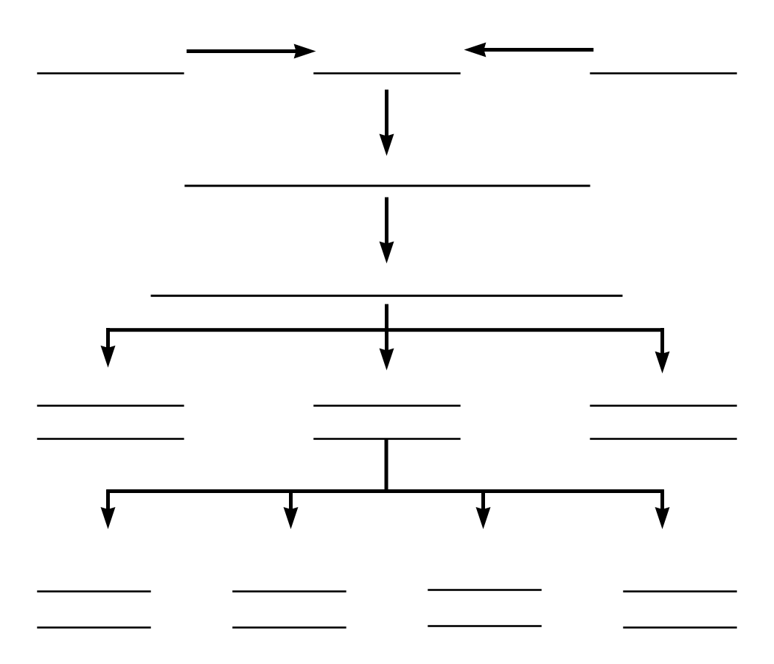

Adapted from Economics: The Options for Dealing with Scarcity by Frank D. Tinari. Scott, Foresman and Company, Glenville, Illinois, 1986

Which of the 5 Es of Economics BEST explains the statements that follow:
1. Economic Growth
2. Allocative Efficiency
3. Productive Efficiency
3a. not using more resources than necessary
3b. using resources where they are best suited
3c. using the appropriate technology
4. Equity
5. Full Employment
- ____ Shortage of Super Bowl Tickets
- ____ Coke lays off 6000 employees and still produces the same amount
- ____ Free trade
- ____ More resources
- ____ Producing more music downloads and fewer CDs
- ____ Law of Diminishing Marginal Utility
- ____ Using all available resources
- ____ Discrimination
- ____ "President Obama Example"
- ____ improved technology
- ____ Due to an economic recession many companies lay off workers
- ____ A "fair" distribution of goods and services
- ____ Food price controls
- ____ Secretaries type letters and truck drivers drive trucks
- ____ Due to government price supports farmers grow too much grain

- ____ Kodak Cuts Jobs - see article below
  - October 24, 2001 Posted: 1728 GMT
[http://edition.cnn.com/2001/BUSINESS/10/24/kodak/index.html
NEW YORK (CNNmoney) -- Eastman Kodak Co. posted a sharp drop in third-quarter profits Wednesday and warned the current quarter won't be much better, adding it will cut up to 4,000 more jobs. . . .Film and photography companies have been struggling with the adjustment to a shift to digital photography as the market for traditional film continues to shrink.

Which of the 5Es explains this news article? Explain.

Not all Lay-offs are Good for Society
WHY ARE THERE LAY-OFFS?
- Productive Efficiency
  - Improved Productive efficiency allows business to produce the SAME AMOUNT OF OUTPUT with fewer workers.
  - These lay-offs are GOOD for society because they reduce scarcity because more products are produced by the laid-off workers in some other company.

- Allocative Efficiency
  - Allocative efficiency means the economy uses its limited resources to produce what people want.
  - Resources are not wasted producing products that people do not want
  - Some lay-offs occur in industries that were producing products that people no longer wanted.
  - These lay-offs are GOOD for society because they reduce scarcity because society gets more utility from its resources.

- Recession (period of high unemployment)
  - Some lay-offs are the result of an economic recession when unemployment rises and people buy fewer products
  - These lay-offs are NOT GOOD for society because they result in MORE SCARCITY because fewer products are produced with society’s resources.
Quick Quiz - Scarcity
1. Economics may best be defined as the:
1. interaction between macro and micro considerations.
2. social science concerned with how individuals, institutions, and society make optimal choices under conditions of scarcity.
3. empirical testing of value judgments through the use of logic.
4. use of policy to refute facts and hypotheses.
2. The study of economics is primarily concerned with:
1. keeping private businesses from losing money.
2. demonstrating that capitalistic economies are superior to socialistic economies.
3. choices that are made in seeking the best use of resources.
4. determining the most equitable distribution of society's output.
3. The economizing problem is:
1. the need to make choices because economic wants exceed economic means.
2. how to distribute resources equally amongst all members of society.
3. that people's means often exceed their wants.
4. that people do not know how to rationally allocate resources.
4. The scarcity problem:
1. persists only because countries have failed to achieve continuous full employment.
2. persists because economic wants exceed available productive resources.
3. has been solved in all industrialized nations.
4. has been eliminated in affluent societies such as the United States and Canada.
5. Productive efficiency refers to:
1. the use of the least-cost method of production.
2. the production of the product-mix most wanted by society.
3. the full employment of all available resources.
4. production at some point inside of the production possibilities curve.
6. Allocative efficiency involves determining:
1. which output-mix will result in the most rapid rate of economic growth.
2. which production possibilities curve reflects the lowest opportunity costs.
3. the mix of output that will maximize society's satisfaction.
4. the optimal rate of technological progress.
7. If an economy produces its most wanted goods but uses outdated production methods, it is:
1. achieving productive efficiency, but not allocative efficiency.
2. achieving allocative efficiency, but not productive efficiency.
3. achieving both productive and allocative efficiency.
4. achieving neither productive nor allocative efficiency.

Resource Quiz
Each of the following is either a/n:
a. consumer good
b. consumer service
c. land
d. capital
e. labor
f. entrepreneur

 | Your answer: |  | Your answer:
medical checkup |  | taxi ride
factory |  | automobile
highway |  | autoworker
candy bar |  | John DeLorean
coal |  | ice cream cone
coke |  | haircut
iron ore |  | waiter
Steve Jobs/Steve Wasnik |  | Ted Turner
forest |  | crude oil
lumber |  | gasoline
class lecture |  | stockings

The Budget Line: A MODEL of an individual's economizing problem:
- Definition: A budget line is a schedule (table) or curve (graph) that shows the various combinations of two products that a consumer can purchase with a specific money income
- Assumptions
  - there are only two goods to purchase (DVDs and books)
  - the amount of income to spend is fixed ( $120 gift card )
  - The goods have prices (DVD's are $20 and books are $10)
Calculate the budget line table and draw the budget line graph
What are the combinations of DVDs and books that you can afford?
______#DVDs______ |  | ______# Books______
0 | and
1 | and
2 | and
3 | and
4 | and
5 | and
6 | and

What happens if income or prices change?
(You must be able to make a new table and budget line graph based on the information given.)
What would happen if income decreases to a $60 gift card (DVD's are $20 and books are $10)
Calculate the budget line table and draw the new budget line graph.

______#DVDs______ |  | ______# Books______
 | and
 | and
 | and
 | and
 | and
 | and
 | and

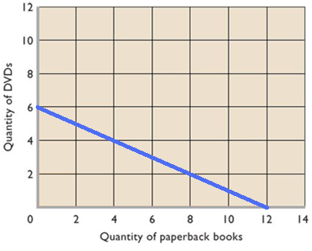

What would happen if price of DVDs increase to $30 (income stays at $120 and books are $10)
Calculate the budget line table and draw the new budget line graph.

______#DVDs______ |  | ______# Books______
 | and
 | and
 | and
 | and
 | and
 | and
 | and

Sketch what would happen if:
- income increases to a $240 gift card ? (DVD's are $20 and books are $10)
- price of DVD decreases to $10 (income stays at $120 and books are $10) ?
- price of books decreases to $5 (income stays at = $120 and DVD's are $20) ?
- price of books increases to $20 (income stays at = $120 and DVD's are $20) ?

a.
b.
c.
d.
Quick Quiz – Budget Lines
1. The budget line shows:
1. the amount of product A that a consumer is willing to give up to obtain one more unit of product B
2. all possible combinations of two goods that can be purchased, given money income and the prices of the goods.
3. the minimum amount of two goods that a consumer can purchase with a given money income.
4. all possible combinations of two goods that yield the same level of utility to the consumer.
2. Use the graph above to answer this question. Suppose you have a money income of $10, all of which you spend on Coke and popcorn. In the above diagram, the prices of Coke and popcorn respectively are:
1. $.50 and $1.00.
2. $1.00 and $.50.
3. $1.00 and $2.00.
4. $.40 and $.50.

3. The shift of the budget line from cd to ab in the above figure is consistent with:
1. decreases in the prices of both M and N.
2. an increase in the price of M and a decrease in the price of N.
3. a decrease in money income.
4. an increase in money income.
4. Any combination of goods lying outside of the budget line:
1. implies that the consumer is not spending all his income.
2. yields less utility than any point on the budget line.
3. yields less utility than any point inside the budget line.
4. is unattainable, given the consumer's income.
5. Suppose Elroy's budget line is as shown on the above diagram. If his tastes change in favor of Coke and against popcorn, the budget line will:
1. become steeper.
2. become flatter.
3. shift rightward.
4. be unaffected.

Production Possibilities: draw the PPC on the graph below
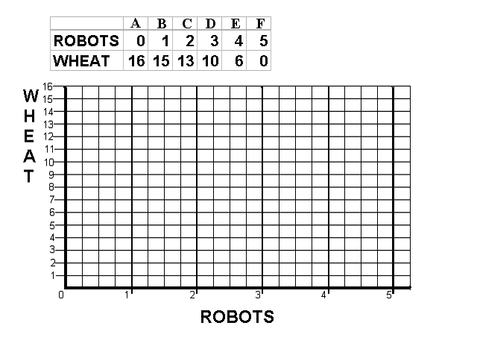
- What does the PPC show?

__________________________________________________________________________________________
__________________________________________________________________________________________

__________________________________________________________________________________________

- What are the assumptions that underlie the PPC?

__________________________________________________________________________________________
__________________________________________________________________________________________

__________________________________________________________________________________________

- Calculate the Opportunity Cost of Producing robots:

the first robot = __________wheat;

second robot = __________wheat;

3rd robot = ________wheat;

4th robot= ________wheat;

5th robot= ________wheat.

- What is the Law of Increasing Costs?

__________________________________________________________________________________________
__________________________________________________________________________________________

__________________________________________________________________________________________

- Explain why the PPC has the shape that it does (concave to the origin).

__________________________________________________________________________________________
__________________________________________________________________________________________

__________________________________________________________________________________________

- What would cause the PPC to be a straight line?

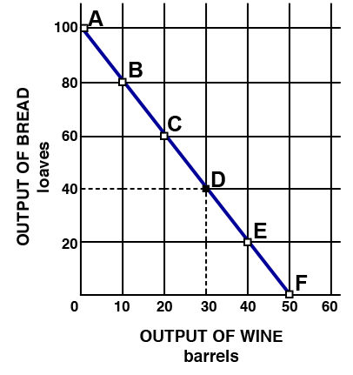

- Mark a point “N” on your production possibilities graph that represents
PRODUCTIVE INEFFICIENCY and/or UNEMPLOYMENT.

- Mark a point “M” that represents a combination of wheat and robots that is
Currently IMPOSSIBLE to produce with given resources and technology.

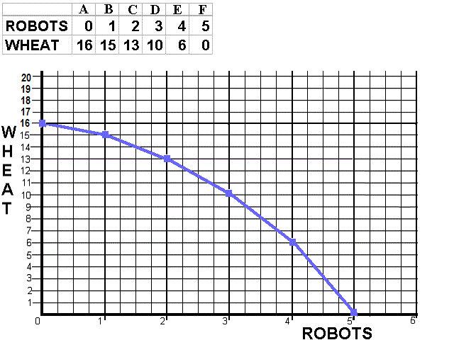

- Explain how the PPC demonstrates that we must make choices.

__________________________________________________________________________________________
__________________________________________________________________________________________

__________________________________________________________________________________________

- Which point A, B, C, D, E, or F is BEST (optimal) for society?

__________________________________________________________________________________________
__________________________________________________________________________________________

__________________________________________________________________________________________

- Define economic growth (the 5Es definition) and explain its causes.

__________________________________________________________________________________________
__________________________________________________________________________________________

__________________________________________________________________________________________

- On the graph below (left) sketch in a new PPC that would represent economic growth.

- On the graph above (right), show what would happen to the PPC if a new wheat seed is invented.

- If we know that robots are Capital goods and wheat is a Consumer good, which combination of robots and wheat, A, B, C, D, E, or F, would result in more growth in the future? Why?

__________________________________________________________________________________________
__________________________________________________________________________________________

__________________________________________________________________________________________

The Production Possibilities Curve can be used to illustrate several important economic concepts:
- we must make choices
- choices have opportunity costs
- the law of increasing costs
- the effect of unemployment
- the effect of productive inefficiency
- the effect of economic growth
- how present choices affect future possibilities
- it does NOT show the optimum product mix (allocative efficiency)
  - later we'll use the MB=MC analysis to do this (see figure 1.3 [p. 13] of your textbook)
Quick Quiz – Production Possibilities
1. Which of the following will not produce an outward shift of the production possibilities curve?
1. an upgrading of the quality of a nation's human resources
2. the reduction of unemployment
3. an increase in the quantity of a society's labor force
4. the improvement of a society's technological knowledge
2. Unemployment:
1. causes the production possibilities curve to shift inward.
2. can exist at any point on a production possibilities curve.
3. is illustrated by a point outside the production possibilities curve.
4. is illustrated by a point inside the production possibilities curve.
3. If the production possibilities curve is a straight line:
1. the two products will sell at the same market prices.
2. economic resources are perfectly substitutable between the production of the two products.
3. the two products are equally important to consumers.
4. equal quantities of the two products will be produced at each possible point on the curve.
4. A production possibilities curve illustrates:
1. the necessity of making choices.
2. market prices.
3. consumer preferences.
4. the distribution of income.
5. The production possibilities curve is:
1. convex to the origin because opportunity costs are constant.
2. linear because opportunity costs are constant.
3. concave to the origin because of increasing opportunity costs.
4. convex to the origin because of increasing opportunity costs.
6. If all discrimination in the United States were eliminated, the economy would:
1. have a less concave production possibilities curve.
2. produce at some point closer to its production possibilities curve.
3. be able to produce at some point outside of its production possibilities curve.
4. shift the production possibilities curve outward.

7. Refer to the above diagram. Other things equal, this economy will achieve the most rapid rate of growth if:
1. it chooses point A.
2. it chooses point B.
3. it chooses point C.
4. it chooses point D.
8. Refer to the above diagram. This economy will experience unemployment if it produces at point:
1. A.
2. B.
3. C.
4. D.
9. Refer to the above production possibilities curve. At the onset of the Second World War the United States had large amounts of idle human and property resources. Its economic adjustment from peacetime to wartime can best be described by the movement from point:
1. c to point b.
2. b to point c.
3. a to point b.
4. c to point d.
10. Refer to the above production possibilities curve. At the onset of the Second World War the Soviet Union was already at full employment. Its economic adjustment from peacetime to wartime can best be described by the movement from point:
1. c to point b.
2. b to point c.
3. a to point b.
4. c to point d.
Answer the next question(s) on the basis of the following production possibilities tables for two countries, North Cantina and South Cantina:
11. Refer to the above tables. If South Cantina is producing at production alternative D, the opportunity cost of the third unit of capital goods will be:
1. 3 units of consumer goods.
2. 4 units of consumer goods.
3. 5 units of consumer goods.
4. 6 units of consumer goods.
12. Refer to the above tables. If North Cantina is producing at production alternative B, the opportunity cost of the eleventh unit of consumer goods will be:
1. 10 units of capital goods.
2. ¹/₄ of a unit of capital goods.
3. 8 units of capital goods.
4. ¹/₈ of a unit of capital goods.
13. Refer to the above diagram. If society is currently producing the combination of bicycles and computers shown by point D, the production of 2 more units of bicycles:
1. cannot be achieved because resources are fully employed.
2. will cost 1 unit of computers.
3. will cost 2 units of computers.
4. will cause some resources to become unemployed.
14. Refer to the above diagram. The combination of computers and bicycles shown by point F:
1. is unattainable, given currently available resources and technology.
2. is attainable, but implies that the economy is not using all its resources.
3. is irrelevant because it is inconsistent with consumer preferences.
4. suggests that opportunity costs are constant.

Benefit Cost Analysis

Definition: The selection of all possible alternatives where the marginal benefits are
greater than the marginal costs.

select ALL possible options up to where MB = MC

this implies ignoring sunk (fixed) costs
select all where: MB > MC
up to where: MB = MC
but never where: MB < MC
Purpose: to make the best decision possible

Example 1 – How many guards should be hired?

# total marginal amount lost total benefit marginal
guards cost cost in shoplifting (amount caught) benefit

0 $ 0 -- $ 1000 $ 0 --

1 $ 200 $ 500 $ 500

2 $ 400 $ 200 $ 800

3 $ 600 $ 50 $ 950

Example 2 - How many bridges should be built?

# total marginal total marginal
bridges cost costs benefits benefits

0 $ 0 -- $ 0 --

1 $ 50 M $ 100 M

2 $ 120 M $ 120 M

3. Multiple Choice Problem
The following data are for a series of increasingly extensive flood control projects:
 |  | Total cost  per year | MC | Total benefit  per year | MB
No project |  | $ 0 | ------------ | $ 0 | ------------
Plan A | levees | 10,000 |  | 20,000
Plan B | small reservoir | 24,000 |  | 34,000
Plan C | medium reservoir | 44,000 |  | 42,000
Plan D | large reservoir | 72,000 |  | 40,000

a. Refer to the above data. For Plan D marginal costs and marginal benefits are:
A. $72,000 and $64,000 respectively.
B. $28,000 and $2,000 respectively.
C. $24,000 and $18,000 respectively.
D. $16,000 and $28,000 respectively.
b. Refer to the above data. On the basis of benefit-cost (marginal) analysis government should:
A. undertake Plan A.
B. undertake Plan B.
C. undertake Plan C.
D. undertake Plan D.
c. Plan C above entails:
A. marginal benefits in excess of marginal costs.
B. fewer spillovers than either Plan A or Plan B.
C. an overallocation (too much) of resources to flood control
D. an underallocation (too little) of resources to flood control.

4. What Happens if the MB > the MC? What happens if the MB< the MC?
__________________________________________________________________________________________
__________________________________________________________________________________________

__________________________________________________________________________________________

__________________________________________________________________________________________
__________________________________________________________________________________________
Quick Quiz – Benefit-Cost Analysis
1. You should decide to go to a movie:
1. if the marginal cost of the movie exceeds its marginal benefit.
2. if the marginal benefit of the movie exceeds its marginal cost.
3. if your income will allow you to buy a ticket.
4. because movies are enjoyable.
2. Even though local newspapers are very inexpensive, people rarely buy more than one of them each day. This fact:
1. is an example of irrational behavior.
2. implies that reading should be taught through phonics rather than the whole language method.
3. contradicts the economic perspective.
4. implies that, for most people, the marginal benefit of reading a second newspaper is less than the marginal cost.
Answer the next question(s) on the basis of the following information for four highway programs of increasing scope. All figures are in millions of dollars.

3. The above data indicate that:
1. the marginal costs and marginal benefits cannot be calculated
2. the marginal cost and marginal benefit of Program B are $6 and $16 respectively.
3. the marginal cost and marginal benefit of Program C are $6 and $5 respectively.
4. the marginal cost and marginal benefit of Program D are $2 and $9 respectively.
4. On the basis of the above data we can say that:
1. Program A is the most efficient on economic grounds.
2. Program B is the most efficient on economic grounds.
3. Program C is the most efficient on economic grounds.
4. Program D is the most efficient on economic grounds.

5. Refer to the above diagram for athletic shoes. The optimal output of shoes is:
1. Q₁.
2. Q₂.
3. Q₃.
4. greater than Q₃.
6. Refer to the above diagram for athletic shoes. If the current output of shoes is Q₁, then:
1. society would consider additional units of shoes to be more valuable than alternative uses of those resources.
2. society would consider additional units of shoes to be less valuable than alternative uses of those resources.
3. society would experience a net loss by producing more shoes.
4. resources are being allocated efficiently to the production of shoes.
7. According to the marginal-cost-marginal-benefit rule:
1. only government projects (as opposed to private projects) should be assessed by comparing marginal costs and marginal benefits.
2. the optimal project size is the one for which MB = MC.
3. the optimal project size is the one for which MB exceeds MC by the greatest amount.
4. project managers should attempt to minimize both MB and MC.
8. The marginal benefit curve is:
1. upsloping because of increasing marginal opportunity costs.
2. upsloping because successive units of a specific product yield less and less extra benefit.
3. downsloping because of increasing marginal opportunity costs.
4. downsloping because successive units of a specific product yield less and less extra benefit.

9. The marginal cost curve is:
1. upsloping because of increasing marginal opportunity costs.
2. upsloping because successive units of a specific product yield less and less extra utility.
3. downsloping because of increasing marginal opportunity costs.
4. downsloping because successive units of a specific product yield less and less extra utility.
10. The output of MP3 players should be:
1. reduced if marginal benefits exceed marginal costs.
2. reduced if marginal costs exceed marginal benefits.
3. increased if marginal costs exceed marginal benefits.
4. reduced to zero if their unit costs exceed the unit costs of alternative products.
Quick Quiz – Economic Systems

1. Which of the following is a distinguishing feature of a command system?
1. private ownership of all capital.
2. central planning.
3. heavy reliance on markets.
4. wide-spread dispersion of economic power.

2. Examples of command economies are:
1. The United States and Japan.
2. Sweden and Norway.
3. Mexico and Brazil.
4. Cuba and North Korea.

3. Economic systems differ according to what two main characteristics?
1. Who owns the factors of production, and the methods used to coordinate economic activity.
2. The technology used in production, and the quantity and quality of natural resources.
3. How goods are produced, and who gets them.
4. The political system in place, and the degree of scarcity facing the economy.

4. Command systems are also known as:
1. market systems.
2. pure capitalism.
3. laissez-faire capitalism.
4. communism.

5. Which of the following is not a characteristic of the market system?
1. private property.
2. freedom of enterprise.
3. government ownership of the major industries.
4. competition in product and resource markets.

6. The regulatory mechanism of the market system is:
1. self-interest.
2. private property.
3. competition.
4. specialization.

7. Economic profits in an industry suggest the industry:
1. can earn more profits by increasing product price.
2. should be larger to better satisfy consumers' desire for the product.
3. has excess production capacity.
4. is the size that consumers want it to be.

8. Two major virtues of the market system are that it:
1. allocates resources efficiently and allows economic freedom.
2. results in an equitable personal distribution of income and always maintains full employment.
3. results in price level stability and a fair personal distribution of income.
4. eliminates discrimination and minimizes environmental pollution.

9. "Consumer sovereignty" means that:
1. buyers can dictate the prices at which goods and services will be purchased.
2. advertising is ineffective because consumers already know what they want.
3. buyers control the quality of goods and services through regulatory agencies.
4. buyers determine what will be produced based on their "dollar votes" for the goods and services offered by sellers.

10. The invisible hand refers to the:
1. fact that the U.S. tax system redistributes income from rich to poor.
2. notion that, under competition, decisions motivated by self-interest promote the social interest.
3. tendency of monopolistic sellers to raise prices above competitive levels.
4. fact that government controls the functioning of the market system.

11. "Because the outputs of many industries are the inputs to other industries, the failure of any single industry to fulfill the output quantities specified in the central plan caused a chain-reaction of adverse repercussions on production." This quotation best identifies the:
1. incentive problem under central planning.
2. self-sufficiency dilemma under communism.
3. resource overcommitment problem under communism.
4. coordination problem under central planning.

12. The incentive problem under communist central planning refers to the idea that:
1. planners had to direct required inputs to each enterprise.
2. workers, managers, and entrepreneurs could not personally gain by responding to shortages or surpluses or by introducing new and improved products.
3. the immediate effect of more investment was less consumption.
4. exports had to be equal to imports for a central plan to work.

13. Innovation lagged in the centrally planned economies because:
1. there was too much domestic business competition.
2. there was too much competition from foreign firms.
3. enterprises resisted innovation in fear that their production targets would be raised.
4. exports had to equal imports for the plan to work.

14. The failure of Soviet central planning was reflected in:
1. a declining growth rate.
2. poor quality goods.
3. the failure to provide promised consumer goods.
D. all of these.
15. Since World War II:
1. North Korea's command economy has significantly outperformed South Korea's market economy.
2. South Korea's command economy has significantly outperformed North Korea's market economy.
3. North Korea's market economy has significantly outperformed South Korea's command economy.
4. South Korea's market economy has significantly outperformed North Korea's command economy.

CHAPTER 3 DEMAND AND SUPPLY

An individual’s demand for Moore’s Pizza:

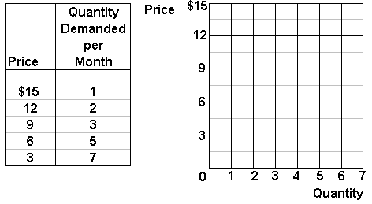
In the graph above, plot this individual’s demand curve for Moore’s pizza.

The supply of Moore’s pizza:

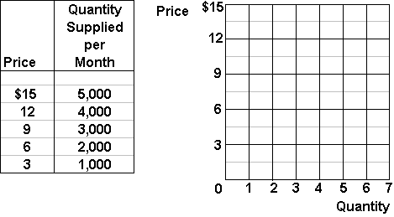1000s
In the graph above, plot the supply curve for Moore’s pizza.

Market Equilibrium:

Assume that there are 1000 people with identical demand curves for Moore’s
Pizza, plot the market demand and supply curves for Moore’s pizza:

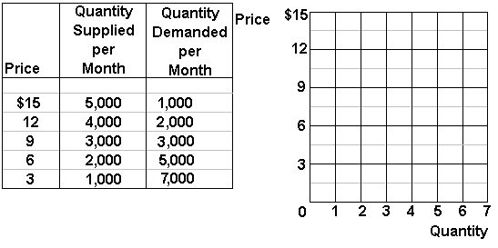1000s

What is the equilibrium price of Moore’s pizza? ___________________

What is the equilibrium quantity? ___________________

Market Disequilibrium:

If Moore charged $12 per pizza:

How many pizzas would be demanded? ____________________

How many pizzas would be supplied? ____________________

There would be a surplus/shortage (circle one) of ________________ pizzas.

If Moore charged $6 per pizza:

How many pizzas would be demanded? ____________________

How many pizzas would be supplied? ____________________

There would be a surplus/shortage (circle one) of ________________ pizzas.

The non-price determinants of demand | The non-price determinants of supply
Pe -- expected price  Pog -- price of other goods  1) substitute goods  2) complementary goods  3) independent goods  I -- income  1) normal goods  2) inferior goods  N -- number of POTENTIAL consumers  T -- tastes and preferences | Pe -- expected price  Pog -- price of other goods produced by same firm  Pres -- price of resources  T --technology  T --taxes and subsidies  N -- number of sellers

Increase in Demand
Decrease in Demand
Increase in Supply
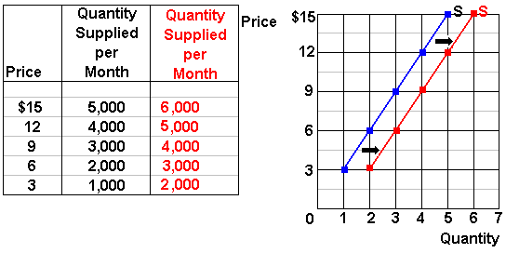
Decrease in Supply

List the Five Non-Price Determinants of Demand:  ______, ______, ______, ______, ______ | List the Six Non-Price Determinants of Supply:  ______, _______, ______, ______, ______, ______
Fill in the blanks with either or  Pe -- expected price  Pe in the future ____D today  Pe in the future ____ D today  Pog -- price of other goods  1) substitute goods  P Maxwell House coffee ____ D Folgers coffee  P of one product ____ D of its substitutes  2) complementary goods  P of wieners ____ D of buns  P of one product ____D of its compliment  I -- income  1) normal goods  Income ____ D for normal goods  Income ____ D for normal goods  2) inferior goods  Income ____ D for inferior goods  Income ____ D for inferior goods  Npot -- number of POTENTIAL consumers  Npot ____ D  Npot ____ D  T -- tastes and preferences  Tastes for a product ____ D for that product  Tastes for a product ____ D for that product | Fill in the blanks with either or  Pe -- expected price  Pe in the future ____ S today  Pe in the future ____ S today  Pog -- price of other goods also produced by the same firm  P soybeans ____ S corn  P soybeans ____ S corn  Pres -- price of resources  P autoworkers wages costs of producing cars ____ S cars  Pres costs ____ S  Pres costs ____ S  Tech --technology  Improved technology costs ____ S  Tax --taxes and subsidies  Taxes costs ____ S  Taxes costs ____ S  Subsidies costs ____ S  Subsidies costs ____ S  N -- number of producers/sellers  Nproducers ____ S  Nproducers ____ S

Non-Price Determinants of Demand  Pe, Pog, I, Npot, T | Non-Price Determinants of Supply  Pe, Pog, Pres, Tech, Tax, Nprod
Pe -- expected price  Pe in the future D today  Pe in the future D today  Pog -- price of other goods  1) substitute goods  P Maxwell House coffee D Folgers coffee P of one product D of its substitute  2) complementary goods  P of wieners D of buns  P of one product D of its compliment  I -- income  1) normal goods  Income D for normal goods  Income D for normal goods  2) inferior goods  Income D for inferior goods  Income D for inferior goods  Npot -- number of POTENTIAL consumers  Npot D  Npot D  T -- tastes and preferences  Tastes for a product D for that product  Tastes for a product D for that product | Pe -- expected price  Pe in the future S today  Pe in the future S today  Pog -- price of other goods also produced by the same firm  P soybeans S corn  P soybeans S corn  Pres -- price of resources  P autoworkers wages costs of producing cars S cars  Pres costs S  Pres costs S  Tech --technology  Improved technology costs S  Tax --taxes and subsidies  Taxes costs S  Taxes costs S  Subsidies costs S  Subsidies costs S  N -- number of producers/sellers  Nproducers S  Nproducers S

Change in Demand vs. Change in Quantity Demanded
Matching: Which of the following tables/graphs shows:

1. a decrease in demand __________
2. a change in quantity demanded ___________
3. an increase in demand _________
A
B
C

Change in Supply vs. Change in Quantity Supplied
Matching: Which of the following tables/graphs shows:
1. a decrease in supply __________
2. a change in quantity supplied ___________
3. an increase in supply _________
A
B
C

INSTRUCTIONS
Use supply and demand curves to illustrate how each of the following changes will affect the price and quantity of the stated product, ceterus paribus.
Before you guess, answer the following questions:
(1) Which determinant has changed?
(2) Will it affect supply or demand?
(3) Will supply or demand increase or decrease?
(4) GRAPH IT! What happens to price and quantity?
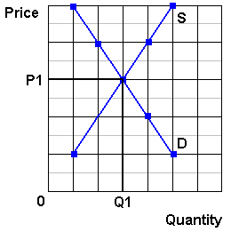
1. Computers  IF: Consumer incomes increase | (1) Which determinant has changed?  (2) Will it affect supply or demand?  (3) Will supply or demand increase or decrease?  (4) GRAPH IT! What happens to price and quantity?

2. Calculators  IF: Improved technology reduces the costs of production | (1) Which determinant has changed?  (2) Will it affect supply or demand?  (3) Will supply or demand increase or decrease?  (4) GRAPH IT! What happens to price and quantity?
3. Sony Play Station  IF: Computer prices drop | (1) Which determinant has changed?  (2) Will it affect supply or demand?  (3) Will supply or demand increase or decrease?  (4) GRAPH IT! What happens to price and quantity? (or maybe)
4. Digital Cameras  IF: Price of memory cards decreases | (1) Which determinant has changed?  (2) Will it affect supply or demand?  (3) Will supply or demand increase or decrease?  (4) GRAPH IT! What happens to price and quantity?
5. Cigarettes  IF: Reduced gov't farm subsidies increase the costs of production | (1) Which determinant has changed?  (2) Will it affect supply or demand?  (3) Will supply or demand increase or decrease?  (4) GRAPH IT! What happens to price and quantity?
6. Coffee  IF: A report links coffee drinking to heart attacks | (1) Which determinant has changed?  (2) Will it affect supply or demand?  (3) Will supply or demand increase or decrease?  (4) GRAPH IT! What happens to price and quantity?
7. Wood furniture  IF: Lumber prices rise | (1) Which determinant has changed?  (2) Will it affect supply or demand?  (3) Will supply or demand increase or decrease?  (4) GRAPH IT! What happens to price and quantity?
8. Steel Furniture  IF: Wood furniture prices increase  OR  IF: lumber prices rise | (1) Which determinant has changed?  (2) Will it affect supply or demand?  (3) Will supply or demand increase or decrease?  (4) GRAPH IT! What happens to price and quantity?
9. Computers  IF: 5 new firms enter the industry | (1) Which determinant has changed?  (2) Will it affect supply or demand?  (3) Will supply or demand increase or decrease?  (4) GRAPH IT! What happens to price and quantity?
10. Cigarettes  IF: Gov't announces a large tax increase will begin in 1 week | (1) Which determinant has changed?  (2) Will it affect supply or demand?  (3) Will supply or demand increase or decrease?  (4) GRAPH IT! What happens to price and quantity?
11. Gasoline  IF: Gasoline taxes increase | (1) Which determinant has changed?  (2) Will it affect supply or demand?  (3) Will supply or demand increase or decrease?  (4) GRAPH IT! What happens to price and quantity?
12. Soybeans  IF: The price of corn rises | (1) Which determinant has changed?  (2) Will it affect supply or demand?  (3) Will supply or demand increase or decrease?  (4) GRAPH IT! What happens to price and quantity?

Read the news article below and circle any determinants of supply and demand that you find. Then follow the instructions at the end of the article.
Global Dairy Demand Drives Up Prices
http://www.npr.org/templates/story/story.php?storyId=14576499
by Emily Harris
September 24, 2007
NPR Morning Edition
Freshly-boxed whipping cream rolls off the conveyor at the Frischli factory in central Germany. Prices of all milk products are rising worldwide, due to what some call a "perfect storm" of low supply and high demand.
. . . . .
If you've been shopping for cheese or milk lately, you may have had to dig a little deeper into your wallet. Dairy prices have been rising fast not just in the U.S., but around the world. Even for a product as local as fresh milk, the global market comes into play.
"Prices are shooting up for virtually every dairy product you care to name," says Chris Horseman of Agra Informa, a company that tracks food commodities.
. . . . .
The Skim-Milk Powder Effect
He sells his milk to a dairy processor, where it's packaged to drink or made into pudding, butter or skim-milk powder an ingredient that is bumping up the price of dairy.
Few people think of skim-milk powder when they look at the sticker price on a gallon at the supermarket. But this powder is used in a wide range of foodstuffs, and its price has shot up to record levels worldwide almost twice as high as last year.
Hans Holtorf, who owns the German dairy manufacturer Frischli, says the powder's price was the first to increase among dairy products.
. . . . .
Fresh milk is still a very local product. It can't be transported very well from Germany or Iowa to China, for example, where demand for dairy products is rising. But powdered milk, cheese and butter can easily be moved around the globe, and as their prices rise, analysts are watching for shifts in production. Agra Informa's Chris Horseman says if a lot of producers chase the high price for milk powder, that could affect the cost of other products.
. . . .
Drought, Affluence Affect Supplies
Agricultural economists say today's milk shortage is basically a case of low supply and high demand worldwide. Supply is down for many reasons. A bad drought in Australia dried up the grass that the country's cows eat. New export taxes were added on Argentina's milk in an attempt to keep the country's food prices under control. Also, European farmers can't significantly increase production until a quota system is phased out eight years from now. The U.S. and Europe always used to have spare dairy products to sell cheaply around the globe, but that's no longer the case, says market expert Erhard Richarts.
. . . . .
"The Chinese per capita consumption is increasing," Henne says. "People get richer in the world. And if people get richer in the world, they like to drink more milk."
Experts say that animal feed prices are rising, partly because biofuel crops are replacing cow fodder. In turn, the high priced animal feed pushes up the cost of milk. But these explanations are trends, not events that clearly explain why dairy prices really shot up in early summer.
Horseman says the rising prices may have temporarily spooked the dairy industry.
"There were certainly elements of panic buying, I suspect, as processors suddenly thought, 'Wow, there is a real possibility that after years and years and years of surpluses, we might not actually have enough milk to meet our needs. So we better make sure that doesn't happen,'" he says.
Production has already started to increase in the U.S., but many market watchers say long-term trends indicate that milk won't be bottoming out again anytime soon.
  - List the non-price determinants of demand and supply.

  - From what you have read what has happened to the PRICE and Quantity of dairy products?

  - Which non-price determinants of demand and/or supply have caused these changes? Explain each determinant and show their effects on a supply and demand graph.

Quick Quiz – Supply and Demand

1. Which diagram above illustrates the effects on the peanut butter market of a higher wage rate for peanut workers?
1) A
2) B
3) C
4) D

2. If peanut butter and grape jelly are complementary products, which diagram above illustrates the effect on the peanut butter market of a decrease in the price of grape jelly?
1) A
2) B
3) C
4) D

3. If peanut butter and cheese spread are substitute products, which diagram above illustrates the effect on the peanut butter market of a decrease in the price of cheese spread?
1) A
2) B
3) C
4) D

4. Which diagram above illustrates the effects on the peanut butter market of a technological advance which reduces the cost of harvesting peanuts?
1) A
2) B
3) C
4) D

5. Refer to the above diagram. A price of $60 in this market will result in:
1. equilibrium.
2. a shortage of 50 units.
3. a surplus of 50 units.
4. a surplus of 100 units.

6. Refer to the above diagram. A price of $20 in this market will result in:
1. a shortage of 50 units.
2. a surplus of 50 units.
3. a surplus of 100 units.
4. a shortage of 100 units.

7. Which of the following will cause a decrease in market equilibrium price and an increase in equilibrium quantity?
1. an increase in supply.
2. an increase in demand.
3. a decrease in supply.
4. a decrease in demand.

8. Other things equal, the provision of a per unit subsidy for a product will:
1. increase its supply.
2. increase its price.
3. decrease the quantity sold.
4. decrease its demand.

9. Which of the following would not shift the demand curve for beef?
1. a widely publicized study that indicates beef increases one's cholesterol
2. a reduction in the price of beef
3. an effective advertising campaign by pork producers
4. a change in the incomes of beef consumers

10. A decrease in the price of digital cameras will:
1. cause the demand curve for memory cards to become vertical.
2. shift the demand curve for memory cards to the right.
3. shift the demand curve for memory cards to the left.
4. not affect the demand for memory cards.
11. An increase in the excise tax on cigarettes raises the price of cigarettes by shifting the:
1. demand curve for cigarettes rightward.
2. demand curve for cigarettes leftward.
3. supply curve for cigarettes rightward.
4. supply curve for cigarettes leftward.
Answer the next question(s) on the basis of the given supply and demand data for wheat:
12. Refer to the above data. Equilibrium price will be:
1. $4.
2. $3.
3. $2.
4. $1.
13. Refer to the above data. If the price in this market was $4:
1. the market would clear; quantity demanded would equal quantity supplied.
2. buyers would want to purchase more wheat than is currently being supplied.
3. farmers would not be able to sell all their wheat.
4. there would be a shortage of wheat.
14. If the supply of a product decreases and the demand for that product simultaneously increases, then equilibrium:
1. price must rise, but equilibrium quantity may rise, fall, or remain unchanged.
2. price must rise and equilibrium quantity must fall.
3. price and equilibrium quantity must both increase.
4. price and equilibrium quantity must both decline.
15. Suppose that in 2007 Ford sold 500,000 Mustangs at an average price of $18,800 per car; in 2008, 600,000 Mustangs were sold at an average price of $19,500 per car. These statements:
1. suggest that the demand for Mustangs decreased between 2007 and 2008.
2. suggest that the supply of Mustangs must have increased between 2007 and 2008.
3. suggest that the demand for Mustangs increased between 2007 and 2008.
4. constitute an exception to the law of demand in that they suggest an upsloping demand curve.

THE EFFICIENCY OF MARKETS - Why are Markets Efficient?
Businesses will produce the profit maximizing quantity. This is the equilibrium quantity where Qd=Qs (see graph below on the left). This is WHAT WE GET.

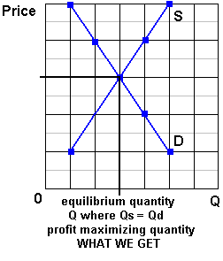 | 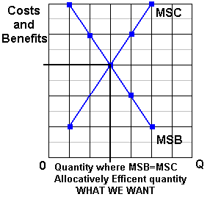
Society wants the allocatively efficient quantity. This is the quantity where MSB=MSC (see graph above on the right). This is WHAT WE WANT.
THEREFORE, If there are no negative externalities (spillover costs) the S = MSC, and if there are no positive externalities (spillover benefits) the D = MSB, WHAT WE GET = WHAT WE WANT and self-interested, profit maximizing, businesses will end up doing what is best for society - achieving allocative efficiency - as if there is some "invisible hand " guiding their decisions.
SUMMARY:
- Businesses will produce the profit maximizing or market equilibrium quantity - the quantity where Qd=Qs; (WHAT WE GET)

- Society wants the allocatively efficient quantity - the quantity where MSB=MSC ; (WHAT WE WANT)

- WHAT WE GET = WHAT WE WANT if:
  - Market Demand = Marginal Social Benefits (D=MSB)
(and this is true if there are no positive externalities [spillover benefits])
  - Market Supply = Marginal Social Costs (S=MSC)
(and this is true if there are no negative externalities [spillover costs))
  - THEREFORE if there are no negative externalities (spillover costs) and no positive externalities (spillover benefits) competitive markets (capitalism) achieves allocative efficiency
WHAT WE GET = WHAT WE WANT
This is the "invisible hand" of capitalism. Even though businesses are not trying to be efficient, when they are selfish and try to maximize their profits, THEY WILL BE EFFICIENT.
In a market economy with no positive externalities (spillover benefits) and no negative externalities (spillover costs):
the profit maximizing or market equilibrium quantity
(what we get)
WILL BE THE SAME AS
the allocative efficient quantity
(what we want)

Read. See questions at end.
The mystical power of free trade
Some people find it hard to believe it really works, but it does
By Michael Kinsley
http://www.cnn.com/ALLPOLITICS/time/1999/12/06/free.trade.html
December 6, 1999 Web posted at: 1:27 p.m. EST (1827 GMT)
Free trade is always a hard sell. In all of social science, the proposition that comes closest to being scientific, in terms of being theoretically provable and true in real life, is that a society benefits from allowing its citizens to buy what they wish--even from foreigners. But people resist this conclusion, sometimes violently, as in Seattle last week. Why?
A couple of reasons. First, the principle of free trade may be true, but it's not obviously true. In fact, it's counterintuitive. If a factory shuts down because of a flood of cheap foreign products, how is that good? If middle-class Americans find themselves competing with foreigners being paid practically nothing and living in squalor, how can this send Americans' standard of living up and not down? If another nation is willing to pollute its air and water in order to produce goods for sale in the global economy, how can America join that economy and still hope to keep its own air and water clean?
There are answers to these questions, but they take a bit of background and a bit of persuading. Students of economics are led step by step through layers of reasoning until the moment they see the light. Skeptics think that the whole routine is like induction into a religious cult and that free trade is more like an article of religious faith than a sound policy recommendation. These skeptics are wrong, but their skepticism is understandable.
The other reason it's hard to sell free trade is that any given example tends to benefit a lot of people in small ways that are hard to identify and tends to harm a few people a lot in ways that are vividly evident. When that factory shuts down, the unemployed workers know they've suffered a loss, and they know why. And it's a big enough loss to stir them politically. It will affect their vote at least, if not cause them to march in the streets.
By contrast, budget-conscious clothes shoppers (maybe those same workers) who are able to save a few bucks on a new sweater are not likely to realize they are enjoying a bargain as a result of global trade or to take to the streets to defend their right to a cheap sweater. Or suppose the U.S. slaps a tariff on foreign sweaters and the foreign country retaliates by raising a tariff on something we're selling them--the people who would lose their jobs aren't even identifiable for sure, though for sure they exist. Likewise the people who lose jobs because shoppers who have to pay more for sweaters have less money to spend on other things.
It's by considering all these things--the risk of losing your job one way minus the risk of losing it another, the extra money you make if your industry is shielded from foreign competition minus the extra money you pay for goods and services that are protected--that you reach the conclusion that on average, free trade benefits us all. Yes, there are various economic theories about circumstances in which all this may not be true, but their authors win prizes precisely because the circumstances are

unusual. In general, the numbers work irrespective of what policies other countries follow. They just get worse if one country's trade restrictions lead other countries to impose more of the same. Trouble is, who's got time for all that math?
Still, a half-century of general prosperity in the U.S. has created a climate of toleration, if not enthusiasm, for the free-trade gospel--mostly, indeed, as a gospel of our civic religion rather than out of anyone's buying the math. Alarm about imports tends to ebb and flow with the economy--less in good times, more in bad. So how, in the best times ever, did the World Trade Organization become the global bogeyman? No earnest college kid ever hitched across the country to carry a picket sign against the General Agreement on Tariffs and Trade, the WTO's predecessor, although its function was similar. It took decades for the CIA, the Trilateral Commission and the Council on Foreign Relations to achieve their places in the pantheon of political paranoia. The WTO has joined them in just four years. And it is despised across the entire political spectrum, whereas these other groups symbolize evil only to one political extreme or the other.
Part of the explanation is the special nature of our current prosperity, which is widening the income gap rather than narrowing it, as in the past. Part is the growth of global economic forces that are actually impinging on national sovereignty, even though it's the paranoid hysterics who say so. But the WTO isn't responsible for either of these trends, both of which are probably inevitable and neither of which undermines the basic case for free trade or for an organization empowered to promote trade through binding arbitration of trade disputes.
Maybe it's the name. If you call yourself the World Trade Organization, you can't complain much if people dial your 800 number and gripe about world trade. If a bunch of heads of government plan a triumphalist self-celebration in Seattle, you can't blame party poopers for showing up to horn in on the publicity. But really, the WTO is O.K. Do the math. Or take it on faith.

Read the article above (especially the highlighted parts) and answer the questions below:

What are the two reasons that the concept of free trade is difficult to accept for many people?

__________________________________________________________________________

__________________________________________________________________________

__________________________________________________________________________

__________________________________________________________________________

Although some people still oppose free trade, and sometimes violently, more people view free trade more favorably now. Why?

__________________________________________________________________________

__________________________________________________________________________

__________________________________________________________________________

QUIZ

Do you think like an economist?
- The purpose of economic activity is:
A. to improve consumer well being
B. to create jobs
- Work is a:
A. cost
B. benefit
- Imports are a
A. benefit
B. cost
- Exports are a
A. cost
B. benefit
- The objective of trade is to
A. get goods cheaply
B. create jobs

From The Wall Street Journal

Assume there is an attorney who is an excellent auto mechanic and his/her car needs repair.
The attorney could fix it in one hour. An auto mechanic could fix it in two hours. (Note: the auto mechanic is not as good at fixing cars, or at doing law, as the attorney.)
Let's say the auto mechanic charges $50 an hour and the attorney charges $200 per hour.
Should the attorney fix the car himself/herself or should they bring it to the auto mechanic?

_______________________________________________________________________

Why?

_________________________________________________________________________________________________________
______________________________________________________________________________
______________________________________________________________________________
______________________________________________________________________________
______________________________________________________________________________
______________________________________________________________________________
______________________________________________________________________________
______________________________________________________________________________
______________________________________________________________________________

Absolute Advantage
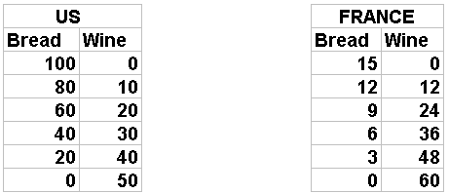
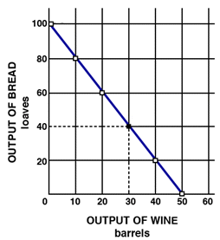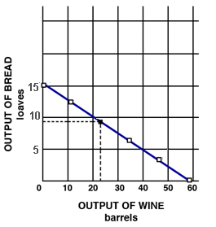
Use the production possibilities curves to answer the following questions. Assume that each country has constant costs and the same size labor force (number of resources).
Assume that before specialization the US is producing 40 bread (B) and 30 wine (W) and France is producing 9B and 24W. Record their production, and the total production, on the table below.
Assume both countries specialize 100% according to their absolute advantage. Record their production, and total production, on the table below.
Now assume they exchange 40 bread for 30 wine. Record the amounts they have now on the table below.
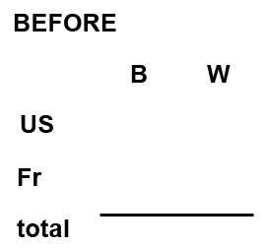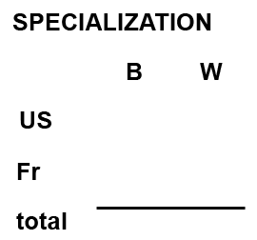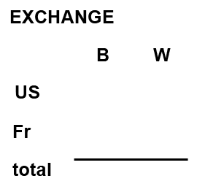
What are the gains from specializing? ____________________ (How much more was produced?)
Indicate on the graphs the quantities that they have after specialization and trade.
Comparative Advantage
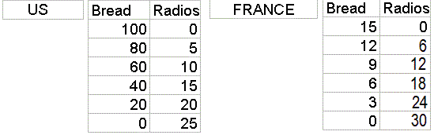
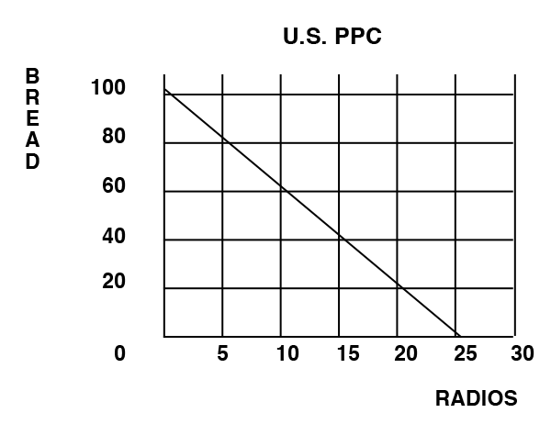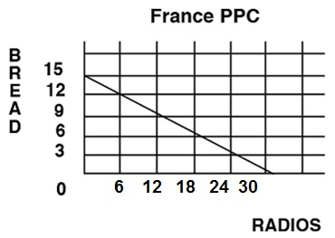
Use the production possibilities curves to answer the following questions. Assume that each country has constant costs and the same size labor force (number of resources).
Assume that before specialization the US is producing 60 bread (B) and 10 radios (R) and France is producing 9 bread and 12 radios. Record their individual production, and the total production, on the table below.
Assume both countries specialize 100% according to their comparative advantage. Record their production, and the total production, on the table below. NOTE: you need to calculate the opportunity costs so that you can find which country has a comparative advantage in which product.
Now assume they exchange 30 bread for 10 radios. Record the amounts they have now on the table below.
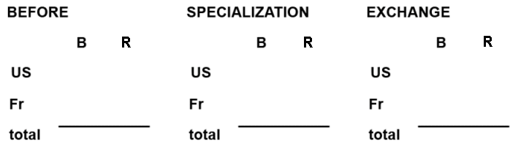
What are the gains from specializing? ____________________ (How much more was produced?)
Indicate on the graphs the quantities that they have after specialization and trade.

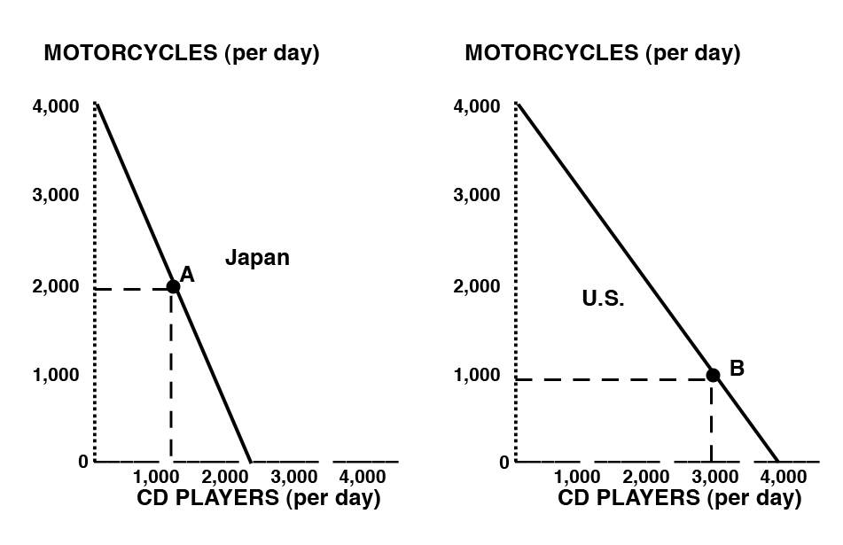
1. Who has a comparative advantage in motorcycles?

2. Who has a comparative advantage in CD players?

3. Assume that before specialization and trade Japan is at point A and the U.S. is at point B. If each country specializes 100% according to their comparative advantage, what are the gains from specialization and trade?

Quick Quiz – Comparative Advantage
1. Refer to the above domestic production possibilities curve for Karalex. The gain to Karalex from specialization and international trade is represented by a move from:
1. A to B.
2. C to A.
3. C to D.
4. B to E.
2. Renee earns $500 per hour in the courtroom as a trial lawyer; she can type up her legal documents at a rate of 80 words per minute. Christopher has no training as a trial lawyer, but can type legal documents at a rate of 50 words per minute for a wage of $30 per hour. Based on the theory of comparative advantage:
1. Renee should do all of her own typing.
2. Renee should specialize in courtroom trials and hire Christopher to type her legal documents.
3. Renee should only hire Christopher if he can raise his typing speed to faster than 80 words per minute.
4. Comparative advantage doesn't apply to this case because it does not involve international trade.

3. The above data would graph as:
1. a straight line for Alpha, but as a concave curve for Omega.
2. a concave curve for Alpha, but as a straight line for Omega.
3. concave curves for both Alpha and Omega.
4. straight lines for both Alpha and Omega

4. Refer to the above data. The domestic opportunity cost of producing 1 ton of steel in Alpha is:
1. ½ ton of wheat.
2. 1 ton of wheat.
3. 15 tons of wheat.
4. 30 tons of wheat.

5. Refer to the above data. The domestic opportunity cost of producing 1 ton of steel in Omega is:
1. ½ ton of wheat.
2. 2 tons of wheat.
3. 3 tons of wheat.
4. 5 tons of wheat.

6. Refer to the above data. Alpha has a comparative advantage in producing:
1. neither steel nor wheat.
2. both steel and wheat.
3. steel.
4. wheat.

7. Refer to the above data. On the basis of the above information:
1. Alpha should export both steel and wheat to Omega.
2. Omega should export both steel and wheat to Alpha.
3. Omega should export steel to Alpha and Alpha should export wheat to Omega.
4. Alpha should export steel to Omega and Omega should export wheat to Alpha.

8. Refer to the above data. If Alpha and Omega each were producing at alternatives B before trade, the gain from specialization and trade would be:
1. 30 tons of wheat.
2. 15 tons of steel.
3. 30 tons of steel and 30 tons of wheat.
4. 60 tons of wheat and 60 tons of steel.
9. According to the concept of comparative advantage, a good should be produced in that nation where:
1. its domestic opportunity cost is greatest.
2. money is used as a medium of exchange.
3. its domestic opportunity cost is least.
4. the terms of trade are maximized.

Should the US use trade restrictions to protect American jobs?
READ:
Could your job go to China?
While U.S. employment leaps ...
September 7, 2001 Posted: 12:07 PM EDT (1607 GMT)
[http://www.cnn.com/2001/CAREER/trends/09/06/china.trade.jobs/index.html]
By Porter Anderson
CNN Career
(CNN) -- Just as Friday's new Labor Department report shows the United States unemployment rate soaring in August to 4.9 percent from 4.6 percent, a newly released, federally funded study reveals that a significant number of production jobs are shifting from the American workplace to China.

Labor Department statistics suggest that U.S. employers cut far more jobs in August than private economists had anticipated -- 113,000 non-farm positions. And this is after American layoffs passed the 1-million mark in July.

But what concerns Stephanie Luce, Ph.D., about her research data is not just her figure of at least 34,900 jobs -- and maybe twice that -- moving from the States to China in a seven-month period as a result of warming Washington-Beijing trade relations.

"What makes it worse," she says, "is that some of these are higher-wage jobs, the type jobs that U.S. cities have been fighting to win. And now they're leaving. Many of those jobs were held by people who'd been working in them for many years, and in some cases their whole lifetimes."

QUESTIONS: AFTER READING, WHAT DO YOU THINK?
Should the US use trade restrictions to protect American jobs?
- What is YOUR answer to this question? YES / NO
- How would most economists answer this question? YES / NO
- According to economic studies which of the following is true for countries that restrict trade?
  - The benefits of trade restrictions are much greater than their costs
  - The costs of trade restrictions are much greater than the benefits

- If YOU answered NO to the first question, how do you reconcile your answer with the news article above? OR what could be done instead of trade restrictions?
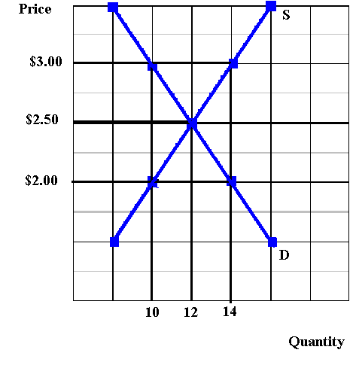
Market Equilibrium Allocative Efficiency (assuming no externalities)
P = ________ P = ________
Q = ________ Q = ________
Price Ceiling Explain the effect of the price ceiling on allocative efficiency:
Ceiling Price = $ 2.00
Qd = ________
Qs = ________
Shortage = ________
Price Floor Explain the effect of the price floor on allocative efficiency:
Floor Price = $ 3.00
Qd = ________
Qs = ________
Surplus = ________

Quick Quiz – Government Set Prices
1. In the above market, economists would call a government-set minimum price of $50 a:
1. price ceiling.
2. price floor.
3. equilibrium price.
4. fair price.
2. In the above market, economists would call a government-set maximum price of $40 a:
1. price ceiling.
2. price floor.
3. equilibrium price.
4. fair price.
3. If government set a minimum price of $50 in the above market, a:
1. shortage of 21 units would occur.
2. shortage of 125 units would occur.
3. surplus of 21 units would occur.
4. surplus of 125 units would occur.
4. If government set a maximum price of $50 in the above market:
1. a shortage of 21 units would arise.
2. a surplus of 21 units would arise.
3. a surplus of 40 units would arise.
4. it would create neither a shortage nor a surplus.

5a
5. Refer to the above diagram. An effective government-set price floor is best illustrated by:
1. price A.
2. price B.
3. price C.
4. quantity E.
6. Refer to the above diagram. Rent controls are best illustrated by:
1. price A.
2. price B.
3. price C.
4. price greater than C
7. A price floor means that:
1. inflation is severe in this particular market.
2. sellers are artificially restricting supply to raise price.
3. government is imposing a maximum legal price that is typically below the equilibrium price.
4. government is imposing a minimum legal price that is typically above the equilibrium price.
8. An effective price floor will:
1. achieve equilibrium.
2. result in a product surplus.
3. result in a product shortage.
4. clear the market.

9. Black markets are associated with:
1. price floors and the resulting product surpluses.
2. price floors and the resulting product shortages.
3. ceiling prices and the resulting product shortages.
4. ceiling prices and the resulting product surpluses.
10. Which of the following is a consequence of rent controls established to keep housing affordable for the poor?
1. Less rental housing is available as prospective landlords find it unprofitable to rent at restricted prices.
2. The quality of rental housing declines as landlords lack the funds and incentive to maintain properties.
3. Apartment buildings are torn down in favor of office buildings, shopping malls, and other buildings where rents are not controlled.
4. All of the above are consequences of rent controls.
Ch. 5 – Market Failures, Government, and the 5 Es

NEGATIVE EXTERNALITIES

Define Negative Externalities (Spillover costs):

Examples of Negative Externalities (Spillover costs):

Use the graph below to answer the questions that follow.

What is the allocatively efficient quantity?

What is the profit maximizing quantity?

Which quantity will be produced without government involvement?

Is there an OVERallocation or an UNDERallocation of resources?
What is the goal of government involvement? [When spillover costs are associated with a product like gasoline what should the government try to do to the QUANTITY -- INCREASE OR DECREASE it?]
What are the possible government policies to achieve this goal?
On your graph show the effect of an increase in the excise tax on gasoline
What happens to the quantity and allocative efficiency when the government taxes a product whose production has negative externalities (spillover costs)?
POSITIVE EXTERNALITIES

Define Positive Externalities (Spillover benefits):

Examples of Positive Externalities (Spillover benefits):

Use the graph below to answer the questions that follow.

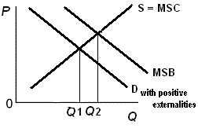

What is the allocatively efficient quantity?

What is the profit maximizing quantity?

Which quantity will be produced without government involvement?

Is there an OVER allocation or an UNDERallocation of resources?

What is the goal of government involvement? [When spillover benefits are associated with a product like education what should the government try to do to the QUANTITY -- INCREASE OR DECREASE it?]

What are the possible government policies to achieve this goal?

On your graph show the effect of an increase supply on the market for education.
What happens to quantity and allocative efficiency when the government subsidizes a product whose production has positive externalities (spillover benefits)?

Quick Quiz - Market Failures, Government, and the 5 Es

1. A pure market economy overallocates resources to the production of goods that:
1. involve negative externalities.
2. involve positive externalities.
3. are public goods.
4. are inexpensive to produce.
2. If a market is competitive but externalities are present, the resulting equilibrium output:
1. will also be the most efficient output.
2. will always be less than the most efficient output.
3. will always be greater than the most efficient output.
4. may be either larger or smaller than the most efficient output.
3. If a good's production creates substantial positive externalities and no negative externalities, then:
1. too much of the good will be produced unless firms are subsidized.
2. too much of the good will be produced unless firms are taxed.
3. too little of the good will be produced unless firms are subsidized.
4. too little of the good will be produced unless firms are taxed.
4. Suppose a product creates substantial negative externalities. If government adopts a policy that forces producers to pay these costs, the:
1. output of the product will decrease.
2. initial misallocation of resources will be intensified.
3. output of the product will increase.
4. price of the product will decrease.
5. The Federal government requires automobile manufacturers to install pollution control equipment. This is an illustration of the:
1. intrusion problem.
2. production of public goods.
3. internalization of external benefits (positive externalities).
4. internalization of external costs (negative externalities).
6. Susie lives in a dorm and likes to play loud music in her room. Her neighbor Kara enjoys the same type of music and gets pleasure from Susie turning up the music. Her other neighbor, Alex, can't stand Susie's music and gets mad when she turns it up for all to hear. When Susie plays her music loudly, she creates:
1. a positive externality for Kara, and a negative externality for Alex.
2. a negative externality for Kara, and a positive externality for Alex.
3. positive externalities for both Kara and Alex.
4. negative externalities for both Kara and Alex.

Government Finance
Federal Government:
_Expenditure Categories Revenue Sources_
|
|
|
|
|
|
|
|
|

State Governments:
_Expenditure Categories Revenue Sources_
|
|
|
|
|
|
|
|
|

Local Governments:
_Expenditure Categories Revenue Sources_
|
|
|
|
|
|
|
|
|
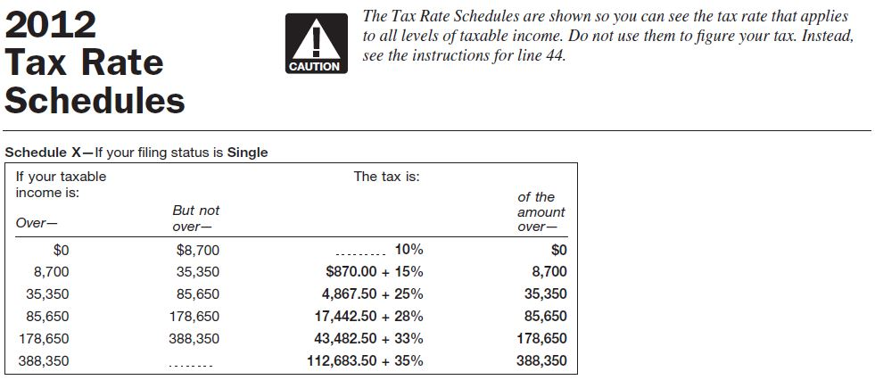
http://www.irs.gov/pub/irs-pdf/i1040tt.pdf
Given the tax rate schedule above, calculate the following.
If the taxable income is $8700
The amount of tax owed: _______

The marginal tax rate: _______

The average tax rate: _______

If the taxable income is $9700
The amount of tax owed: _______

The marginal tax rate: _______

The average tax rate: _______

