William Rainey Harper College

MACROECONOMICS

IN THE GLOBAL ECONOMY
Fall 2009

http://www.harpercollege.edu/mhealy/eco212/machome.htm

COURSE DESCRIPTION
Almost every day we hear news reports of economic problems and successes from around the world. All over the world, countries are undertaking economic reforms (often called STRUCTURAL ADJUSTMENT POLICIES) that their leaders believe will provide their citizens with lower unemployment and higher living standards.
This course will cover the area of economics commonly defined as macroeconomics. The main goal of macroeconomics is to gain a better understanding of the causes of, and remedies for, UNEMPLOYMENT and INFLATION, as well as the factors that affect ECONOMIC GROWTH.
We will study these macroeconomic issues in an international context to try to understand the economic reforms many countries are undertaking.

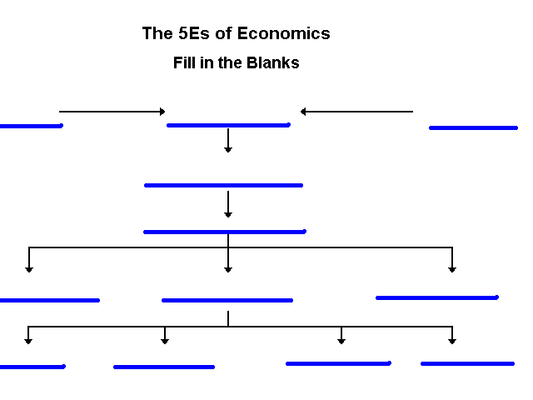

Adapted from Economics: The Options for Dealing with Scarcity by Frank D. Tinari. Scott, Foresman and Company, Glenville, Illinois, 1986

Production Possibilities

- What is the Law of Increasing Costs?
________________________________________________________________

________________________________________________________________
________________________________________________________________

- Calculate the Opportunity Cost of Producing the first robot:

the first robot = __________wheat; second robot = __________wheat;
3rd = ________wheat; 4th = ________wheat; 5th = ________wheat.

- Mark a point “M” on your production possibilities graph that represents
PRODUCTIVE INEFFICIENCY or UNEMPLOYMENT.

Mark a point “M” that represents a combination of wheat and robots that is
Currently IMPOSSIBLE to produce with given resources and technology.

- On the graph above, sketch in a new PPC that would represent economic growth.

5. If we know that robots are Capital goods and wheat is a Consumer good, which
combination of robots and wheat, B,C,D or E, would result I more growth in
the future?

Benefit Cost Analysis

Definition: The selection of all possible alternatives where the marginal benefits are
greater than the marginal costs.

select ALL possible options up to where MB = MC

this implies ignoring sunk costs

Purpose: to make the best decision possible

Example 1 – How many guards should be hired?

# total marginal amount lost total benefit marginal
guards cost cost in shoplifting (amount caught) benefit

0 $ 0 -- $ 1000 $ 0 --

1 $ 200 $ 500 $ 500

2 $ 400 $ 200 $ 800

3 $ 800 $ 50 $ 950

Example 2 - How many bridges should be built?

# total marginal total marginal
bridges cost costs benefits benefits

0 $ 0 -- $ 0 --

1 $ 50 M $ 100 M

2 $ 120 M $ 120 M

CHAPTER 3 Demand and Supply

Quantity Demanded
An individual’s demand for Moore’s Pizza: Price Per Month
$15 1
- 2
- 3
- 5
- 7

Assume that there are 1000 people with identical demand curves for Moore’s
Pizza, plot the market demand curve:

The Supply of Moore’s pizza: Quantity Supplies
Price Per Month
$15 5,000
- 4,000
- 3,000
- 2,000
- 1,000

In the graph above, plot the supply curve for Moore’s pizza.

Market Equilibrium:
What is the equilibrium price of Moore’s pizza? ___________________
What is the equilibrium quantity? ___________________

Market Disequilibrium:
If Moore charged $12 per pizza;
How many pizzas would be demanded? ____________________
How many pizzas would be supplied? ____________________
There would be a surplus/shortage of ________________ pizzas.
If Moore charged $6 per pizza;
How many pizzas would be demanded? ____________________
How many pizzas would be supplied? ____________________
There would be a surplus/shortage of ________________ pizzas.

Consumption and Saving Functions

Y C S APC MPC APS MPS ____________________________________________________________________________________________

0 40 - 40 -- -- --
_ _ _ _ _ _ _ _ _ _ _ _ _ _ _ _ _ _ _ _ _ _ _ _ _ _ _ _ _ _ _ _ _ _ _ _ _ _ _ _ _ _ _ _ _ _ _ _ _ _ _ _ _ _ _ _ _ _ _ _ _

100 120 - 20
_ _ _ _ _ _ _ _ _ _ _ _ _ _ _ _ _ _ _ _ _ _ _ _ _ _ _ _ _ _ _ _ _ _ _ _ _ _ _ _ _ _ _ _ _ _ _ _ _ _ _ _ _ _ _ _ _ _ _ _ _ _

200 200 0
_ _ _ _ _ _ _ _ _ _ _ _ _ _ _ _ _ _ _ _ _ _ _ _ _ _ _ _ _ _ _ _ _ _ _ _ _ _ _ _ _ _ _ _ _ _ _ _ _ _ _ _ _ _ _ _ _ _ _ _ _ _

- 280
_ _ _ _ _ _ _ _ _ _ _ _ _ _ _ _ _ _ _ _ _ _ _ _ _ _ _ _ _ _ _ _ _ _ _ _ _ _ _ _ _ _ _ _ _ _ _ _ _ _ _ _ _ _ _ _ _ _ _ _ _ _

- 380
_ _ _ _ _ _ _ _ _ _ _ _ _ _ _ _ _ _ _ _ _ _ _ _ _ _ _ _ _ _ _ _ _ _ _ _ _ _ _ _ _ _ _ _ _ _ _ _ _ _ _ _ _ _ _ _ _ _ _ _ _ _

- 440
_ _ _ _ _ _ _ _ _ _ _ _ _ _ _ _ _ _ _ _ _ _ _ _ _ _ _ _ _ _ _ _ _ _ _ _ _ _ _ _ _ _ _ _ _ _ _ _ _ _ _ _ _ _ _ _ _ _ _ _ _ _

- 520
_ _ _ _ _ _ _ _ _ _ _ _ _ _ _ _ _ _ _ _ _ _ _ _ _ _ _ _ _ _ _ _ _ _ _ _ _ _ _ _ _ _ _ _ _ _ _ _ _ _ _ _ _ _ _ _ _ _ _ _ _ _

- 600
_ _ _ _ _ _ _ _ _ _ _ _ _ _ _ _ _ _ _ _ _ _ _ _ _ _ _ _ _ _ _ _ _ _ _ _ _ _ _ _ _ _ _ _ _ _ _ _ _ _ _ _ _ _ _ _ _ _ _ _ _ _

Given the graphs below, calculate the change in government spending that is needed for this economy to achieve full employment.

- Change in government spending needed to achieve full employment is _________________________.

- MPC = _____________

- MPS = _____________

- initial GOP = ___________ full employment GOP = ____________

- multiplier = ____________

- What happens to the size of the multiplier with the addition of Taxes and Imports?

- What would happen to your answer in #1 if we included Taxes and Imports?

/tmp/in/input.doc
- Notice that as this economy approaches full employment, there is no inflation. What happens to the size of the multiplier if there is inflation?

- What would happen to your answer in #1 if there was some inflation?

- What is the lump-sum tax multiplier? ___________________

- What change in taxes is needed to achieve full employment? ________________

If the MPC = .6 and government spending decreases by $100 B, what happens to equilibrium GOP?

/tmp/in/input.doc

How Banks Create Money

Major Point: An initial increase in funds available to the banking industry
results in a MULTIPLE increase in the money supply.

Three Step Process per Round:

- An increase in demand deposits or other liabilities of a bank increases
the bank’s reserves.

- Bank can make loans equal to its excess reserves. Loans made by
increasing demand deposits.

- The loan check is spent, deposited in a different bank, and CLEARS.
First bank now has no excess reserves, but second does and can
therefore make a loan.

Given: Required Reserve Ratio = 20%

FNB = First National Bank
SNB = Second National Bank
TNB = Third National Bank

ER = excess reserves
All banks initially have no excess reserves.
Banks make loans equal to their excess reserves.

$10 cash is deposited in a checking (DD) account at FNB.

Show: The CHANGES in the balance sheets of each bank as a result of this $10 cash
deposit and the increased loan making ability of the banks.

Round One

Step 1: $10 deposited in FNB

/tmp/in/input.doc
Money Supply Changes:

How much money was created inn round one? _______________________

How much money was created in round two? ________________________

How much money can be created in round three? _____________________

Deposit Expansion Multiplier = _____________1_____________________
(Also called Money Multiplier) Required Reserve Ratio

Total increase in money supply
Money Multiplier = ___________________________________
Initial increase in excess reserves

What is the money Multiplier? ________________________________

What is the maximum total increase in the
money supply that can occur as a result of
the initial $10 cash deposit? ________________________________

What are the limitations on this money creation process?
___________________________________________________________

___________________________________________________________

___________________________________________________________

/tmp/in/input.doc

