**Price Ceilings and Price Floors (Supports)**

**Price Ceiling Price Floor**

# pceilingyellowans pcflooryellowans

# Market Equilibrium

# P = __$2.50__

# Q = ___12___

# also the allocatively efficient quantity because at Q = 12, MSB=MSC

# Price Ceiling

# Ceiling Price = $ 2.00

# Qd = __14­­___

# Qs = __10____

# Shortage = ___4___ = allocative inefficiency: at the quantity of 10, MSB > MSC, so there is an UNDERallocation of resources

# Price Floor

# Floor Price = $ 3.00

# Qd = ___10­­___

# Qs = ___14___

# Shortage = ____4___ = allocative inefficiency: at the quantity of 14 MSB < MSC, so there is an OVERallocation of resources

**Quick Quiz – Government Set Prices**

 

1. In the above market, economists would call a government-set minimum price of $50 a:   
A. price ceiling.  
**B. price floor.**  
C. equilibrium price.  
D. fair price.

2. In the above market, economists would call a government-set maximum price of $40 a:   
**A. price ceiling.**  
B. price floor.  
C. equilibrium price.  
D. fair price.

3. If government set a minimum price of $50 in the above market, a:   
A. shortage of 21 units would occur.  
B. shortage of 125 units would occur.  
**C. surplus of 21 units would occur.**  
D. surplus of 125 units would occur.

4. If government set a maximum price of $50 in the above market:   
A. a shortage of 21 units would arise.  
B. a surplus of 21 units would arise.  
C. a surplus of 40 units would arise.  
**D. it would create neither a shortage nor a surplus.**



5. Refer to the above diagram. A government-set price floor is best illustrated by:   
A. price A.  
B. price B.  
**C. price C.**  
D. quantity E.

6. Refer to the above diagram. Rent controls are best illustrated by:   
**A. price A.**  
B. price B.  
C. price C.

7. A price floor means that:   
A. inflation is severe in this particular market.  
B. sellers are artificially restricting supply to raise price.  
C. government is imposing a maximum legal price that is typically below the equilibrium price.  
**D. government is imposing a minimum legal price that is typically above the equilibrium price.**

8. An effective price floor will:   
A. achieve equilibrium.  
**B. result in a product surplus.**  
C. result in a product shortage.  
D. clear the market.

9. Black markets are associated with:   
A. price floors and the resulting product surpluses.  
B. price floors and the resulting product shortages.  
**C. ceiling prices and the resulting product shortages.**  
D. ceiling prices and the resulting product surpluses.

10. Which of the following is a consequence of rent controls established to keep housing affordable for the poor?   
A. Less rental housing is available as prospective landlords find it unprofitable to rent at restricted prices.  
B. The quality of rental housing declines as landlords lack the funds and incentive to maintain properties.  
C. Apartment buildings are torn down in favor of office buildings, shopping malls, and other buildings where rents are not controlled.  
**D. All of the above are consequences of rent controls.**

READ: Chapter 3: Application: Government Set Prices pp. 59-62

**PRICE CEILING**

* A PRICE CEILING is a government set maximum price.
* The purpose of a price ceiling is to lower the price
* Examples include:
  + World War II price controls
  + New York City rent controls
  + anti-price gouging laws (plywood after a hurricane)
  + food price controls in LDCs
* Therefore, an EFECTIVE PRICE CEILING must be set below the equilibrium or at a price of $2.00 on the graph below
  + At a price of $2.00 the quantity supplied is 10, but the quantity demanded is 14
  + An effective price ceiling will create a shortage of 4, therefore causing Allocative inefficiency

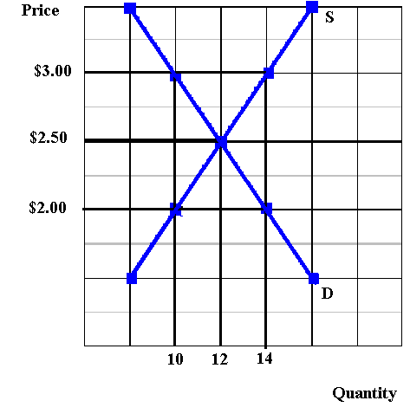

* But what if they set the price ceiling at $3.00 on the graph above?
  + Nothing would change
  + The profit maximizing price (i.e. the equilibrium price) is $2.50. This is the price that will be charged to make the greatest profits.
  + If the government said that businesses can charge less than $3.00 but they cannot charge any price over $3.00 nothing would change because businesses would still charge the profit maximizing price of $2.50

**PRICE FLOOR**

* A PRICE FLOOR is a government set minimum price.
* Also called a “price support”
* The purpose of a price floor is to raise the price
* Examples include:
  + agricultural price supports
  + the minimum wage
* Therefore, an EFECTIVE PRICE FLOOR must be set above the equilibrium or at a price of $3.00 on the graph below
  + At a price of $3.00 the quantity supplied is 14, but the quantity demanded is 10
  + An effective price floor will create a surplus of 4, therefore causing Allocative inefficiency



* But what if they set the price floor at $2.00 on the graph above?
  + Nothing would change
  + The profit maximizing price (i.e. the equilibrium price) is $2.50. This is the price that will be charged to make the greatest profits.
  + If the government said that business can charge more than $2.00 but they cannot charge any price less than $2.00, nothing would change because business would still charge the profit maximizing price of $2.50