**Absolute Advantage**

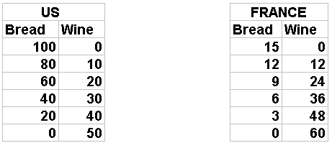

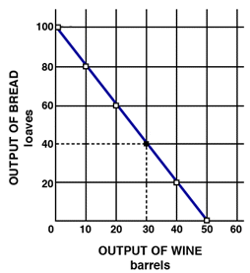 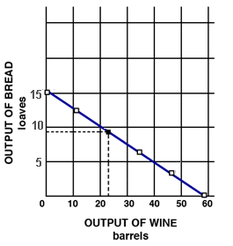

**Use the production possibilities curves to answer the following questions. Assume that each country has constant costs and the same size labor force (number of resources).**

Assume that **before** specialization the US is producing 40 bread (B) and 30 wine (W) and France is producing 9B and 24W. Record their production, and the total production, on the table below.

Who has an absolute advantage in Bread? __________ Wine? ____________

Assume both countries **specialize** 100% according to their **absolute advantage**. Record their production, and total production, on the table below.

Now assume they **exchange** 40 bread for 30 wine. Record the amounts they have now on the table below.

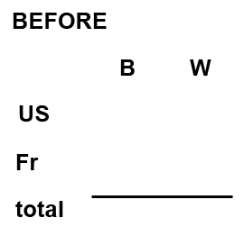 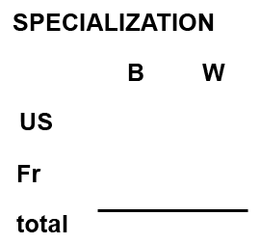 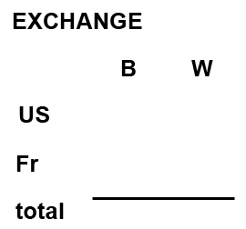

What are the gains from specializing? ____________________ (How much more was produced?)  
Indicate on the graphs the quantities that they have after specialization and trade.

**Comparative Advantage**

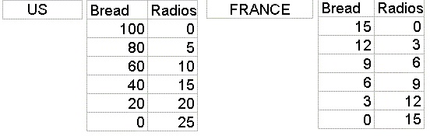

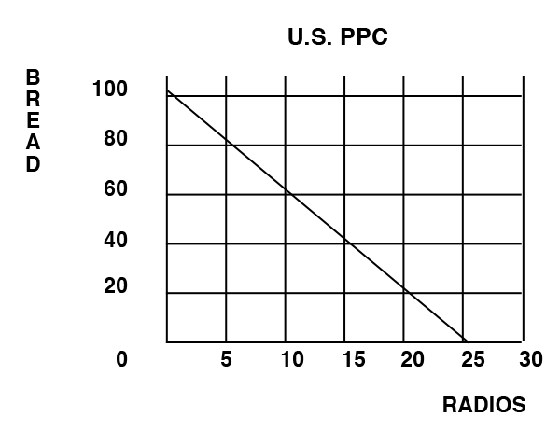 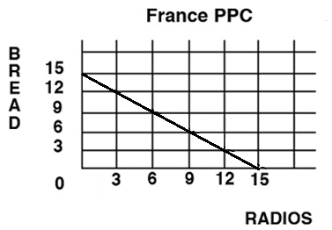

**Use the production possibilities curves to answer the following questions. Assume that each country has constant costs and the same size labor force (number of resources).**

Assume that **before** specialization the US is producing 60 bread (B) and 10 radios (R) and France is producing 12 bread and 3 radios. Record their individual production, and the total production, on the table below.

Who has an absolute advantage in Bread? __________ Radios? ____________

Assume both countries **specialize** 100% according to their **comparative advantage**. Record their production, and the total production, on the table below. NOTE: you need to calculate the opportunity costs so that you can find which country has a comparative advantage in which product.

Now assume they **exchange** 30 bread for 10 radios. Record the amounts they have now on the table below.

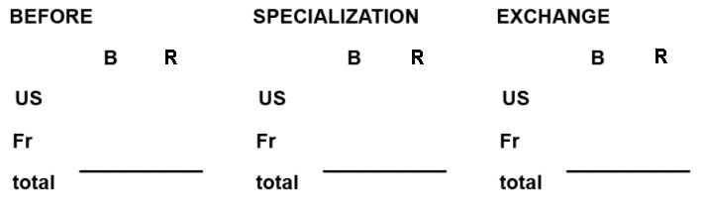

What are the gains from specializing? ____________________ (How much more was produced?)

Indicate on the graphs the quantities that they have after specialization and trade.