Chapter 14
Review Questions: ANSWERS

1. What are the two types of demand that make up total demand for money?

The first type of demand for money is transaction demand or demand for money as a medium of exchange. Households in part demand money because it is convenient for purchasing goods and services and valuable to have on hand because some purchases are unplanned. The level of nominal GDP is also a determinant of the total transactions demand for money. The larger the monetary value of goods and services in an economy, the larger the transaction demand for money. This increase in demand occurs in both cases when prices rise and real output increases.
The second type of demand for money is asset demand due to money’s function as a store of value. It’s attractive to hold some of one’s assets as money because it is the most liquid of all assets. Money is also relatively attractive to hold if other assets, like bonds, are expected to decline in value. On the flipside, money receives little or no interest, which can make it less attractive than other assets. Ultimately, what determines asset demand is the interest rate, which is inversely related to money demand. [text: E p. 259; MA p. 259]

2. Analyze what would happen to the equilibrium rate of interest in the money market if the supply of money were increased while the demand schedule remained the same.

Because the quantity of money demanded is inversely related to the interest rate, an increase in the supply of money would result in a higher equilibrium quantity of money being demanded at a lower equilibrium rate of interest. [text: E pp. 259-261; MA pp. 259-261]

3. What are the three principal tools of monetary policy? Explain how they can be used.

The Federal Reserve Banks use three principal tools (techniques or instruments) to control the reserves of banks and the size of the money supply. (1) The Federal Reserve can buy or sell government securities in the open market to change the lending ability of the banking system: (a) buying government securities in the open market from either banks or the public increases the excess reserves of banks; (b) selling government securities in the open market to either banks or the public decreases the excess reserves of banks. (2) The Fed can raise or lower the reserve ratio: (a) raising the reserve ratio decreases the excess reserves of banks and the size of the monetary (checkable-deposit) multiplier; (b) lowering the reserve ratio increases the excess reserves of banks and the size of the monetary multiplier. (3) The Fed can also raise or lower the discount rate: (a) raising the discount rate discourages banks from borrowing reserves from the Fed; (b) lowering the discount rate encourages banks to borrow from the Fed. [text: E pp. 263-267; MA pp. 263-267]

4. Answer the next question based on the following consolidated balance sheet for the commercial banking system. Assume the required reserve ratio is 25%. All figures are in billions of dollars.
Assets | Liabilities + Net Worth
Reserves $100  Securities 200  Loans 100  Property 600 | Checkable deposits $300  Stock shares 700

(a) What is the amount of excess reserves in this commercial banking system?
(b) What is the maximum amount that the money supply can be expanded?
(c) If the reserve ratio fell to 25%, what is now the maximum amount that the money supply can be expanded?

(a) Required reserves are $300 billion × .25 = $75 billion. Actual reserves are $100 billion, so excess reserves are $25 billion.
(b) The monetary multiplier is 1/.25 or 4. Maximum expansion of the money supply is $25 billion × 4, or $100 billion.
(c) If the reserve ratio was 20%, then excess reserves would be $40 billion [$100 billion – (.20 × $300 billion)]. The monetary multiplier would be 1/.20 or 5, so the maximum expansion of the money supply is $200 billion [5 × $40 billion].
[text: E pp. 252-254; E pp. 252-254]

5. What is the difference between the Federal Reserve Banks’ purchases of securities from the commercial banking system and those from the public? Give an example.

Assume that the commercial banks are “loaned up.” Purchases of bonds by the Fed from commercial banks increase actual reserves and excess reserves of the commercial banks by the full amount of the bond purchase. Purchases of bonds by the Fed from the public increase actual reserves, but also increase checkable deposits. Some of the checkable deposits must be kept as legal reserves, so the commercial banking system has fewer excess reserves to lend out. Despite this difference the end result is the same amount of increase in the money supply.
For example, if the Fed buys a $1000 bond from commercial banks, the banks have $1000 in excess reserves to lend. If the reserve ratio is 20%, then the commercial banks can increase the money supply by $5000. If the Fed buys a $1000 bond from the public, then $1000 in checkable deposits is created. The bank can lend the excess reserves, which in this case will be $800 because 20% of $1000 must be kept as legal reserves. The $800 in excess reserves increases the money supply by $4000. Adding this $4000 in bank lending to the $1000 in new checkable deposits results in a total increase in the money supply of $5000. [text: E pp. 263-264; pp. 263-264]

6. The following are simplified balance sheets for the commercial banking system and the Federal Reserve System. Perform each of the following three transactions, a, b, and c, making appropriate changes in columns (1) through (3) in each balance sheet. Do not cumulate your answers. Also, answer these three questions for each part: (a) What change, if any, took place in the money supply as a direct result of this transaction? (b) What change, if any, occurred in commercial bank reserves? (c) What change occurred in the money-creating potential of the commercial banking system if the reserve ratio is 20%? All figures are in billions of dollars.
Consolidated Balance Sheet: Commercial Banking System
 | (1) | (2) | (3)
Assets:  Reserves $ 50  Securities 75  Loans 75  Liabilities:  Checkable deposits 190  Loans from FRBs 10 | $_____  _____  _____  _____  _____ | $_____  _____  _____  _____  _____ | $_____  _____  _____  _____  _____

Consolidated Balance Sheet: Federal Reserve Banks
 | (1) | (2) | (3)
Assets:  Securities $90  Loans to CBs 10  Liabilities:  Reserves of CBs 50  Treasury deposits 10  Federal Reserve notes 10 | $_____  _____  _____  _____  _____ | $_____  _____  _____  _____  _____ | $_____  _____  _____  _____  _____

(a) Suppose a drop in the discount rate causes commercial banks to borrow an additional $3 billion from the Fed. Show the new sheet figures in column 1.
(b) The Fed buys $2 billion of government bonds from the public. Show the new sheet figures in column 2.
(c) The Treasury spends $1 billion on research on new farm products. Show the new sheet figures in column 3.

Consolidated Balance Sheet: Commercial Banking System
 | (1) | (2) | (3)
Assets:  Reserves $ 50  Securities 75  Loans 75  Liabilities:  Checkable deposits 190  Loans from FRBs 10 | ($53)  75  75  190  (13) | ($52)  75  75  (192)  10 | ($51)  75  75  (191)  10

Consolidated Balance Sheet: Federal Reserve Banks
 | (1) | (2) | (3)
Assets:  Securities $90  Loans to CBs 10  Liabilities:  Reserves of CBs 50  Treasury deposits 10  Federal Reserve notes 10 | $90  (13)  (53)  10  40 | ($92)  10  (52)  10  40 | $90  10  (51)  (9)  40

(a) No direct change in the money supply; bank reserves up by $3 billion; money-creating potential up by $15 billion.
(b) Money supply up by $2 billion; bank reserves up by $2 billion; money-creating potential up by 5 × $1.6 = $8 billion.

(c) Money supply up by $1 billion; bank reserves up by $1 billion; money-creating potential up by 5 times $.8 = $4 billion.
[text: E pp. 263-267; MA pp. 263-267]

7. Use the below graphs to answer the following questions assuming the nominal GDP in the economy is given.
(a) Look at graph A and suppose the supply of money increases from 100 to 200. What will be the equilibrium rate of interest?
(b) Look at graph B which shows an investment-demand curve for this economy. Given the answer to part (a) above, how much will investors plan to spend on capital goods?
(c) What will happen to aggregate demand?
(d) Now trace what will happen in parts (a)–(c) if the money supply increases to $300.

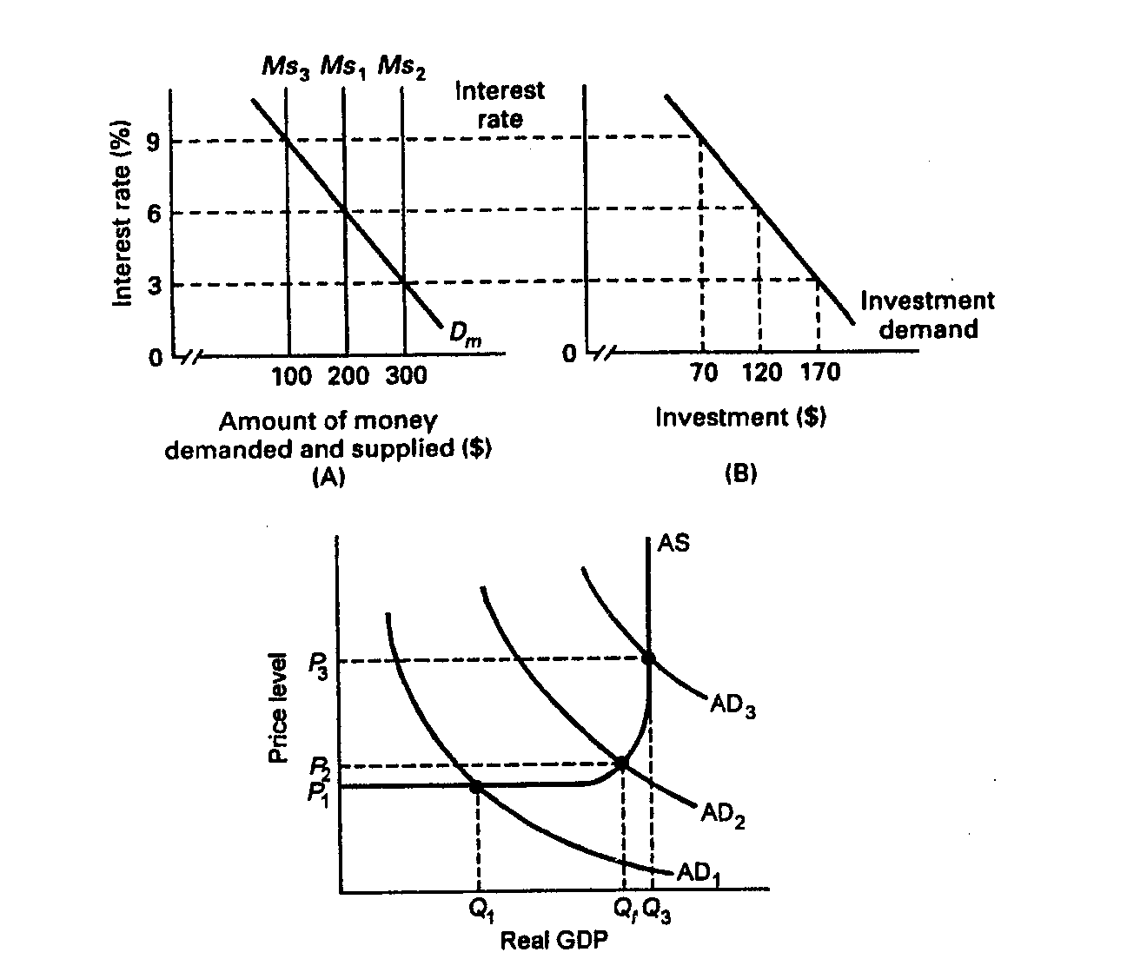

(a) 6%
(b) $120
(c) Aggregate demand will increase by a multiple of the increase in investment depending on the size of the multiplier.
(d) 3%; $170; Aggregate demand will increase by a multiple of the decrease in investment depending on the size of the multiplier.
[text: E pp. 271-273; MA pp. 271-273]

8. Suppose the economy is experiencing inflation. What would be the interpretation of how a restrictive monetary policy would address this problem?

With a restrictive monetary policy, the Federal Reserve sells bonds, raises the reserve ratio, or raises the discount rate. As a consequence of these actions, excess reserves decrease, which in turn decreases the money supply. When this happens, interest rates rise, investment spending decreases and aggregate demand decreases. The end result is a fall in real GDP by a multiple of the decrease in investment. [text: E p. 273; MA p. 273]

9. Explain two strengths of monetary policy for achieving economic stability.

Monetary policy is relatively speedy and flexible relative to fiscal policy because the decision-making body is smaller and the decisions to change monetary policy can be implemented immediately. A second strength is that monetary policy is largely removed from political pressure since the members of the Board of Governors are appointed to 14-year terms. Unpopular, but necessary, changes can thus be made which might not be possible with fiscal policy where the decision makers are elected officials who may be reluctant to make unpopular decisions. [text: E p. 274; MA p. 274]

10. One of the advantages of monetary policy is its speed and flexibility, but there are limitations. Explain.

Monetary policy is not subject to an administration lag because once the decision is made action can be taken quickly. The major timing problems are recognition lags that occur because it sometimes take time to recognize or understand that there is a problem that needs to be addressed by a change in monetary policy. Also, there is an operational lag that occurs between the time that the problem is recognized and the monetary policy takes effect. It may take 3 to 6 months for interest rate changes to have the anticipated effect on the economy. [text: E p. 274; MA p. 274]

