Spring 2013



ECO 211 – Microeconomics

Yellow Pages

ANSWERS

Unit 1

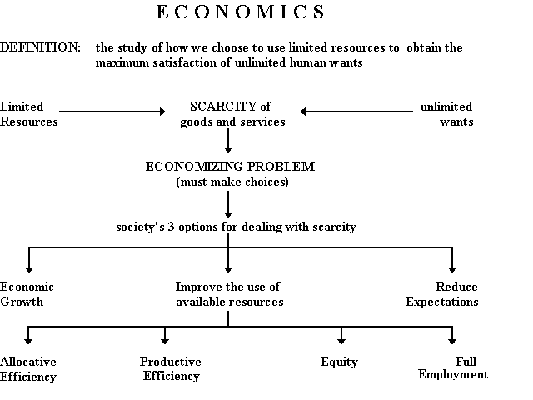

Mark Healy
William Rainey Harper College
E-Mail: mhealy@harpercollege.edu
Office: J-262
Phone: 847-925-6352
Which of the 5 Es of Economics BEST explains the statements that follow:
1. Economic Growth
2. Allocative Efficiency
3. Productive Efficiency
3a. not using more resources than necessary
3b. using resources where they are best suited
3c. using the appropriate technology
4. Equity
5. Full Employment
- __2__ Shortage of Super Bowl Tickets – Allocative Efficiency
- __3a__ Coke lays off 6000 employees and still produces the same amount – Productive Efficiency
- __3b__ Free trade – Productive Efficiency
- __1__ More resources – Economic Growth
- __2__ Producing more music downloads and fewer CDs – Allocative Efficiency
- __4__ Law of Diminishing Marginal Utility - Equity
- __5__ Using all available resources – Full Employment
- __3b__ Discrimination – Productive Efficiency
- __4__ "President Obama Example" - Equity
- __1__ improved technology – Economic Growth
- __5__ Due to an economic recession many companies lay off workers – Full Employment
- __4__ A "fair" distribution of goods and services - Equity
- __2__ Food price controls – Allocative Efficiency
- __3b__ Secretaries type letters and truck drivers drive trucks – Productive Efficiency
- __2__ Due to government price supports farmers grow too much grain – Allocative Efficiency

- __2__ Kodak Cuts Jobs - see article below
  - October 24, 2001 Posted: 1728 GMT
[http://edition.cnn.com/2001/BUSINESS/10/24/kodak/index.html
NEW YORK (CNNmoney) -- Eastman Kodak Co. posted a sharp drop in third-quarter profits Wednesday and warned the current quarter won't be much better, adding it will cut up to 4,000 more jobs. . . .Film and photography companies have been struggling with the adjustment to a shift to digital photography as the market for traditional film continues to shrink.
Which of the 5Es explains this news article? Explain.

ANSWER: Allocative Efficiency – they were not producing what consumers wanted. They were producing film and most consumers wanted to take digital pictures.
Quick Quiz – Scarcity

1. Economics may best be defined as the:
1. interaction between macro and micro considerations.
2. social science concerned with how individuals, institutions, and society make optimal choices under conditions of scarcity.
3. empirical testing of value judgments through the use of logic.
4. use of policy to refute facts and hypotheses.

2. The study of economics is primarily concerned with:
1. keeping private businesses from losing money.
2. demonstrating that capitalistic economies are superior to socialistic economies.
3. choices that are made in seeking the best use of resources.
4. determining the most equitable distribution of society's output.

3. The economizing problem is:
1. the need to make choices because economic wants exceed economic means.
2. how to distribute resources equally amongst all members of society.
3. that people's means often exceed their wants.
4. that people do not know how to rationally allocate resources.

4. The scarcity problem:
1. persists only because countries have failed to achieve continuous full employment.
2. persists because economic wants exceed available productive resources.
3. has been solved in all industrialized nations.
4. has been eliminated in affluent societies such as the United States and Canada.

5. Productive efficiency refers to:
1. the use of the least-cost method of production.
2. the production of the product-mix most wanted by society.
3. the full employment of all available resources.
4. production at some point inside of the production possibilities curve.

6. Allocative efficiency involves determining:
1. which output-mix will result in the most rapid rate of economic growth.
2. which production possibilities curve reflects the lowest opportunity costs.
3. the mix of output that will maximize society's satisfaction.
4. the optimal rate of technological progress.
7. If an economy produces its most wanted goods but uses outdated production methods, it is:
1. achieving productive efficiency, but not allocative efficiency.
2. achieving allocative efficiency, but not productive efficiency.
3. achieving both productive and allocative efficiency.
4. achieving neither productive nor allocative efficiency.

Resource Quiz
Each of the following is either a/n:
a. consumer good
b. consumer service
c. land
d. capital
e. labor
f. entrepreneur

 | Your answer: |  | Your answer:
medical checkup | Service | taxi ride | Service
factory | Capital | automobile | Most are goods  Capital if used by a taxi company
highway | Capital | autoworker | Labor
candy bar | Good | John DeLorean | Entrepreneur
coal | Land | ice cream cone | Good
coke | Coca-cola=good  Coke made out of coal used to make steel = capital | haircut | Service
iron ore | Land | waiter | Labor
Steve Jobs/Steve Wasnik | Entrepreneurs | Ted Turner | Entrepreneur
forest | Land | crude oil | Land
lumber | Capital if used by a carpenter  Good if used by me | gasoline | Most is a consumer good
class lecture | service | stockings | Good

The Budget Line: A MODEL of an individual's economizing problem:
- Definition: A budget line is a schedule (table) or curve (graph) that shows the various combinations of two products that a consumer can purchase with a specific money income
- Assumptions
  - there are only two goods to purchase (DVDs or books)
  - the amount of income to spend is fixed = $120 gift card
  - The goods have prices: DVD's are $20 and books are $10
Calculate the budget line table and draw the budget line graph
What are the combinations of DVDs and books that you can afford?
______#DVDs______ |  | ______# Books______
0 | and | 12
1 | and | 10
2 | and | 8
3 | and | 6
4 | and | 4
5 | and | 2
6 | and | 0

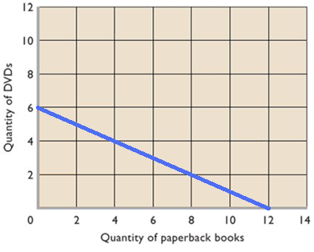
What happens if income or prices change?
(be able to make a new table and budget line graph)

income decreases to a $60 gift card (DVD's are $20 and books are $10)

______#DVDs______ |  | ______# Books______
0 | and | 6
1 | and | 4
2 | and | 2
3 | and | 0
 | and
 | and
 | and

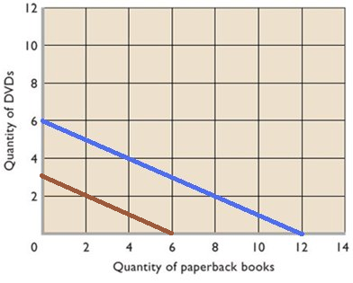

price of DVD increases to $30 (income stays at $120 and books are $10)
______#DVDs______ |  | ______# Books______
0 | and | 12
1 | and | 9
2 | and | 6
3 | and | 3
4 | and | 0
 | and
 | and

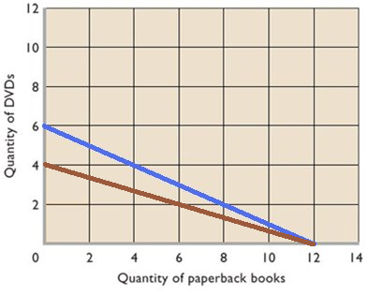

What would happen if:

- income increases to a $240 gift card ?
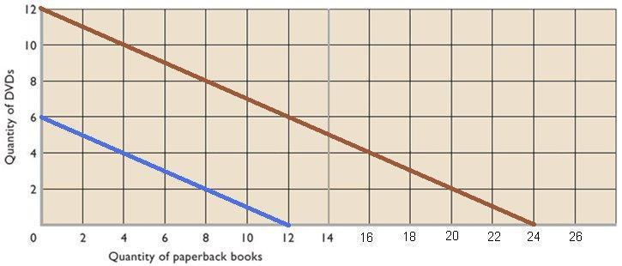

- price of DVD decreases to $10 (income stays at $120 and books are $10) ?

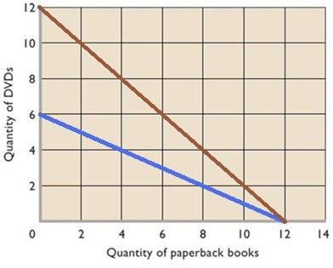

- price of books decreases to $5 (income stays at = $120 and DVD's are $20) ?

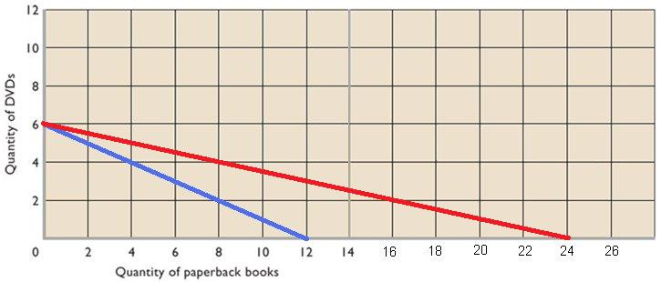

- price of books increases to $20 (income stays at = $120 and DVD's are $20) ?

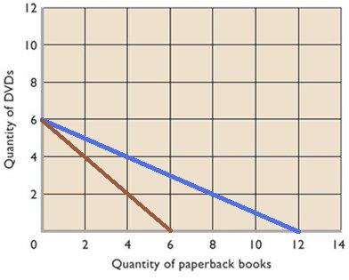
Quick Quiz – Budget Lines
1. The budget line shows:
1. the amount of product A that a consumer is willing to give up to obtain one more unit of product B
2. all possible combinations of two goods that can be purchased, given money income and the prices of the goods.
3. the minimum amount of two goods that a consumer can purchase with a given money income.
4. all possible combinations of two goods that yield the same level of utility to the consumer.

2. Use the graph above to answer this question. Suppose you have a money income of $10, all of which you spend on Coke and popcorn. In the above diagram, the prices of Coke and popcorn respectively are:
1. $.50 and $1.00.
2. $1.00 and $.50.
3. $1.00 and $2.00.
4. $.40 and $.50.
3. The shift of the budget line from cd to ab in the above figure is consistent with:
1. decreases in the prices of both M and N.
2. an increase in the price of M and a decrease in the price of N.
3. a decrease in money income.
4. an increase in money income.
4. Any combination of goods lying outside of the budget line:
1. implies that the consumer is not spending all his income.
2. yields less utility than any point on the budget line.
3. yields less utility than any point inside the budget line.
4. is unattainable, given the consumer's income.

5. Suppose Elroy's budget line is as shown on the above diagram. If his tastes change in favor of Coke and against popcorn, the budget line will:
1. become steeper.
2. become flatter.
3. shift rightward.
4. be unaffected.

Production Possibilities
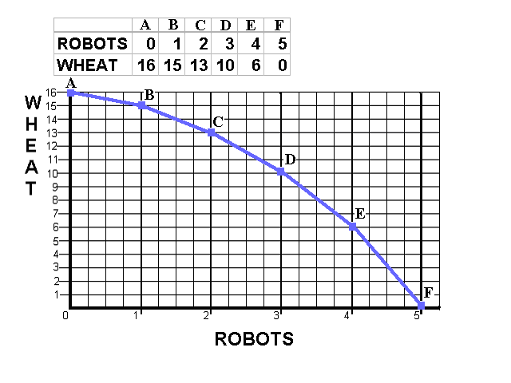
- Calculate the Opportunity Cost of Producing the first robot:

the first robot = __1__wheat;
second robot = ___2_wheat;
3rd = ___3___wheat;
4th = ___4__wheat;
5th = ___6___wheat.

- What is the Law of Increasing Costs?
As the production of a good increases, the opportunity cost of producing an additional unit rises. As we increase the production of robots, larger and larger amounts of wheat must be given up to produce each one additional robot.

Mark a point “N” on your production possibilities graph that represents
PRODUCTIVE INEFFICIENCY or UNEMPLOYMENT.

Mark a point “M” that represents a combination of wheat and robots that is
Currently IMPOSSIBLE to produce with given resources and technology.

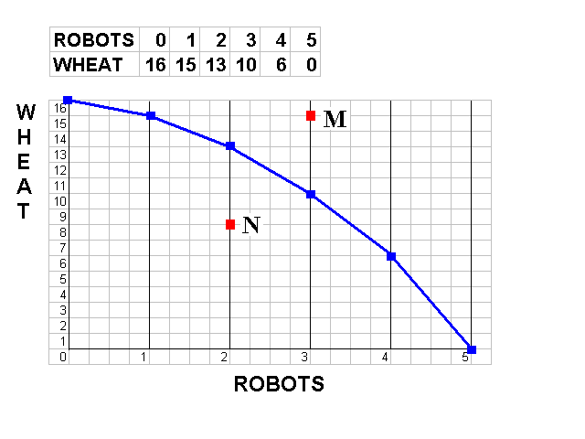

- On the graph above, sketch in a new PPC that would represent economic growth.

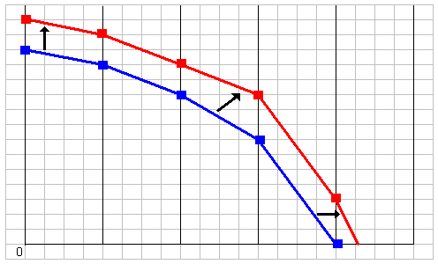

5. If we know that robots are Capital goods and wheat is a Consumer good, which combination of robots and wheat, B,C, D or E, would result in more growth in the future?

E, because of these four possibilities, point E has the most capital, and capital is a resource. Economic growth is caused by having MORE RESOURCES, better resources, and better technology.

Quick Quiz – Production Possibilities

1. Which of the following will not produce an outward shift of the production possibilities curve?
1. an upgrading of the quality of a nation's human resources
2. the reduction of unemployment
3. an increase in the quantity of a society's labor force
4. the improvement of a society's technological knowledge

2. Unemployment:
1. causes the production possibilities curve to shift inward.
2. can exist at any point on a production possibilities curve.
3. is illustrated by a point outside the production possibilities curve.
4. is illustrated by a point inside the production possibilities curve.

3. If the production possibilities curve is a straight line:
1. the two products will sell at the same market prices.
2. economic resources are perfectly substitutable between the production of the two products.
3. the two products are equally important to consumers.
4. equal quantities of the two products will be produced at each possible point on the curve.

4. A production possibilities curve illustrates:
1. the necessity of making choices.
2. market prices.
3. consumer preferences.
4. the distribution of income.

5. The production possibilities curve is:
1. convex to the origin because opportunity costs are constant.
2. linear because opportunity costs are constant.
3. concave to the origin because of increasing opportunity costs.
4. convex to the origin because of increasing opportunity costs.

6. If all discrimination in the United States were eliminated, the economy would:
1. have a less concave production possibilities curve.
2. produce at some point closer to its production possibilities curve.
3. be able to produce at some point outside of its production possibilities curve.
4. shift the production possibilities curve outward.

7. Refer to the above diagram. Other things equal, this economy will achieve the most rapid rate of growth if:
1. it chooses point A. (Do you know WHY?)
2. it chooses point B.
3. it chooses point C.
4. it chooses point D.

8. Refer to the above diagram. This economy will experience unemployment if it produces at point:
1. A.
2. B.
3. C.
4. D.

9. Refer to the above production possibilities curve. At the onset of the Second World War the United States had large amounts of idle human and property resources. Its economic adjustment from peacetime to wartime can best be described by the movement from point:
1. c to point b.
2. b to point c.
3. a to point b.
4. c to point d.
10. Refer to the above production possibilities curve. At the onset of the Second World War the Soviet Union was already at full employment. Its economic adjustment from peacetime to wartime can best be described by the movement from point:
1. c to point b.
2. b to point c.
3. a to point b.
4. c to point d.
Answer the next question(s) on the basis of the following production possibilities tables for two countries, North Cantina and South Cantina:
11. Refer to the above tables. If South Cantina is producing at production alternative D, the opportunity cost of the third unit of capital goods will be:
1. 3 units of consumer goods.
2. 4 units of consumer goods.
3. 5 units of consumer goods.
4. 6 units of consumer goods.
12. Refer to the above tables. If North Cantina is producing at production alternative B, the opportunity cost of the eleventh unit of consumer goods will be:
1. 10 units of capital goods.
2. ¹/₄ of a unit of capital goods.
3. 8 units of capital goods.
4. ¹/₈ of a unit of capital goods.
13. Refer to the above diagram. If society is currently producing the combination of bicycles and computers shown by point D, the production of 2 more units of bicycles:
1. cannot be achieved because resources are fully employed.
2. will cost 1 unit of computers.
3. will cost 2 units of computers.
4. will cause some resources to become unemployed.
14. Refer to the above diagram. The combination of computers and bicycles shown by point F:
1. is unattainable, given currently available resources and technology.
2. is attainable, but implies that the economy is not using all its resources.
3. is irrelevant because it is inconsistent with consumer preferences.
4. suggests that opportunity costs are constant.

Benefit Cost Analysis

Definition:
- The selection of all possible alternatives where the marginal benefits are
- greater than the marginal costs.
- select ALL possible options up to where MB = MC
- this implies ignoring sunk costs

Purpose: to make the best decision possible

Example 1 – How many guards should be hired?

# total marginal amount lost total benefit marginal
guards cost cost in shoplifting (amount caught) benefit

0 $ 0 -- $ 1000 $ 0 --

1 $ 200 $200 $ 500 $ 500 $500

2 $ 400 $200 $ 200 $ 800 $300

3 $ 800 $200 $ 50 $ 950 $150

Benefit-Cost Analysis is the selection of ALL possible alternatives where the marginal benefits are greater than the marginal cost
select all where: MB > MC
up to where: MB = MC
but never where: MB < MC
Should they spend $200 hiring the first guard if it saves them $500? Yes. Should they spend an additional $200 hiring the second guard if it saves them $300 more? Yes. Should they spend an additional $200 hiring the third guard if it saves them $150? No. So they should stop at two guards.

Example 2 - How many bridges should be built?

# total marginal total marginal
bridges cost costs benefits benefits

0 $ 0 -- $ 0 --

1 $ 50 M $50 $ 100 M $100

2 $ 120 M $70 $ 120 M $20

Should they spend $50 on the first bridge if it brings in $100 in benefits? Yes. Should they spend an additional $70 on the second bridge if it brings in only $20 in additional benefits? No. They should only produce the first bridge.
Quick Quiz – Benefit Cost Analysis
1. You should decide to go to a movie:
1. if the marginal cost of the movie exceeds its marginal benefit.
2. if the marginal benefit of the movie exceeds its marginal cost.
3. if your income will allow you to buy a ticket.
4. because movies are enjoyable.
2. Even though local newspapers are very inexpensive, people rarely buy more than one of them each day. This fact:
1. is an example of irrational behavior.
2. implies that reading should be taught through phonics rather than the whole language method.
3. contradicts the economic perspective.
4. implies that, for most people, the marginal benefit of reading a second newspaper is less than the marginal cost.
Answer the next question(s) on the basis of the following information for four highway programs of increasing scope. All figures are in millions of dollars.
3. The above data indicate that:
1. the marginal costs and marginal benefits cannot be calculated
2. the marginal cost and marginal benefit of Program B are $6 and $16 respectively.
3. the marginal cost and marginal benefit of Program C are $6 and $5 respectively.
4. the marginal cost and marginal benefit of Program D are $2 and $9 respectively.
4. On the basis of the above data we can say that:
1. Program A is the most efficient on economic grounds.
2. Program B is the most efficient on economic grounds.
3. Program C is the most efficient on economic grounds.
4. Program D is the most efficient on economic grounds.

5. Refer to the above diagram for athletic shoes. The optimal output of shoes is:
1. Q₁.
2. Q₂.
3. Q₃.
D. greater than Q₃.
6. Refer to the above diagram for athletic shoes. If the current output of shoes is Q₁, then:
1. society would consider additional units of shoes to be more valuable than alternative uses of those resources.
2. society would consider additional units of shoes to be less valuable than alternative uses of those resources.
3. society would experience a net loss by producing more shoes.
4. resources are being allocated efficiently to the production of shoes.
7. According to the marginal-cost-marginal-benefit rule:
1. only government projects (as opposed to private projects) should be assessed by comparing marginal costs and marginal benefits.
2. the optimal project size is the one for which MB = MC.
3. the optimal project size is the one for which MB exceeds MC by the greatest amount.
4. project managers should attempt to minimize both MB and MC.
8. The marginal benefit curve is:
1. upsloping because of increasing marginal opportunity costs.
2. upsloping because successive units of a specific product yield less and less extra benefit.
3. downsloping because of increasing marginal opportunity costs.
4. downsloping because successive units of a specific product yield less and less extra benefit.

9. The marginal cost curve is:
1. upsloping because of increasing marginal opportunity costs.
2. upsloping because successive units of a specific product yield less and less extra utility.
3. downsloping because of increasing marginal opportunity costs.
4. downsloping because successive units of a specific product yield less and less extra utility.
10. The output of MP3 players should be:
1. reduced if marginal benefits exceed marginal costs.
2. reduced if marginal costs exceed marginal benefits.
3. increased if marginal costs exceed marginal benefits.
4. reduced to zero if their unit costs exceed the unit costs of alternative products.

CHAPTER 3 DEMAND AND SUPPLY
An individual’s demand for Moore’s Pizza:

In the graph above, plot this individual’s demand curve for Moore’s pizza.

The supply of Moore’s pizza:

1000s
In the graph above, plot the supply curve for Moore’s pizza.

Market Equilibrium:

Assume that there are 1000 people with identical demand curves for Moore’s
Pizza, plot the market demand and supply curves for Moore’s pizza:

What is the equilibrium price of Moore’s pizza? __$9, this is where Qd=Qs__

What is the equilibrium quantity? ___3000________
Market Disequilibrium:

If Moore charged $12 per pizza:

How many pizzas would be demanded? _____2,000______

How many pizzas would be supplied? _____4,000__________

There would be a surplus/shortage of ___surplus of 2000___ pizzas.

If Moore charged $6 per pizza:

How many pizzas would be demanded? ______5,000______________

How many pizzas would be supplied? ______2,000______________

There would be a surplus/shortage of __shortage of 3,000___ pizzas.

Change in Demand vs. Change in Quantity Demanded
Matching: Which of the follow tables/graphs shows:

1. a decrease in demand ___C____
2. a change in quantity demanded ____A_____
3. an increase in demand ___B____
A
B
C

Change in Supply vs. Change in Quantity Supplied
1. a decrease in supply ___C_____
2. a change in quantity supplied ____A_____
3. an increase in supply ___B____
A
B | 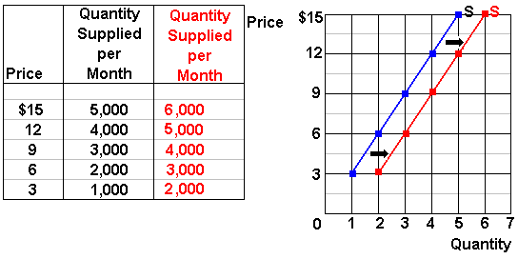
C

ANSWERS
Use supply and demand curves to illustrate how each of the following changes will affect the price and quantity of the stated product, ceterus paribus.
Before you guess, answer the following questions:
(1) Which determinant has changed?
(2) Will it affect supply or demand?
(3) Will supply or demand increase or decrease?
(4) GRAPH IT! What happens to price and quantity?
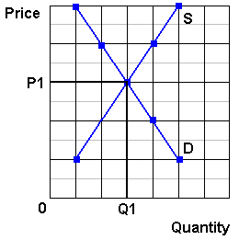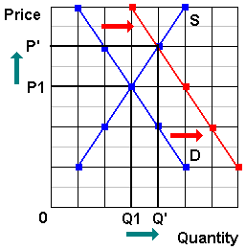

1. Computers  Consumer incomes increase | (1) Which determinant has changed? Incomes  (2) Will it affect supply or demand? Demand  (3) Will supply or demand increase or decrease? Demand increases - they are normal goods  (4) GRAPH IT! What happens to price and quantity? See graph above
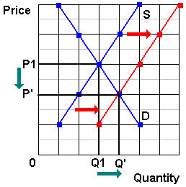
2. Calculators  Improved technology reduces the costs of production | (1) Which determinant has changed? Technology  (2) Will it affect supply or demand? Supply  (3) Will supply or demand increase or decrease? Supply increases  (4) GRAPH IT! What happens to price and quantity? See graph above
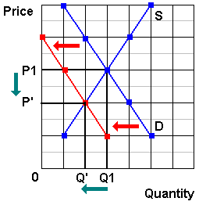

3. Sony Play Station  Computer prices drop | (1) Which determinant has changed? Price of other goods  (2) Will it affect supply or demand? Demand  (3) Will supply or demand increase or decrease? Demand decreases (assuming they are substitutes)  (4) GRAPH IT! What happens to price and quantity? See graph above  Or maybe: (#3 continued)  (1) Which determinant has changed? Price of other goods  (2) Will it affect supply or demand? Supply assuming they are Sony computers  (3) Will supply or demand increase or decrease? Supply increases  (4) GRAPH IT! What happens to price and quantity? Price down, Quantity up See graph below

4. Digital Cameras  IF: Price of memory cards decreases decreases | (1) Which determinant has changed? Price of other goods  (2) Will it affect supply or demand? Demand  (3) Will supply or demand increase or decrease? Demand increases - they are complementary goods  (4) GRAPH IT! What happens to price and quantity? See graph above
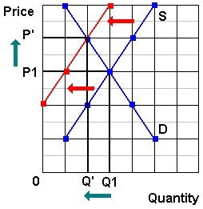
5. Cigarettes  Reduced gov't farm subsidies increase the costs of production | (1) Which determinant has changed? Subsidies (Taxes)  (2) Will it affect supply or demand? Supply  (3) Will supply or demand increase or decrease? Supply decreases  (4) GRAPH IT! What happens to price and quantity? See graph above
6. Coffee  a report links coffee drinking to heart attacks | (1) Which determinant has changed? Tastes  (2) Will it affect supply or demand? Demand  (3) Will supply or demand increase or decrease? Demand decreases  (4) GRAPH IT! What happens to price and quantity? See graph above
7. Wood furniture  Lumber prices rise | (1) Which determinant has changed? Price of resources  (2) Will it affect supply or demand? Supply  (3) Will supply or demand increase or decrease? Supply will decrease  (4) GRAPH IT! What happens to price and quantity? See graph above
8. Steel Furniture  Wood furniture prices increase | (1) Which determinant has changed? Price of other goods  (2) Will it affect supply or demand? Demand  (3) Will supply or demand increase or decrease? Demand will increase  (4) GRAPH IT! What happens to price and quantity? See graph above. NOTE: Higher LUMBER prices (see #7 above) may have an effect on STEEL furniture by making wood furniture more expensive.
9. Computers  5 new firms enter the industry | (1) Which determinant has changed? Number of producers  (2) Will it affect supply or demand? Supply  (3) Will supply or demand increase or decrease? Supply  (4) GRAPH IT! What happens to price and quantity? See graph above
10. Cigarettes  Gov't announces a large tax increase will begin in 1 week | (1) Which determinant has changed? Expected Price (tax takes effect next week)  (2) Will it affect supply or demand? Demand  (3) Will supply or demand increase or decrease? Demand increases today  (4) GRAPH IT! What happens to price and quantity? See graph above (prices increase today)
11. Gasoline  Gasoline taxes increase | (1) Which determinant has changed? Taxes  (2) Will it affect supply or demand? Supply  (3) Will supply or demand increase or decrease? Supply decreases  (4) GRAPH IT! What happens to price and quantity? See graph above
12. Soybeans  The price of corn rises | (1) Which determinant has changed? Price of other goods  (2) Will it affect supply or demand? Supply - price of other goods produced by the same farm  (3) Will supply or demand increase or decrease? Supply of soybeans decreases  (4) GRAPH IT! What happens to price and quantity? See graph above

Global Dairy Demand Drives Up Prices
http://www.npr.org/templates/story/story.php?storyId=14576499
by Emily Harris
September 24, 2007
NPR Morning Edition
Freshly-boxed whipping cream rolls off the conveyor at the Frischli factory in central Germany. Prices of all milk products are rising worldwide, due to what some call a "perfect storm" of low supply and high demand.
. . . . .
If you've been shopping for cheese or milk lately, you may have had to dig a little deeper into your wallet. Dairy prices have been rising fast not just in the U.S., but around the world. Even for a product as local as fresh milk, the global market comes into play.
"Prices are shooting up for virtually every dairy product you care to name," says Chris Horseman of Agra Informa, a company that tracks food commodities.
. . . . .
The Skim-Milk Powder Effect
He sells his milk to a dairy processor, where it's packaged to drink or made into pudding, butter or skim-milk powder an ingredient that is bumping up the price of dairy.
Few people think of skim-milk powder when they look at the sticker price on a gallon at the supermarket. But this powder is used in a wide range of foodstuffs, and its price has shot up to record levels worldwide almost twice as high as last year.
Hans Holtorf, who owns the German dairy manufacturer Frischli, says the powder's price was the first to increase among dairy products.
. . . . .
Fresh milk is still a very local product. It can't be transported very well from Germany or Iowa to China, for example, where demand for dairy products is rising. But powdered milk, cheese and butter can easily be moved around the globe, and as their prices rise, analysts are watching for shifts in production. Agra Informa's Chris Horseman says if a lot of producers chase the high price for milk powder, that could affect the cost of other products.
. . . .
Drought, Affluence Affect Supplies
Agricultural economists say today's milk shortage is basically a case of low supply and high demand worldwide. Supply is down for many reasons. A bad drought in Australia dried up the grass that the country's cows eat. New export taxes were added on Argentina's milk in an attempt to keep the country's food prices under control. Also, European farmers can't significantly increase production until a quota system is phased out eight years from now. The U.S. and Europe always used to have spare dairy products to sell cheaply around the globe, but that's no longer the case, says market expert Erhard Richarts.
. . . . .
"The Chinese per capita consumption is increasing," Henne says. "People get richer in the world. And if people get richer in the world, they like to drink more milk."
Experts say that animal feed prices are rising, partly because biofuel crops are replacing cow fodder. In turn, the high priced animal feed pushes up the cost of milk. But these explanations are trends, not events that clearly explain why dairy prices really shot up in early summer.
Horseman says the rising prices may have temporarily spooked the dairy industry.
"There were certainly elements of panic buying, I suspect, as processors suddenly thought, 'Wow, there is a real possibility that after years and years and years of surpluses, we might not actually have enough milk to meet our needs. So we better make sure that doesn't happen,'" he says.
Production has already started to increase in the U.S., but many market watchers say long-term trends indicate that milk won't be bottoming out again anytime soon.
ANSWER:
What determinants have changed?
Two determinants of the supply of dairy products have changed. Both will DECREASE the SUPPLY of dairy products
Price of resources have increased for two reasons:
- “ . . . bad drought in Australia dried up the grass that the country’s cows eat.”
- “Experts say that animal feed prices are rising, partly because biofuel crops are replacing cow fodder.”
Taxes have increased:
- “New export taxes were added on Argentina’s milk”
One determinant of demand for dairy products has changes that will INCREASE DEMAND:
Incomes have increased:
- “ . . . if people get richer in the world, they like to drink more milk.”
GRAPH: So, if supply has decreased and demand has increased the changes on the graph would be as shown below.
As you can see the supply had decreased (shifted to the left) and the demand has increased (shifted to the right). This will cause the equilibrium price to increase from P1 to P2.
What happens to the equilibrium quantity? On the graph I show the quantity staying the same, but it depends on HOW MUCH the supply and demand curves shift. If the article indicated that the quantity has increased I would have shown a larger shift of the demand curve so that the equilibrium quantity would be higher. If the article had said that the quantity had decreased then I would have shown the supply shifting more so that the equilibrium quantity would decrease. Since the article is unclear about what has happen to quantity I made it stay the same.
Quick Quiz - Supply and Demand

1. Which diagram above illustrates the effects on the peanut butter market of a higher wage rate for peanut workers?
1) A
2) B
3) C
4) D

2. If peanut butter and grape jelly are complementary products, which diagram above illustrates the effect on the peanut butter market of a decrease in the price of grape jelly?
1) A
2) B
3) C
4) D

3. If peanut butter and cheese spread are substitute products, which diagram above illustrates the effect on the peanut butter market of a decrease in the price of cheese spread?
1) A
2) B
3) C
4) D

4. Which diagram above illustrates the effects on the peanut butter market of a technological advance which reduces the cost of harvesting peanuts?
1) A
2) B
3) C
4) D

5. Refer to the above diagram. A price of $60 in this market will result in:
1. equilibrium.
2. a shortage of 50 units.
3. a surplus of 50 units.
4. a surplus of 100 units.

6. Refer to the above diagram. A price of $20 in this market will result in:
1. a shortage of 50 units.
2. a surplus of 50 units.
3. a surplus of 100 units.
4. a shortage of 100 units.

7. Which of the following will cause a decrease in market equilibrium price and an increase in equilibrium quantity?
1. an increase in supply. GRAPH IT!
2. an increase in demand.
3. a decrease in supply.
4. a decrease in demand.

8. Other things equal, the provision of a per unit subsidy for a product will:
1. increase its supply.
2. increase its price.
3. decrease the quantity sold.
4. decrease its demand.

9. Which of the following would not shift the demand curve for beef?
1. a widely publicized study that indicates beef increases one's cholesterol
2. a reduction in the price of beef
3. an effective advertising campaign by pork producers
4. a change in the incomes of beef consumers

10. A decrease in the price of digital cameras will:
1. cause the demand curve for memory cards to become vertical.
2. shift the demand curve for memory cards to the right.
3. shift the demand curve for memory cards to the left.
4. not affect the demand for memory cards.

11. An increase in the excise tax on cigarettes raises the price of cigarettes by shifting the:
1. demand curve for cigarettes rightward.
2. demand curve for cigarettes leftward.
3. supply curve for cigarettes rightward.
4. supply curve for cigarettes leftward.

Answer the next question(s) on the basis of the given supply and demand data for wheat:
12. Refer to the above data. Equilibrium price will be:
1. $4.
2. $3.
3. $2.
4. $1.
13. Refer to the above data. If the price in this market was $4:
1. the market would clear; quantity demanded would equal quantity supplied.
2. buyers would want to purchase more wheat than is currently being supplied.
3. farmers would not be able to sell all their wheat.
4. there would be a shortage of wheat.
14. If the supply of a product decreases and the demand for that product simultaneously increases, then equilibrium:
1. price must rise, but equilibrium quantity may rise, fall, or remain unchanged.
GRAPH IT!
2. price must rise and equilibrium quantity must fall.
3. price and equilibrium quantity must both increase.
4. price and equilibrium quantity must both decline.
15. Suppose that in 2007 Ford sold 500,000 Mustangs at an average price of $18,800 per car; in 2008, 600,000 Mustangs were sold at an average price of $19,500 per car. These statements:
1. suggest that the demand for Mustangs decreased between 2007 and 2008.
2. suggest that the supply of Mustangs must have increased between 2007 and 2008.
3. suggest that the demand for Mustangs increased between 2007 and 2008.
4. constitute an exception to the law of demand in that they suggest an upsloping demand curve.

Price Ceilings and Price Floors (Supports)
Price Ceiling Price Floor

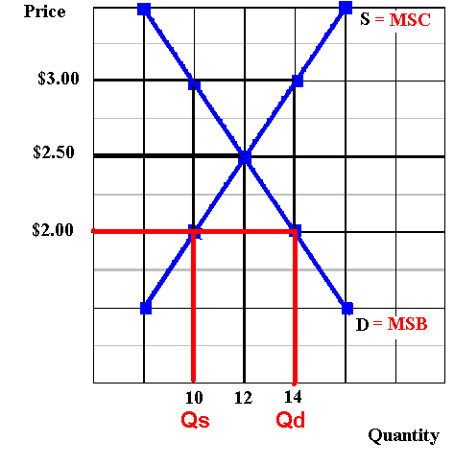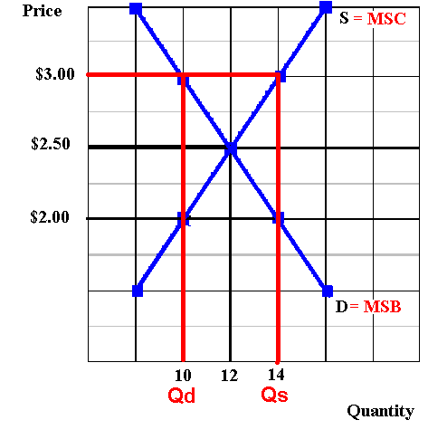

Market Equilibrium Allocative Efficiency (assuming no externalities)

P = __$2.50__ P = __$2.50__

Q = ___12___ Q = ___12___

Price Ceiling

Ceiling Price = $ 2.00

Qd = __14___

Qs = __10____

Shortage = ___4___= allocative INefficiency: at the quantity of 10 MSB > MSC
So there is an UNDERallocation of resources; too little is being produced since the efficient quantity is where MSB=MSC which is at a quantity of 12.

Price Floor

Floor Price = $ 3.00

Qd = ___10___

Qs = ___14___

Shortage = ____4___ = allocative inefficiency: at the quantity of 14 MSB < MSC
So there is an OVERallocation of resources; too much is being produced since the efficient quantity is where MSB=MSC which is at a quantity of 12

Quick Quiz – Government Set Prices
1. In the above market, economists would call a government-set minimum price of $50 a:
1. price ceiling.
2. price floor.
3. equilibrium price.
4. fair price.
2. In the above market, economists would call a government-set maximum price of $40 a:
1. price ceiling.
2. price floor.
3. equilibrium price.
4. fair price.
3. If government set a minimum price of $50 in the above market, a:
1. shortage of 21 units would occur.
2. shortage of 125 units would occur.
3. surplus of 21 units would occur.
4. surplus of 125 units would occur.
4. If government set a maximum price of $50 in the above market:
1. a shortage of 21 units would arise.
2. a surplus of 21 units would arise.
3. a surplus of 40 units would arise.
4. it would create neither a shortage nor a surplus.
5. Refer to the above diagram. A government-set price floor is best illustrated by:
1. price A.
2. price B.
3. price C.
4. quantity E.
6. Refer to the above diagram. Rent controls are best illustrated by:
1. price A.
2. price B.
3. price C.
4. Price greater than C
7. A price floor means that:
1. inflation is severe in this particular market.
2. sellers are artificially restricting supply to raise price.
3. government is imposing a maximum legal price that is typically below the equilibrium price.
4. government is imposing a minimum legal price that is typically above the equilibrium price.
8. An effective price floor will:
1. achieve equilibrium.
2. result in a product surplus.
3. result in a product shortage.
4. clear the market.
9. Black markets are associated with:
1. price floors and the resulting product surpluses.
2. price floors and the resulting product shortages.
3. ceiling prices and the resulting product shortages.
4. ceiling prices and the resulting product surpluses.
10. Which of the following is a consequence of rent controls established to keep housing affordable for the poor?
1. Less rental housing is available as prospective landlords find it unprofitable to rent at restricted prices.
2. The quality of rental housing declines as landlords lack the funds and incentive to maintain properties.
3. Apartment buildings are torn down in favor of office buildings, shopping malls, and other buildings where rents are not controlled.
4. All of the above are consequences of rent controls.

Ch. 5 -- The Economic Functions of Government and the 5 Es

NEGATIVE EXTERNALITIES

Define Negative Externalities (Spillover costs):
A negative externality occurs when some of the costs of producing or consuming a product are not paid by the producer or consumer by rather "spillover" onto a third party who otherwise would not be involved in the market transaction. If negative externalities exist the producer AVOIDS some of the costs of production so their costs are lower. With lower costs, more - too much - will be produced.

Examples of Negative Externalities (Spillover costs):
An example of a negative externality (or spillover or external cost) is any product that creates polution when produced or consumed. pollution. Assume that a paper manufacturer dumps toxic chemicals into a river killing the fish sport fishers seek. The buyer in this market is the purchaser of paper. The seller is the paper manufacturer. If the firm is allowed to pollute the river a third party, i.e. people who fish, or live, downstream, suffer from this pollution. They pay the cost. A negative externality allows polluters to enjoy lower production costs because the firm is passing along the cost of pollution damage or cleanup to society. Because the firm does not bear the entire cost, it will overallocate resources to the production of goods. TOO MUCH will be produced. Other products that have negative externalities (or spillover or external costs) include:
- cigarettes
- alcohol
- gasoline

Use the graph at the right to answer the questions that follow.

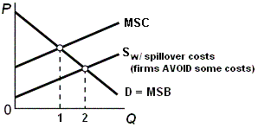

What is the allocatively efficient quantity? Quantity 1, the quantity where MSB=MSC. This is WHAT WE WANT.

What is the profit maximizing quantity? Quantity 2, the quantity where Qs=Qd. This is the equilibrium quantity or WHAT WE GET.

Which quantity will be produced without government involvement? Quantity 2 (WHAT WE GET)

Is there an OVER allocation or an UNDERallocation of resources? There is an OVERallocation of resources, Too much is being produced. Q2 (what we get) is greater then Q1 (what we want)
What is the goal of government involvement? [When spillover costs are associated with a product like gasoline what should the government try to do to the QUANTITY -- INCREASE OR DECREASE it?] Since too much is being produced the government should try to DECREASE the quantity being produced
What are the possible government policies to achieve this goal?
1. tax the product
2. use government regulations to force businesses to internalize the negative externalities
3. create a market for pollution rights (cap and trade)

On your graph show the effect of an increase in the excise tax on gasoline

What happens to the quantity and allocative efficiency when the government taxes a product whose production has negative externalities (spillover costs)? The quantity produced will go down and it will be closer to the allocatively efficient quantity
From the online lecture:
Negative Externalities (also called spillover costs or external costs)
Externalities occur when some of the benefits or costs of production are not fully reflected in market demand or supply schedules. Some of the benefits or costs of a good may "spill over" onto third parties.
A negative externality occurs when some of the costs of producing or consuming a product are not paid by the producer or consumer by rather "spillover" onto a third party who otherwise would not be involved in the market transaction. If negative externalities exist the producer AVOIDS some of the costs of production so their costs are lower. With lower costs, more - too much - will be produced.
Graphically when negative externalities exist the supply curve does not equal the MSC curve. Since the firm AVOIDS some costs, the costs to the firm are lower than the costs to society and the supply curve is further to the right (supply increases when costs decrease). So the profit maximizing quantity occurs where Qs=Qd or at quantity 2 on the graph below. This is the quantity that will be produced. This is WHAT WE GET when negative externalities exist. But the allocatively efficient quantity is 1, where MSB=MSC. This is the quantity that maximizes society's satisfaction. This is WHAT WE WANT. So when negative externalities exist TOO MUCH will be produced and there is an overallocation of resources. At quantity 2 the MSB<MSC. We said in chapter 1 that when MB<MC too much is being done.

An example of a negative externality (or spillover or external cost) is any product that creates polution when produced or consumed. pollution. Assume that a paper manufacturer dumps toxic chemicals into a river killing the fish sport fishers seek. The buyer in this market is the purchaser of paper. The seller is the paper manufacturer. If the firm is allowed to pollute the river a third party, i.e. people who fish, or live, downstream, suffer from this pollution. They pay the cost. A negative externality allows polluters to enjoy lower production costs because the firm is passing along the cost of pollution damage or cleanup to society. Because the firm does not bear the entire cost, it will overallocate resources to the production of goods. TOO MUCH will be produced. Other products that have negative externalities (or spillover or external costs) include:
- cigarettes
- alcohol
- gasoline
So what is the role of government when negative externalities exist? Well, the GOAL is to reduce the amount that is produced. Using the graph above the goal would be to reduce the quantity from 2 to 1.
To correct for negative externalities requires that government get producers to internalize these costs. There are two ways that the government can do this:
1. Legislation can limit or prohibit pollution, smoking, drinking, etc. Such legislation causes the firm's costs to increase and the firm's supply curve to shift to the left resulting in a higher price and a smaller quantity demanded. (See graph below.)
2. Specific taxes on the amounts of pollution, smoking, alcohal, etc. can be assessed, which causes the firm's supply curve to shift to the left resulting in a higher price and a smaller quantity demanded. (See graph below.)

Think about the products that the government does tax: alcohol, cigarettes, gasoline. Now we know why. Because without the tax the produce avoids some costs and passes them onto society as a whole. Therefore without the tax the price would be lower and more would be consumed. TOO MUCH would be consumed - more than the quantity that is optimum for society or the allocatively efficient quantity.
Have you ever wondered why bar owners live above their bars? It may be so that they can avoid the problems of drunk drivers leaving their bars. This way they feel safer and can sell more alcohol and make more money. What would happen to the amount of alcohol sold if there was a law that said all bar owners or bartenders must stand in the middle of the street outside their bar when their customers leave? Would they sell the same amount to their customers? I believe that in this case THEY would have to PAY (possibly with their lives) if they sell the profit maximizing quantity of alcohol to their customers, so they would sell less which would be better for society.

POSITIVE EXTERNALITIES

Define Positive Externalities (also called Spillover Benefits or External Benefits):

A positive externality ( or spillover or external benefit) occurs if some of the benefits of producing or consuming a product "spillover" onto a third party who does not have to pay. Not just the buyer or the seller benefit but someone else also benefits Public health vaccinations and education are two examples. Other examples of products with positive externalities are public parks and public libraries. Because some of the benefits of these services go to others, not just the person being vaccinated or the student being educated, but others also benefit. Even if you do not get vaccinated you will benefit if everyone else does. It is not just the student (or the school and teachers) who benefit from your education but also future employers and society as a whole benefit. When positive externalities exist individuals will demand too little for themselves and resources will be underallocated by the market. Therefore positive externalities are bad for society.

Examples of Positive Externalities (Spillover benefits):

See above

Use the graph below to answer the questions that follow.

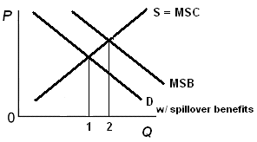

What is the allocatively efficient quantity?
Quantity 2 where MSB=MSC. This is WHAT WE WANT

What is the profit maximizing quantity?
Quantity 1 where Qd=Qs. This is WHAT WE GET.

Which quantity will be produced without government involvement?
Quantity 1

Is there an OVER allocation or an UNDERallocation of resources?
UNDERallocation of resources; too little will be produced

What is the goal of government involvement? [When spillover benefits are associated with a product like education what should the government try to do to the QUANTITY -- INCREASE OR DECREASE it?]
Since there is an UNDERallocation of resources and too little would be produced without the government, the role of the government is to INCREASE the quantity.

What are the possible government policies to achieve this goal?

Correcting for positive externalities requires that the government somehow increase the quantity to the allocatively efficient amount. The goal of government is to have more produced - more than what would be produced if there were no government involvement. The government has three tools to achieve this:
1. Government can increase demand by providing subsidies to consumers like food stamps and education grants to subsidize consumers. On the graph this would increase demand because it is like giving consumers additional income to buy the product. See Graph.

2. Government can finance production of good or service itself such as public education or public health. This would increase supply just like having more producers. (See graph below.)
3. Government can increase supply by subsidizing production, such as higher education, immunization programs, or public hospitals. This would also increase supply. (See graph below.)

Note that government finance and subsidizing producers does not increase demand, but it does increase the quantity for 1 to 2 which is just what society wants.

On your graph show the effect of an increase supply on the market for education.

What happens to quantity and allocative efficiency when the government subsidizes a product whose production has positive externalities (spillover benefits)?
Since with government intervention the quantity increases, this gets the quantity closer to the allocatively efficient quantity (Q2)
From the online lecture:
Positive Externalities (Spillover Benefits or External Benefits)
A positive externality ( or spillover or external benefit) occurs if some of the benefits of producing or consuming a product "spillover" onto a third party who does not have to pay. Not just the buyer or the seller benefit but someone else also benefits Public health vaccinations and education are two examples. Other examples of products with positive externalities are public parks and public libraries. Because some of the benefits of these services go to others, not just the person being vaccinated or the student being educated, but others also benefit. Even if you do not get vaccinated you will benefit if everyone else does. It is not just the student (or the school and teachers) who benefit from your education but also future employers and society as a whole benefit. When positive externalities exist individuals will demand too little for themselves and resources will be underallocated by the market. Therefore positive externalities are bad for society.
Since some people benefit from positive externalities who do not demand, or pay for, the product, the demand curve does not include all of the benefits that society gets from the product. The demand curve only measures the benefits that go to those who demand, and pay for, the product. Therefore the demand curve does not equal the MSB (marginal Social Benefits) that all of society receives from the product. The demand will be less than the MSB and on the graph the demand curve will be further to the left. See graph below.
Profit maximizing business will produce the equilibrium quantity where QS = Qd, or quantity 1 on the graph below. But the allocatively efficient quantity is where MSB=MSC or quantity 2 on the graph below. When positive externalities exist TOO LITTLE will be produced, there will be an UNDERallocation of resources to the production of these products, and society will suffer from allocative inefficiency.

Correcting for positive externalities requires that the government somehow increase the quantity to the allocatively efficient amount. The goal of government is to have more produced - more than what would be produced if there were no government involvement. The government has three tools to achieve this:
1. Government can increase demand by providing subsidies to consumers like food stamps and education grants to subsidize consumers. On the graph this would increase demand because it is like giving consumers additional income to buy the product. See Graph.

2. Government can finance production of good or service itself such as public education or public health. This would increase supply just like having more producers. (See graph below.)
3. Government can increase supply by subsidizing production, such as higher education, immunization programs, or public hospitals. This would also increase supply. (See graph below.)

Note that government finance and subsidizing producers does not increase demand, but it does increase the quantity for 1 to 2 which is just what society wants.

Quick Quiz - The Economic Functions of Government and the 5 Es

1. A pure market economy overallocates resources to the production of goods that:
1. involve negative externalities.
2. involve positive externalities.
3. are public goods.
4. are inexpensive to produce.
2. If a market is competitive but externalities are present, the resulting equilibrium output:
1. will also be the most efficient output.
2. will always be less than the most efficient output.
3. will always be greater than the most efficient output.
4. may be either larger or smaller than the most efficient output.
3. If a good's production creates substantial positive externalities and no negative externalities, then:
1. too much of the good will be produced unless firms are subsidized.
2. too much of the good will be produced unless firms are taxed.
3. too little of the good will be produced unless firms are subsidized.
4. too little of the good will be produced unless firms are taxed.
4. Suppose a product creates substantial negative externalities. If government adopts a policy that forces producers to pay these costs, the:
1. output of the product will decrease.
2. initial misallocation of resources will be intensified.
3. output of the product will increase.
4. price of the product will decrease.

5. The Federal government requires automobile manufacturers to install pollution control equipment. This is an illustration of the:
1. intrusion problem.
2. production of public goods.
3. internalization of external benefits.
4. internalization of external costs.

6. Susie lives in a dorm and likes to play loud music in her room. Her neighbor Kara enjoys the same type of music and gets pleasure from Susie turning up the music. Her other neighbor, Alex, can't stand Susie's music and gets mad when she turns it up for all to hear. When Susie plays her music loudly, she creates:
1. a positive externality for Kara, and a negative externality for Alex.
2. a negative externality for Kara, and a positive externality for Alex.
3. positive externalities for both Kara and Alex.
4. negative externalities for both Kara and Alex.
7. As it relates to a public good, nonrivalry means that:
1. the public sector is able to provide the good profitably.
2. there is no need or demand for the good.
3. either the public sector or the public sector can produce the good, but not both.
4. one person's benefit from the good does not reduce the benefit available to others.
8. As it relates to a public good, nonexcludability means that:
1. free riders cannot be barred from receiving the benefits.
2. there is no need or demand for the good.
3. either the public sector or the public sector can produce the good, but not both.
4. one person's benefit from the good does not reduce the benefit available to others.
9. Unlike a private good, a public good:
1. produces no external benefits or external costs.
2. has no opportunity costs.
3. has benefits that are available to all, regardless of payment.
4. is characterized by rivalry and excludability.
10. Which of the following is a public good?
1. chewing gum
2. bread
3. a professional baseball game
4. street lights in a city
11. Which of the following would not be appropriate if government were trying to reduce high unemployment?
1. an increase in tax rates
2. an increase in subsidies to businesses
3. an increase in transfer payments to households
4. an increase in government spending
QUIZ

Do you think like an economist?
- The purpose of economic activity is:
A. to improve consumer well being
B. to create jobs
- Work is a:
A. cost
B. benefit
- Imports are a
A. benefit
B. cost
- Exports are a
A. cost
B. benefit
- The objective of trade is to
A. get goods cheaply
B. create jobs
This quiz was printed in the Wall Street Journal in the 1980s when there was a lot of discussion of free trade vs. trade restrictions. The Wall Street Journal said that even though there is no correct answer for each question, IT COULD BE ARGUED THAT ANSWER A IS BEST FOR ALL OF THE QUESTIONS ABOVE. The goal of economics is to reduce scarcity – i.e. GET MORE STUFF. Answer A in each question helps an economy reduce scarcity.
1. The purpose of economic activity is to improve consumer well being (get more stuff). We work so that we can buy things. Would an economy be successful if everyone had to work 18 hours a day, 365 days a yea but everyone was still poor, homeless, and starving?
2. Work is a cost. That is why they have to pay you to do it. If worl was a benefit we would all volunteer to do it for nothing.
3. Imports are a benefit in the sense that it allows an economy to have more stuff (reduce scarcity).
4. Exports are a cost in the sense that we are sending our stuff somewhere else and therefore we have less – more scarcity.
5. The objective of trade is to get goods cheaply. This reduces scarcity. Economists always think about scarcity.
Assume there is an attorney who is an excellent auto mechanic and his/her car needs repair.
The attorney could fix it in one hour. An auto mechanic could fix it in two hours. (Note: the auto mechanic is not as good at fixing cars, or at doing law, as the attorney – he attorney is better at both)
Let's say the auto mechanic charges $50 an hour and the attorney charges $200 per hour.
Should the attorney fix the car himself/herself or should they bring it to the auto mechanic? Why?
If the attorney fixes the car himself/herself it will cost him one hour of lost work in which he could have made $200, but it the mechanic fixes the attorney's car it will only cost the attorney $100 (2 hours x $50). THEREFORE, even if the attorney is better at BOTH fixing cars and doing law, he/she can benefit from specializing in doing law and exchanging with the auto mechanic. This is due to the principle of comparative advantage. To the mechanic the cost of fixing the car himself/herself is greater than the cost of having the mechanic fix it. Since the mechanic can fix the car at a lower opportunity cost, he/she has a comparative advantage in fixing cars and the attorney has a comparative advantage in doing law. Even though the attorney is better, more productive, at both jobs, both the attorney and the auto mechanic can gain from specializing and exchanging (trade). The same thing happens between countries. Even if a country is better at producing two items it may gain by specializing in one and trading with another country for the other. This is the principle of COMPARATIVE ADVANTAGE.
Absolute Advantage
Below are the production possibilities curves for two countries: the US and France. Notice that we have assumed constant costs so that the curves are straight lines. In a previous lecture we said that PPCs are concave to the origin because all resources within a country are not the same (the law of increasing costs). Here, we assume that all resources in the US are the same so there are constant costs and the PPC is a straight line. The resources in France are also all identical to each other (but different than those in the US) so France also has constant costs and a straight PPC.

Lets begin by assuming that initially there is no trade and each country is self-sufficient - producing all of its own bread and wine. Let's assume that the US choses to produce 40 bread and 30 wine and France produces 9 bread and 24 wine. These amounts are shown on the tables and graphs below.

Total production by both countries then is show in the table below: 49 breads and 54 wines. This is just one possible level of total production but it will help us understand how both countries can benefit from trade.
BEFORE | SPECIALIZATION | EXCHANGE
   | B | W
  US | 40 | 30
  Fr | 9 | 24
  total | 49 | 54
   | B | W
  US
  Fr
  total
   | B | W
  US
  Fr
  total

Now, let’s assume that each country specializes and produces more of the product in which they have an absolute advantage. This means they produce more of the product in which their resources are more productive. In which product will each country specialize? Looking at the production possibilities tables we can answer this question if we assume that each country has the same amount of resources so the data could represent output per worker. So which country has resources tat are more productive in producing bread? If the US ONLY PRODUCES BREAD it could produce 100 bread and no wine. If France only produces bread it can only produce 15. So the US has an absolute advantage in the production of bread. France can produce a maximum of 60 wines whereas the US can only produce 50. So France's resources are more productive in the production of wheat - they have an absolute advantage in the production of wheat.
If both countries specialize and produce only those products in which they have an absolute advantage we will get a total production of 100 bread (all produced by the US) and 60 wine (all produced by France). See tables and graphs below.

Now compare total production with specialization according to their absolute advantage with total production before, when they were self sufficient (see table below). You can see that with the SAME AMOUNT OF RESOURCES (remember the assumptions behind the production possibilities curve) MORE IS BEING PRODUCED. Before, when self-sufficient, total production was 49 bread and 54 wine. With 100% specialization we can now produce 100 bread and 60 wines. With the same amount of resources 51 MORE bread is being produced (100 - 49) and 6 MORE wine (60 - 54). This reduces scarcity by producing more output from the same amount of resources.
BEFORE | SPECIALIZATION | EXCHANGE
   | B | W
  US | 40
  Fr | 9 | 24
  total | 49 | 54
   | B | W
  US | 100 | 0
  Fr | 0 | 60
  total | 100 | 60
   | B | W
  US
  Fr
  total
So specialization results in more output from the same amount of resources, but is each country better off now than before? Probably not. In the US they have plenty of bread to eat but no wine. And in France they are starving (no bread) but they are happy (lots of wine) :-).
Let's see if both countries can gain from exchanging (trade). Let's assume that the US offers the starving French 1 brad for all of their wine. France would probably say no, but they offer the thirsty American's 1 wine for all 100 bread. the US would probably refuse. so they begin to bargain until they find a "trade" that is acceptable to both sides. Let's assume they agree to trade 20 bread for 32 wine.
The graphs below show the results of this exchange. Each country is still PRODUCING as they were before, but now after the trade they are CONSUMING more. In the US after trading 20 breads to France still have 80 left and they received 32 wines leaving France with 28.

Looking at the graphs above and the table below we can see the gains from trade. The US is now consuming 80 bread and 32 wine. This combination is OUTSIDE their production possibilities curve. In an earlier lecture we said that this was impossible or unattainable. But with trade more can be consumed than if they were self-sufficient. the same is true for France. Both countries then benefit from specializing and exchanging. Both countries can consume quantities that are impossible for them to produce.
BEFORE | SPECIALIZATION | EXCHANGE
   | B | W
  US | 40
  Fr | 9 | 24
  total | 49 | 54
   | B | W
  US | 100 | 0
  Fr | 0 | 60
  total | 100 | 60
   | B | W
  US | 80 | 32
  Fr | 20 | 28
  total | 100 | 60
Comparative Advantage
Look at the production possibilities tables and graphs below for the US and France producing bread and radios. Who has an absolute advantage in producing bread? Since the US can produce 100 loaves if they only produce bread and France can produce only 15, assuming that they have the same amount of resources, the US is more productive in producing bread. The US has an absolute advantage in bread production. Who has an absolute advantage in producing radios? Again it is the US. The US (like the attorney above) is more productive at producing both products.

So will they benefit from trading with France? YES! - but which products should they specialize in and trade to the other country? They should specialize according to their COMPARATIVE ADVANTAGES. They should produce more of the product which they can produce for a lower opportunity cost.
So the first thing we have to do is calculate the opportunity costs. This is similar to what we did in a previous lecture.
In the US, when they produce 1 radio, how many breads do they have to give up? Well, if they produce no radios, they can produce 100 bread. but if they produce 25 radios they can't produce any bread. So for 25 radios they have to give up 100 bread OR 4 bread for every 1 radio. In France what is the cost of 1 radios in terms of bread given up? if they produce no radios they can produce 15 bread. If they produce 10 radios they can't produce any bread. So for 10 radios they gave up 15 bread OR 1 and 1/2 bread for 1 radio.
US: 1 radio costs 4 bread | France: 1 radio costs 1 and 1/2 bread
So, who has a comparative advantage in the production of radios? Who can produce radios at a smaller cost? Who can produce radios and give up less bread? The answer is FRANCE. the US has an absolute advantage (more productive) in the production of radios, but France has a comparative advantage. France can produce radios at a lower opportunity cost.
Who has a comparative advantage in the production of bread? Who can produce bread at a lower opportunity cost? Which country gives up fewer radios for each bread produced?

In the US, when they produce 1 bread, how many radios do they have to give up? Well, if they produce no bread, they can produce 25 radios. but if they produce 100 bread they can't produce any radios. So for 100 bread they have to give up 25 radios OR 1/4 radio for every 1 bread. In France what is the cost of 1 bread in terms of radios given up? If they produce no bread they can produce 10 radios. If they produce 15 bread they can't produce any radios. So for 15 bread they gave up 10 radios OR 2/3 (10/15 ) radios for 1 bread.
US: 1 bread costs 1/4 radio | France: 1 bread costs 2/3 radio
So, who has a comparative advantage in the production of bread? Who can produce bread at a smaller cost? Who can produce bread and give up fewer radios? The answer is the US. The US can produce radios at a lower opportunity cost so they have a comparative advantage in the production of bread.
Self Sufficiency Before Specialization
Let's assume that before specialization and trade both countries produce the quantities shown below. I selected these quantities as our starting point so that I can show that the countries both gain from trade.

So, total production without trade is 72 bread and 12 radios. See table below.
BEFORE | SPECIALIZATION | EXCHANGE
   | B | R
  US | 60 | 10
  Fr | 12 | 0
  total | 72 | 12
   | B | R
  US
  Fr
  total
   | B | R
  US
  Fr
  total
Specialization
Now, lets assume that each country specializes and produces more of the product in which they have an comparative advantage. We just calculated the opportunity costs and we concluded that the US has a comparative advantage in the production of bread and France has a comparative advantage in the production of radios.
On our exams we'll assume that they specialize 100%, which means each country will only produced one products, but here (as in the real world) we'll have them produce MORE of that product in which they have a comparative advantage but not only that product.
So, the tables and graphs below show the results of this specialization according to the principle of comparative advantage. Notice that the US now is producing more bread than when they were self-sufficient and France is producing more radios than before.

So, total output is now 83 bread and 13 radios. See table below.
BEFORE | SPECIALIZATION | EXCHANGE
   | B | R
  US | 60 | 10
  Fr | 12 | 0
  total | 72 | 12
   | B | R
  US | 80 | 5
  Fr | 3 | 8
  total | 83 | 13
   | B | R
  US
  Fr
  total
Now compare total production with specialization with total production before keeping in mind the assumptions behind the productions possibilities model. These assumptions include "fixed resources", the quantity of resources does not change, but what happens to the amount produced? The amount increases by 11 bread (83 - 72) and 1 radio (13 - 12). So from the same amount of resources we are now producing 11 more bread and 1 more radio. This reduces scarcity.
But are the US and France better off now than before? We can't tell yet, but let's assume they decide to trade. The US produces a lot of bread and few radios and France has a lot of radios and little bread. So the US may offer to trade 1 bread to France for all their radios -- and France will probably decline the offer. France may then offer to trade 1 radio for all of the bread produced in the US -- and the US will most likely refuse.
If they continue bargaining, they may find a trade that is beneficial to each country. Let's say they decide to trade 12 bread for 6 radios.
The US which is producing 80 bread 5 radios (see below) and trading 12 bread to France for 6 radios remains with 68 bread (80 - 12) and 11 radios (5 + 6).
France which is producing 8 radios and 3 bread trades 6 radios to the US in return for 12 bread. They end up with 2 radios (8 - 6) and 15 bread (3 + 12).

If we plot these quantities on the production possibilities graphs of each country (see above) we see that they lie outside the production possibilities curves of each country. In an earlier lesson we said that these quantities are impossible -- but we should have said "impossible without trade". Both countries are consuming more with trade than they could without trade. This reduces scarcity.
BEFORE | SPECIALIZATION | EXCHANGE
   | B | R
  US | 60 | 10
  Fr | 12 | 0
  total | 72 | 12
   | B | R
  US | 80 | 5
  Fr | 3 | 8
  total | 83 | 13
   | B | R
  US | 68 | 11
  Fr | 15 | 2
  total | 83 | 13
"Specialization according to comparative advantage results in a more efficient allocation of the world's resources, and larger outputs ...." (McConnell and Brue 1993)
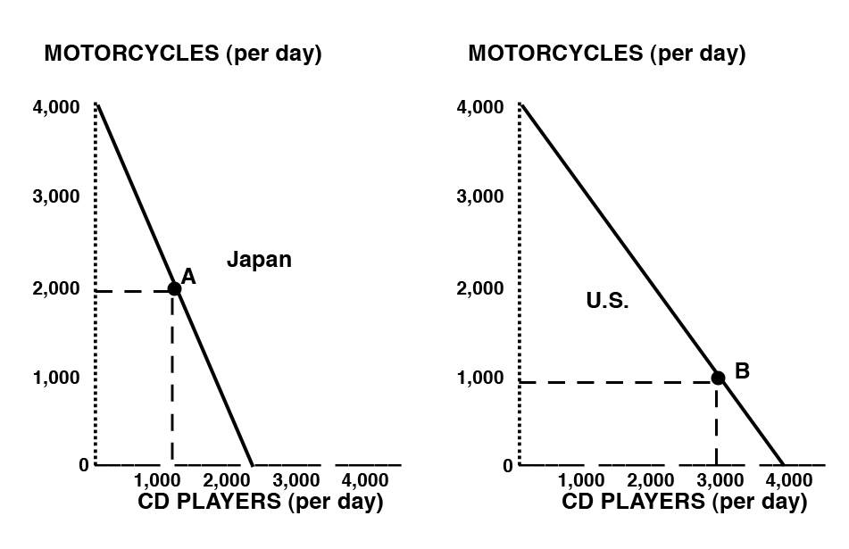
The first thing you do is find the opportunity costs:
Japan: 2000 CD = 4000 M or 1CD = 2 M and 1M = 1/2 CD
US: 4000 CD = 4000 M or 1 CD = 1M and 1M = 1 CD
1. Who has a comparative advantage in motorcycles?
In Japan 1M = 1/2 CD and in the US 1M = 1 CD, so Japan can produce motorcyles at a lower opportunity cost (1/2 CD is less than 1 CD), so Japan has a comparative advantage in motorcycles
2. Who has a comparative advantage in CD players?
In Japan 1CD = 2 M and in the US 1 CD = 1M so the US can produce CDs at a lower opportunity cost (1M is less than 2M), so the US has a comparative advantage in CDs.
3. Assume that before specialization and trade Japan is at point A and the U.S. is at point B. If each country specializes 100% according to their comparative advantage, what are the gains from specialization and trade?
The first thing you need to do is make some tables like the ones below. From the tables you can see that the totals with specialization are 1000 motorcycles higher than they were before. From the same amount of resources 1000 more motorcycle can be produced if these countries specialize and exchange.
BEFORE | SPECIALIZATION
   | M | CD
  Japan | 2000 | 1000
  US | 1000 | 3000
  total | 3000 | 4000
   | M | CD
  Japan | 4000 | 0
  US | 0 | 4000
  total | 4000 | 4000

Quick Quiz – Comparative Advantage

1. Refer to the above domestic production possibilities curve for Karalex. The gain to Karalex from specialization and international trade is represented by a move from:
1. A to B.
2. C to A.
3. C to D.
4. B to E.

2. Renee earns $500 per hour in the courtroom as a trial lawyer; she can type up her legal documents at a rate of 80 words per minute. Christopher has no training as a trial lawyer, but can type legal documents at a rate of 50 words per minute for a wage of $30 per hour. Based on the theory of comparative advantage:
1. Renee should do all of her own typing.
2. Renee should specialize in courtroom trials and hire Christopher to type her legal documents.
C. Renee should only hire Christopher if he can raise his typing speed to faster than 80 words per minute.
4. Comparative advantage doesn't apply to this case because it does not involve international trade.

3. The above data would graph as:
1. a straight line for Alpha, but as a concave curve for Omega.
2. a concave curve for Alpha, but as a straight line for Omega.
3. concave curves for both Alpha and Omega.
4. straight lines for both Alpha and Omega.
4. Refer to the above data. The domestic opportunity cost of producing 1 ton of steel in Alpha is:
1. ½ ton of wheat.
2. 1 ton of wheat.
3. 15 tons of wheat.
4. 30 tons of wheat.
5. Refer to the above data. The domestic opportunity cost of producing 1 ton of steel in Omega is:
1. ½ ton of wheat.
2. 2 tons of wheat.
3. 3 tons of wheat.
4. 5 tons of wheat.
6. Refer to the above data. Alpha has a comparative advantage in producing:
1. neither steel nor wheat.
2. both steel and wheat.
3. steel.
4. wheat.
7. Refer to the above data. On the basis of the above information:
1. Alpha should export both steel and wheat to Omega.
2. Omega should export both steel and wheat to Alpha.
3. Omega should export steel to Alpha and Alpha should export wheat to Omega.
4. Alpha should export steel to Omega and Omega should export wheat to Alpha.
8. Refer to the above data. If Alpha and Omega each were producing at alternatives B before trade, the gain from specialization and trade would be:
1. 30 tons of wheat.
2. 15 tons of steel.
3. 30 tons of steel and 30 tons of wheat.
4. 60 tons of wheat and 60 tons of steel.
9. According to the concept of comparative advantage, a good should be produced in that nation where:
1. its domestic opportunity cost is greatest.
2. money is used as a medium of exchange.
3. its domestic opportunity cost is least.
4. the terms of trade are maximized.

