How to Register Into Your Thinkwell Course

If your instructor has chosen Thinkwell as part of your course, the following instructions will show you how to register. You only need to register one time and you will be part of your instructor’s class. Failure to complete this process means your instructor will not see the results of your work completed in the Thinkwell system.

If you have any questions, email us: techsupport@thinkwell.com.

1. Go to www.thinkwell.com and click “Register.”

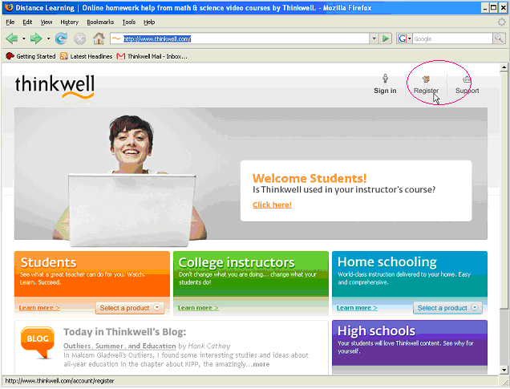

2. Use the pull-down menu to select your state.

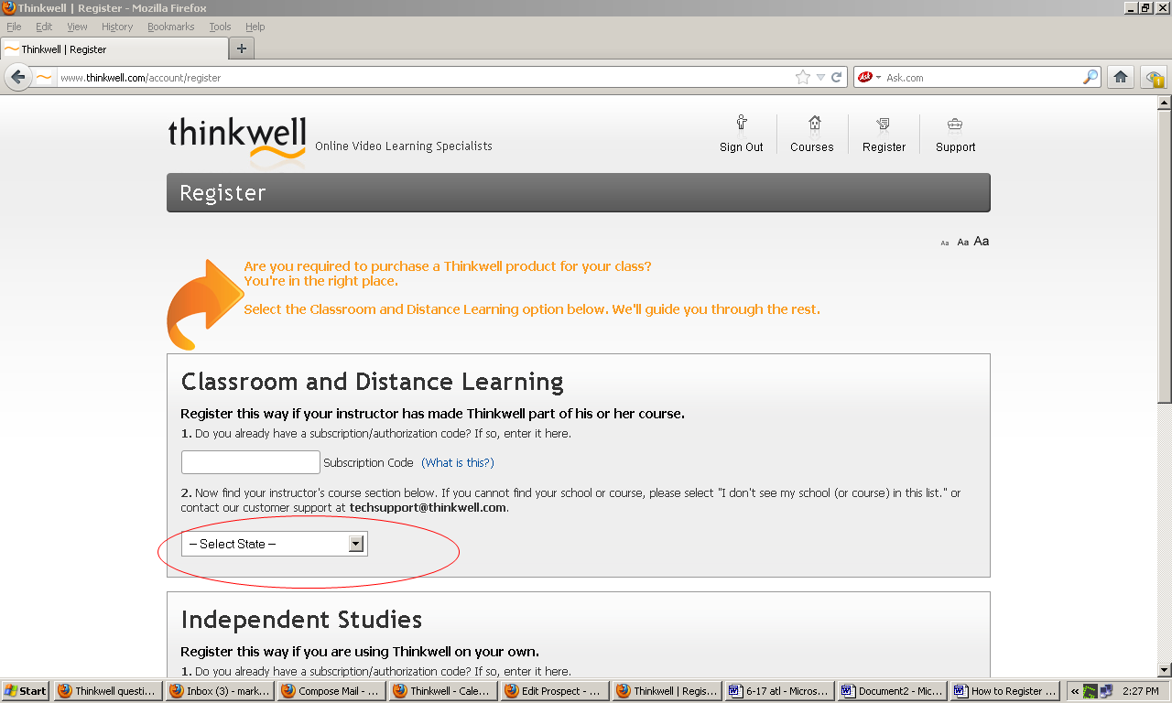

3. Use the pull-down menu to select your school.

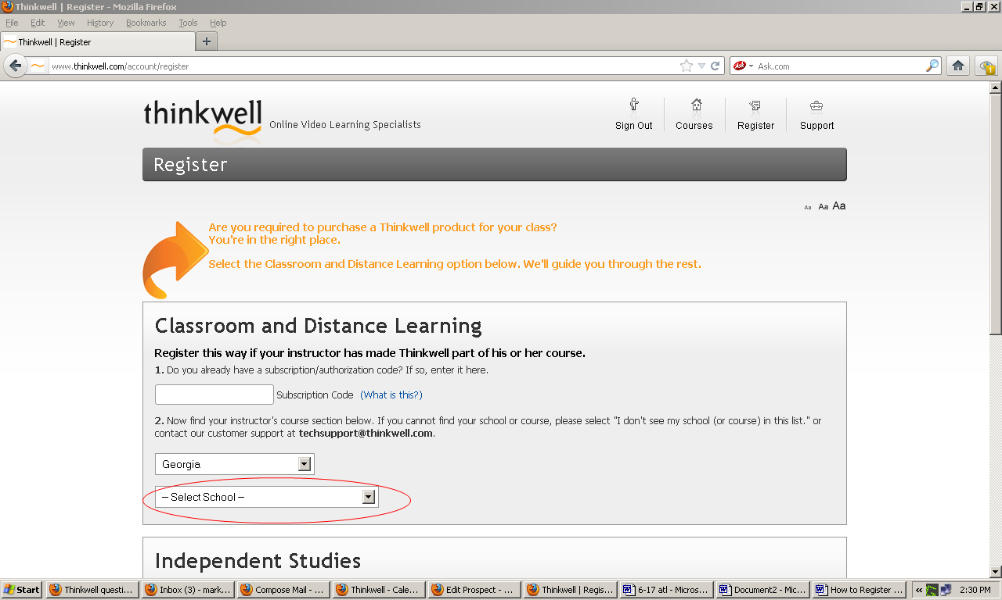
4. Use the pull-down menu to select your class section, then click “Register without Subscription Code” and follow the onscreen instructions.

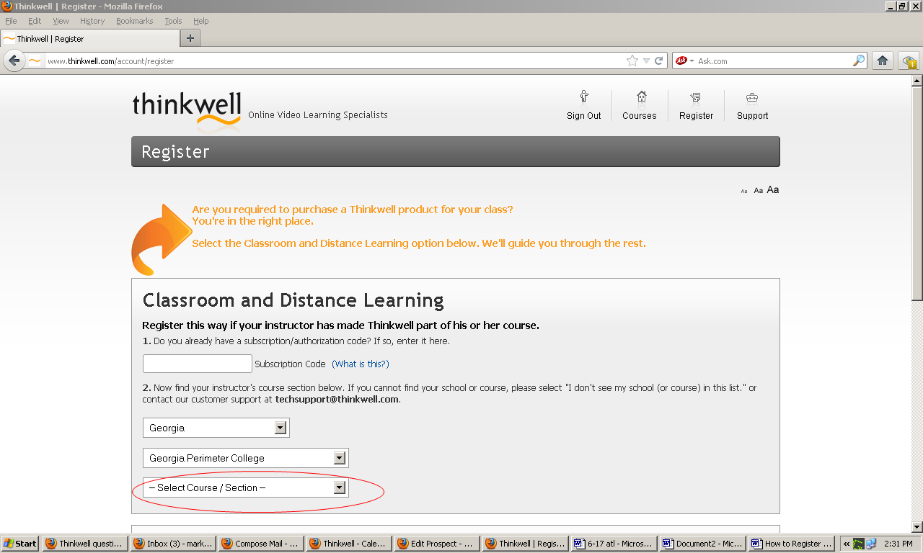

- Both classroom and distance learning students should check the button labeled "Classroom Registration," then click "Continue."

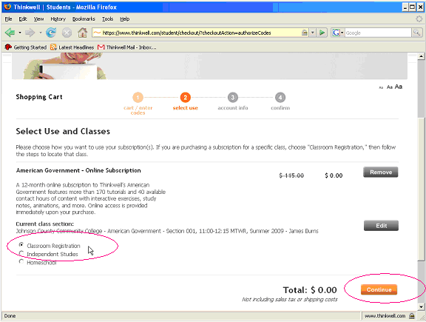

6. Follow the instructions to enter the required fields.

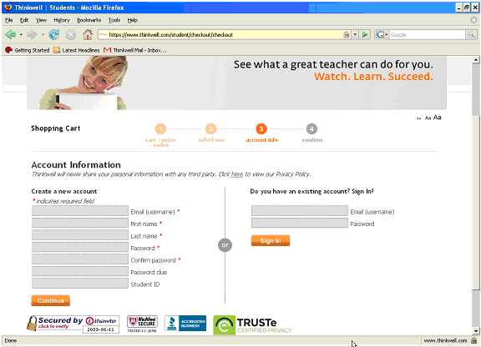

7. Next time you come to Thinkwell.com, click the “Sign In” button to enter your username and password.
