**SUMMARY OF THE MODELS OF UNIT 4**

**Lessons 12a and 13a: Eight Labor Market Models**

1. Competitive labor market in a competitive product market  
2. Competitive labor market in an imperfectly competitive product market  
3. Monopsony  
4. Union Model: increasing demand for labor  
5. Union Model: craft (exclusive) union  
6. Union Model: industrial (inclusive) union  
7. Union Model: bilateral monopoly  
8. Minimum Wage (three models)

a. traditional minimum wage model  
b. minimum wage in a monopsony  
c. minimum wage and the price elasticity of demand for labor

**Lesson 20a: Income Inequality**

MODEL: The Case for Equality: The Utility Maximizing Distribution of Income (The 5Es President Example)

MODEL: The Occupational Segregation Model of Discrimination

**Lesson 22a: Immigration**

MODEL: A Simple Immigration Model

MODEL: Impact of Illegal Workers in a Low Wage Labor Market

**Eight Labor Market Models - SUMMARY**

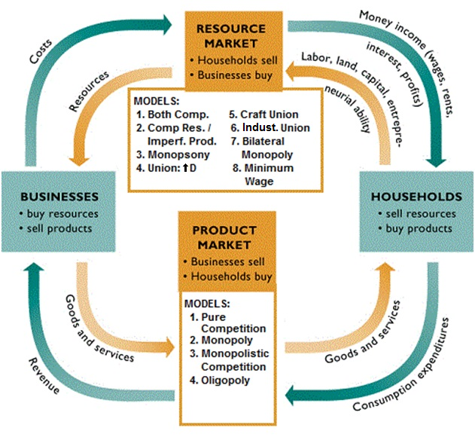

**Eight Labor Market Models**

1. Competitive labor market in a competitive product market  
2. Competitive labor market in an imperfectly competitive product market  
3. Monopsony  
4. Union Model: increasing demand for labor  
5. Union Model: craft (exclusive) union  
6. Union Model: industrial (inclusive) union  
7. Union Model: bilateral monopoly  
8. Minimum Wage (three models)

a. traditional minimum wage model  
b. minimum wage in a monopsony  
c. minimum wage and the price elasticity of demand for labor

For EACH model know the following:

1. assumptions, characteristics, and examples  
2. graph  
3. find the profit maximizing quantity of labor (this is the quantity that WILL BE HIRED, where MRP = MRC)  
4. find the allocatively efficient quantity of labor (where VMP = W, or Qd=Qs)

You will find a summary of each of these eight (actually ten) models in our Yellow Pages. It is strongly recommended that you study these summaries.

**REMEMBER: to find the profit maximizing quantity of workers to hire firms will continue to hire up to the point where MRP = MRC.**

**So for any questions that ask "how many will be hired?" or "what will the wage be?", the first thing you do is calculate MRP and MRC and then hire all where the MRP is greater than MRC (MRP > MRC) up to where MRP = MRC.**

**Perfect Comp. in the Labor Market and Perfect Comp. in the Product Market 12a**

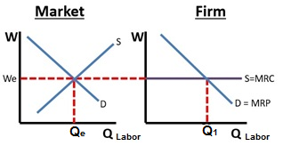

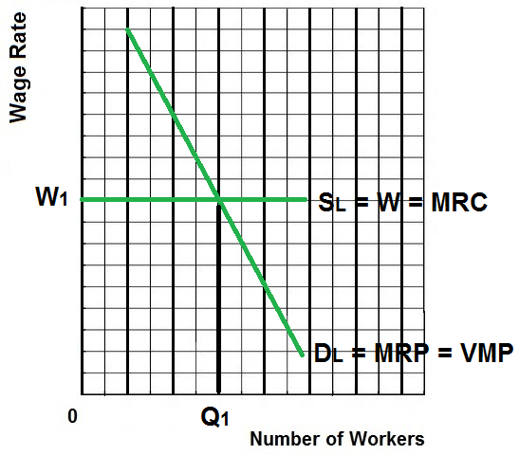

**Explanation / Characteristics / Results:**

* Competitive Product Market (Pure Competition)
  + Very many producers
  + Producing a standardized product
  + No barriers to entry
  + No market power
  + The demand curve for the product is horizontal (perfectly elastic) at the market price
  + We assume a competitive product market so Dlabor = MRP = VMP
  + Example: Agriculture
* Competitive Labor Market:
  + Very many qualified workers with identical skills
  + Workers are therefore “wage takers” with no power to get a higher wage
  + Therefore the supply of labor graph (Slabor = W) is horizontal (perfectly elastic) at the market wage
  + Example: The market for unskilled labor – Walmart hiring unskilled workers
* Example of Competitive Product Market in a Competitive Labor Market: Agriculture hiring unskilled labor
* Result:
  + Profit maximizing (equilibrium) quantity to hire is Q1 (where MRP = MRC)
  + Allocatively efficient quantity to hire is Q1 (where VMP = W)
  + We know that a competitive product market is allocatively efficient in the product market. They are also allocatively efficient in the labor market.

**Perfect Comp. in the Labor Market and Imperfect Comp. in the Product Market 12a**

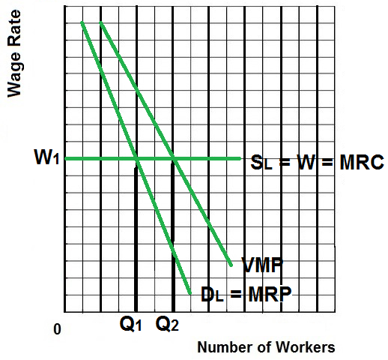

**Explanation / Characteristics / Results:**

* Imperfect Competition in the Product Market (Monopoly or Oligopoly)
  + One or Few producers
  + Significant barriers to entry
  + A lot of market power
  + The demand curve for the product is downward sloping – firm must lower its price to sell more
  + Example: Monopolies and Oligopolies
* Competitive Labor Market:
  + Very many qualified workers with identical skills
  + Workers are therefore “wage takers” with no power to get a higher wage
  + Therefore the supply of labor graph (Slabor = W) is horizontal (perfectly elastic) at the market wage
  + Example: The market for unskilled labor
* Example of imperfectly competitive product market in a competitive labor market:
  + Most businesses hiring unskilled labor
  + We know that monopolies and oligopolies will produce less and sell at a higher price and are allocatively inefficient in the product market, therefore they will hire fewer workers and are allocatively inefficient in the labor market.
* Results:
  + Profit maximizing (equilibrium) quantity to hire is Q1 (where MRP = MRC)
  + Allocatively efficient quantity to hire is Q2 (where VMP = W)

**Monopsony 13a**

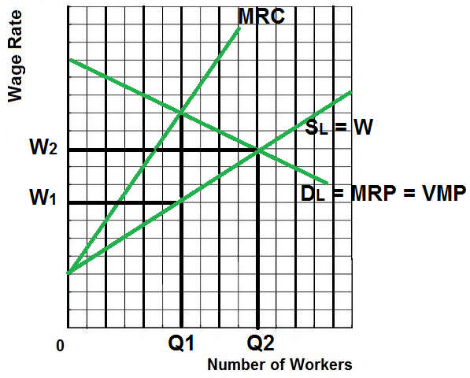

**Explanation / Characteristics / Results:**

* A single buyer of labor
* Examples:
  + Major employer in a small town
  + A mining town in Appalachia
  + A Colorado ski town
* Firm is a “wage maker” – they will try to pay as low a wage as possible, therefore the supply of labor graph is upward sloping.
* MRC is higher than the wage because when they raise wages to hire more workers they must also raise the wages of all current employees which makes the cost of hiring another worker very high.
* We assume a competitive product market so Dlabor = MRP = VMP
* Results:
  + Profit maximizing (equilibrium) quantity to hire is Q1 (where MRP = MRC)
  + Wage paid is W1
  + Allocatively efficient quantity and wage is Q2 and W2 (where VMP = W)

**Union Model – Increasing the Demand for Labor 13a**

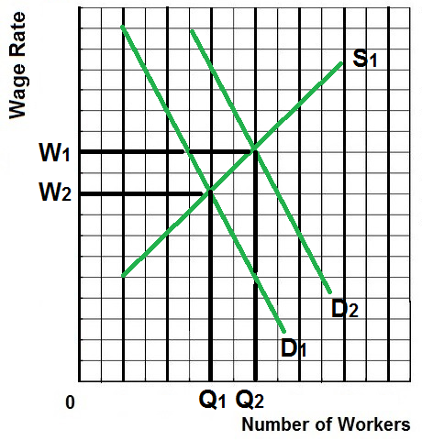

**Explanation / Characteristics / Results:**

* To increase wages some unions try to increase demand for union labor
* To keep things simple assume a competitive product market so Dlabor = MRP = VMP
* How? (See determinants of labor demand lesson 12a)
  + Increase demand for the products they produce  
    Example: unions lobby governments for more government construction projects
  + Increase demand for union labor by increasing the price of substitute resources  
    Example: unions support increases in the minimum wage even though union workers are already paid more than the minimum wage
  + Increase demand for union labor by decreasing the price of complimentary resources  
    Example: trucking unions support allowing more low wage foreign agricultural workers to enter the country so that there are more agricultural products to haul

**Exclusive or Craft Union (Decreasing the Supply of Labor) 13a**

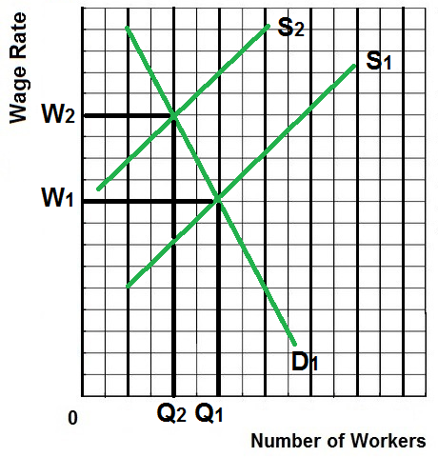

**Explanation / Characteristics / Results:**

* Some unions try to increase wages by reducing the supply of labor
* To keep things simple assume a competitive product market so Dlabor = MRP = VMP
* Examples – Some unions support:
  + restricting immigration
  + laws banning child labor
  + compulsory retirement
  + shorter work week
* Craft (or Exclusive) Unions
  + A union of workers that all possess a certain skill
  + They then restrict membership in the union through various means including high fees and long apprenticeships
  + Examples: electricians union, carpenters union, plumbers union
  + A similar technique to increase wages is used by professional organizations like the American Medical Association (doctors), the American Bar Association (lawyers) and the National Education Association (teachers) which try to set strict and difficult requirements for getting a license to work in their fields
  + Even barbers and hair stylists support licensing requirements that restrict how many people can cut and style hair.
* Results:
  + Therefore the firm will hire Q2 workers at a wage of W2. This is the equilibrium or profit maximizing quantity to hire.
  + Allocatively efficient quantity to hire is Q1 (where VMP = W). Exclusive unions cause allocative inefficiency in the labor market.

**Inclusive or Industrial Union 13a**

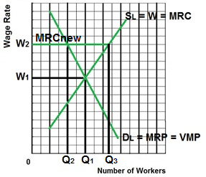

**Explanation / Characteristics / Results:**

* Inclusive (Industrial) Unions try to include all workers of a company in the union including skilled workers and unskilled workers, assembly line workers, secretaries, etc.
* Then they increase wages by threatening to go on strike (all workers will stop working which will shut down the company).
* To keep things simple assume a competitive product market so Dlabor = MRP = VMP
* Examples:
  + Autoworkers union
  + Steelworkers union
* Result:
  + W1 is the competitive wage if there is no union
  + W2 is the union negotiated wage rate
  + Since all workers must be paid W2 it becomes the firms new MRC (extra cost of hiring one more worker)
  + Therefore the firm will hire Q2 workers because this is where MRP = MRCnew (the new profit maximizing quantity to hire with the union contract)
  + Q1 is the allocatively efficient quantity to employ (the competitive quantity) so inclusive unions cause allocative inefficiency in the labor market.
  + At the Union wage of W2, Q3 workers want to work but only Q2 workers are hired creating a surplus of labor.

**Bilateral Monopoly 13a**

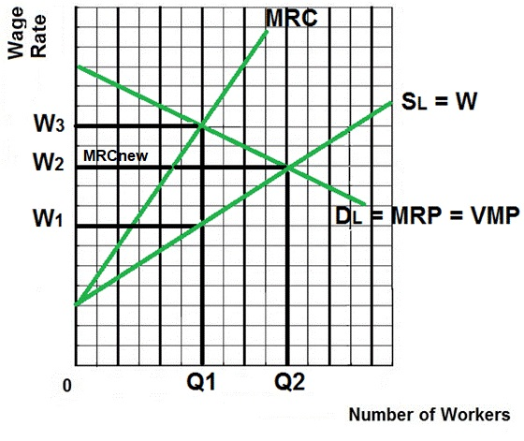

**Explanation / Characteristics / Results:**

* A Bilateral Monopoly exists if you have an inclusive union working for a monopsony – a single seller of labor (the union) and a single buyer of labor (the large company)
* Examples: Steel industry, automobile industry, professional sports teams, aircraft manufacturing
* To keep things simple we assume a competitive product market so Dlabor = MRP = VMP
* Result:
  + Indeterminate; we can’t tell what the quantity of labor will be or the wage rate, it depends on negotiations between the company and the union
  + The efficient quantity of labor and wage is Q2 and W2 (where VMP = W)
  + The company (monopsony) wants to pay W1 and hire Q1 where MRP = MRC (alloc. Inefficiency in the labor market)
  + The union wants a wage of W3 and the firm will hire Q1 (alloc. Inefficiency in the labor market)
  + After negotiations, the likely resulting wage will be between W1 and W3.
  + If they negotiate a wage rate of W2 then that rate becomes the firms new MRC (the extra cost of hiring one more worker will be the negotiated wage rate) and the firm will hire Q2 (where MRP = MRCnew)
  + Once the union and the company agree on a wage rate between W1 and W2:
    - MORE WILL BE EMPLOYED
    - the labor market could achieve allocative efficiency (VMP = W at Q2)

**Minimum Wage – The Traditional Price Floor Model (FEWER are employed) 13a**

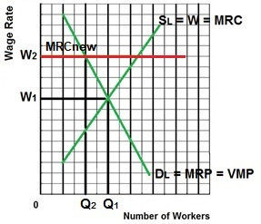

**Explanation / Characteristics / Results:**

* Assume that without the minimum wage we have a competitive product market and a competitive labor market
* Without the minimum wage Q1 will be employed at a wage of W1 and the labor market is allocatively efficient (MRP = MRC and VMP = W).
* Results with a minimum wage set at W2:
  + Higher wage (W2 instead of W1)
  + Fewer employed (Q2 instead of Q1; where MRP = MRCnew)
  + Allocative inefficiency. Fewer workers than the efficient (competitive) quantity will be employed.
  + Similar to what happens with an effective price floor in the product market.

**Minimum Wage with a Monopsony (MORE are employed) 13a**

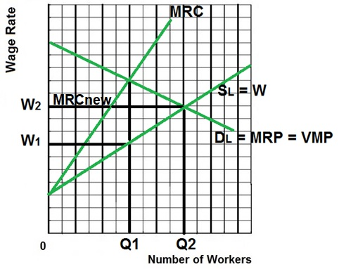

**Explanation / Characteristics / Results:**

* To keep things simple we assume a competitive product market so Dlabor = MRP = VMP
* Example: Minimum wage in a non-unionized one industry town like a steel mill town, mining town in Appalachia, or a small Colorado ski town.
* The allocatively efficient quantity is Q2 (where VMP = W)
* Without minimum wage Q1 would be employed by the monopsonist at a wage of W1 (allocative inefficiency)
* Results with a minimum wage set at W2:
  + Wages increase from W1 to W2
  + **Quantity of labor hired increases from Q1 to Q2** (where MRP = MRCnew)
    - W2 becomes the firm’s new MRC curve (the extra cost of hiring one more worker is the minimum wage that they have to pay)
    - To maximize profits firms will hire the quantity of labor where MRP = new MRC
    - With the minimum wage the profit maximizing quantity to hire for a monopsony will be Q2, more than what they would hire if they could pay a lower wage.
    - The quantity of labor will be allocatively more efficient

**Minimum Wage and Price Elasticity of Demand for Labor 13a  
(Jobs are lost, but do the poor gain more income?)**

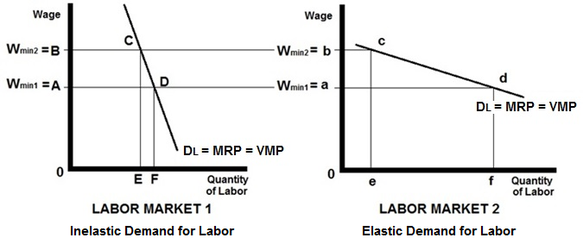

**Explanation / Characteristics / Results:**

* To keep things simple we assume a competitive product market so Dlabor = MRP = VMP
* The traditional minimum wage model predicts less employment, but will the poor be better off even though more are unemployed? Will their total incomes be higher?
* It depends on the price elasticity of demand for labor
* If the demand for labor is INELASTIC (see Labor Market 1 graph) :   
  raising the minimum wage from A to B will increase incomes from 0ADF to 0BCE. This is good for the working poor.
* If the demand for labor is ELASTIC (see Labor Market 2 graph):   
  raising the minimum wage from a to b will decrease incomes from 0adf to 0bce. This is bad for the working poor.
* Determinants of elasticity of labor demand (review from lesson 12a)

1. Ease of Labor Substitutability

* + If there are MANY SUBSTITITES for labor, then the demand for labor is MORE ELASTIC
  + If there are FEW SUBSTITUTES for labor, then the demand for the labor is LESS ELASTIC

2. Elasticity of Product Demand

* If demand for the product is MORE ELASTIC, then demand for the labor used to produce the product is MORE ELASTIC
* If demand for the product is LESS ELASTIC, then demand for the labor used to produce the product is LESS ELASTIC

3. Labor-Cost to Total-Cost Ratio

* If the labor cost is a LARGE FRACTION of the total costs, then demand for labor is MORE ELASTIC
* If the labor cost is a SMALL FRACTION of the total costs, then demand for labor is LESS ELASTIC

**MODEL - The Case for Equality = The President Trump Example of the 5Es 20a**

**The Utility Maximizing Distribution of Income**

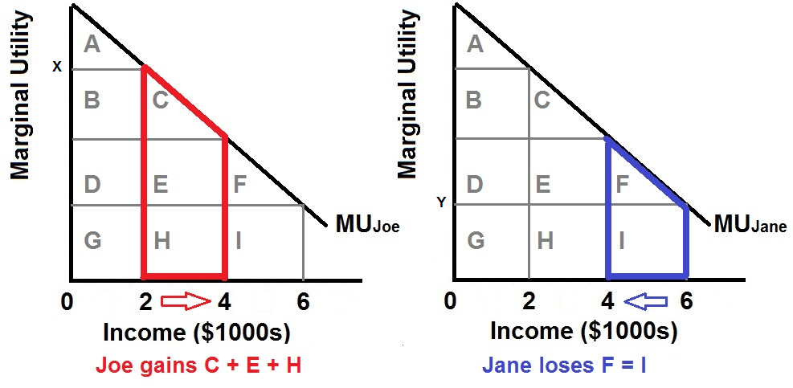

**Assumptions:**

* Assume that the money incomes of two individuals, Joe and Jane, are subject to diminishing marginal utility.
* In any time period, income receivers spend the first dollars received on the products they value most, products whose marginal utility is high.
* The identical diminishing-marginal-utility-from-income curves (MU*Joe* and MU*Jane* in the figure) reflect the assumption that Joe and Jane have the same capacity to derive utility from income.
* Income is initially unequally distributed (say, $2000 to Joe and $6000 to Jane), therefore, the marginal utility derived from the last dollar will be greater for Joe (X) than for Jane (Y).

**Conclusions:**

* The basic argument for an equal distribution of income is that income equality maximizes total consumer satisfaction (utility) from any particular level of output and income.
* If a single dollar of income is shifted from Jane to Joe, that is, toward greater equality, then Joe’s utility increases by X and Jane's utility decreases by Y. The combined utility then increases by X minus Y (Joe's large gain minus Jane's small loss).
* The area under the MU curve and to the left of the individual's particular level of income represents the total utility of that income. Therefore, as a result of the transfer of the $2000, Joe has gained utility represented by the red area below curve MU*Joe* (area C + E + H), and Jane has lost utility represented by the blue area below curve MU*Jane* (area F + I).
* The red area is obviously greater than the blue area, so if the income distribution is initially unequal, then distributing income more equally can increase the combined utility of the two individuals**.**

**Criticisms: Incentives and Efficiency (The Equality-Efficiency Trade-off)**

* Although the logic of the argument for equality is sound, critics attack its fundamental assumption that there is some fixed amount of output produced and therefore income to be distributed.
* Critics of income equality argue that the way in which income is distributed is an important determinant of the amount of output, or income, that is produced and is available for distribution. A more equal distribution of income may be a disincentive to work and cause the total amount of income to decrease. (the Equality-Efficiency trade-off).

**MODEL - The Occupational Segregation Model of Discrimination 20a**

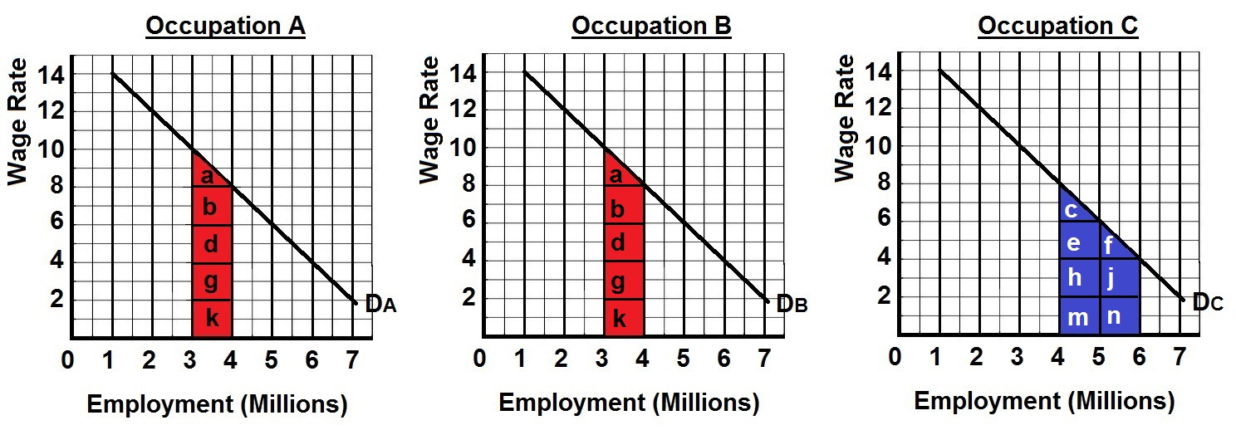

**Assumptions:**

* the labor force is comprised of 6 million men and 6 million women workers
* the economy has 3 occupations, A, B, and C, each having identical demand curves for labor
* men and women workers are homogeneous with respect to their labor-market capabilities
* women are discriminated against by being excluded from occupations A and B and are confined to C
* except for discrimination, the economy is competitive, therefore Dlabor = MRP = P x MP.
* There areno barriers to mobility between the occupations for men.

**Conclusions:**

* Men would distribute themselves equally in occupations A and B (3 million in each) and earn high wages, $10
* All 6 million women will be crowded into occupation C and earn low wages, $4
* **The result of discrimination is a loss of output for society** (less is being produced with the same number of workers)
  + Remember that labor demand reflects labor's marginal revenue product (MRP = P x MP), which is labor's contribution to domestic output.
  + Thus, the red areas for occupations A and B (a + b + d + g + k in each occupation) in the figure above show the decrease in domestic output (MP x P) caused by subtracting 1 million women from each of these occupations.
  + Similarly, the blue area for occupation C (c + e + h+ m + f + j + n) shows the increase in domestic output caused by moving 2 million women into occupation C.
  + Although society would gain the added output represented by the blue area in occupation C, it would lose the output represented by the sum of the red areas in occupations A and B. **That output loss exceeds the output gain, producing a net output loss for society caused by discrimination.**
* **If discrimination disappears**, women, attracted by higher wage rates, shift from occupation C to A and B
  + 1 million women move into A and another 1 million move into B.
  + Ending discrimination clearly benefits women, who now receive higher wages; it hurts men, who now receive lower wages.
  + **Society gains.** The elimination of occupational segregation reverses the net output loss discussed above. Society gains the output represented by the two red areas in occupations A and B and loses the output represented by the blue area in occupation C. **When discrimination is ended society gains more than it loses.**

**MODEL - A Simple Immigration Model 22a**

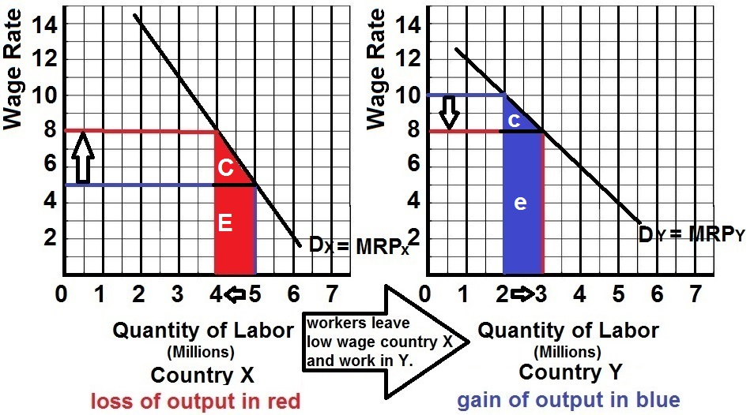

**Assumptions:**

* *Dx* is the demand for labor in country X; *Dy* is the demand for labor in country Y. The demand for labor presumably is greater in the country Y because it has more capital, more advanced technology, and better infrastructure that enhance the productivity of labor. Therefore, wages are higher in country Y
* before-migration the labor force of country X is 5 million and the wage is $5
* before-migration the labor force of country Y is 2 million and the wage is $10
* there is full employment in both countries;
* labor quality is the same in both countries.
* migration (1) has no cost, (2) occurs solely in response to wage differentials, and (3) is unimpeded by law in both countries

**Conclusions:**

* workers will migrate from low wage country X to high wage country Y until wage rates in the two countries are equal at$8
* At that level, 1 million workers will have migrated from country X to Country Y.
* In country Y, the wage rate will decrease from $10 to $8
* In country Y the domestic output (the sum of the marginal revenue products of the entire workforce) will increase as shown by the blue area c + e.
* In country X, the wage rate will rise from $5 to $8
* In country X the domestic output (the sum of the marginal revenue products of the entire workforce) will decrease as shown by the red area C + E.
* Observe that the gain in domestic output in country Y exceeds the loss of domestic output country X. The migration from Y to X has increased the world's output and income.
* Migration enables the world to produce a larger output with its currently available resources. So labor mobility joins international trade in enhancing the world's standard of living.

**MODEL - Impact of Illegal Workers in a Low Wage Labor Market 22a**

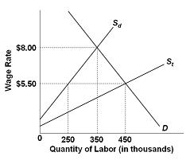

**Assumptions:**

* Employers in this market are willing and able to ignore minimum wage laws
* Sd represents the supply of domestically-born (and legal immigrant) workers;
* St represents the total supply of workers in this labor market (Sd plus illegal immigrants
* The horizontal distances between *St* and *Sd* at the various wage rates measure the number of illegal immigrants offering their labor services at those wage rates
* Unless otherwise stated, illegal immigration is *not* effectively blocked by the government.

**Conclusions:**

* With illegal workers present, as implied by curve *St*, the equilibrium wage and level of employment in this labor market are $5.50 and 450,000.
* At the low wage of $5.50
  + Only 250,000 domestic-born workers are willing to work
  + the other workers (200,000) are illegal immigrants.
* Can we therefore conclude that illegal workers have filled jobs that most U.S.-born workers do not want?
  + The answer is “yes,” but only with the proviso: “at wage rate $5.50”
  + if the United States cut off the full inflow of illegal workers to this market, the relevant supply curve would be *Sd* and the wage rate would rise to $8.00. Then 100,000 more domestic-born workers would work and 200,000 illegal immigrants would lose jobs.
* Can we therefore conclude that illegal workers reduce the employment of Americans by an amount equal to the employment of illegal workers? No.
* illegal immigration causes some substitution of illegal workers for domestic workers, but the amount of displacement is less than the total employment of the illegal workers. Illegal immigration, as with legal immigration, increases total employment in the United States.