**ECO 211 Microeconomics Math Prequiz**

Students in ECO 211 are expected to be able to do the following types of math problems. If you cannot, you should seriously consider withdrawing from the course and improve your math skills before registering again. At Harper College about 40 % of the students who register for ECO 211 receive a final grade of “W”, “F”, or “D”. Studies have shown that one contributing factor of this low success rate is the lack of mathematical skills (Anderson, et. al. 1994, Ballard and Johnson 2004, Hafer, 2002; ).

**Please complete the following. You may NOT use a calculator and you must show your work.**

1. Solve for x.

150 = x/3

1. Solve for x.

8 = 40/x

1. Find the average of the following:

24  
27  
28  
30  
35  
36

1. If there are 8 people with an average income of $15,000, what is their total income?
2. Find the slope of line A on the graph below:

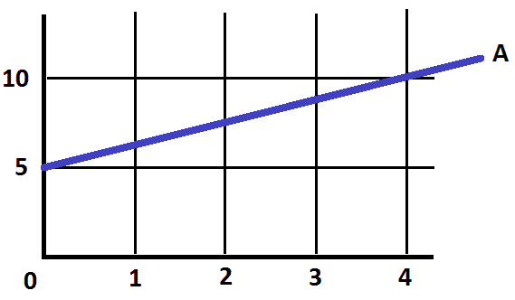

1. What is 5% of 160?
2. 24 is what % of 400?
3. In 2009 Joe’s income was $48,000. Three years later in 2012 his income was $66,000. By what percent did his income increase in that three year period?
4. Add the following:

10  
 5  
 -8  
 3  
-15  
 20

1. Express 0.60 as a fraction.
2. Express 1/8 as a decimal.
3. Reduce 6/63 to its lowest terms.
4. Joe earns $60,000 a year. What is his average monthly salary?
5. Find the area of the following:

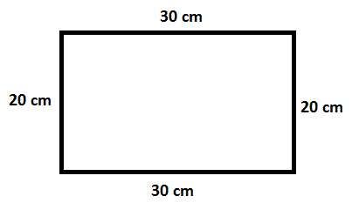

1. Find the area of the following:

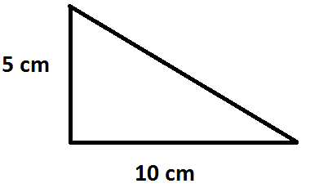

1. Calculate:

.5 ÷ 2.5

1. Calculate:

.8/.2

1. Calculate:

.2/.8

1. Calculate:

.5 x 22

1. Calculate:

.08 x .022

1. Calculate:

1/5 x 4/5

1. Calculate:

1/2 x 1/2

Anderson, G., Benjamin, D., and Fuss, M. “The Determinants of Success in University Introductory Economics Courses”. *The Journal of Economic Education*. 1994.

Ballard, C. and Johnson, M. “Basic Math Skills and Performance in an Introductory Economics Class”. *The Journal of Economic Education*. 2004.

Hafer, Gail Heyne,. “Do entry-level math skills predict success in principles of economics?” http://www.thefreelibrary.com/Do+entry-level+math+skills+predict+success+in+principles+of+economics%3F-a0166751881