**ECO 211 Name: ________________________________**

**Math Pre-Quiz Class Meeting time: _____________________**

**Complete the following, circle the answer below AND mark the letter of your answer on the Scantron answer sheet provided.**

**You may NOT use a calculator and YOU MUST SHOW YOUR WORK. Correct answers without the work shown will receive no credit.**

1. Solve for x.

$$150=\frac{x}{3}$$

a. 3 b. 50 c. 150 d. 300 e. 450

1. Solve for x.

$$8=\frac{40}{x}$$

a. 5 b. 8 c. 32 d. 320 e. 840

1. Solve for x.

$$20=8x+4$$ a. 2 b. 6 c. 8 d. 12 e. 32

1. Find the average of the following:

24  
27  
28  
30  
35  
36

a. 24 b. 27 c. 30 d. 36 e. 180

1. If there are 8 people with an average income of $15,000, what is their total income?

a. $8 b. $1,875 c. $15,000 d. $120,000 e. $150,000

1. Joe earns $60,000 a year. What is his average monthly salary?

a. $5000 b. $30,000 c. $60,000 d. $600,000 e. $720,000

1. Find the slope of line A on the graph below:

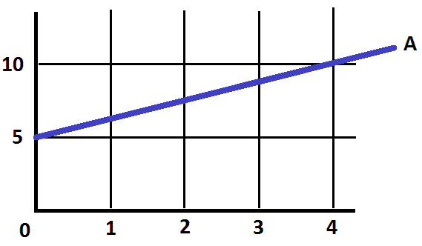

a. 0 b. 0.8 c. 1.2 d. 20 e. 400

1. What is 5% of 160?

1. 0.5 b. 8 c. 32 d. 165 e. 800
2. 24 is what % of 400?

a. 0.06% b. 4 % c. 6 % d. 16 2/3% e. 24%

1. In 2009 Joe’s income was $48,000. Three years later in 2012 his income was $66,000. By what percent did his income increase in that three year period?

a. 18 % b. 27.3 % c. 33 % d. 37.5 % e. 72.3 %

1. Add the following:

10  
 5  
 -8  
 3  
-15  
 20

a. -23 b. 0 c.15 d. 38 e. 61

1. Express 0.60 as a fraction.

a. 10/6 b. 5/3 c. 100/60 d. 60/10 e. 60/100

1. Express 1/8 as a decimal.

a. 0.125 b. 0.25 c. 0.8 d. 1.0 e. 8.0

1. Reduce 6/63 to its lowest terms.
2. 6/63 b. 3/21 c. 63/6 d. 57 e. 69
3. Find the area of the following:

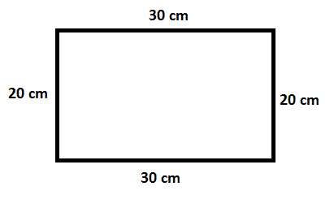

1. 50 cm2 b. 100 cm2 c. 600 cm2 d. 1200 cm2 e. 3600 cm2
2. Find the area of the following:

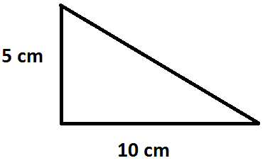

1. 5 cm2 b. 15 cm2 c. 25 cm2 d. 50 cm2 e. 125 cm2
2. Calculate:

0.8 ÷ 0.2

1. 0.25 b. 0.4 c. 0.6 d. 4 e. 16
2. Calculate:

0.5 x 22

1. 1.1 b. 4.4 c. 11 d. 44 e. 110
2. Calculate:

1/2 x 1/2

1. 1/22 b. 1/4 c. 1 d. 4 e. 12
2. Calculate:

1/4 ÷ 1/8

a. 1/32 b. 1/12 c. 1/4 d. 1/2 e. 2