**ECO 211 Name: ________________________________**

**Math Pre-Quiz Class Meeting time: _____________________**

**Please complete the following. You may NOT use a calculator and YOU MUST SHOW YOUR WORK.**

1. Solve for x.
$$150=\frac{x}{3}$$

2. Solve for x.

$$8=\frac{40}{x}$$

1. Solve for x.

$$20=8x+4$$

1. Find the average of the following:

24  
27  
28  
30  
35  
36

1. If there are 8 people with an average income of $15,000, what is their total income?

1. Joe earns $60,000 a year. What is his average monthly salary?

1. Find the slope of line A on the graph below:

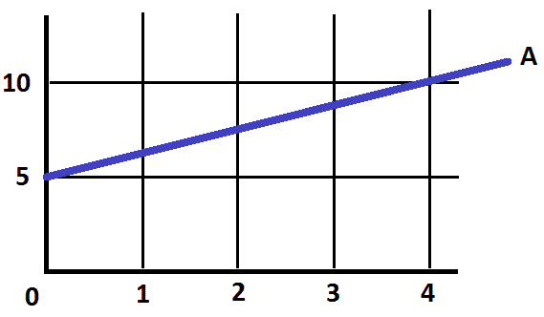

1. What is 5% of 160?

1. 24 is what % of 400?
2. In 2009 Joe’s income was $48,000. Three years later in 2012 his income was $66,000. By what percent did his income increase in that three year period?
3. Add the following:

10  
 5  
 -8  
 3  
-15  
 20

1. Express 0.60 as a fraction.

1. Express 1/8 as a decimal.

1. Reduce 6/63 to its lowest terms.

1. Find the area of the following:

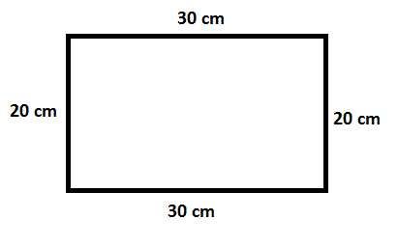

1. Find the area of the following:

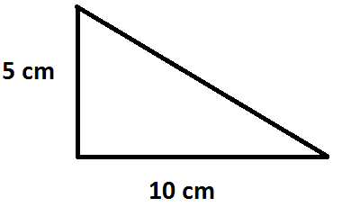

1. Calculate:

0.8 ÷ 0.2

1. Calculate:

0.5 x 22

1. Calculate:

1/2 x 1/2

1. Calculate:

1/4 ÷ 1/8