Getachew and Malathy,

Here is a math skills quiz from: Ballard, C. and Johnson, M. “Basic Math Skills and Performance in an Introductory Economics Class”. *The Journal of Economic Education*. 2004.

Mark  
  
1. Solve the following system of equations for x:

x = y- 6, y= 10

(a) -60   
(b) 10/6   
(c) 3  
 (d) 4   
(e) -4

2. Solve the following system of equations for x:

y = 2x +3, y = 3x

(a) 0   
(b) 3   
(c) 3/5   
(d) -3/2   
(e) none of the above

3. Suppose that



Then if a = 6 and b = 2, solve for x.

(a) 12   
(b) 8   
(c) 3   
(d) 4   
(e) 1/3

4. Suppose that



Then if x = 4 and b = 2, solve for a.

(a) 1/2   
(b) 2   
(c) 4   
(d) 8   
(e) 16

5. Suppose



Then if x = 4 and a = 8, solve for b.

(a) 1   
(b) 2   
(c) 32   
(d) 4   
(e) 1/2

6. Perform the following division:



(a) 3   
(b) 3/2  
(c) 3/4   
(d) 4/3   
(e) 1/3

7. Find the area of the right triangle drawn below.

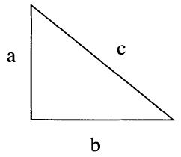

The length of side a = 3 and the length of side b = 4, and the length of side c = 5.

The area of the triangle is:

(a) 3   
(b) 4   
(c) 6   
(d) 12   
(e) 25

8.   
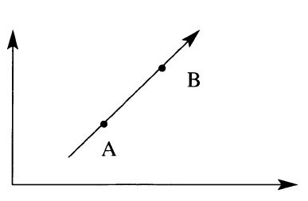

The coordinates of point A are (1,2) and the coordinates of point B are (2,4). Find the slope of the line.

(a) 1/2   
(b) 1   
(c) -1   
(d) 2   
(e) -2

9.  
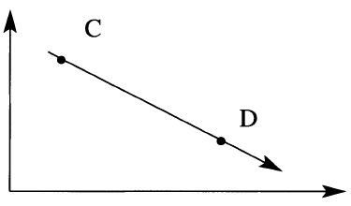

The coordinates of point C are (1,4) and the coordinates of point D are (5,2). Find the slope of the line.   
(a) 1/2   
(b) -1/2   
(c) 2   
(d) -2   
(e) 5/4

10. Suppose you want to carpet a rectangular room that is 6 feet by 12 feet. Carpet costs $10 per square yard. Note that 1 yard = 3 feet. How much does it cost to carpet the room?   
(a) $720   
(b) $2160   
(c) $240   
(d) $80   
(e) $8