CHAPTER 8: Consumer Behavior and Utility Maximization
What is UTILITY?

Define MARGINAL UTILITY and give its FORMULA.

What is the LAW OF DIMINISHING MARGINAL UTILITY?

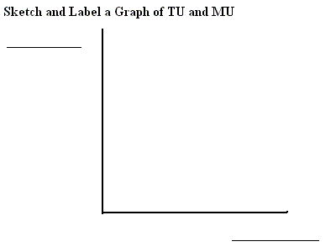
Can utility be measured?

Write the Benefit-Cost Analysis formula

Write the utility maximizing rule formula

Explain why the utility maximizing rule is really a version of Benefit-Cost Analysis.

PROBLEM 1
Assume that a consumer purchases a combination of products A and B. The MUa is 5 and the Pa is $5. The MUb is 6 and the Pb is $6.
What should this consumer do to maximize utility?

PROBLEM 2
Assume that a consumer purchases a combination of products Y and Z. The MUy is 50 and the Py is $25. The MUz is 20 and the Pz is $5.
What should this consumer do to maximize utility?

PROBLEM 3
Columns 1 through 3 in the table below show the marginal utility which a particular consumer would get by purchasing various quantities of products A, B, and C.
Unit of product | MU, A ____________ | MU, B ___________ | MU, C ___________
First | 18 | 39 | 12
Second | 16 | 36 | 10
Third | 14 | 33 | 9
Fourth | 12 | 30 | 8
Fifth | 10 | 27 | 7
Sixth | 8 | 24 | 5
Seventh | 6 | 21 | 3
If the prices of A, B, and C are $2, $3, and $1, respectively, and the consumer has $26 to spend on these three products, what combination of the three products should be purchased in order to maximize utility?

If the prices of A, B, and C are $2, $3, and $1, respectively
Unit of product | Marginal utility, A | MU/Pa | Marginal utility, B | MU/Pb | Marginal utility, C | MU/Pc
First | 18 | 9 | 39 | 13 | 12 | 12
Second | 16 | 8 | 36 | 12 | 10 | 10
Third | 14 | 7 | 33 | 11 | 9 | 9
Fourth | 12 | 6 | 30 | 10 | 8 | 8
Fifth | 10 | 5 | 27 | 9 | 7 | 7
Sixth | 8 | 4 | 24 | 8 | 5 | 5
Seventh | 6 | 3 | 21 | 7 | 3 | 3
The consumer has $26 to spend on these three products, what combination of the three products should be purchased in order to maximize utility?

