chapter twenty-one
Consumer Behavior
and Utility Maximization

CHAPTER OVERVIEW
This chapter may be omitted without damaging the continuity or understanding of the material in ensuing chapters. Those instructors who think it important to explain the law of demand on a more sophisticated level than that of previous chapters should assign this chapter. It may also be used as an enrichment chapter for brighter students. This chapter may be combined with Chapters 3 and 20.
The law of demand is explained in terms of (1) the income and substitution effects and (2) diminishing marginal utility. The latter approach leads into a detailed discussion of the theory of consumer choice. The numerical illustrations of the utility-maximizing rule should be viewed as a pedagogical technique, rather than an attempt to portray the actual choice-making process of consumers. When this illustration is explained by “order of purchase,” the brief algebraic summary of consumer equilibrium should pose no great difficulties for most students. The discussion of the diamond-water paradox helps students look beyond what may be their first conclusions about the importance and value of products.
The opportunity cost of time may be considered as a component of product price. This chapter concludes with a simplified integration of time into the theory of consumer behavior.
The appendix to this chapter introduces indifference curve analysis for those intending to pursue further study in economic, or for those who desire a more rigorous explanation of consumer choice. This material is linked to the coverage provided in the rest of the chapter by using indifference curve analysis to develop an individual’s demand curve for a product.

WHAT’S NEW
Many of the examples have been changed to make them more relevant to the students, but the numbers used in the tables have not been altered. The section on “transfers and gifts” has been revised and changed to “cash and in-kind gifts.” Note that “budget constraint” is used rather than “budget restraint.”

The Last Word is new. One of the Web-Based Questions has been revised.

INSTRUCTIONAL OBJECTIVES
After completing this chapter, students should be able to:
- Define and distinguish between the income and substitution effects of a price change.
- Explain why a consumer will buy more (less) of a commodity when its price falls (rises) by using the income and substitution effects.
- Define marginal utility and state the law of diminishing marginal utility.
- Explain how the law of diminishing marginal utility and price elasticity of demand are related.
- List four assumptions made in the theory of consumer behavior.
- State the utility-maximizing rule.
- Use the utility-maximizing rule to determine a consumer’s spending when given income, utility, and price data.
- Use the theory of consumer behavior to define the market shift to compact discs from records since the early 1980s.
- Explain the diamond-water paradox.
- Explain how the value of time fits in the theory of consumer behavior and give two examples of implications that result.
- Describe how the theory of consumer behavior helps us understand different values placed on time.
- Explain why a cash gift will give the receiver more utility than a noncash gift costing the same amount.
- Define and identify terms and concepts listed at the end of the chapter.
After completing the appendix, students should be able to:
- Define a budget constraint line and explain shifts in a budget constraint line.
- Explain three characteristics of indifference curves.
- Identify a consumer’s equilibrium position, given a set of indifference curves and a budget constraint line.
- Use indifference curve analysis to derive an individual’s demand curve for a product by showing consumption responses to a change in the price of the product.
- Define and identify terms and concepts listed at the end of the appendix

COMMENTS AND TEACHING SUGGESTIONS
- Demonstrate the law of diminishing marginal utility, and perhaps even the idea of a saturation point (MU = 0), by having a student consume jelly beans or something similar while you review the law of demand, income and substitution effects, etc. Normally, the student will stop eating in a few minutes even though the candy is “free.”
- Imagine a case in which marginal utility rises rather than diminishes with increased consumption. (Drug addiction comes to mind.) Reason with students how this would ultimately result in a consumer spending all of his/her income on this one good. Emphasize that this is fortunately not consistent with most consumer behavior. This helps support the law of diminishing marginal utility and the process by which consumers allocate their incomes among many different goods and services.
- Ask students to identify people who would be likely to value time very highly and others who would place a low value on time. Have them discuss how those two groups of people would react to such situations as: (a) waiting in line to buy a product; (b) shopping for hours to find the best prices on products such as cars, stereo equipment, and soft drinks; or (c) hiring cleaning, laundry, and gardening services.
- The marginal-total relationship presented in this chapter is the first of many the students will be asked to learn as they go through the Microeconomics chapters. Spend a little extra time on this relationship and explain that they will be using the concept in somewhat altered forms later in the course.
- What consumers decide to purchase depends on their personal preferences and priorities. No two people will make exactly the same decisions. Test this hypothesis by handing out monopoly money in different amounts and asking students to write down the purchases they would make with the sum given. Then have the students compare their choices. (This would be a good group activity.) Were there any identical lists? Some students got much more “money” than others. Was this “fair”? This exercise can be used to demonstrate the problem of making interpersonal comparisons and the problem of income inequality. Explain that the concept of consumer equilibrium puts each person in charge of his/her own satisfaction. The objective is to maximize their satisfaction but to stay within their budget.
- The final objective of the chapter is to illustrate the concept of a constrained maximum. Without the use of calculus this demonstration can be time consuming and confusing. Yet the equimarginal principle is a powerful tool and is central to the concept of efficiency with many applications. Consumer equilibrium, (where total utility is maximum) occurs when marginal utility per dollar is the same for every good consumed. This means that the consumer’s dollars are doing equal work at the margin. A dollar’s worth of taffy apples is giving the same satisfaction as a dollar’s worth of peanut butter cookies. Students may be able to grasp the concept intuitively by using physical examples (refer to the Last Word Chapter 1). Fast food customers try to join the shortest line and, in the process they make the food servers do equal work. The same thing happens in the grocery store as shoppers jockey for position at the check-out stand. A foreman of an assembly line achieves efficiency when he assigns workers tasks requiring equal time.
- Ask students to think about the silliest, most undesirable, ugliest or useless gift they ever received. Assuming the giver had good intentions, why was there a loss of efficiency?
- Debate: Resolved welfare recipients should be provided income in kind (food, clothing, shelter, etc.) not cash.

STUDENT STUMBLING BLOCK
The indifference curve analysis found in the appendix is most appropriate for advanced students or those who have had beginning calculus. While other students can grasp these concepts without calculus, the amount of time spent in explaining indifference curves has a great opportunity cost in terms of the topics that must be sacrificed later in most 12-to-15-week semesters. The topic is covered thoroughly in an intermediate microeconomic theory course.

LECTURE NOTES

I. Introduction

A. Americans spend trillions of dollars on goods and services each year—more than 95 percent of their after-tax incomes, yet no two consumers spend their incomes in the same way. How can this be explained?

B. Why does a consumer buy a particular bundle of goods and services rather than others? Examining these issues will help us understand consumer behavior and the law of demand.

II. Two Explanations of the Law of Demand

A. Income and substitution effects explain the inverse relationship between price and quantity demanded.

1. The income effect is the impact of a change in price on consumers’ real incomes and consequently on the quantity of that product demanded. An increase in price means that less real income is available to buy subsequent amounts of the product.

2. The substitution effect is the impact of a change in a product’s price on its expensiveness relative to other substitute products’ prices. A higher price for a particular product with no change in the prices of substitutes means that the item has become relatively more expensive compared to its substitutes. Therefore, consumers will buy less of this product and more of the substitutes, whose prices are relatively lower than before.

B. The law of diminishing marginal utility is a second explanation of the downward sloping demand curve. Although consumer wants in general are insatiable, wants for specific commodities can be fulfilled. The more of a specific product consumers obtain, the less they will desire more units of that product. This can be illustrated with almost any item. The text uses the automobile example, but houses, clothing, and even food items work just as well.

1. Utility is a subjective notion in economics, referring to the amount of satisfaction a person gets from consumption of a certain item.

2. Marginal utility refers to the extra utility a consumer gets from one additional unit of a specific product. In a short period of time, the marginal utility derived from successive units of a given product will decline. This is known as diminishing marginal utility.

3. Figure 21.1 and the accompanying table illustrate the relationship between total and marginal-utility.

a. Total utility increases as each additional tacos is purchased through the first five, but utility rises at a diminishing rate since each tacos adds less and less to the consumer’s satisfaction.

b. At some point, marginal utility becomes zero and then even negative at the seventh unit and beyond. If more than six tacos were purchased, total utility would begin to fall. This illustrates the law of diminishing marginal utility.

4. The law of diminishing marginal utility is related to demand and elasticity.

a. Successive units of a product yield smaller and smaller amounts of marginal utility, so the consumer will buy more only if the price falls. Otherwise, it is not worth it to buy more.

b. If marginal utility falls sharply as successive units are consumed, demand is predicted to be inelastic. That is, price must fall a relatively large amount before consumers will buy more of an item.

III. Theory of consumer behavior uses the law of diminishing marginal utility to explain how consumers allocate their income.

A. Consumer choice and the budget constraint:

1. Consumers are assumed to be rational, i.e. they are trying to get the most value for their money.

2. Consumers have clear-cut preferences for various goods and services and can judge the utility they receive from successive units of various purchases.

3. Consumers’ incomes are limited because their individual resources are limited. Thus, consumers face a budget constraint.

4. Goods and services have prices and are scarce relative to the demand for them. Consumers must choose among alternative goods with their limited money incomes.

B. Utility maximizing rule explains how consumers decide to allocate their money incomes so that the last dollar spent on each product purchased yields the same amount of extra (marginal) utility.

1. A consumer is in equilibrium when utility is “balanced (per dollar) at the margin.” When this is true, there is no incentive to alter the expenditure pattern unless tastes, income, or prices change.

2. Table 21.1 provides a numerical example of this for an individual named Holly with $10 to spend. Follow the reasoning process to see why 4 units of A and 4 of B will maximize Holly’s utility, given the $10 spending limit.

3. It is marginal utility per dollar spent that is equalized; that is, consumers compare the extra utility from each product with its cost.

4. As long as one good provides more utility per dollar than another, the consumer will buy more of the first good; as more of the first product is bought, its marginal utility diminishes until the amount of utility per dollar just equals that of the other product.

5. Table 21.2 summarizes the step-by-step decision-making process the rational consumer will pursue to reach the utility-maximizing combination of goods and services attainable.

6. The algebraic statement of this utility-maximizing state is that the consumer will allocate income in such a way that:

MU of product A/price of A = MU of product B/price of B = etc.

IV. Utility Maximization and the Demand Curve

A. Determinants of an individual’s demand curve are tastes, income, and prices of other goods.

B. Deriving the demand curve can be illustrated using item B in Table 21.1 and considering alternative prices at which B might be sold. At lower prices, using the utility-maximizing rule, we see that more will be purchased as the price falls.

C. The utility-maximizing rule helps to explain the substitution effect and the income effect.

1. When the price of an item declines, the consumer will no longer be in equilibrium until more of the item is purchased and the marginal utility of the item declines to match the decline in price. More of this item is purchased rather than another relatively more expensive substitute.

2. The income effect is shown by the fact that a decline in price expands the consumer’s real income and the consumer must purchase more of this and other products until equilibrium is once again attained for the new level of real income.

V. Applications and Extensions

A. The compact disc (CD) takeover:

1. CDs have revolutionized the music industry since 1983, when fewer than 1 million were sold as compared to 210 million LPs. In 1999, 939 million CDs were sold, while only 2.9 million LPs were sold.

a. Preferences changed due to improved quality and the amount of music available on one CD.

b. CD player prices fell from over $1,000 or more to under $200.

2. CD players and CDs have a higher ratio of marginal utility to price than do LP players and LPs. To maximize their utility, consumers will switch from LPs to CDs.

B. The diamond-water paradox:

1. Before marginal analysis, economists were puzzled by the fact that some essential goods like water had lower prices than luxuries like diamonds.

2. The paradox is resolved when we look at the abundance of water relative to diamonds.

3. Theory tells us that consumers should purchase any good until the ratio of its marginal utility to price is the same as that ratio for all other goods.

a. The marginal utility of an extra unit of water may be low as is its price, but the total utility derived from water is very large.

b. The total utility of all water consumed is much larger than the total utility of all diamonds purchased.

c. However, society prefers an additional diamond to an additional drop of water, because of the abundant stock of water available.

C. Time also has a value, so this must be considered in decision-making and utility maximization. The total price of an item must include the value of the time spent in consuming the product, i.e., the wage value of an hour of time. When time is considered, consumer behavior appears to be much more rational.

1. Highly paid doctors may not spend hours hunting for bargains because their time is more valuable than the money to be saved from finding the best buy.

2. Foreigners observe that Americans waste material goods but conserve time. This could be because our high productivity makes our time more valuable than many of the goods we waste.

D. Buying medical care or eating at a buffet:

1. Most Americans have health insurance for which they pay a fixed monthly premium, which covers, say, 80 percent of their health care costs. Therefore, the cost of obtaining care is only 20 percent of its stated price for the insured patient.

2. Following the law of demand, people purchase a larger quantity of medical care than if they had to pay the full price for each visit.

3. If you buy a meal at an “all-you-can-eat” buffet, you eat more than if you paid separately for each item.

E. Cash and noncash gifts:

1. Noncash gifts may yield less utility to the receiver than a cash gift of equal monetary value because the noncash gift may not match the receiver’s preferences.

2. Individuals know their own preferences better than the gift giver.

3. Look back at Table 21.1. If Holly had no income and was given $2 worth, she would rather have the cash transfer to spend on B than to be given 2 units of A. (She gets more utility or satisfaction by spending her $2 on B.)

VI. LAST WORD: Criminal Behavior

A. The theory of consumer behavior can provide some useful insights into criminal behavior.

B. A person who steals from a store imposes uncompensated costs on others – the store owner, customers.

C. Whereas a person who is thinking about buying an item weighs the cost (the price) and the benefit (utility) of a particular purchase, a person who steals also weighs the cost and benefit of stealing the item.

D. The cost to the potential criminal is the possible guilt felt, the tools of the trade, the income forgone while engaging in an illegitimate activity, and possible fines and imprisonment. The potential criminal will engage in criminal behavior if the benefits exceed the costs.

E. Society can reduce criminal behavior by increasing the cost of guilt through family, educational, and religious efforts and by increasing the direct costs by using more sophisticated security systems. Society can also increase the penalties on those who are caught.

APPENDIX TO CHAPTER 21: INDIFFERENCE CURVE ANALYSIS

I. The Budget Constraint Line

A. Show various combinations of two products which can be purchased with a given money income with knowledge of the prices of the two products. Table 1 and Figure 1.

B. A decrease in money income shifts the budget constraint line inward to the left in Figure 1; an increase in money income shifts the budget constraint line outward to the right in Figure 1.

C. Price changes in either of the two products will rotate the budget constraint line. For example, in Figure 1, if the price of A rises, less of A will be purchased at each of the possible combinations of A and B, so the curve will fan downward along the vertical A-axis. A decrease in A’s price would have the curve fanning upward along the A-axis. See Figure 5 (a).

II. Indifference curves show all combinations of two products that will yield the same level of satisfaction or utility to the consumer. (Figure 2)

A. Curves are downward sloping because the consumer will be able to maintain the same level of total utility by substituting more of B for less of A.

B. Curves are convex to the origin.

1. The slope of the curve measures the marginal rate of substitution of one good for the other (B for A) for the consumer to have a constant level of satisfaction.

2. Rationale for this shape is related to diminishing marginal utility. If the consumer has a lot of A and very little of B, B is more valuable at the margin, while A has a lower marginal utility. The consumer will then be willing to give up a substantial amount of product A to get more units of B. However, as the consumer obtains more and more of B and gives up more and more A, this relationship changes. The consumer will not be willing to give up much A to get more of B. In other words, the slope of the curve diminishes, and the curve is, by definition, convex to the origin.

3. An indifference map refers to successive indifference curves where each entails a different level of utility. As one moves away from the origin on the map, the level of utility increases. Figure 3.

C. The consumer’s utility-maximizing combination of A and B will occur on the highest attainable indifference curve. This is where the budget constraint line is tangent to an indifference curve, which is the highest attainable level of utility. Higher levels will be unattainable or off the budget line. Figure 4. (Key Question 4)

D. The measurement of utility is not necessary when decisions are being made on a relative basis. The marginal rate of substitution is the ratio of the prices of the two goods, A and B. Also, the ratio of the marginal utilities at the maximizing point is equivalent to the ratio of the two prices. Therefore, the marginal rate of substitution is equivalent to the ratio of marginal utilities of two goods, and it is not necessary to find the absolute measure of marginal utility.

E. The demand curve can be derived using the indifference curve approach and determining how the quantity purchased will change when the price of one good changes to various levels. Figure 5 illustrates this procedure.

ANSWERS TO END-OF-CHAPTER QUESTIONS

21-1 Explain the law of demand through the income and substitution effects, using a price increase as a point of departure for your discussion. Explain the law of demand in terms of diminishing marginal utility.

When the price of a good rises, the real income of those who demand it is reduced; they now can buy less of this good (and of all other commodities). The second reason for buying less of the good whose price has risen is that it has become more expensive in relation to substitute goods. People will, therefore, substitute the now relatively cheaper goods for the one whose price has risen. For these two reasons— a decrease in real income and the now relatively higher price of the good in question—people buy less of a good when its price rises.

This reasoning also works in reverse; people’s real income rises when the price of a good drops and they tend to substitute it for other goods whose prices have not changed. This is the law of demand: People tend to buy more of a commodity as its price drops.

As people acquire more and more of any commodity, eventually their desire for yet more of it decreases. In other words, the extra or marginal utility they derive from additional units of the commodity decreases. This being so, people can only be induced to buy more and more of a commodity if its price gets progressively less.

21-2 (Key Question) Complete the following table and answer the questions below:
Units consumed | Total utility |  | Marginal utility
0  1  2  3  4  5  6 | 0  10  ___  25  30  ___  34 |  | ___  10  8  ___  ___  3  ___

a. At which rate is total utility increasing: a constant rate, a decreasing rate, or an increasing rate? How do you know?

b. “A rational consumer will purchase only 1 unit of the product represented by these data, since that amount maximizes marginal utility.” Do you agree? Explain why or why not.

c. “It is possible that a rational consumer will not purchase any units of the product represented by these data.” Do you agree? Explain why or why not.

Missing total utility data top – bottom: 18; 33. Missing marginal utility data, top – bottom: 7; 5; 1.

(a) A decreasing rate; because marginal utility is declining.

(b) Disagree. The marginal utility of a unit beyond the first may be sufficiently great (relative to product price) to make it a worthwhile purchase.

(c) Agree. This product’s price could be so high relative to the first unit’s marginal utility that the consumer would buy none of it.

21-3 Mrs. Wilson buys loaves of bread and quarts of milk each week at prices of $1 and 80 cents, respectively. At present she is buying these two products in amounts such that the marginal utilities from the last units purchased of the two products are 80 and 70 utils, respectively. Is she buying the utility-maximizing combination of bread and milk? If not, how should she reallocate her expenditures between the two goods?

Mrs. Wilson is not buying the utility-maximizing combination of bread and milk since the marginal utility per cent spent on each good is not equal. The marginal utility per cent of bread is 0.8 (= 80 utils/100 cents); the utility per cent of milk is 0.875 (= 70 utils/80 cents). Mrs. Wilson should buy more milk and less bread.

21-4 (Key Question) Columns 1 through 4 of the accompanying table show the marginal utility, measured in terms of utils, which Ricardo would get by purchasing various amounts of products A, B, C, and D. Column 5 shows the marginal utility Ricardo gets from saving. Assume that the prices of A, B, C, and D are $18, $6, $4, and $24, respectively, and that Ricardo has a money income of $106.
Column 1 |  | Column 2 |  | Column 3 |  | Column 4 |  | Column 5
Units  of A | MU | Units  of B | MU | Units  of C | MU | Units  of D | MU | No. of  $ saved | MU
1  2  3  4  5  6  7  8 | 72  54  45  36  27  18  15  12 | 1  2  3  4  5  6  7  8 | 24  15  12  9  7  5  2  1 | 1  2  3  4  5  6  7  8 | 15  12  8  7  5  4  3.5  3 | 1  2  3  4  5  6  7  8 | 36  30  24  18  13  7  4  2 | 1  2  3  4  5  6  7  8 | 5  4  3  2  1  1/2  1/4  1/8

a. What quantities of A, B, C, and D will Ricardo purchase in maximizing his utility?

b. How many dollars will Ricardo choose to save?

c. Check your answers by substituting them into the algebraic statement of the utility-maximizing rule.

(a) 4 units of A; 3 units of B; 3 units of C, and 0 units of D.

(b) Save $4.

(c) 36/$18 = 12/$6 = 8/$4 = 2/$1. The marginal utility per dollar of the last unit of each product purchased is 2.

21-5 (Key Question) You are choosing between two goods, X and Y, and your marginal utility from each is as shown below. If your income is $9 and the prices of X and Y are $2 and $1, respectively, what quantities of each will you purchase in maximizing utility? What total utility will you realize? Assume that, other things remaining unchanged, the price of X falls to $1. What quantities of X and Y will you now purchase? Using the two prices and quantities for X, derive a demand schedule (price-quantity-demanded table) for X.
Units of X | MU_{x} | Units of Y |  | MU_{y}
1  2  3  4  5  6 | 10  8  6  4  3  2 | 1  2  3  4  5  6 |  |  | 8  7  6  5  4  3

Buy 2 units of X and 5 units of Y. Marginal utility of last dollar spent will be equal at 4 (= 8/$2 for X and 4/$1 for Y) and the $9 income will be spent. Total utility = 48 (= 10 + 8 for X plus 8 + 7 + 6 + 5 + 4 for Y). When the price of X falls to $1, the quantity of X demanded increases from 2 to 4. Total utility is now 58 (= 10 + 8 + 6 + 4 for X plus 8 + 7 + 6 + 5 + 4 for Y).

Demand schedule: P = $2; Q = 2. P = $1; Q = 4.

21-6 How can time be incorporated into the theory of consumer behavior? Explain the following comment: “Want to make a million dollars? Devise a product that saves Americans time.”

Time is money. This expression is a time-saving way of making the point that for a person who can make so much per hour, every hour spent not working is so much money not made. A person can be said to “consume” a ball game or an evening at the theater. If the ball game costs $10 and the theater $20, at first sight one could say the ball game is a better deal. But if the person makes $20 an hour and is forgoing this in taking the time off, then we must take into account the time spent at the ball game and at the theater. If the ball game goes into extra innings and takes 4 hours, then its total cost is $90 (= $10 + $80). If the theater takes 3 hours, its total cost is $80 (= $20 + $60). Assuming the marginal utility of the ball game and attending the theater are the same, the theory of consumer behavior (with time taken into account) would therefore have this consumer going to the theater.

A time-saving device would free the individual up to earn more income. As long as the amount of extra income earned is greater than the cost of the device, many Americans will buy the device. For many Americans, what is scarcest in their lives is time.

21-7 Explain:

a. “Before economic growth, there were too few goods; after growth, there is too little time.”

b. “It is irrational for an individual to take the time to be completely rational in economic decision making.”

c. “Telling Santa what you want for Christmas make sense in terms of utility maximization.”

(a) Before economic growth, most people live at the subsistence level. By practically anyone’s definition, this implies “too few goods.” After economic growth, goods are in relative abundance. To make more takes time, but the relative abundance of goods means that there are already many goods to enjoy. So, now there is a clash between the use of time to make more goods and the use of time to relax and enjoy the goods one already has. There just isn’t enough time.

(b) To be completely rational in economic decision making, provided one does not take time into consideration, one has to take account of every factor. This would take a great deal of time. One could not, for example, make any purchase without first searching the classifieds to see whether a better deal could be had, rather than simply heading for the nearest store. However, this would be most irrational, for time does have value. While making an extensive search before making any deal, one would be forgoing the income to make this or any deal. For every penny saved to make the perfect deal, one would be losing dollars in income because of the time spent in making the perfect deal.

(c) There is little time sacrificed in making a request to Santa for a specific item. If one receives it, the benefit will likely exceed the cost.

21-8 In the last decade or so there has been a dramatic expansion of small retail convenience stores (such as Kwik Shops, 7-Elevens, Gas ‘N Shops) although their prices are generally much higher than those in the large supermarkets. What explains the success of the convenience stores?

These stores are selling convenience as well as the goods that are purchased there. Because of their small size and convenient locations, they save busy consumers time. In an era when most consumers are working at least 40 hours per week, their time is valuable, and when only a few items are needed, the time saved must be worth the additional cost one pays for shopping at these convenience stores. (You seldom, if ever, see anyone buying a week’s worth of groceries at such shops.)

21-9 Many apartment-complex owners are installing water meters for each individual apartment and billing the occupants according to the amount of water they use. This is in contrast to the former procedure of having a central meter for the entire complex and dividing up the water expense as part of the rent. Where individual meters have been installed, water usage has declined 10 to 40 percent. Explain this drop, referring to price and marginal utility.

The way we pay for a good or service can significantly alter the amount purchased. An individual living in an apartment complex who paid a share of the water expense measured by a central meter would have little incentive to conserve. Individual restraint would not have much impact on the total amount of water used.

Suppose there were 10 apartments in the complex, each apartment would be billed for one tenth of the cost of the water. A single gallon of water would carry a price equal to one tenth the amount charged by the water district. The very low price per gallon would encourage the use of water until the marginal utility of an additional gallon was correspondingly low. If the tenants paid separately for their own water, the full market price of water would be considered when making their consumption choices.

21-10 Advanced analysis: A mathematically “fair bet” is one in which a gambler bets, say $100, for a 10 percent chance to win $1000 dollars ($100 = .10 x 1000). Assuming diminishing marginal utility of dollars, explain why this is not a fair bet in terms of utility. Why is it even less fair a bet when the “house” takes a cut of each dollar bet? So is gambling irrational?

Because of marginal utility of money diminishes the more you have, the utility of the $100 used to make the bet is greater than the $100 that you might gain ($1000 - $900) if you win the bet.

It is even less of a “fair bet’ when the “house” takes its cut, because the $100 bet has the possibility of yielding less than $100 in winnings.

Maybe. The activity of gambling may provide enough extra utility to offset the poor utility odds of winning.

21-11 Advanced analysis: Let MUa = z = 10 - x and MUb = z = 21 -2y, where z is marginal utility measured in utils, x is the amount spent on product A, and y is the amount spent on B. Assume the consumer has $10 to spend on A and B; that is, x + y = 10. How is this $10 best allocated between A and B? How much utility will the marginal dollar yield?

The consumer should spend $3 on A and $7 on B. The marginal dollar will yield 7 utils.

Proof:
$\text{Substituting in }z=\text{10}−x\text{, }z=\text{10}−3=7$
$\text{Substituting in }z=\text{21}−2y, z=\text{21}−2×7=\text{21}−\text{14}=7$

21-12 (Last Word) In what way is criminal behavior similar to consumer behavior? Why do most people obtain goods via legal behavior as opposed to illegal behavior?

Both criminal behavior and consumer behavior uses cost/benefit analysis. Consumers weigh the cost of purchasing the product against the benefits received from the product. Criminals also use cost/benefit analysis. The cost to the criminal includes “guilt costs,” the cost of tools, the forgone income from not engaging in legitimate activities, and the possibility of fines and imprisonment. For most people, the costs of illegal behavior outweigh the benefits. Society must increase the costs by increasing the guilt factor, make it more difficult for a person to engage in criminal activity by improved security systems, enhance the possibilities to legitimate earnings through education and training programs, and impose greater penalties on those who get caught and convicted.

Chapter 21-Appendix Questions

21A-1 What information is embodied in a budget line? What shifts will occur in the budget line as money income (a) increases and (b) decreases? What shifts will occur in the budget line as the product price shown on the horizontal axis (a) increases and (b) decreases?

A budget line shows all the combinations of any two products that a consumer can purchase, given the prices of the products and the consumer’s income.

As money income (a) increases, the budget line shifts to the right (outward); (b) decreases, the budget line shifts to the left (inward).

As the price of the product on the horizontal axis (a) increases, the budget line, while remaining anchored at its original position on the vertical axis, will fan to the left (inward); (b) decreases, the budget line, while remaining anchored at its original position on the vertical axis, will fan to the right (outward).

21A-2 What information is contained in an indifference curve? Why are such curves (a) downsloping and (b) convex to the origin? Why does total utility increase as the consumer moves to indifference curves further from the origin? Why can’t indifference curves intersect?

Every point on an indifference curve shows some combination of two products that will give equal utility to a consumer; that is, each combination of the two products has the same level of total utility. Indifference curves are:

(a) downsloping because both products yield utility to the consumer. Going down the curve means more of one commodity is being consumed, thus increasing the consumer’s total utility. To keep total utility constant, some amount of the other commodity must be given up to precisely offset the gain in total utility. Thus, the quantities of the two commodities are inversely related. Any curve showing an inverse relationship is downsloping.

(b) convex to the origin because the consumer’s willingness to give up more of one commodity to get more of another diminishes as more and more of one commodity is substituted for the other. When the consumer has much of one commodity but little of the other, the consumer will resist more and more giving up what little still remains of the first commodity. This resistance is shown by the consumer demanding a great deal of the abundant commodity in exchange for a small amount of the scarce commodity. Technically expressed, the marginal rate of substitution declines as one moves southeast along an indifference curve.

Total utility increases as the consumer moves to indifference curves further from the origin because each successive curve embodies larger amounts of both commodities.

Indifference curves cannot intersect, because each curve shows a different level of total utility over its entire length, but a point of intersection of two curves would necessarily mean that at that point the two curves had the same total utility.

21A-3 (Key Question) Using Figure 4, explain why the point of tangency of the budget line with an indifference curve is the consumer’s equilibrium position. Explain why any point where the budget line intersects an indifference curve will not be equilibrium. Explain: “The consumer is in equilibrium where MRS = PB/PA.”

The tangency point places the consumer on the highest attainable indifference curve; it identifies the combination of goods yielding the highest total utility. All intersection points place the consumer on a lower indifference curve. MRS is the slope of the indifference curve; PB/PA is the slope of the budge line. Only at the tangency point are these two slopes equal. If MRS > PB/PA or MRS < PB/PA, adjustments in the combination of products can be made to increase total utility (get to a higher indifference curve).

21A-4 Assume that the data in the accompanying table indicate an indifference curve for Mr. Chen. Graph this curve, putting A on the vertical and B on the horizontal axis. Assuming the prices of A and B are $1.50 and $1.00, respectively, and that Chen has $24 to spend, add the resulting budget line to your graph. What combination of A and B will Chen purchase? Does your answer meet the MRS = PB/PA rule for equilibrium?
Units of A | Units of B
16  12  8  4 | 6  8  12  24

$\begin{aligned}\text{As shown in the graph, Mr}\text{.}\text{ Chen will purchase 8A and 12B, spending his } \\ \$\text{24}\left[\left(8×\$1\text{.}\text{50}\right)+\left(\text{12}×\$1\text{.}\text{00}\right)\right]\text{.}\text{ The answer does meet the MRS }={{\text{ P}}_{B}}/{P_{A}}\text{ rule}\text{.}\text{ Thus, } \\ \text{MRS }=8/{\text{12}}={P_{B}}/{P_{A}}=\$1\text{.}\text{00}\text{/\$}1\text{.}\text{50}=2/3\text{.}\end{aligned}$
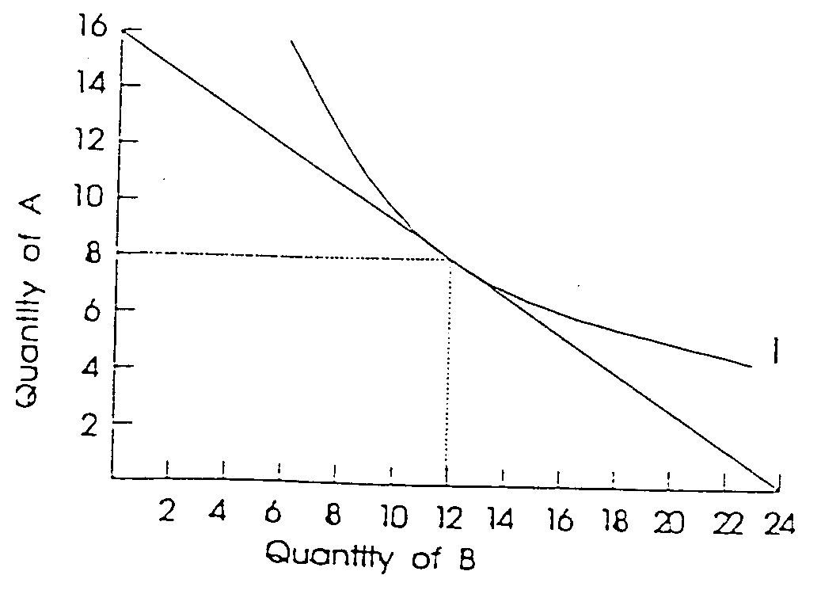

21A-5 Explain graphically how indifference analysis can be used to derive a demand curve.

In the top graph, the initial equilibrium is at X, where the budget line is tangent to indifference curve I2. Money income is $12; the price of A is $1.50 and the price of B is $1.00. Dropping a perpendicular from X in the top diagram to the bottom diagram, we obtain X’, a point on the demand curve of B. We note that at the price of $1.00, Q is 7.

We now assume that the price of B rises to $2.00, causing the budget line to fan to the left (inwards) from its anchor on the vertical (A) axis to Q of 6 on the horizontal (B) axis. This causes the new budget line to be tangent, at Y, to an indifference curve, I1, closer to the origin—one that gives less utility. Dropping a perpendicular from Y in the top diagram to the bottom diagram, we obtain Y’, the second point on the demand curve of B. We note that at the higher price of $2.00, Q is 3.

We can continue this procedure to obtain more points on the demand curve of B.

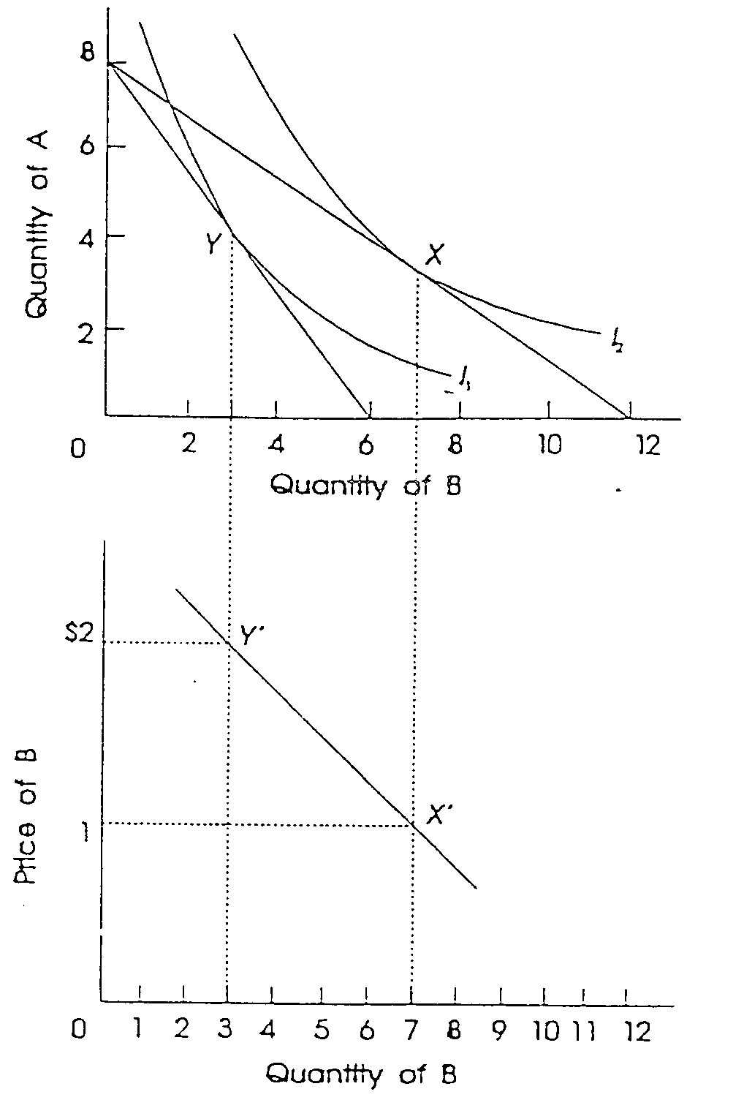
21A-6 Advanced analysis: Demonstrate mathematically that the equilibrium condition MRS = PB/PA is the equivalent of the utility maximizing rule MUA/PA = MUB/PB.

Since MRS = MUB/MUA, we have MUB/MUA = PB/PA. Multiplying both sides of the equation by MUA/PB, we have: MUB/PB = MUA/PA.

