chapter twenty-eight
Wage Determination

CHAPTER OVERVIEW
Building on the resource demand analysis of the previous chapter, this chapter provides a detailed supply and demand analysis of wage determination in a variety of possible labor market structures. Though the analysis may seem rigorous, it is little more than an application of supply and demand tools.
A discussion of the general level of real wages opens the chapter. The critical link between labor productivity and real wages merits emphasis as a theoretical and policy issue.
The section on wage determination in particular labor markets is the heart of the chapter. Competitive, monopsonistic, unionized, and bilateral monopoly market models are examined. Discussion of the effectiveness of unions in raising wages, and the complex issue of minimum wage laws follow.
Wage differentials are explained by the differences among worker characteristics, job characteristics, and lack of worker mobility. The chapter concludes with a discussion of pay schemes that link earnings to worker performance, their contributions to efficiency, and possible negative side effects.

WHAT’S NEW
The section on “Recent Stagnation of Real Wages” has been omitted. The graphs on Figure 28.3 have been transposed and the wage rate has been increased to $10. The section on monopsony discusses the monopsony power as well as pure monopsonies and updates some of the monopsony examples. The discussion of the minimum wage has been updated. A new Figure 28.9 has been added that shows how wage differentials are caused by supply and demand differences. “Stock options” has been added to the list of incentive pay devices. Global Perspective 28.2 has been eliminated.
One Web-Based Question has been revised and the other is new.

INSTRUCTIONAL OBJECTIVES
After completing this chapter, students should be able to:
- Differentiate between nominal and real wages.
- List those factors that have led to an increasing level of real wages in the U.S. historically.
- Determine the equilibrium wage rate and employment level when given appropriate data for a firm operating in a purely competitive product and labor market; a firm operating in a monopolistically competitive product market and a purely competitive labor market; and a firm operating in a purely competitive product market and a monopsonistic labor markets.
- Illustrate graphically how wage rates are determined in purely competitive and monopsonistic labor markets.
- List the methods used by labor organizations to increase wages and the impact each has on employment. Give specific examples.
- Illustrate graphically how an inclusive (industrial) union and an exclusive (craft) union would affect wages and employment in a previously competitive labor market.
- Explain and illustrate graphically wage determination in the bilateral monopoly model.
- Present the major points in the cases for and against the minimum wage.
- Explain the demand factors that create wage differentials.
- Explain the supply factors that create wage differentials.
- Describe briefly salary systems in which pay is linked to performance rather than to time.
- Describe the negative side effects of poorly planned incentive pay plans.
- Define and identify terms and concepts listed at the end of the chapter.

COMMENTS AND TEACHING SUGGESTIONS
This chapter affords the opportunity for some community-based research.
- Are local wages higher or lower than expected? Why? What factors contribute?
- Is there a dominant industry in the community? Does it fit the monopsony model? Are the workers unionized?
- Is the unemployment rate higher or lower than the current national average? Why?
- If time permits a guest speaker such as a union leader and/or a director of human resources would be interesting.
(Last Word) Ask students to research the requirements for licensing and other barriers to entry to jobs that they would like to have. Have they, or a family member or friend, been turned down for employment because of a license, or certificate requirement? Are requirements in their field reasonable? Ask if they would favor dispensing with all professional licenses and government regulation of working conditions. Can they define what is “reasonable” in licensing requirements?

STUDENT STUMBLING BLOCK
The concept of monopsony hiring is not an easy one for students to grasp. However, the results of monopsony hiring make intuitive sense. It may be best to focus on the results first (fewer workers hired at a lower wage than would be the competitive outcome) and then address the theory. The results emphasize the importance of monopsony power in labor markets, which all students can grasp even if they have difficulty with the theory.

LECTURE NOTES

I. Introduction

A. Wage rates may be the most important price a student will encounter in his/her life.

B. This chapter explores some of the factors behind the determination wage and wage differences. This is important since wages and salaries accounts for 80 percent of our national income when proprietors’ income is included.

II. Labor, Wages, and Earnings

A. Wages refer to the price paid for the use of labor.

1. Labor may be workers in the popular sense of the terms blue-collar and white-collar workers.

2. Labor also refers to professional people and owners of small businesses, in terms of the labor services they provide in operating their businesses.

B. Wages may take the form of bonuses, royalties, commissions, and salaries, but in this text the term “wages” is used to mean wage rate or price paid per unit of labor time.

C. It is important to distinguish between nominal and real wages.

1. Nominal wages are the amount of money received per hour, per day, per week and so on.

2. Real wages are the purchasing power of the wage, i.e., the quantity of goods and services that can be obtained with the wage. One’s real wages depend not only on one’s nominal wage but also on the price level of the goods and services that will be purchased.

3. Example: If nominal wages rise by 10 percent and there is a 5 percent rate of inflation, then the “real” wage rose only by 5 percent.

4. In this discussion, it is assumed that the price level is constant, and so the term “wages” is used in the sense of “real wages.”

III. The general level of wages differs greatly among nations, regions, occupations, and individuals. (See Global Perspective 28-1)

A. Productivity plays an important role in determination of wages. Historically, American wages have been high and have risen because of high productivity. There are several reasons for this high productivity.

1. Capital equipment per worker is high—approximately $132,000 per worker.

2. Natural resources have been abundant relative to the labor force in the United States.

3. Technological advances have been generally higher in the U.S. than in most other nations, and work methods are steadily improving.

4. The quality of American labor has been high because of good education, health and work attitudes.

5. There are other, less tangible items underlying the high productivity of American workers.

a. Stable business, social and political environment.

b. Efficient, flexible management.

c. Vast size of the domestic market, which allows for economies of scale.

B. Real wages and productivity: real wages per worker can increase only at about the same rate as output per worker. This is illustrated historically for the U.S. in Figure 28.1.

C. There has been a long-term, secular growth pattern in real wages in the U.S. as seen in Figure 28.2.

IV. A Purely Competitive Labor Market

A. Analysis of the competitive labor market model.

1. Characteristics of a competitive labor market include:

a. Many firms competing to hire a specific type of labor,

b. Numerous qualified workers with identical skills available to independently supply this type of labor service, and

c. “Wage taker” behavior that pertains to both employer and employee; neither can control the market wage rate.

2. The market demand is determined by summing horizontally the labor demand curves (the MRP curves) of the individual firms, as suggested in Figure 28.3a (Key Graph).

3. The market supply will be determined by the amount of labor offered at different wage rates; more will be supplied at higher wages because the wage must cover the opportunity costs of alternative uses of time spent either in other labor markets or in household activities or leisure.

4. The market equilibrium wage and quantity of labor employed will be where the labor demand and supply curves intersect; in Figure 28.3a this occurs at a $10 wage and 1,000 employed. (Key Questions 3 and 4)

a. Each individual firm will take this wage rate as given, and will hire workers up to the point at which the market wage rate is equal to the MRP of the last worker hired (according to the MRP = MRC rule). Note that the demand curve in Figure 28.3 is based on figures from Table 27.1 in the last chapter.

b. For each firm, the MRC is constant and equal to the wage because the firm is a “wage taker” and by itself has no influence on the wage in the competitive model. (Table 28.1)

B. In the monopsony model, the firm’s hiring decisions have an impact on the wage.

1. Characteristics of the monopsony model:

a. The firm’s employment is a large portion of the total employment of a particular kind of labor.

b. The type of labor is relatively immobile, either geographically or in the sense that to find alternative employment workers must acquire new skills.

c. The firm is a “wage maker” in the sense that the wage rate the firm pays varies directly with the number of workers it employs.

2. Complete monopsonistic power exists when there is only one major employer in a labor market; oligopsony exists when there are only a few major employers in a labor market. (Note: the root “sony” means “to purchase,” whereas the root “poly” means “to sell.”) The monopsonistic market is illustrated in Figure 28.4.

a. The labor supply curve will be upward sloping for the monopsonistic firm; if the firm is large relative to the market, it will have to pay a higher wage rate to attract more labor.

b. As a result, the marginal resource cost will exceed the wage rate in monopsony because the higher wage paid to additional workers will have to be paid to all similar workers employed. Therefore, the MRC is the wage rate of an added worker plus the increments that will have to be paid to others already employed. (See Table 28.2)

c. Equilibrium in the monopsonistic labor market will also occur where MRC = MRP, but now the MRC is above the wage, so the wage will be lower than it would be if the market were competitive. As a result, the monopsonistic firm will hire fewer workers than under competitive conditions.

d. Conclusion: In a monopsonistic labor market there will be fewer workers hired and at a lower wage than would be the case if that same labor market were competitive, other things being equal.

e. Illustrations: Nurses are paid less in towns with fewer hospitals than in towns with more hospitals. In professional athletics, players’ salaries are held down as a result of the “player drafts” that prevent teams from competing for the new players’ services for several years until they become “free agents.” (Key Question 5)

C. Union models illustrate a different model of imperfect competition in the labor market where the workers are organized so that employers do not deal directly with the individual workers, but with their unions, who try to raise wage rates in several ways. There are three models of these methods.

1. Unions prefer to raise wages by increasing the demand for labor. (Figure 28.5)

a. Unions may try to increase the demand for their products through advertising and through political lobbying to protect their jobs in various ways.

b. Unions sometimes increase productivity through training and joint labor-management committees designed to increase labor productivity.

c. Unions may try to increase the price of substitutes resources, thus increasing the demand for union workers, e.g., higher minimum wages.

d. Unions can increase the demand for their labor by supporting public actions that reduce the price of a complementary resource, e.g., utility prices.

2. Exclusive or craft unions raise wages by restricting the supply of workers, either by large membership fees, long apprenticeships, or forcing employers to hire only union workers. (Figure 28.6)

3. Occupational licensing requirements are another way of restricting labor supply in order to keep wages high. Six hundred occupations are licensed in the U.S.

4. Inclusive or industrial unions do not limit membership but try (usually unsuccessfully) to unionize every worker in a certain industry so that they have the power to impose a higher wage than the employers would otherwise pay (Figure 28.7.) The bargained wage becomes the MRC for the employer between point “a” and point “e”.

5. Employers will hire fewer workers than they would if the workers were free to accept a lower wage.

a. Studies indicate that the size of the union advantage is between 10 and 15 percent.

. b. The size of the unemployment effect will depend on certain factors.

1. Growth in the economy—If demand is increasing, then this shift in labor demand can offset the unemployment effect of the union wage increase.

2. If the demand for the product and/or labor is inelastic, the wage increase will not have as much effect on employment as it would if the demand were elastic.

D. Bilateral monopoly model occurs when a monopsonist employer faces a unionized labor force; in other words, both the employer and employees have monopoly power.

1. In such a model, the outcome of the wage is indeterminate and will depend on negotiation (see Figure 28.8) and bargaining power.

2. A bilateral monopoly may be more desirable than one-sided market power. In other words, if a competitive market does not exist, it may be more socially desirable to have power on both sides of the labor market, so that neither side exploits the other. This can be shown by comparing Qu = Qm and Qc.

V. The minimum wage controversy concerns the effectiveness of minimum wage legislation as an antipoverty device. (Figure 28.7 and Figure 28.8 can be used by substituting the minimum wage for the bargained wage.)

A. The case against the minimum wage contains two major criticisms.

1. The minimum wage forces employers to pay a higher than equilibrium wage, so they will hire fewer workers as the wage pushes them higher up their MRP curve.

2. The minimum wage is not an effective tool to fight poverty. Most minimum wage workers are teens from affluent families who do not need protection from poverty.

B. The case for the minimum wage argues includes other arguments.

1. Minimum-wage laws occur in markets that are not competitive and not static. In a monopolistic market, the minimum wage increases wages with minimal effects on employment.

2. Increasing minimum wage may increase productivity.

a. Managers will use workers more efficiently when they have higher wages.

b. The minimum wage may reduce labor turnover and thus training costs.

C. Evidence and conclusions

1. During the 1980s, some unemployment resulted from the minimum wage, especially among teens, but the effect of increases during the 1990s were inconclusive.

2. Because many who are affected by the minimum wage are not from poverty families, an increase in the minimum wage is not as strong an antipoverty tool as many supports contend.

3. More workers are helped by the minimum wage than are hurt.

4. The minimum wage helps give some assurance that employers are not taking advantage of their workers.

VI. Wage Differentials

A. Table 28.3 gives a selection of wages in different occupations to illustrate the substantial differences among them.

B. Wage differentials can be explained by using supply and demand for various occupations.

1. Given the same supply conditions, workers for whom there is a strong demand will receive higher wages; given the same demand conditions, workers where there is a reduced supply will receive higher wages. (Figure 28.9)

2. The worker’s contribution to the employer’s total revenue (MRP) will depend upon the worker’s productivity and the demand for the final product. (Figure 28.9 (a) and (b))

3. On the supply side, workers are not homogeneous, i.e., they are in noncompeting groups. These differences that determine these noncompeting groups are:

a. Ability levels differ among workers.

b. Education and training, i.e. “investment in human capital.”

1. Figure 28.10 indicates that those with more years of schooling achieve higher incomes.

2. The pay gap between college graduates and high school graduates increased between 1980 and 2000.

4. Workers also will experience wage differentials partly due to “compensating differences” among jobs. These are the nonmonetary aspects of the job that may make some jobs preferable to others because of working conditions, location, etc. (Figure 28.9 (c) and (d))

D. Since market imperfections exist, labor markets are not perfectly competitive.

1. Workers may lack information about alternative job opportunities.

2. Workers may be reluctant to move to other geographic locations.

3. Artificial restraints on mobility may be created by unions, professional organizations, and the government.

4. Discrimination in certain labor markets may crowd women and minorities into certain labor markets and out of others.

VII. Pay and performance are linked in many jobs, unlike the standardized wage rate per time unit.

A. When one considers workers as the firm’s agents and the firm as the principal, the principal-agent problem emerges.

1. Both the workers and the firm want the firm to survive and be profitable.

2. If the agents do not perceive that the workers’ and firm’s interests are identical, there may be a problem, because workers will act to improve their own well-being, often at the expense of the firm. Some examples include loafing on the job, using company materials, and generally not working as hard as they might.

3. Some incentive methods of payment help to avoid the principal-agent problem.

a. With piece-rate payments, workers earn according to the quantity of output produced.

b. Commissions and royalties are payment schemes linked to the value of sales.

c. Bonuses, stock options, and profit sharing are other ways to motivate workers to have the same interests as the firm.

d. Efficiency wages are a way of providing incentives by paying workers above-equilibrium wages to encourage extra effort.

B. Pay for performance can help overcome the principle-agent problem and enhance worker productivity, but such plans can have negative side effects.

1. A rapid production pace can compromise quality and endanger workers.

2. Commissions may cause salespeople to exaggerate claims, suppress information, and use other fraudulent sales practices.

3. Bonuses based on personal performance may disrupt cooperation among workers.

4. Less energetic workers can take a “free ride” in profit sharing firms.

5. Firms paying “efficiency wages” may have fewer opportunities to hire the new workers who could energize the workplace.

VIII. LAST WORD: African-Style Hairbraiders and Stodgy Economists

A. Licensing requirements that are passed under the guise of protecting the “public interest” often benefit special interests by erecting barriers to entry in the marketplace.

B. The Example of Cornrows, Co. (a hairbraiding business) is a classic example of licensing as a barrier to entry. The license required a year of training in everything from manicures to eyebrow arching at a cost of thousands of dollars—but none of the classes covered hairbraiding techniques and other African styles.

C. Cornrows, Co. successfully challenged the city’s outdated cosmetology code and was able to obtain a separate operating license with sensible training requirements.

ANSWERS TO END-OF-CHAPTER QUESTIONS

28-1 Explain why the general level of wages is higher in the United States and other industrially advanced countries. What is the single most important single factor underlying the long-run increase in average real-wage rates in the United States?

The general level of wages is higher in the United States and other industrially advanced nations because of the high demand for labor in relation to supply. Labor productivity is high in the U.S and other industrially advanced countries because: (1) capital per worker is very high; (2) natural resources are abundant relative to the size of the labor force particularly in the U.S.; (3) technology is advanced in the United States and other industrially advanced countries relative to much of the rest of the world; (4) labor quality is high because of health, vigor, training, and work attitudes compared to labor; (5) other factors contributing to high American productivity are the efficiency and flexibility of American management; the business, social, and political environment that greatly emphasizes production and productivity; and the vast domestic market, which facilitates the gaining of economies of scale.

The most important single factor underlying the long-run increase in average real wage rates in the United States is the increase in output per worker, that is, in productivity.

28-2 Why is a firm in a purely competitive labor market a wage taker? What would happen if it decided to pay less than the going market wage?

A firm in a purely competitive labor market is a wage taker because there are a large number of firms wanting to buy the labor services of the workers in that market and a large number of workers with identical skills wanting to sell their labor services. As a result, the individual firm has no control over the price of labor.

If a firm attempted to pay a wage below the going wage, no workers would offer their services to that firm.

28-3 (Key Question) Describe wage determination in a labor market in which workers are unorganized and many firms actively compete for the services of labor. Show this situation graphically, using W1 to indicate the equilibrium wage rate and Q1 to show the number of workers hired by the firms as a group. Show the labor supply curve of the individual firm, and compare it with that of the total market. Why the difference? In the diagram representing the firm, identify total revenue, total wage cost, and revenue available for the payment of nonlabor resources.

The labor market is made up of many firms desiring to purchase a particular labor service and of many workers with that labor service. The market demand curve is downward sloping because of diminishing returns and the market supply curve is upward sloping because a higher wage will be necessary to attract additional workers into the market. Whereas the individual firm’s supply curve is perfectly elastic because it can hire any number of workers at the going wage, the market supply curve is upward sloping.

For the graphs, see Figure 28.3 and its legend.

28-4 (Key Question) Complete the accompanying labor supply table for a firm hiring labor competitively.
Units  of labor | Wage  rate |  | Total  labor cost  (wage bill) |  | Marginal resource  (labor) cost
0  1  2  3  4  5  6 | $14  14  14  14  14  14  14 |  | $____  ____  ____  ____  ____  ____  ____ | $____  ____  ____  ____  ____  ____

a. Show graphically the labor supply and marginal resource (labor) cost curves for this firm. Explain the relationships of these curves to one another.

b. Plot the labor demand data of question 2 in Chapter 27 on the graph in part a above. What are the equilibrium wage rate and level of employment? Explain.

Total labor cost data, top to bottom: $0; $14; $28; $42; $56; $70; $84. Marginal resource cost data: $14, throughout.

(a) The labor supply curve and MRC curve coincide as a single horizontal line at the market wage rate of $14. The firm can employ as much labor as it wants, each unit costing $14; wage rate = MRC because the wage rate is constant to the firm.

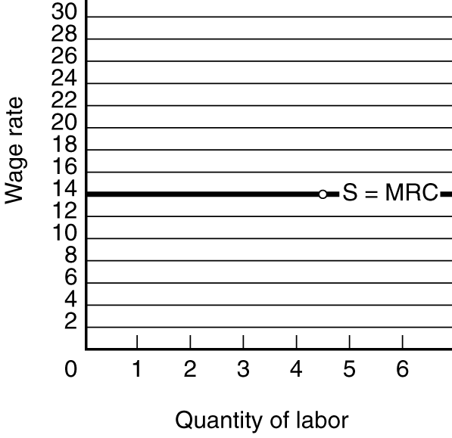
- Graph: equilibrium is at the intersection of the MRP and MRC curves. Equilibrium wage rate = $14; equilibrium level of employment = 4 units of labor. Explanation: From the tables: MRP exceeds MRC for each of the first four units of labor, but MRP is less than MRC for the fifth unit.

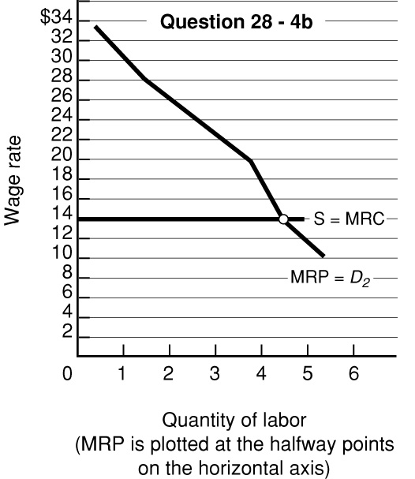

28-5 Suppose that the formerly competing firms in question 3 form an employers’ association that hires labor as a monopsonist would. Describe verbally the impact upon wage rates and employment. Adjust the market graph, showing the monopsonistic wage rate and employment level as W2 and Q2 respectively. Using this monopsony model, explain why hospital administrators frequently complain about a “shortage” of nurses. How might such a shortage be corrected?

The equilibrium wage in the monopsonistic market declines from the competitive market’s Wl rate to W2. The employment level in this market will decline from Q1 to Q2. See Figure 28.4.

If there are only one or two hospitals in an area, there exists a monopsonistic market for nurses. Their wages would be less than those for nurses where there is competition among employers (numerous hospitals and/or clinics). Because hospitals prefer to hire more nurses at a wage W2, they view the difference between Q3 and Q2 as a shortage. However, since their profits are maximized at W2, they are unwilling to raise wages voluntarily. The hospital administrator might offer a higher wage, but this wage would not be profit maximizing. Another solution would be for nurses to organize and demand higher wages. This would allow nurses to earn wages closer to their MRP and as wages rise toward W1, the shortage would disappear.

28-6 (Key Question) Assume a firm is a monopsonist that can hire the first worker for $6 but must increase the wage rate by $3 to attract each successive worker. Draw the firm’s labor supply and marginal resource cost curves and explain their relationships to one another. On the same graph, plot the labor demand data of question 2 in Chapter 27. What are the equilibrium wage rate and level of employment? What will be the equilibrium wage rate and the level of employment? Why do these differ from your answer to question 4?

The monopsonist faces the market labor supply curve S—it is the only firm hiring this labor. MRC lies above S and rises more rapidly than S because all workers get the higher wage rate that is needed to attract each added worker. Equilibrium wage/rate = $12; equilibrium employment = 3 (where MRP = MRC). The monopsonist can pay a below -competitive wage rate by restricting its employment.

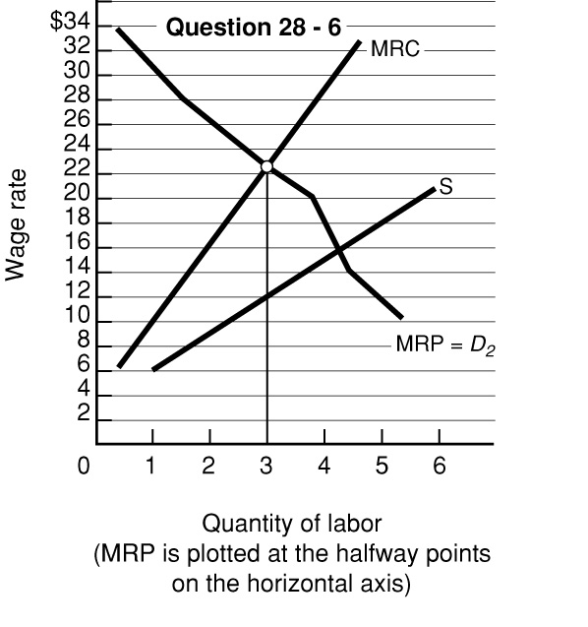

28-7 (Key Question) Assume a monopsonistic employer is paying a wage rate of Wm and hiring Qm workers, as indicated in Figure 28.8. Now suppose that an industrial union is formed and that it forces the employer to accept a wage rate of Wc. Explain verbally and graphically why in this instance the higher wage rate will be accompanied by an increase in the number of workers hired.

The union wage rate Wc becomes the firm’s MRC, which would be shown as a horizontal line to the left of the labor supply curve. Each unit of labor now adds only its own wage rate to the firm’s costs. The firm will employ Qc workers, the quantity of labor where MRP = MRC (= Wc); Qc is greater than the Qm workers it would employ if there were no union and if the employer did not have any monopsonistic power, i.e., more workers are will to offer their labor services when the wage is Wc than Wm.

28-8 Have you ever worked for the minimum wage? If so, for how long? Would you favor increasing the minimum wage by a dollar? By two dollars? By five dollars? Explain your reasoning.

28-9 “Many of the lowest-paid people in society—for example, short-order cooks—also have relatively poor working conditions. Hence, the notion of compensating wage differentials is disproved.” Do you agree? Explain.

Short-order cooks generally need few specific skills, i.e., practically anyone is thought to be capable of flipping burgers. Since the supply of unskilled workers is high relative to the demand for them, their wages are low. In this case, the concept of compensating wage differentials is swamped by the excess supply of low-wage workers.

28-10 What is meant by investment in human capital? Use this concept to explain (a) wage differentials, and (b) the long-run rise in real wage rates in the United States.

Investment in human capital is any action that improves a worker’s the skills and abilities, i.e., increases the productivity of workers.

(a) Wage differentials are explainable to some extent through the concept of human capital investment. There is a strong positive correlation between time spent acquiring a formal education and lifetime earnings. Of course, it can be said that the brain surgeon who spent over twenty years in training, starting in grade 1, had the qualities to succeed in the labor market without spending over twenty years in school. Though this counter-argument has some merit, the point still is that this highly-skilled individual would never have become a brain surgeon without the over twenty years in school and might not have achieved the particular high income that goes with being a medical specialist.

(b) The long-run rise in real wage rates in the United States is positively correlated to investment in human capital. Without the increase in education and training of the American labor force that has occurred over the years, productivity (output per person per hour) would still have risen because of the investment in real capital, improved technology, and our abundant natural resource base. But the real wage would undoubtedly now be very much lower, because an unskilled labor force could not possibly have made efficient use of the material resources and advancing technology of the economy.

28-11 What is the principal-agent problem? Have you ever worked in a setting where this problem has arisen? If so, do you think increased monitoring would have eliminated the problem? Why don’t firms simply hire more supervision to eliminate shirking?

Business owners who hire workers because they are needed to help produce the goods or services of the firm face the dilemma of the principal-agent problem. Workers are the agents; they are hired to promote the interests of the firm's owners (the principals). Owners and workers both have a common goal in the survival of the firm, but their interests are not identical. A principal- agent problem arises when those interests diverge. Workers may seek to increase their utility by shirking their responsibilities and providing less than the agreed upon effort. Owners of firms have a profit incentive to reduce or eliminate shirking. Hiring more supervisory personnel can be costly and there is no guarantee that it will eliminate the problem.

28-12 (Last Word) Do you think that African-style hairbraiders should be allowed to braid hair without a cosmetology license? If so, do you think that you would have the same view if you were a licensed cosmetologist?

Licensing requirements that are passed under the guise of protecting the “public interest” are often the work of special interest groups. Licensed cosmetologists benefit by limiting their numbers. Restrictions on entering the market allow the license holders to charge a higher price. Eliminating the barriers to entry will increase competition and lower the average compensation of the group. Economists are nearly unanimous in their opinion of trade barriers. They are against them.

