Chapter One
The Nature and Method of Economics

CHAPTER OVERVIEW
This chapter begins with a discussion of the meaning and importance of economics. In this first chapter, however, we will not plunge into problems and issues; instead we consider some important preliminaries. We first look at the economic perspective—how economists think about problems. Next, we state some of the benefits of studying economics. Then, we examine the specific methods economists use to examine economic behavior and the economy, distinguishing between macroeconomics and microeconomics. Finally, the problems, limitations, and pitfalls that hinder sound economic reasoning are examined.
The Appendix to Chapter 1 provides an important introduction to graphical analysis. While this will be review material for most students, for some this may be new. Instructors are strongly urged to confirm that their students understand this section before proceeding. The software supplement can provide effective remedial help for those students who are not familiar with graphical analysis.

WHAT’S NEW
There has been substantial rewriting of the material in this chapter. Many of the paragraphs have been shortened and tightened up and the examples have been changed and updated. Note that the term “material wants” has been changed to “economic wants.” A major revision has been made in the discussion of “Economic Methodology.” The section starts with an explanation of the scientific method and how it is used by economists to study human and institutional behavior. It continues with a discussion of the relationship between facts and theories and the importance of establishing theories, laws, principles, and models within the social scientists’ use of the scientific method. The presentation of the material eliminates the references to deductive versus inductive logic. Figure 1.1 has been changed to reflect the changes in the text.

Note that the prices used in Table 2 of the appendix have been doubled to make them more realistic. All of the explanatory numbers in text have been changed to reflect the change in the ticket prices.

There are some changes in the WEB-BASED QUESTIONS at the end of the chapter.

INSTRUCTIONAL OBJECTIVES
After completing this chapter, students should be able to:
- Define economics.
- Describe the “economic way of thinking,” including definitions of rational behavior, marginal costs, marginal benefits and how these concepts may be used in decision making.
- State some important reasons for studying economics.
- Explain how economists use the scientific method to formulate economic principles.
- Explain the importance of ceteris paribus in formulating economic principles.
- Explain the steps used by policy makers.
- List eight economic goals and give examples of conflicting and complementary goals.
- Differentiate between micro- and macroeconomics.
- Differentiate between positive and normative economics.
- Explain and give examples of the fallacy of composition and post hoc fallacy.
- Explain and illustrate a direct relationship between two variables, and define and identify a positive sloping curve.
- Explain and illustrate an inverse relationship between two variables, and define and identify a negative slope.
- Identify independent and dependent variables.
- Define and identify terms and concepts listed at end of chapter and appendix.

COMMENTS AND TEACHING SUGGESTIONS
- This chapter and related classroom activities will set the tone for the rest of the course. The methods used in the initial class meetings set the expectations and attitudes of the students. Making dramatic changes later can be confusing and the outcome less successful than desired. Please refer to the “Getting Started” section in the introduction for detailed suggestions. If you plan to make current events an integral part of the class, consider offering educational subscriptions to The Wall Street Journal or one of the weekly news or business publications.
- On the level of personal decision making, students might be asked to list all of the economic choices they had to make that day or that week. This impresses upon them that, as Marshall said in the 1890s, “economics is the study of man in the ordinary business of life.” To illustrate the rational basis of their decisions, students could analyze one or two of these choices in terms of the alternatives they gave up. What other choices did they have? What criteria were used to judge the alternatives? A discussion of how rational our decisions are might also follow!
- As the text suggests, it may be useful to discuss several noneconomic examples to illustrate the importance of models or simplification – for example, explaining that a road map is a model or simplification of the real world. The amount of detail on any road map would be determined by the needs of the traveler, i.e., “I need to travel between Chicago and Denver as quickly as possible,” versus, “I would like to visit some historical museums as I am traveling through Nebraska.” Neither road map would have the details of the real world. Devoting some time and effort to this point can help students see the importance of using economic models to represent the real world.
- The section on Economic Methodology can be used to explain what economists do when employed in both the private and public sectors. An economist may be asked by his/her railroad employer to determine how the company should best allocate its box cars, or a legislative aide may be asked to research the effects of a state’s current welfare-to-work program.
- A discussion on the Economics Goals allows the instructor to introduce many concepts (Gross Domestic Product, Unemployment Rate, Consumer Price Index, Balance of Trade, etc.) and current statistics (growth rates, unemployment rates, inflation rates, etc.), each of which will be expanded upon in later chapters. The students can be asked to choose the most important goals for them personally and for the nation. In class, students can be asked to explain why they chose a particular goal. The discussion of the goals can illustrate how relevant the goals are to their lives, and the economic and political difficulty of achieving these goals.
- The first 30-minute segment of the “Economics USA” video series is entitled “What is Economics?” This is one way to introduce the course. The series has 28 half-hour programs on economic concepts designed for a telecourse or supplementary use. Call 1-800-LEARNER for more information, or ask your McGraw-Hill representative about the possibility of obtaining some or all of this series free of charge.

STUDENT STUMBLING BLOCKS
- After thirty years of teaching economics, it has become clear to me that instructors cannot take for granted students’ background knowledge of economics. Students generally have no idea about the magnitude of common economic measurements and, therefore, their reading of the news may be colored by this lack of knowledge. One teaching tip that has worked for others is to give students a pretest during the first week of class, in which simple questions are asked about the U.S. economy. For example, questions can be asked about the size of population and labor force, unemployment and inflation rates, GDP, federal budget, deficits and debt. You will find wildly different answers to these questions with most far away from “ball park” figures. This exercise accomplishes two things. First, it lets students know that they have a lot to learn about “everyday” news items. Second, the correct answers can give them some early perspective on news events as they relate to the course. As the course progresses, don’t forget to reinforce these facts by reminding students of them.
- The instructor could treat the appendix on graphical analysis as a supplement for those students who have weak backgrounds in reading or constructing simple graphs. There is often a wide disparity among student abilities here. Instructors may wish to have a remedial session and special assignments for students deficient in graphing skills. Comparing graphs to maps seems to help students who have “graph anxiety.”

LECTURE NOTES
- Definition of Economics

A. The social science concerned with the efficient use of limited or scarce resources to achieve maximum satisfaction of human materials wants.

B. Human wants are unlimited, but the means to satisfy the wants are limited.
- The Economic Perspective

A. Scarcity and choice

1. Resources can only be used for one purpose at a time.

2. Scarcity requires that choices be made.

3. The cost of any good, service, or activity is the value of what must be given up to obtain it. (opportunity cost).

B. Rational Behavior

1. Rational self-interest entails making decisions to achieve maximum fulfillment of goals.

2. Different preferences and circumstances lead to different choices.

3. Rational self-interest is not the same as selfishness.

C. Marginalism: benefits and costs

1. Most decisions concern a change in current conditions; therefore the economic perspective is largely focused on marginal analysis.

2. Each option considered weighs the marginal benefit against the marginal cost.

3. Whether the decision is personal or one made by business or government, the principle is the same.

4. The marginal cost of an action should not exceed its marginal benefits.

5. There is “no free lunch” and there can be “too much of a good thing.”
- Why Study Economics?

A. Economics for citizenship.

1. Most political problems have an economic aspect, whether it is balancing the budget, fighting over the tax structure, welfare reform, international trade, or concern for the environment.

2. Both the voters and the elected officials can fulfill their role more effectively if they have an understanding of economic principles.

B. Professional and personal applications

1. The study of economics helps to develop an individual’s analytical skills and allows students to better predict the logical consequences of their actions.

2. Economic principles enable business managers to make more intelligent decisions.

3. Economics can help individuals make better buying decisions, better employment choices, and better financial investments.

4. Economics is however, mainly an academic, not a vocational subject. Its primary objective is to examine problems and decisions from a social rather than personal point of view. It is not a series of “how to make money” examples.
- Economic Methodology

A. Economists use the scientific method to establish theories, laws, and principles.

1. The scientific method consists of:

a. The observation of facts (real data).

b. The formulations of explanations of cause and effect relationships (hypotheses) based upon the facts.

c. The testing of the hypotheses.

d. The acceptance, reject, or modification of the hypotheses.

The determination of a theory, law, principle, or model.

2. Theoretical economics: The systematic arranging of facts, interpretation of the facts, making generalizations.

3. Principles are used to explain and/or predict the behavior of individuals and institutions.

4. Terminology—Principles, laws, theories, and models are all terms that refer to generalizations about economic behavior. They are used synonymously in the text, with custom or convenience governing the choice in each particular case.

5. Generalization—Economic principles are expressed as the tendencies of the typical or average consumer, worker, or business firm.

6. “Other things equal” or ceteris paribus assumption—In order to judge the effect one variable has upon another it is necessary to hold other contributing factors constant. Natural scientists can test with much greater precision than can economists. They have the advantage of controlled laboratory experiment. Economists must test their theories using the real world as their laboratory.

7. Abstractions—Economic principles, theories or models are abstractions, simplifications, which attempt to find the important connections and relationships of economic behavior. These models are useful precisely because they strip away the clutter and complexity of reality.

8. Graphical Expression—Many economic relationships are quantitative, and are demonstrated efficiently with graphs. The “key graphs” are the most important.

B. Policy economics applies economic facts and principles to help resolve specific problems and to achieve certain economic goals.

1. Steps in formulating economic policy:

a. State goals.

b. Recognize various options that can be used to achieve goals.

c. Evaluate the options on the basis of specific criteria important to decision-makers.

2. Economic goals widely accepted in our economy.

a. Economic growth

b. Full employment

c. Economic efficiency

d. Price level stability

e. Economic freedom

f. Equitable distribution of income

g. Economic security

h. Balance of trade

3. Goals may be complementary (full employment and economic security).

4. Some goals may conflict (efficiency and equity). (Key Question 6)

5. All goals cannot be achieved, so priorities must be set.
- Macroeconomics and Microeconomics

A. Macroeconomics examines the economy as a whole.

1. It includes measures of total output, total employment, total income, aggregate expenditures, and the general price level.

2. It is a general overview examining the forest, not the trees.

B. Microeconomics looks at specific economic units.

1. It is concerned with the individual industry, firm or household and the price of specific products and resources.

2. It is an examination of trees, and not the forest.

C. Positive and Normative Economics.

1. Positive economics describes the economy as it actually is, avoiding value judgments and attempting to establish scientific statements about economic behavior.

2. Normative economics involves value judgments about what the economy should be like and the desirability of the policy options available.

3. Most disagreements among economists involve normative, value-based questions.
- Pitfalls to Objective Thinking

A. Biases—Preconceptions that are not based on facts.

B. Loaded terminology.

1. Terms that contain the prejudice and value judgments of others.

2. It is very difficult for a person to describe economic behavior without letting their options about that behavior creep into their discussion. The distinction between positive and normative statements is not always clearly apparent.

3. Often, however, there is a deliberate attempt to sway opinion by using loaded terminology. (greedy owners, obscene profits, exploited workers, mindless bureaucrats, costly regulations, creeping socialism)

C. Definitions

1. Economics is a second language.

2. It is often difficult for students to recognize terms as new vocabulary that needs to be studied as diligently as though they had never before encountered the words.

3. Students in a physics class encountering terms like erg, ohm, or foot-pound recognize the need to investigate. Students that are reading a text filled with words like rent, capital, or investment assume that they already have an adequate working definition.

D. Causation Fallacies

1. Post hoc fallacy: When two events occur in time sequence, the first event is not necessarily the cause of the second event.

2. Correlation versus causation: Events may be related without a causal relationship.

a. The positive relationship between education and income does not tell us which causes the increase in the other. (Which is the independent variable and which is the dependent variable?)

b. It may be that the increase income that occurs with increased education is due to some other third factor that is not under direct consideration.
- A Look Ahead

A. Chapter 2 builds the production possibilities model that visually demonstrates the basic economic principles of scarcity, choice, opportunity cost, and the law of increasing costs.

B. Chapter 3 builds the supply and demand model for individual markets.

C. Chapter 4 combines all the markets in the economy and observes the coordination of economic activity through market prices.

D. Chapters 5 and 6 examine the important sectors of the economy (households, businesses, government, and the international sector) discussing their role and interaction.
- LAST WORD: Fast Food Lines—An Economic Perspective

A. People choose the shortest line to reduce time cost.

B. Lines tend to have equal lengths as people shift from longer to shorter lines in effort to save time.

C. Lines are chosen based on length without much other information—cost of obtaining more information is not worth the benefit.

1. Imperfect information may lead to an unexpected wait.

2. Imperfect information may cause some people to leave when they see a long line.

D. When a customer reaches the counter, other economic decisions are made about what to order. From an economic perspective, these choices will be made after the consumer compares the costs and benefits of possible choices.

APPENDIX TO CHAPTER 1
This appendix is to prepare students for reading, analyzing, and constructing simple graphs in later chapters. To determine which students need help in this area, the instructor may want to give a brief pretest. In other words, you may want to excuse those students who already have graphing skills from this review. For students who do need help in this area, software graphics tutorials are also very useful, especially the ones designed to accompany the text.
- Graphs and Their Meaning

A. Graphs help students to visualize and understand economic relationships. Most of our economic models explain relationships between just two sets of economic facts.

B. Constructing a two-dimensional graph involves drawing a horizontal and a vertical axis.

1. Mark the axis using convenient increments and fitting the data given.

2. Each point on the graph yields two pieces of information, the quantity of the variable on the horizontal axis and the corresponding quantity of the variable on the vertical axis.

C. Direct and inverse relationships

1. If two variables change in the same direction (an increase in one is associated with an increase in the other) it is a direct or positive relationship.

2. If the two sets of data move in opposite directions, they are inversely or negatively related.

D. Dependent and independent variables:

1. Economists are often interested in determining which variable is the “cause” and which is the “effect” when two variables appear to be related.

2. Mathematicians are always consistent in applying the rule that the independent variable or “cause” is placed on the horizontal axis and the dependent variable or outcome (effect) is placed on the vertical axis.

3. Economists are less tidy, and traditionally have put price and cost data on the vertical axis.

4. Note that inverse relationships are downward sloping to the right and direct relationships are upward sloping to the right regardless of which variable is placed on the horizontal or vertical axis.

E. Other things equal

1. When economists plot the relationship between two variables, all other influences are assumed to remain exactly the same (ceteris paribus).

2. If any of the other factors do change, a new plot of the original relationship must be made.

3. This point is extremely important for student understanding of the market model developed in chapter 3. It provides the distinction between a “slide” along an existing curve, and the “shift” of a curve that is required if a variable not labeled on the axis is changed.

F. The slope of a straight line is the ratio of the vertical change to horizontal change between any two points on the line.

1. The slope of a line will be positive if both variables change in the same direction (a positive or direct relationship).

2. The slope of a line will be negative if the variables change in the opposite direction (an inverse or negative relationship).

3. The numerical value of the slope will depend on the way the relevant variables are measured.

4. Economic analysis is often concerned with marginal changes, the relative change in one variable with respect to another; it is this rate of change that is measured by the slope.

5. Lines that are parallel with either the horizontal or vertical axis indicate that the two variables are unrelated, that is, a change in one variable has no effect on the value of the other.

a. A vertical line has an infinite slope.

b. A horizontal line has a zero slope.

G. The vertical intercept of a line is the point where the line intersects the vertical axis.

H. Equation of a linear relationship

1. If the vertical intercept and the slope are known, the general form y = a + bx describes the line.

2. y represents the variable on the vertical axis (the dependent variable in standard mathematical form) a is the vertical intercept, b is the slope of the line, and x represents the variable on the horizontal axis (the independent variable in standard mathematical form).

3. The income—consumption example places the dependent and the independent in proper mathematical form.

4. The price-quantity example reverses their position and places price (the independent variable) on the vertical axis and quantity (the dependent variable) on the horizontal axis.

I. Slope of a nonlinear curve

1. The slope of a nonlinear relationship changes from one point to another.

2. The slope of a curve at point a is equal to the slope of a line tangent to the curve at point a.

ANSWERS TO END-OF-CHAPTER AND APPENDIX QUESTIONS

1-1 (Key Question) Use the economic perspective to explain why someone who is normally a light eater at a standard restaurant may become somewhat of a glutton at a buffet-style restaurant which charges a single price for all you can eat.

This behavior can be explained in terms of marginal costs and marginal benefits. At a standard restaurant, items are priced individually—they have a positive marginal cost. If you order more, it will cost you more. You order until the marginal benefit from the extra food no longer exceeds the marginal cost. At a buffet you pay a flat fee no matter how much you eat. Once the fee is paid, additional food items have a zero marginal cost. You therefore continue to eat until your marginal benefit becomes zero.

1-2 What is the scientific method and how does it relate to theoretical economics? What is the difference between a hypothesis and an economic law or principle?

The scientific method is the technique used by economists to determine economic laws or principles. These laws or principles are formulated to explain and/or predict behavior of individuals or institutions.

A hypothesis is a “guessimate” as to the possible cause-and effect relationships between and among the facts. An economic law or principle is formulated after the hypothesis has been tested for validity.

1-3 Why is it significant that economics is not a laboratory science? What problems may be involved in deriving and applying economic principles?

Because the world of reality is cluttered with innumerable interrelated facts, researchers must be highly selective in gathering information. They must determine which facts are relevant to the problem under consideration. But even when this sorting process is complete, the relevant information may at first seem random and unrelated.

The economist seeks principles—generalizations about the way individuals and institutions behave. Deriving principles is called theoretical economics or economic analysis. The role of economic theorizing or economic analysis is to systematically arrange facts, interpret them, and generalize from them.

1-4 Explain the following statements:

a. “Good economic policy requires good economic theory.”

b. “Generalization and abstraction are nearly synonymous.”

c. “Facts serve to sort out good and bad hypotheses.”

d. “The other things equal assumption helps isolate key economic relationships.”

(a) Economic theories are the foundation of economic policy. Economic policy is a course of action intended to resolve a specific problem or further a nation’s economic goals. Therefore, the action taken (the policy) is effective only if the underlying theory is correct.

(b) The full scope of economic reality is too complex and bewildering to be understood as a whole. Economists abstract—that is, build models—to give meaning to an otherwise overwhelming and confusing maze of facts. Economic principles are generalizations; they are expressed as the tendencies of typical, or average, consumers, workers, or business firms. Generalizations or abstractions are of practical use because the simplification and removal of clutter make analysis of problems easier.

(c) To test a hypothesis, economists must subject it to systematic and repeated comparison with relevant facts. If real-world data confirm the hypothesis repeatedly, we have a good theory, otherwise it must be discarded and a new hypothesis developed.

(d) Natural scientists such as chemists or physicists can much more easily control experiments and test with great precision an assumed relationship between two variables. Economists have a much more difficult time trying to isolate key economic relationships. Nonetheless, the “other things equal assumption” is extremely important. Economists must test their theories using real world data, generated by the actual operation of the economy. Under these conditions “other things” do change and despite sophisticated statistical techniques, controls are less than perfect. As a result economics principles are less precise than those of laboratory sciences.

1-5 (Key Question) Explain in detail the interrelationships between economic facts, theory, and policy. Critically evaluate this statement: “The trouble with economic theory is that it is not practical. It is detached from the real world.”

Economic theory consists of factually supported generalizations about economic behavior that can be used to formulate economic policies. Economic theory enables policymakers to formulate economic policies that are relevant to real-world goals and problems that are based upon carefully observed facts.
  - To what extent do you accept the eight economic goals stated and described in this chapter? What priorities would you assign to them?

The first two parts of this question will be answered differently depending on the basic philosophy or values of the student.

Those who favor especially a high and growing standard of living should favor goals 1 (economic growth) and 2 (full employment).

Those more committed to equity, to “fair shares,” and the lessening of poverty, will probably prefer to stress goals 6 (an equitable distribution of income) and 7 (economic security). Such students should also make at least some reference to goals 1 and 2 or at least explain how they expect greater fairness in the economy to come about in the absence of a growing economy that in itself requires at least the absence of heavy unemployment.

Those most committed to free enterprise will probably mention goal 5 (economic freedom) first. But these students should not completely ignore the other goals, for freedom to change jobs or to seek one is of little use in times of high unemployment and no or negative growth. Moreover, such times can well lead to social unrest to such an extent that even the economic freedom of the wealthy is threatened.

Those concerned by the growing international indebtedness of the United States will mention goal 8 (balance of trade) but, at this stage of their studies, should not be expected to go very deeply—if at all—into the need for increasing productivity (implied in goal 3: economic efficiency) and maintaining price stability in relation to America’s trading partners in order to improve the balance of international trade in goods and services. Nor should students at this stage be expected to relate the Federal budget deficit and the related Federal borrowing abroad to the trade deficit.

With regard to the third part of this question, most students will probably agree that progress, stability, justice, and freedom are compatible with the list of goals given in the chapter. It is hard to imagine progress without economic growth and at least the absence of substantial unemployment. High inflation and the consequent arbitrary redistribution of incomes preclude stability, as does, in fact, high unemployment. Justice, in the view of most, is bound up with the goal of an equitable distribution of income, as it is defined in the chapter. And freedom, in the broadest sense, is linked with all eight of the goals—even of the eighth, if Americans wish to be free of the undue influence creditors can exert on a debtor.

1-7 (Key Question) Indicate whether each of the following statements applies to microeconomics or macroeconomics:

(a), (d), and (f) are macro; (b), (c), and (e) are micro.

1-8 (Key Question) Identify each of the following as either a positive or a normative statement:

a. The high temperature today was 89 degrees.

b. It was too hot today.

c. Other things being equal, higher interest rates reduce the total amount of borrowing.

d. Interest rates are too high.

(a) and (c) are positive; (b) and (d) are normative..

1-9 (Key Question) Explain and give an illustration of (a) the fallacy of composition; and (b) the “after this, therefore because of this” fallacy. Why are cause-and-effect relationships difficult to isolate in the social sciences?

(a) The fallacy of composition is the mistake of believing that something true for an individual part is necessarily true for the whole. Example: A single auto producer can increase its profits by lowering its price and taking business away from its competitors. But matched price cuts by all auto manufacturers will not necessarily yield higher industry profits.

(b) The “after this, therefore because of this” fallacy is incorrectly reasoning that when one event precedes another, the first even necessarily caused the second. Example: Interest rates rise, followed by an increase in the rate of inflation, leading to the erroneous conclusion that the rise in interest rates caused the inflation. Actually higher interest rates slow inflation.

Cause-and-effect relationships are difficult to isolate because “other things” are continually changing.
  - Suppose studies show that students who study more hours receive higher grades. Does this relationship guarantee that any particular student who studies longer will get higher grades?

No, not necessarily, because cause and effect are not clear. The observed relationship could largely reflect the fact that smarter students study more hours than do less able students. A less able student thus might not get better grades by studying longer, at least to the extent suggested by the graph.
  - Studies indicate that married men on average earn more income than unmarried men of the same age. Why must we be cautious in concluding that marriage is the cause and higher income is the effect?

Correlation does not necessarily mean that there is causation. The relationship could be purely coincidental or dependent on some other factor not included in the analysis. It is also possible that higher income is the variable that “causes” marriage.

1-12 (Last Word) Use the economic perspective to explain the behavior of the workers (rather than the customers) observed at a fast-food restaurant. Why are these workers there, rather than, say cruising around in their cars? Why do they work so diligently? Why do so many of them quit these jobs once they have graduated high school?

Workers at the fast-food restaurant are also engaging in rational behavior attempting to achieve maximum fulfillment of their goals. Each worker is weighing the opportunity cost of being in the restaurant rather than participating in the activity that is perceived as the next best alternative (say, cruising around in their cars).

The diligence observed is a function of their desire to maintain employment and the marginal benefit they receive from another day’s pay. Many of them quit their jobs after high school graduation because they receive more highly valued offers for the use of their time.

Chapter 1 - Appendix

1-1 Briefly explain the use of graphs as a way to present economic relationships. What is an inverse relationship? How does it graph? What is a direct relationship? How does it graph? Graph and explain the relationships you would expect to find between (a) the number of inches of rainfall per month and the sale of umbrellas, (b) the amount of tuition and the level of enrollment at a university, and (c) the popularity of a music artist and the price of her concert tickets.

In each case cite and explain how variables other than those specifically mentioned might upset the expected relationship. Is your graph in part b consistent with the fact that, historically, enrollments and tuition have both increased? If not, explain any difference.

Graphs can be used to illustrate the relationship between two sets of data. An inverse relationship is when the two variables change in opposite directions. The line is downward sloping. A direct relationship is when the two variables change in the same direction. The line is upward sloping. Statements (a) and (c) illustrate direct relationships. Statement (b) illustrates an inverse relationship. The inverse relationship is assuming that everything else remains equal.

1-2 (Key Question) Indicate how each of the following might affect the data shown in Table 2 and Figure 2 of this appendix:

a. GSU’s athletic director schedules higher-quality opponents.

b. An NBA team locates in the city where GSU plays.

c. GSU contracts to have all its home games televised.

(a) More tickets are bought at each price; the line shifts to the right.

(b) Fewer tickets are bought at each price, the line shifts to the left.

(c) Fewer tickets are bought at each price, the line shifts to the left.

1-3 (Key Question) The following table contains data on the relationship between saving and income. Rearrange these data into a meaningful order and graph them on the accompanying grid. What is the slope of the line? The vertical intercept? Interpret the meaning of both the slope and the intercept. Write the equation which represents this line. What would you predict saving to be at the $12,500 level of income?

Income  (per year)` | Saving  (per year)
$15,000  0  10,000  5,000  20,000 | $1,000  -500  500  0  1,500

Income column: $0; $5,000; $10,000, $15,000; $20,000. Saving column: $-500; 0; $500; $1,000; $1,500. Slope = 0.1 (= $1,000 - $500)/($15,000 - $10,000). Vertical intercept = $-500. The slope shows the amount saving will increase for every $1 increase in income; the intercept shows the amount of saving (dissaving) occurring when income is zero. Equation: S = $-500 + 0.1Y (where S is saving and Y is income). Saving will be $750 at the $12,500 income level.

1-4 Construct a table from the following data shown on the accompanying graph. Which is the dependent variable and which the independent variable? Summarize the data in equation form.

 | Study time  (hours)  0  2  4  6  8  9 | Exam scores  10  30  50  70  90  100

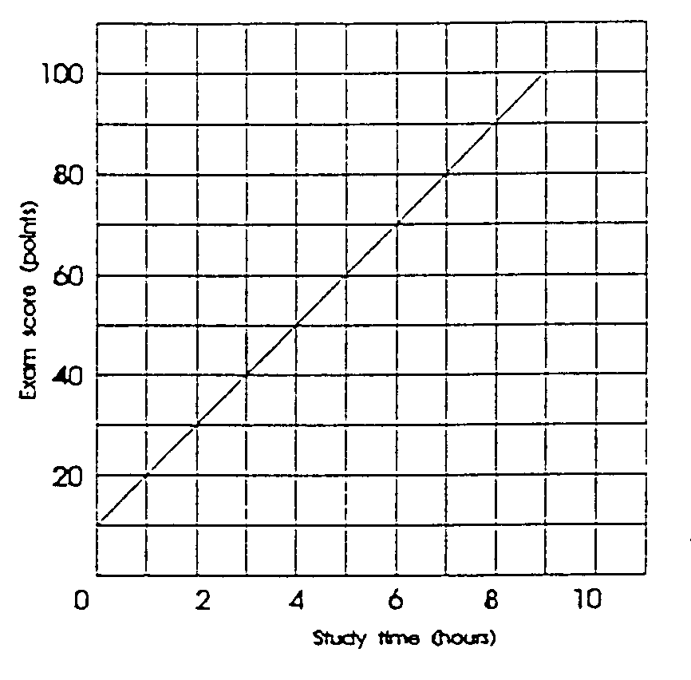
The dependent variable (the effect) is the exam score and the independent variable (the cause) is the study time.

The equation is:

$\begin{aligned}\text{Exam score}=\text{10}+{\left(\text{50}−\text{30}\right)}/{\left(4−2\right)}×\text{Study time} \\ =\text{10}+{\text{20}}/2×\text{Study time} \\ =\text{10}+\text{10}×\text{Study time}\end{aligned}$

Proof:

Exam score when study time is 6 hours:

$$\begin{aligned}=\text{10}+\left(\text{10}×6\right) \\ =\text{10}+\text{60} \\ =\text{70}\text{ as shown in the table above}\end{aligned}$$

1-5 Suppose that when the interest rate is 16 percent, businesses find it unprofitable to invest in machinery and equipment. However, when the interest rate is 14 percent, $5 billion worth of investment is profitable. At 12 percent interest, a total of $10 billion of investment is profitable. Similarly, total investment increases by $5 billion for each successive 2-percentage point decline in the interest rate. Describe the relevant relationship between the interest rate and investment in words, in a table, graphically, and as an equation. Put the interest rate on the vertical axis and investment on the horizontal axis, and in your equation use the form i = a + bI, where i is the interest rate, a is the vertical intercept, b is the slope of the line (which is negative), and I is the level of investment. Comment on the advantages and disadvantages of the verbal, tabular, graphic, and equation forms of description.
Interest  rate  (in percent) |  | Amount of  investment  (billions of dollars)
16  14  12  10  8  6  4  2  0 |  | $ 0  5  10  15  20  25  30  35  40

When the interest rate is 16%, investment spending will be zero. When the interest rate is 14%, investment spending will be $5 billion. For each successive drop of 2 percentage points in the interest rate, investment spending will increase by $5 billion.

$$\begin{aligned}\text{Using equation }I=a−\text{bI} \\ I=\text{16}−\left[{\left(\text{16}−\text{14}\right)}/{\left(5−0\right)}\right]×I \\ =\text{16}−2/5I\end{aligned}$$

Proof: substituting data from the table when I is $25 billion, i = 16 -2/5(25) = 16 - 10 = 6

The verbal presentation can be made, but is hard to visualize. The tabular presentation is precise; all the facts are there, neatly arrayed, and it is easier to visualize than the verbal one. The graphic presentation shows at a glance the relationship between the variables and, moreover, is best for showing large changes, that is, movements of a whole curve. However, the graph requires careful drafting to ensure that it is as accurate as the table. The equation is as precise as the table and, moreover, describes all the intermediate points not set out in the table. For most people, though, the equation form is probably the hardest to visualize.

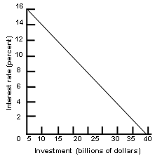

1-6 (Key Question) The accompanying graph shows curve XX and tangents at points A, B, and C. Calculate the slope of the curve at these three points.

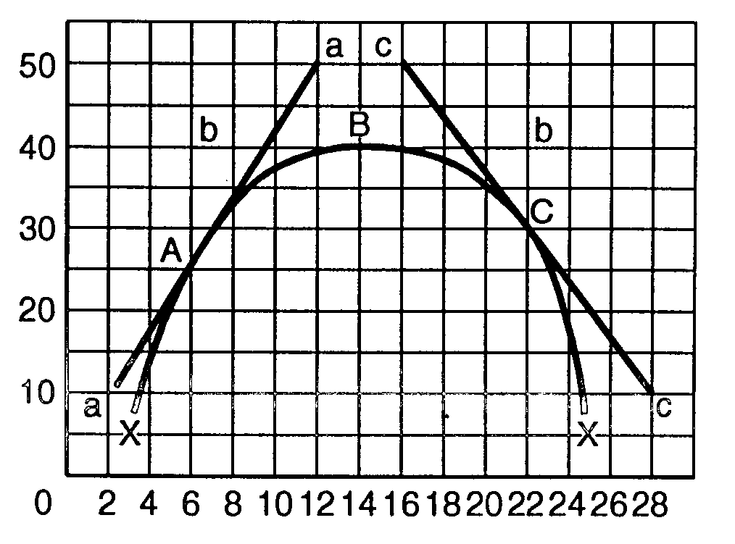
Slopes: at A = +4; at B = 0; at C = -4.

1-7 In the accompanying graph, is the slope of curve AA’ positive or negative? Does the slope increase or decrease as we move along the curve from A to A’? Answer the same two questions for curve BB’.

Slope of AA’ is positive (rising from left to right). The slope increases as we move from A to A’.

Slope of BB’ is negative (dropping from left to right). The slope increases as we move from B to B’.

The slopes of both curves are tending to infinity as they continue to move to the right.

