Ch. 5 & 17 -- The Economic Functions of Government and the 5 Es

pp. 79-83 The Public Sector: Government's Role
pp. 314-328 (in chapter 17)

SPILLOVER COSTS

Define Spillover costs:

Examples of Spillover costs:

Use the graph below to answer the questions that follow.

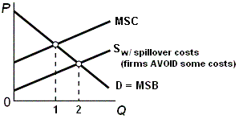

Use the graph below to answer the questions that follow.

What is the allocatively efficient quantity?

What is the profit maximizing quantity?

Which quantity will be produced without government involvement?

Is there an OVER allocation or an UNDERallocation of resources?

What is the goal of government involvement?

What are the possible government policies to achieve this goal?
SPILOVER BENEFITS

Define Spillover benefits:

Examples of Spillover benefits:

Use the graph below to answer the questions that follow.

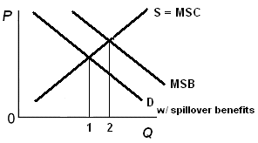

Use the graph below to answer the questions that follow.

What is the allocatively efficient quantity?

What is the profit maximizing quantity?

Which quantity will be produced without government involvement?

Is there an OVER allocation or an UNDERallocation of resources?

What is the goal of government involvement?

What are the possible government policies to achieve this goal?

