Ch. 4 -- The Economic Functions of Government and the 5 Es
pp. 72-73 Reallocating Resources

NEGATIVE EXTERNALITIES

Define Negative Externalities (Spillover costs):

Examples of Negative Externalities (Spillover costs):

Use the graph below to answer the questions that follow.

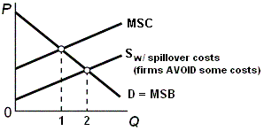

What is the allocatively efficient quantity?

What is the profit maximizing quantity?

Which quantity will be produced without government involvement?

Is there an OVER allocation or an UNDERallocation of resources?

What is the goal of government involvement?

What are the possible government policies to achieve this goal?

POSITIVE EXTERNALITIES

Define Positive Externalities (Spillover benefits):

Examples of Positive Externalities (Spillover benefits):

Use the graph below to answer the questions that follow.

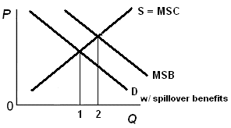

What is the allocatively efficient quantity?

What is the profit maximizing quantity?

Which quantity will be produced without government involvement?

Is there an OVER allocation or an UNDERallocation of resources?

What is the goal of government involvement?

What are the possible government policies to achieve this goal?

