REVIEW – Short Run Costs (Ch. 9)

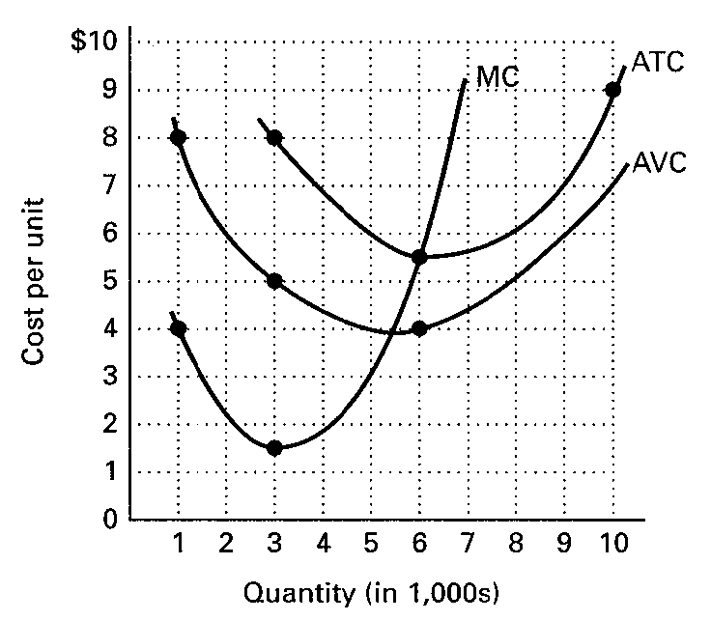

(a) How can you tell if these cost curves are for the short run or the long run?

(b) What does the graph indicate about:

(1) AVC at 6,000 units of output?

(2) ATC at 6,000 units of output?

(3) AFC at 6,000 units of output?

(4) TVC at 6,000 units of output and show on graph?

- TFC at all levels of output and show on graph?
(6) TC at 6,000 units of output and show on graph?

(7) When do diminishing returns set in?

ANSWERS

(a) The ATC, AVC, and MC curves are for one size of plant. In the short run, there are fixed costs and variable costs. In the long run, all costs are variable.
(b) (1) AVC at 6,000 units is $4.00.
(2) ATC at 6,000 units is $5.50.
(3) AFC at 6,000 units is $1.50.
(4) TVC at 6,000 units is $24,000 ($4.00 x 6,000).
(5) TFC at all levels of output is $9,000.
(6) TC at 6,000 units is $90,000.
(7) Diminishing marginal returns set in at 3,000 units.
[text: E pp. 398-403; MI pp. 154-159]

