Fall 2012
MICROECONOMICS
Unit 3-Product Markets: Decision Making and Efficiency

Chapters 8 and 9 - Pure Competition in the Short Run and the Long Run
- Reading Assignments
  - Chapters 8: ALL
  - Chapter 9: 181-184, 186-192
- Study Guide – Chapter 8
  - Multiple Choice: # 1-7, 9-15, 20, 22
  - Problems: # 1-3, 4 a & c
- Study Guide – Chapter 9
  - Multiple Choice: #3-24
  - Problems: # 1 (ignore the “quantity supplied” column in the table”), 2
- Worked Problems 8.1, 8.2, 8.3 at http://highered.mcgraw-hill.com/sites/0077337735/student_view0/chapter8/worked_problems.html
- Web Quizzes:
  - Chapter 8: ALL at http://highered.mcgraw-hill.com/sites/0077337735/student_view0/chapter8/quiz.html
  - Chapter 9: # 1-5, 7, 9, 10 at http://highered.mcgraw-hill.com/sites/0077337735/student_view0/chapter9/quiz.html
- End-of-Chapter Questions and Problems:
  - Chapter 8: Questions # 1-7; Problem # 4
  - Chapter 9: Questions # 1, 3, 5, 6, 7, 9; Problems # 2 (skip the last question)
Chapter 10 AND 18 - Pure Monopoly and Regulation
- Reading Assignments:
  - Chapter 10: ALL
  - Chapter 18: pp. ALL
- Study Guide
  - Chapter 10
    - Multiple Choice: # 1-4, 6-16, 18-24
    - Problems: # 1, 2, 3, 4
  - Chapter 18
    - Multiple Choice: # 1, 7, 9, 10, 11, 14, 16, 18, 19
    - Problems: # 3
- Worked Problems # 10.1 and 10.2 at http://highered.mcgraw-hill.com/sites/0077337735/student_view0/chapter10/worked_problems.html
- Web Quizzes at http://highered.mcgraw-hill.com/sites/0077337735/student_view0/chapter10/quiz.html
  - Chapter 10: ALL
  - Chapter 18: # 4, 5, 8, 9, 10 [What is wrong with question #8?]
- End-of-Chapter Questions and Problems:
  - Chapter 10: Questions 2-9; Problems 1, 2
  - Chapter 18: Questions # 1, 5, 10, 12, 13; Problems # 2
Chapter 11 - Monopolistic Competition and Oligopoly
- Reading Assignments: Ch. 11: ALL (not the appendix)
- Study Guide - Chapter 11
  - Multiple Choice: # 1-27, 30
  - Problems: # 1 -5
- Worked Problem 11.1 at http://highered.mcgraw-hill.com/sites/0077337735/student_view0/chapter11/worked_problems.html
- Web Quiz: Chapter 11 # 1-5, 7-10 at http://highered.mcgraw-hill.com/sites/0077337735/student_view0/chapter11/quiz.html
- End-of-Chapter Questions and Problems:
  - Questions # 1, 2, 6, 7, 9, 10: Problems # 1
Four Market Models

CHARACTERISTIC | PURE  COMPETITION  (Ch. 8-9) | MONOPOLISTIC  COMPETITION  (Ch. 11) | OLIGOPOLY  (Ch. 11) | MONOPOLY  (Ch. 10)
Number of Firms:

Type of product:

Control over price:

Conditions of entry:

Nonprice competition

Examples:

Quick Quiz – Product Market Models
1. Economists would describe the U.S. automobile industry as:
1. purely competitive.
2. an oligopoly.
3. monopolistically competitive.
4. a pure monopoly.
2. In which of the following market structures is there clear-cut mutual interdependence with respect to price-output policies?
1. pure monopoly
2. oligopoly
3. monopolistic competition
4. pure competition
3. Which of the following industries most closely approximates pure competition?
1. agriculture
2. farm implements
3. clothing
4. steel
4. Economists use the term imperfect competition to describe:
1. all industries which produce standardized products.
2. any industry in which there is no nonprice competition.
3. a pure monopoly only.
4. those markets which are not purely competitive.
5. In which of the following industry structures is the entry of new firms the most difficult?
1. pure monopoly
2. oligopoly
3. monopolistic competition
4. pure competition
6. An industry comprised of 40 firms, none of which has more than 3 percent of the total market for a differentiated product is an example of:
1. monopolistic competition.
2. oligopoly.
3. pure monopoly.
4. pure competition.
7. A one-firm industry is known as:
1. monopolistic competition.
2. oligopoly.
3. pure monopoly.
4. pure competition.
8. An industry comprised of four firms, each with about 25 percent of the total market for a product is an example of:
1. monopolistic competition.
2. oligopoly.
3. pure monopoly.
4. pure competition.
9. An industry comprised of a very large number of sellers producing a standardized product is known as:
1. monopolistic competition.
2. oligopoly.
3. pure monopoly.
4. pure competition.
10. An industry comprised of a small number of firms, each of which considers the potential reactions of its rivals in making price-output decisions is called:
1. monopolistic competition.
2. oligopoly.
3. pure monopoly.
4. pure competition.
Price and Output Determination – Pure competition

Decision: How many should the firm produce?

Goal: Profit Maximization

2 Steps: 1. Find the best quantity, where MR = MC
2. Compare AR with AVC, produce only if AR > AVC

Assumptions: Pure Competition

3 Cases: Note – this cost data is the same as that which we used in the yellow page for the chapter 7 (Costs of Production)

Profit Maximization Loss Minimization Shut Down
P = $ 10 P = $ 5 P = $ 2

Q | TC | MC | TR | MR
0 | $25 | -- |  | --
1 | 35
2 | 41
3 | 45
4 | 47
5 | 49
6 | 52
7 | 57
8 | 65
9 | 79
10 | 100

Q | TC | MC | TR | MR
0 | $25 | -- |  | --
1 | 35
2 | 41
3 | 45
4 | 47
5 | 49
6 | 52
7 | 57
8 | 65
9 | 79
10 | 100

Q | TC | MC | TR | MR
0 | $25 | -- |  | --
1 | 35
2 | 41
3 | 45
4 | 47
5 | 49
6 | 52
7 | 57
8 | 65
9 | 79
10 | 100

Short-Run Cost Schedules and Curves (from chapter 7 yellow pages)

Q | TFC | TVC | TC | AFC | AVC | ATC | MC
0 | $ 25 | $ 0 | $ 25 | $ -- | $ -- | $ -- | $ --
1 | 25 | 10 | 35 | 25 | 10.00 | 35 | 10
2 | 25 | 16 | 41 | 12.50 | 8.00 | 20.50 | 6
3 | 25 | 20 | 45 | 8.33 | 6.67 | 15.00 | 4
4 | 25 | 22 | 47 | 6.25 | 5.50 | 11.75 | 2
5 | 25 | 24 | 49 | 5.00 | 4.80 | 9.80 | 2
6 | 25 | 27 | 52 | 4.17 | 4.50 | 8.67 | 3
7 | 25 | 32 | 57 | 3.57 | 4.57 | 8.14 | 5
8 | 25 | 40 | 65 | 3.125 | 5.00 | 8.125 | 8
9 | 25 | 54 | 79 | 2.78 | 6.00 | 8.78 | 14
10 | 25 | 75 | 100 | 2.50 | 7.50 | 10.00 | 21

Pure Competition – Price = $ 10

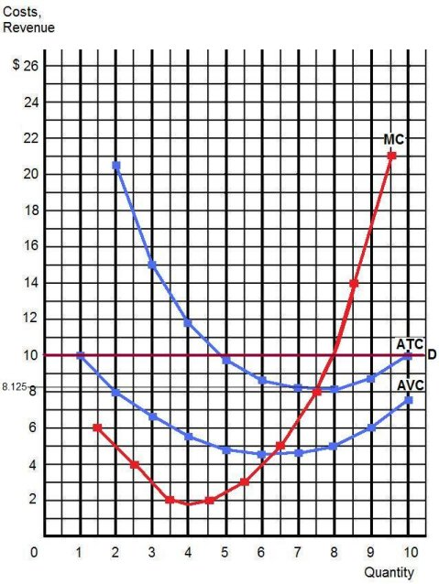

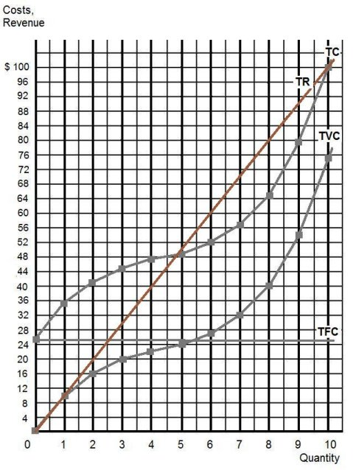

Pure Competition – Price = $ 5

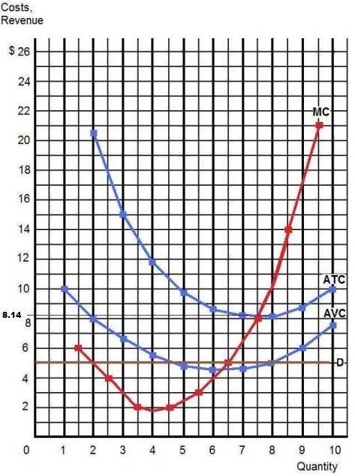

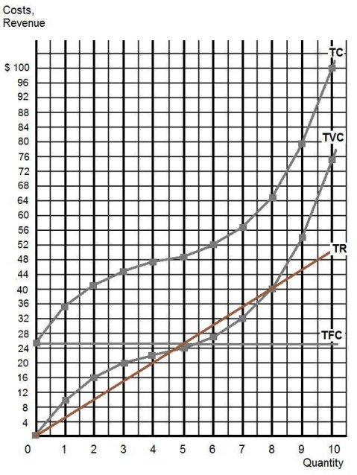
Pure Competition – Price = $ 2

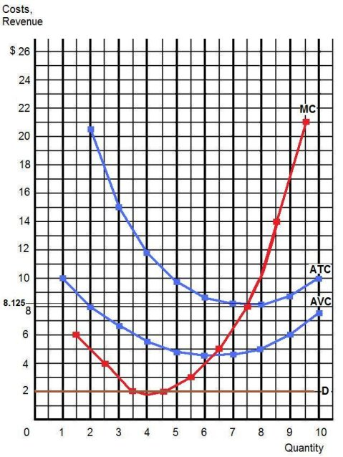

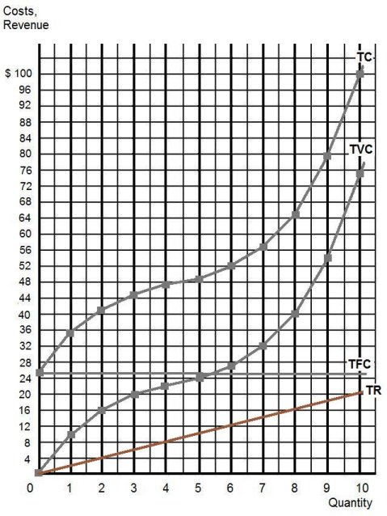

REVIEW QUESTIONS: Pure Competition

Use the cost and revenue curves to answer the questions that follow. Assume the firm is a profit maximizer.

- Q =

- P =

- Will this firm produce this quantity?

- AR =

- TR =

- ATC =

- TC =

- Does this firm earn profits or losses?

- Profits or losses =

- At this quantity, AFC =

- TFC =

- If the price dropped to $.30, will this firm continue to produce?

- If so, what quantity will it produce?

- Will it now earn profits or losses?

- Profits or losses =

- Why does it continue to produce?

________________________________________________________________________

- If the price dropped to $.15 will this firm continue to produce?

- What will be its losses if the price = $.15?

- At a price of $.30 the firm earns enough revenues to cover its entire fixed/variable cost, as well as PART of its fixed/variable cost?

- Which curve and what portion of it constitutes the firm’s short run supply curve?

________________________________________________________________________

Quick Quiz – Pure Competition – Short Run
1. Refer to the above data. If the market price for the firm's product is $12, the competitive firm will produce:
1. 4 units at a loss of $109.
2. 4 units at an economic profit of $31.75.
3. 8 units at a loss of $48.80.
4. zero units at a loss of $100.

2. Refer to the above data. If the market price for the firm's product is $32, the competitive firm will produce:
1. 8 units at an economic profit of $16.
2. 5 units at a loss of $10.
3. 8 units at a loss equal to the firm's total fixed cost.
4. 7 units at an economic profit of $41.50.

3. Refer to the above diagram. To maximize profit or minimize losses this firm will produce:
1. K units at price C.
2. D units at price J.
3. E units at price A.
4. E units at price B.
4. Refer to the above diagram. At the profit-maximizing output, total revenue will be:
1. 0AHE.
2. 0BGE.
3. 0CFE.
4. ABGE.
5. Refer to the above diagram. At the profit-maximizing output, total cost is equal to:
1. 0AHE.
2. 0BGE.
3. 0CFE.
4. BCFG.
6. Refer to the above diagram. At the profit-maximizing output, the firm will realize:
1. a loss equal to BCFG.
2. a loss equal to ACFH.
3. an economic profit of ACFH.
4. an economic profit of ABGH.

Quick Quiz – Pure Competition – Long Run
1. Refer to the above diagrams, which pertain to a purely competitive firm producing output q and the industry in which it operates. Which of the following is correct?
1. The diagrams portray neither long-run nor short-run equilibrium.
2. The diagrams portray both long-run and short-run equilibrium.
3. The diagrams portray short-run equilibrium, but not long-run equilibrium.
4. The diagrams portray long-run equilibrium, but not short-run equilibrium.
2. Refer to the above diagrams, which pertain to a purely competitive firm producing output q and the industry in which it operates. In the long run we should expect:
1. firms to enter the industry, market supply to rise, and product price to fall.
2. firms to leave the industry, market supply to rise, and product price to fall.
3. firms to leave the industry, market supply to fall, and product price to rise.
4. no change in the number of firms in this industry.
3. The term productive efficiency refers to:
1. any short-run equilibrium position of a competitive firm.
2. the production of the product-mix most desired by consumers.
3. the production of a good at the lowest average total cost (where MC=ATC)
4. fulfilling the condition P = MC.
4. The term allocative efficiency refers to:
1. the level of output that coincides with the intersection of the MC and AVC curves.
2. minimization of the AFC in the production of any good.
3. the production of the product-mix most desired by consumers.
4. the production of a good at the lowest average total cost.
5. If the price of product Y is $25 and its marginal cost is $18:
1. Y is being produced with the least-cost combination of resources.
2. society will realize a net gain if less of Y is produced.
3. resources are being underallocated to Y.
4. resources are being overallocated to Y.
6. Under pure competition in the long run:
1. neither allocative efficiency nor productive efficiency are achieved.
2. both allocative efficiency and productive efficiency are achieved.
3. productive efficiency is achieved, but allocative efficiency is not.
4. allocative efficiency is achieved, but productive efficiency is not.
7. If for a firm P = minimum ATC = MC, then:
1. neither allocative efficiency nor productive efficiency is being achieved.
2. productive efficiency is being achieved, but allocative efficiency is not.
3. both allocative efficiency and productive efficiency are being achieved.
4. allocative efficiency is being achieved, but productive efficiency is not.
8. The above diagram portrays:
1. a competitive firm that should shut down in the short run.
2. the equilibrium position of a competitive firm in the long run.
3. a competitive firm that is realizing an economic profit.
4. the loss-minimizing position of a competitive firm in the short run.
9. Refer to the above diagram. If this competitive firm produces output Q, it will:
1. suffer an economic loss.
2. earn a normal profit.
3. earn an economic profit.
4. achieve productive efficiency, but not allocative efficiency.
10. Refer to the above diagram. By producing output level Q:
1. neither productive nor allocative efficiency are achieved.
2. both productive and allocative efficiency are achieved.
3. allocative efficiency is achieved, but productive efficiency is not.
4. productive efficiency is achieved, but allocative efficiency is not.
Monopoly Firms and Short Run Decisions

Q | AR | TR | MR |  | TC | MC | TFC | ATC | AFC | AVC
0 | $ 16 | $ | $ -- |  | $ 12 | $ -- | $ | $ -- | $ -- | $ --
1 | $ 14 |  |  |  | $ 20
2 | $ 12 |  |  |  | $ 23
3 | $ 10 |  |  |  | $ 26
4 | $ 8 |  |  |  | $ 32
5 | $ 6 |  |  |  | $ 50

Make three plots:
- AR and MR
- AR, MR, ATC, and MC
- TR and TC

AR and MR
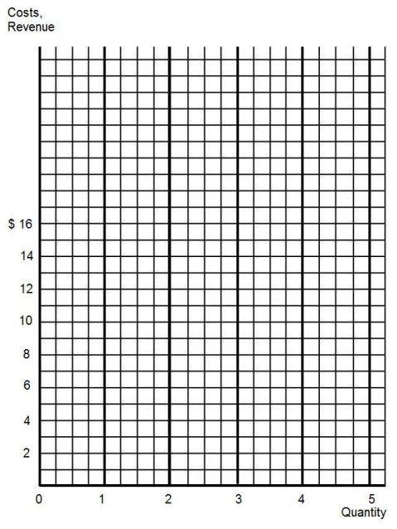
AR, MR, ATC, and MC
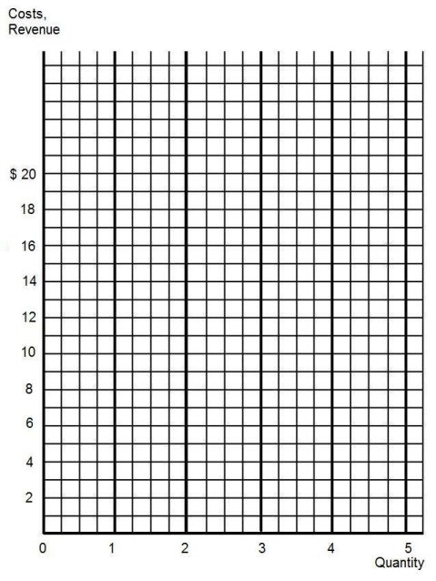

TC and TR
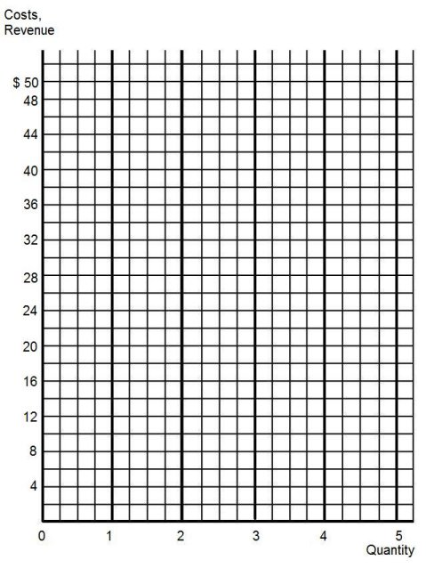

AR, MR, ATC, and MC
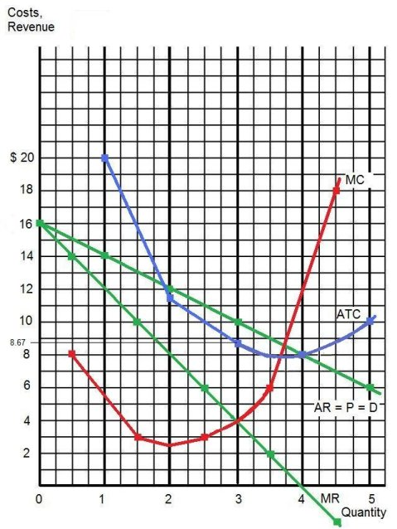

TC and TR
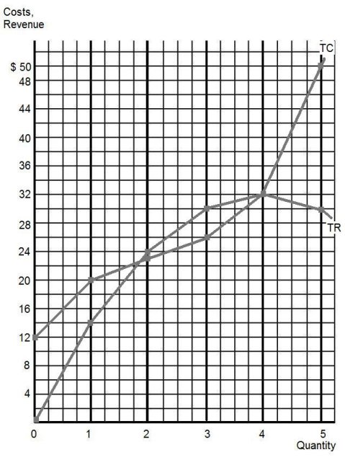
REVIEW QUESTIONS: Monopoly

Use the cost and revenue curves below to answer the questions that follow. Assume the firm is a profit maximizer.

- Q =

- P =

- Will this firm produce this quantity?

- AR =

- TR =

- ATC =

- TC =

- Does this firm earn profits or losses?

- Profits or losses =

- At this quantity, AFC =

- TFC =

- If the price dropped to $.75 (due to decreased demand), ceterus paribus, will this firm continue to produce in the short run?

- Will it now earn profits or losses?

- Why does it continue to produce?

________________________________________________________________________

- If the price dropped to $.45 will this firm continue to produce?

- Is this firm achieving productive efficiency? Explain.

________________________________________________________________________

________________________________________________________________________

- Could the monopolist “afford” to expand production to the level where price equals ATC, an output of 57 in this example? Explain.

________________________________________________________________________

________________________________________________________________________

Monopoly: Long Run Equilibrium
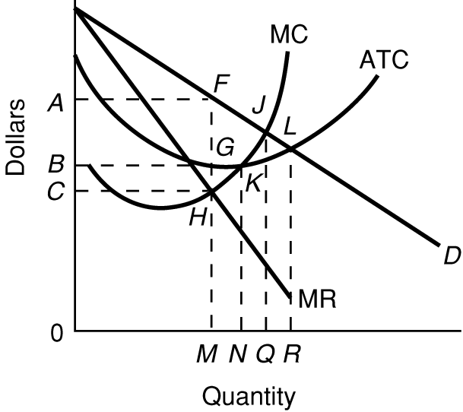

Regulated Monopoly: Long Run Equilibrium
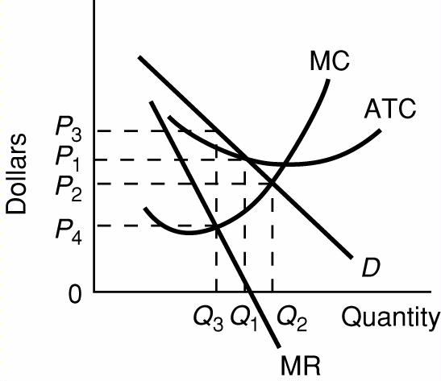

Quick Quiz – Monopoly – Short Run

1. Refer to the above data for a nondiscriminating monopolist. This firm will maximize its profit by producing:
1. 3 units.
2. 4 units.
3. 5 units.
4. 6 units.
2. Refer to the above data for a nondiscriminating monopolist. At its profit-maximizing output, this firm will be operating in the:
1. perfectly elastic portion of its demand curve.
2. perfectly inelastic portion of its demand curve.
3. elastic portion of its demand curve.
4. inelastic portion of its demand curve.
3. Refer to the above data for a nondiscriminating monopolist. At its profit-maximizing output, this firm's total profit will be:
1. $82.
2. zero.
3. $54.
4. $27.
4. If the above data was for a PERFECTLY PRICE DISCRIMINATING MONOPOLIST it would maximize its profits by producing what quantity?
1. 3 units.
2. 4 units.
3. 5 units.
4. 6 units.

5. If the above data was for a PERFECTLY PRICE DISCRIMINATING MONOPOLIST what would its total revenues be at the profit maximizing quantity?
1. $60
2. $300
3. $400
4. zero

6. If the above data was for a PERFECTLY PRICE DISCRIMINATING MONOPOLIST what would its profits be at the profit maximizing quantity?
1. zero
2. $152
3. $248
4. $400
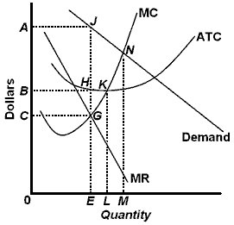
7. Refer to the above diagram. To maximize profits or minimize losses this firm should produce:
1. E units and charge price C.
2. E units and charge price A.
3. M units and charge price N.
4. L units and charge price LK.
8. Refer to the above diagram. At the profit-maximizing level of output, total revenue will be:
1. NM times 0M.
2. 0AJE.
3. 0EGC.
4. 0EHB.
9. Refer to the above diagram. At the profit-maximizing level of output, total cost will be:
1. NM times 0M.
2. 0AJE.
3. 0CGC.
4. 0BHE.
10. Refer to the above diagram. At the profit-maximizing level of output, the firm will realize:
1. an economic profit of ABHJ.
2. an economic profit of ACGJ.
3. a loss of GH per unit.
4. a loss of JH per unit.
Quick Quiz – Monopoly – Long Run

1. At its profit-maximizing output, a pure nondiscriminating monopolist achieves:
1. neither productive efficiency nor allocative efficiency.
2. both productive efficiency and allocative efficiency.
3. productive efficiency but not allocative efficiency.
4. allocative efficiency but not productive efficiency.

2. The profit-maximizing output of a pure monopoly is allocatively inefficient because in equilibrium:
1. price equals minimum average total cost.
2. marginal revenue equals marginal cost.
3. marginal cost exceeds price.
4. price exceeds marginal cost.

3. Comparing a pure monopoly and a purely competitive firm with identical costs, we would find in long-run equilibrium that the pure monopolist's:
1. price, output, and average total cost would all be higher.
2. price and average total cost would be higher, but output would be lower.
3. price, output, and average total cost would all be lower.
4. price and output would be lower, but average total cost would be higher.
4. X-inefficiency refers to a situation in which a firm:
1. is not as technologically progressive as it might be.
2. encounters diseconomies of scale.
3. fails to realize all existing economies of scale.
4. fails to achieve the minimum average total costs attainable at each level of output.

5. The monopolistic (monopoly) market model in long run equilibrium is portrayed in the above figures by:
1. Figure A.
2. Figure B.
3. Figure C.
4. Figure D.
6. Use the figure above for a monopoly in long run equilibrium to answer this question. What quantity will this monopolist produce and what price will it charge?
1. quantity 0Q; price 0B
2. quantity 0M; price 0C
3. quantity 0M; price 0A
4. quantity 0n; price 0B
7. Use the figure above for a monopoly in long run equilibrium to answer this question. The allocatively efficient quantity is
1. 0M
2. 0N
3. 0Q
4. 0R
8. Use the figure above for a monopoly in long run equilibrium to answer this question. The productively efficient quantity is
1. 0M
2. 0N
3. 0Q
4. 0R
9. Use the figure above for a monopoly in long run equilibrium to answer this question. In long run equilibrium this firm will
1. produce too much.
2. produce too little.
3. produce the efficient quantity.
4. not produce anything at all.

Monopolistic Competition: Long Run Equilibrium

Monopolistic Competition – Quick Quiz

1. Refer to the above diagram for a monopolistically competitive firm in short-run equilibrium. This firm will realize an economic:
1. loss of $320.
2. profit of $480.
3. profit of $280.
4. profit of $600.

2. Refer to the above diagram for a monopolistically competitive firm. If more firms were to enter the industry, then for this firm:
1. resource misallocation would become more severe.
2. the demand curve would increase.
3. equilibrium output would decline and equilibrium price would rise.
4. equilibrium output would decline and equilibrium price would fall.

3. In the short run a monopolistically competitive firm's economic profit:
1. will be maximized where price equals average total cost.
2. may be positive, zero, or negative.
3. are always positive.
4. will always be zero.

4. Refer to the above diagrams, which pertain to monopolistically competitive firms. Short-run equilibrium entailing economic loss is shown by:
1. diagram a only.
2. diagram b only.
3. diagram c only.
4. both diagrams a and c.
5. Refer to the above diagrams, which pertain to monopolistically competitive firms. A short-run equilibrium entailing economic profits is shown by:
1. diagram a only.
2. diagram b only.
3. diagram c only.
4. both diagrams b and c.
6. Refer to the above diagrams, which pertain to monopolistically competitive firms. Long-run equilibrium is shown by:
1. diagram a only.
2. diagram b only.
3. diagram c only.
4. both diagrams b and c.

7. Refer to the above diagram for a monopolistically competitive firm. Long-run equilibrium price will be:
1. above A.
2. EF.
3. A.
4. B.
8. Refer to the above diagram for a monopolistically competitive firm. Long-run equilibrium output will be:
1. greater than E.
2. E.
3 D.
4. C.
9. Long-run equilibrium for a monopolistically competitive firm where economic profits are zero results from:
1. rising marginal costs.
2. a perfectly elastic product demand curve.
3. relatively easy entry.
4. product differentiation and development.
10. Which of the following is not characteristic of long-run equilibrium under monopolistic competition?
1. price equals minimum average total cost
2. marginal cost equals marginal revenue
3. price is equal to average total cost
4. price exceeds marginal cost

11. In long-run equilibrium, the firm shown in the diagram above will:
1. earn a normal profit.
2. go bankrupt.
3. incur a loss.
4. realize an economic profit.
12. In long-run equilibrium, production for the firm shown in the diagram above is:
1. greater than would occur under pure competition.
2. less efficient than in a purely competitive market.
3. more efficient than in a purely competitive market.
4. optimally efficient.

13. When a monopolistically competitive firm is in long-run equilibrium:
1. production takes place where ATC is minimized.
2. marginal revenue equals marginal cost and price equals average total cost.
3. normal profit is zero and price equals marginal cost.
4. economic profit is zero and price equals marginal cost.

14. In the long run, new firms will enter a monopolistically competitive industry:
1. provided economies of scale are being realized.
2. even though losses are incurred in the short run.
3. until minimum average total cost is achieved.
4. until economic profits are zero.
15. If some firms leave a monopolistically competitive industry, the demand curves of the remaining firms will:
1. be unaffected.
2. shift to the left.
3. become more elastic.
4. shift to the right.
16. When a monopolistically competitive firm is in long-run equilibrium:
1. P = MC = ATC.
2. MR = MC and minimum ATC > P.
3. MR > MC and P = minimum ATC.
4. MR = MC and P > minimum ATC.

Oligopoly: Long Run Equilibrium in the Kinked Demand Model

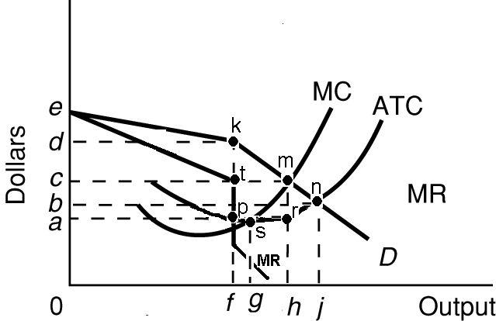

Quick Quiz -- Oligopoly – Short Run

1. The above diagram portrays:
1. pure competition.
2. collusive oligopoly.
3. noncollusive oligopoly.
4. pure monopoly.

2. Refer to the above diagram. Equilibrium output is:
1. j.
2. h.
3. g.
4. f.

3. Refer to the above diagram. Equilibrium price is:
1. e.
2. d.
3. c.
4. b.

4. Refer to the above diagram. This firm's demand and marginal revenue curves are based on the assumption that:
1. the firm has no immediate rivals.
2. rivals will match both a price increase and a price decrease.
3. rivals will match a price increase, but ignore a price decrease.
4. rivals will ignore a price increase, but match a price decrease.

5. Refer to the above diagram. In equilibrium the firm:
1. is realizing an economic profit of ad per unit.
2. should close down in the short run.
3. is incurring a loss.
4. is realizing an economic profit of bd per unit.

Oligopoly – Long Run – Quick Quiz
1. We would expect a cartel to achieve:
1. both allocative efficiency and productive efficiency.
2. allocative efficiency, but not productive efficiency.
3. productive efficiency, but not allocative efficiency.
4. neither allocative efficiency nor productive efficiency.
2. Suppose that a particular industry has a four-firm concentration ratio of 85 and a Herfindahl Index of 3,000. Most likely, this industry would achieve:
1. both productive efficiency and allocative efficiency.
2. allocative efficiency but not productive efficiency.
3. neither productive efficiency nor allocative efficiency.
4. productive efficiency but not allocative efficiency.
3. Suppose that an industry is characterized by a few firms and price leadership. We would expect that:
1. price would equal marginal cost.
2. price would equal average total cost.
3. price would exceed both marginal cost and average total cost.
4. marginal revenue would exceed marginal cost.
4. The conclusion that oligopoly is inefficient relative to the competitive ideal must be qualified because:
1. industry price leaders often select a price equal to marginal cost.
2. over time oligopolistic industries may promote more rapid product development and greater improvement of production techniques than if they were purely competitive.
3. increased output due to persuasive advertising may perfectly offset the restriction of output caused by monopoly power.
4. many oligopolists sell their products in monopolistically competitive or even purely competitive industries.

All Market Models – Long Run – Quick Quiz
The graphs below show the long run equilibrium for each of the four product market models.
1. The purely competitive market model is portrayed in the above figures by:
1. Figure A.
2. Figure B.
3. Both Figures B and D.
4. Figure C.
2. Refer to the above figures. We would expect industry entry and exit to be relatively easy in:
1. Figure A only.
2. Figure C only.
3. Both Figures A and D.
4. Both Figures B and D.
3. Refer to the above figures. Both allocative and productive efficiency are being realized in:
1. All four figures.
2. Figures B and D.
3. Figure D only.
4. Figure B only.
4. Refer to the above figures. Collusion is most likely to occur in the industry(ies) represented by:
1. Figure A.
2. Figure B.
3. Figure C.
4. Both Figures B and D.
5. Refer to the above figures. Product differentiation may be present in:
1. Figure A only.
2. Figure B only.
3. Figure C only.
4. Both Figures C and D.
6. Refer to the above figures. Government regulation of price and service is most likely to occur in:
1. Figure A only.
2. Figure D only.
3. Both Figures A and C.
4. Both Figures A and D.
7. Refer to the above figures. Long-run economic profits are most likely to occur in:
1. Figures A and B.
2. Figure B only.
3. Figure D.
4. Figures A and C.
8. Refer to the above figures. Industry entry is likely to be most difficult in:
1. Figure A.
2. Figure B.
3. Figure C.
4. Figure D.
9. Refer to the above figures. A homogeneous or standardized product is most likely to be produced in:
1. Figure A.
2. Figure B.
3. Figure C.
4. Figure D.

