Fall 2011



ECO 211 – Microeconomics

Yellow Pages

ANSWERS

Unit 3

Mark Healy
William Rainey Harper College
E-Mail: mhealy@harpercollege.edu
Office: J-262
Phone: 847-925-6352
Four Market Models

CHARACTERISTIC | PURE  COMPETITION  (Ch. 8-9) | MONOPOLISTIC  COMPETITION  (Ch. 11) | OLIGOPOLY  (Ch. 11) | MONOPOLY  (Ch. 10)
Number of Firms: | Very many | Many | Few | One
Type of product: | Standardized | Differentiated | Standardized or Differentiated | Unique; no close substitutes
Control over price: | None; they are price takers; demand facing the firm is perfectly price elastic | Little; it depends on product differentiation | Some, but limited by mutual interdependence | Considerable
Conditions of entry: | Very easy; No barriers | Relatively easy | Significant barriers | Blocked
Nonprice competition | None | A lot | Typically a lot, especially with differentiated products | Public Relations type advertising
Examples: | Agriculture | Retail trade, Restaurants, Manufactured Ice, Plastic Pipe, Book Publishing. | Automobiles, cigarettes, breakfast cereal, beer, soaps and detergents, refrigerators, roasted coffee, copper, flat glass | Public utilities: (gas, electric, water; Western Union), Wham-O (Frisbees), and the DeBeers diamond syndicate are "near" monopolies.
Quick Quiz – Product Market Models
1. Economists would describe the U.S. automobile industry as:
1. purely competitive.
2. an oligopoly.
3. monopolistically competitive.
4. a pure monopoly.
2. In which of the following market structures is there clear-cut mutual interdependence with respect to price-output policies?
1. pure monopoly
2. oligopoly
3. monopolistic competition
4. pure competition
3. Which of the following industries most closely approximates pure competition?
1. agriculture
2. farm implements
3. clothing
4. steel
4. Economists use the term imperfect competition to describe:
1. all industries which produce standardized products.
2. any industry in which there is no nonprice competition.
3. a pure monopoly only.
4. those markets which are not purely competitive.
5. In which of the following industry structures is the entry of new firms the most difficult?
1. pure monopoly
2. oligopoly
3. monopolistic competition
4. pure competition
6. An industry comprised of 40 firms, none of which has more than 3 percent of the total market for a differentiated product is an example of:
1. monopolistic competition.
2. oligopoly.
3. pure monopoly.
4. pure competition.
7. A one-firm industry is known as:
1. monopolistic competition.
2. oligopoly.
3. pure monopoly.
4. pure competition.
8. An industry comprised of four firms, each with about 25 percent of the total market for a product is an example of:
1. monopolistic competition.
2. oligopoly.
3. pure monopoly.
4. pure competition.
9. An industry comprised of a very large number of sellers producing a standardized product is known as:
1. monopolistic competition.
2. oligopoly.
3. pure monopoly.
4. pure competition.
10. An industry comprised of a small number of firms, each of which considers the potential reactions of its rivals in making price-output decisions is called:
1. monopolistic competition.
2. oligopoly.
3. pure monopoly.
4. pure competition.
Price and Output Determination – Pure competition

Decision: How many should the firm produce?

Goal: Profit Maximization

2 Steps: 1. Find the best quantity, where MR = MC
2. Compare AR with AVC, produce only if AR > AVC

Assumptions: Pure Competition

3 Cases: Note – this cost data is the same as that which we used in the yellow page for the chapter 8 (Costs of Production)

Profit Maximization Loss Minimization Shut Down
P = $ 10 P = $ 5 P = $ 2

Q | TC | MC | TR | MR
0 | $25 | -- | 0 | --
1 | 35 | 10 | 10 | 10
2 | 41 | 6 | 20 | 10
3 | 45 | 4 | 30 | 10
4 | 47 | 2 | 40 | 10
5 | 49 | 2 | 50 | 10
6 | 52 | 3 | 60 | 10
7 | 57 | 5 | 70 | 10
8 | 65 | 8 | 80 | 10
9 | 79 | 14 | 90 | 10
10 | 100 | 21 | 100 | 10

Q | TC | MC | TR | MR
0 | $25 | -- | 0 | --
1 | 35 | 10 | 5 | 5
2 | 41 | 6 | 10 | 5
3 | 45 | 4 | 15 | 5
4 | 47 | 2 | 20 | 5
5 | 49 | 2 | 25 | 5
6 | 52 | 3 | 30 | 5
7 | 57 | 5 | 35 | 5
8 | 65 | 8 | 40 | 5
9 | 79 | 14 | 45 | 5
10 | 100 | 21 | 50 | 5

Q | TC | MC | TR | MR
0 | $25 | -- | 0 | --
1 | 35 | 10 | 2 | 2
2 | 41 | 6 | 4 | 2
3 | 45 | 4 | 6 | 2
4 | 47 | 2 | 8 | 2
5 | 49 | 2 | 10 | 2
6 | 52 | 3 | 12 | 2
7 | 57 | 5 | 14 | 2
8 | 65 | 8 | 16 | 2
9 | 79 | 14 | 18 | 2
10 | 100 | 21 | 20 | 2

Short-Run Cost Schedules and Curves (from chapter 7)

Q | TFC | TVC | TC | AFC | AVC | ATC | MC
0 | $ 25 | $ 0 | $ 25 | $ -- | $ -- | $ -- | $ --
1 | 25 | 10 | 35 | 25 | 10.00 | 35 | 10
2 | 25 | 16 | 41 | 12.50 | 8.00 | 20.50 | 6
3 | 25 | 20 | 45 | 8.33 | 6.67 | 15.00 | 4
4 | 25 | 22 | 47 | 6.25 | 5.50 | 11.75 | 2
5 | 25 | 24 | 49 | 5.00 | 4.80 | 9.80 | 2
6 | 25 | 27 | 52 | 4.17 | 4.50 | 8.67 | 3
7 | 25 | 32 | 57 | 3.57 | 4.57 | 8.14 | 5
8 | 25 | 40 | 65 | 3.125 | 5.00 | 8.125 | 8
9 | 25 | 54 | 79 | 2.78 | 6.00 | 8.78 | 14
10 | 25 | 75 | 100 | 2.50 | 7.50 | 10.00 | 21

Pure Competition – Price = $ 10

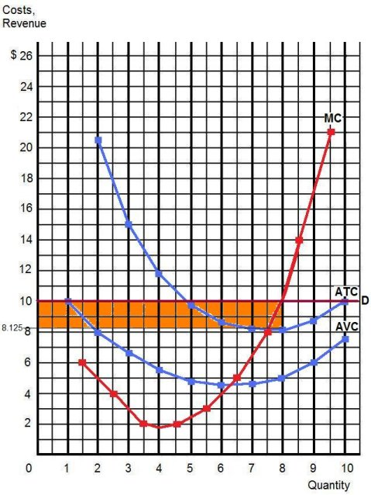

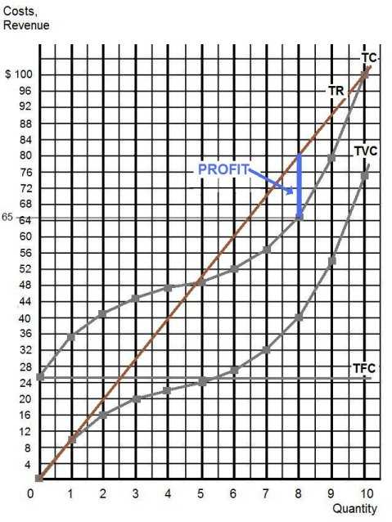

Pure Competition – Price = $ 5

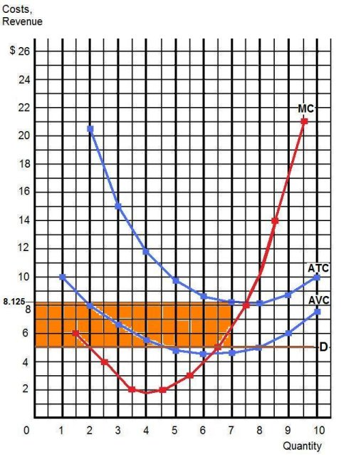

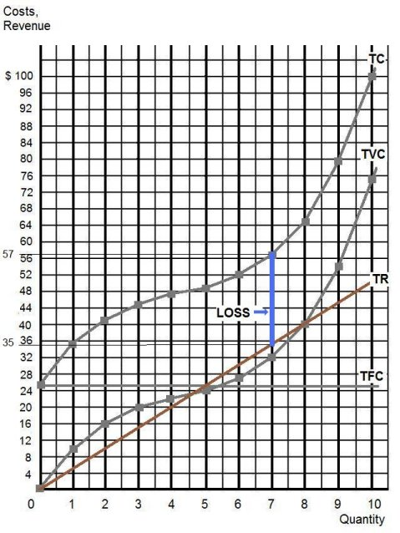

Pure Competition – Price = $ 2

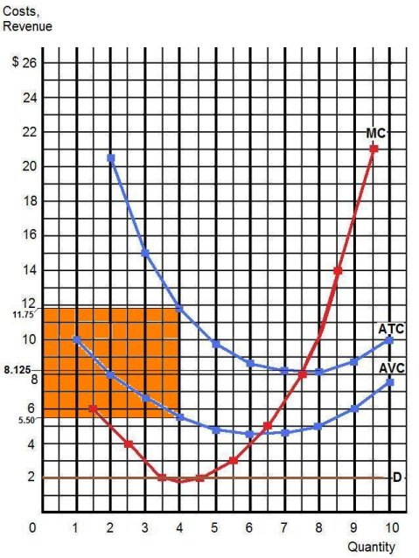

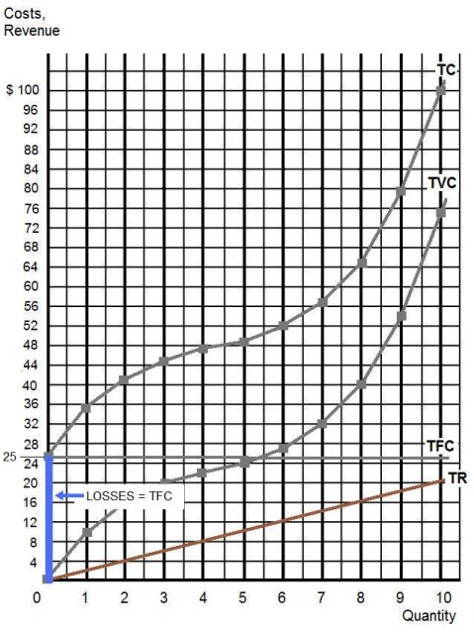

REVIEW QUESTIONS: Pure Competition

Use the cost and revenue curves to answer the questions that follow. Assume the firm is a profit maximizer.

- Q = 250

- P = $0.65

- Will this firm produce this quantity? Yes

- AR = $0.65 (same as price)

- TR = P x Q = $0.65 x 250 = $162.50

- ATC = $0.50

- TC = ATC x Q = $0.50 x 250 = $125.00

- Does this firm earn profits or losses? Yes, because AR (or price) > AVC

- Profits or losses = TR – TC = $162.50 - $125.00 = $37.50

- At this quantity, AFC = ATC – AVC = $0.50 - $0.30 = $0.20

- TFC = AFC x Q = $0.20 x 250 = $50.00
- If the price dropped to $.30, will this firm continue to produce?
Yes, because AR (or price) is still > AVC

- If so, what quantity will it produce? 150

- Will it now earn profits or losses? losses

- Profits or losses = TR – TC = $45 - $75 = -$30

- Why does it continue to produce? Because if it shut down (produced nothing) it would lose more. If if produced nothing it would still lose its TFC which are $50.00 (see question 11).

________________________________________________________________________

- If the price dropped to $.15 will this firm continue to produce?
No, because P < AVC

- What will be its losses if the price = $.15? Since it would shut down and produce nothing its losses would be its TRFC = $50.00

- At a price of $.30 the firm earns enough revenues to cover its entire fixed/variable cost, as well as PART of its fixed/variable cost?

- Which curve and what portion of it constitutes the firm’s short run supply curve?

The firm’s short run supply curve is the MC above the AVC curve.
Quick Quiz – Pure Competition – Short Run
1. Refer to the above data. If the market price for the firm's product is $12, the competitive firm will produce:
1. 4 units at a loss of $109.
2. 4 units at an economic profit of $31.75.
3. 8 units at a loss of $48.80.
4. zero units at a loss of $100.

2. Refer to the above data. If the market price for the firm's product is $32, the competitive firm will produce:
A 1. 8 units at an economic profit of $16.
2. 5 units at a loss of $10.
3. 8 units at a loss equal to the firm's total fixed cost.
4. 7 units at an economic profit of $41.50.

3. Refer to the above diagram. To maximize profit or minimize losses this firm will produce:
1. K units at price C.
2. D units at price J.
3. E units at price A.
4. E units at price B.
4. Refer to the above diagram. At the profit-maximizing output, total revenue will be:
1. 0AHE.
2. 0BGE.
3. 0CFE.
4. ABGE.
5. Refer to the above diagram. At the profit-maximizing output, total cost is equal to:
1. 0AHE.
2. 0BGE.
3. 0CFE.
4. BCFG.
6. Refer to the above diagram. At the profit-maximizing output, the firm will realize:
1. a loss equal to BCFG.
2. a loss equal to ACFH.
3. an economic profit of ACFH.
4. an economic profit of ABGH.
Quick Quiz – Pure Competition – Long Run
1. Refer to the above diagrams, which pertain to a purely competitive firm producing output q and the industry in which it operates. Which of the following is correct?
1. The diagrams portray neither long-run nor short-run equilibrium.
2. The diagrams portray both long-run and short-run equilibrium.
3. The diagrams portray short-run equilibrium, but not long-run equilibrium.
4. The diagrams portray long-run equilibrium, but not short-run equilibrium.
2. Refer to the above diagrams, which pertain to a purely competitive firm producing output q and the industry in which it operates. In the long run we should expect:
1. firms to enter the industry, market supply to rise, and product price to fall.
2. firms to leave the industry, market supply to rise, and product price to fall.
3. firms to leave the industry, market supply to fall, and product price to rise.
4. no change in the number of firms in this industry.
3. The term productive efficiency refers to:
1. any short-run equilibrium position of a competitive firm.
2. the production of the product-mix most desired by consumers.
3. the production of a good at the lowest average total cost (where MC=ATC)
4. fulfilling the condition P = MC.
4. The term allocative efficiency refers to:
1. the level of output that coincides with the intersection of the MC and AVC curves.
2. minimization of the AFC in the production of any good.
3. the production of the product-mix most desired by consumers.
4. the production of a good at the lowest average total cost.
5. If the price of product Y is $25 and its marginal cost is $18:
1. Y is being produced with the least-cost combination of resources.
2. society will realize a net gain if less of Y is produced.
3. resources are being underallocated to Y.
4. resources are being overallocated to Y.
6. Under pure competition in the long run:
1. neither allocative efficiency nor productive efficiency are achieved.
2. both allocative efficiency and productive efficiency are achieved.
3. productive efficiency is achieved, but allocative efficiency is not.
4. allocative efficiency is achieved, but productive efficiency is not.
7. If for a firm P = minimum ATC = MC, then:
1. neither allocative efficiency nor productive efficiency is being achieved.
2. productive efficiency is being achieved, but allocative efficiency is not.
3. both allocative efficiency and productive efficiency are being achieved.
4. allocative efficiency is being achieved, but productive efficiency is not.
8. The above diagram portrays:
1. a competitive firm that should shut down in the short run.
2. the equilibrium position of a competitive firm in the long run.
3. a competitive firm that is realizing an economic profit.
4. the loss-minimizing position of a competitive firm in the short run.
9. Refer to the above diagram. If this competitive firm produces output Q, it will:
1. suffer an economic loss.
2. earn a normal profit.
3. earn an economic profit.
4. achieve productive efficiency, but not allocative efficiency.
10. Refer to the above diagram. By producing output level Q:
1. neither productive nor allocative efficiency are achieved.
2. both productive and allocative efficiency are achieved.
3. allocative efficiency is achieved, but productive efficiency is not.
4. productive efficiency is achieved, but allocative efficiency is not.
Monopoly Firms and Short Run Decisions

Q | AR | TR | MR |  | TC | MC | TFC | ATC | AFC | AVC
0 | $ 16 | $ 0 | $ -- |  | $ 12 | $ -- | $ 12 | $ -- | $ -- | $ --
1 | $ 14 | 14 | 14 |  | $ 20 | 8 | 12 | 20 | 12 | 8
2 | $ 12 | 24 | 10 |  | $ 23 | 3 | 12 | 11.50 | 6 | 5.50
3 | $ 10 | 30 | 6 |  | $ 26 | 3 | 12 | 8.67 | 4 | 4.67
4 | $ 8 | 32 | 2 |  | $ 32 | 6 | 12 | 8.00 | 3 | 5
5 | $ 6 | 30 | -2 |  | $ 50 | 18 | 12 | 10 | 2.40 | 7.60

Make three plots:
- AR and MR
- AR, MR, ATC, and MC
- TR and TC

AR and MR
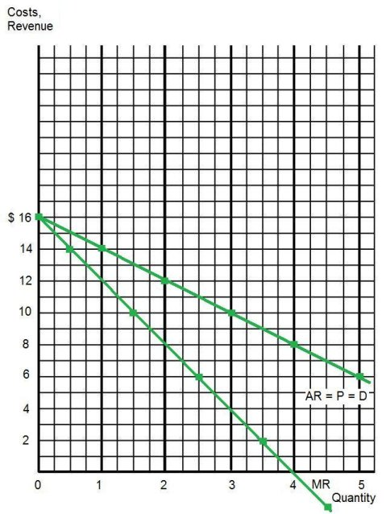

AR, MR, ATC, and MC
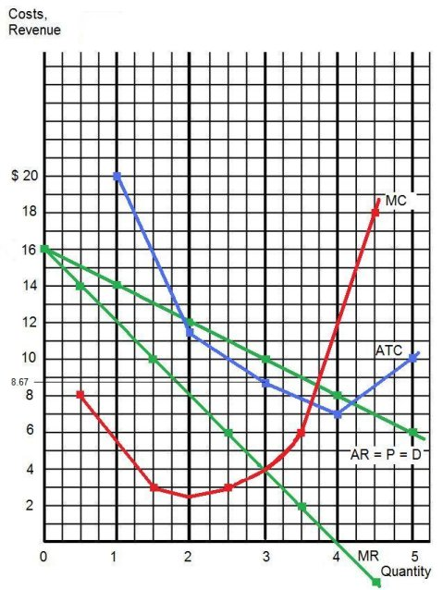

TC and TR
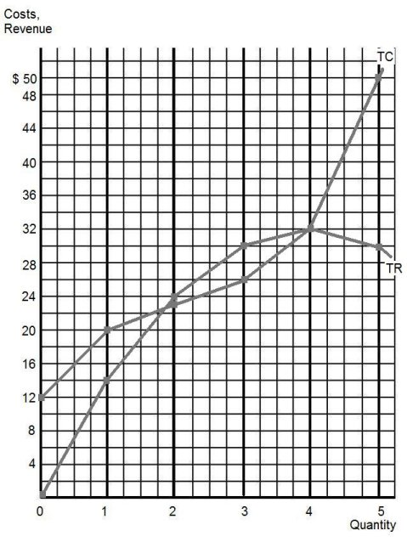

AR, MR, ATC, and MC
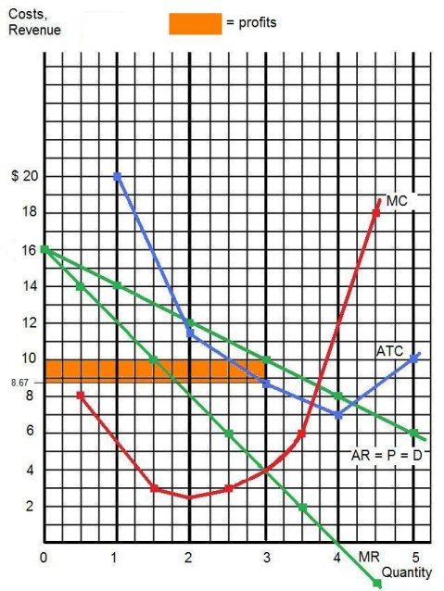

TC and TR
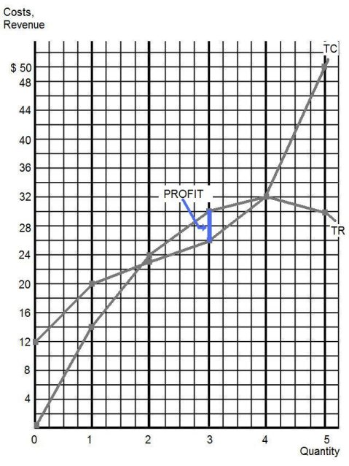
REVIEW QUESTIONS: Monopoly

Use the cost and revenue curves below to answer the questions that follow. Assume the firm is a profit maximizer.

- Q = 35

- P = $1.20

- Will this firm produce this quantity?
Yes, because the AR (average revenue or price) is above the AVC curve.

- AR = $1.20 (same thing as price)

- TR = P x Q = $1.20 x 35 = $42.00

- ATC = $0.90

- TC = ATC x Q = $0.90 x 35 = $31.50

- Does this firm earn profits or losses? Profits

- Profits or losses = TR – TC = $42 - $32.50 = $10.50

- At this quantity, AFC = ATC – AVC = $0.90 -$0.60 = $0.30

- TFC = AFC x Q = $0.30 x 35 = $10.50
- If the price dropped to $.75 (due to decreased demand), ceterus paribus, will this firm continue to produce in the short run? Yes, because P (or AR) is still greater than AVC

- Will it now earn profits or losses? Losses

- Why does it continue to produce?
Because if it shut down (produced nothing) it would lose more.

- If the price dropped to $.45 will this firm continue to produce? No, because $0.45 is less than AVC so it will lose less if it shuts douwn (produces nothing)

- Is this firm achieving productive efficiency? Explain.

No, because at the profit maximizing quantity (35) ATC is NOT at its lowest point. (The lowest ATC is where MC = ATC).

- Could the monopolist “afford” to expand production to the level where price equals ATC, an output of 57 in this example? Explain.

Yes, because at a quantity of 57 on the graph we can see that TR = TC and the economic profit will be zero. A zero economic profit is good because it means that you are making as much as you could make in your next best alternative.

Quick Quiz – Monopoly – Short Run

1. Refer to the above data for a nondiscriminating monopolist. This firm will maximize its profit by producing:
1. 3 units.
2. 4 units.
3. 5 units.
4. 6 units.
2. Refer to the above data for a nondiscriminating monopolist. At its profit-maximizing output, this firm will be operating in the:
1. perfectly elastic portion of its demand curve.
2. perfectly inelastic portion of its demand curve.
3. elastic portion of its demand curve.
4. inelastic portion of its demand curve.
3. Refer to the above data for a nondiscriminating monopolist. At its profit-maximizing output, this firm's total profit will be:
1. $82
2. zero
3. $54
4. $27
4. If the above data was for a PERFECTLY PRICE DISCRIMINATING MONOPOLIST it would maximize its profits by producing what quantity?
1. 3 units.
2. 4 units.
3. 5 units.
4. 6 units.

5. If the above data was for a PERFECTLY PRICE DISCRIMINATING MONOPOLIST what would its total revenues be at the profit maximizing quantity?
1. $60
2. $300
3. $400
4. zero

6. If the above data was for a PERFECTLY PRICE DISCRIMINATING MONOPOLIST what would its profits be at the profit maximizing quantity?
1. zero
2. $152
3. $248
4. $400

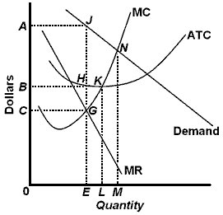
7. Refer to the above diagram. To maximize profits or minimize losses this firm should produce:
1. E units and charge price C.
2. E units and charge price A.
3. M units and charge price N.
4. L units and charge price LK.
8. Refer to the above diagram. At the profit-maximizing level of output, total revenue will be:
1. NM times 0M.
2. 0AJE.
3. 0EGC.
4. 0EHB.
9. Refer to the above diagram. At the profit-maximizing level of output, total cost will be:
1. NM times 0M.
2. 0AJE.
3. 0CGC.
4. 0BHE.
10. Refer to the above diagram. At the profit-maximizing level of output, the firm will realize:
1. an economic profit of ABHJ.
2. an economic profit of ACGJ.
3. a loss of GH per unit.
4. a loss of JH per unit.
Quick Quiz – Monopoly – Long Run

1. At its profit-maximizing output, a pure nondiscriminating monopolist achieves:
1. neither productive efficiency nor allocative efficiency.
2. both productive efficiency and allocative efficiency.
3. productive efficiency but not allocative efficiency.
4. allocative efficiency but not productive efficiency.

2. The profit-maximizing output of a pure monopoly is allocatively inefficient because in equilibrium:
1. price equals minimum average total cost.
2. marginal revenue equals marginal cost.
3. marginal cost exceeds price.
4. price exceeds marginal cost.

3. Comparing a pure monopoly and a purely competitive firm with identical costs, we would find in long-run equilibrium that the pure monopolist's:
1. price, output, and average total cost would all be higher.
2. price and average total cost would be higher, but output would be lower.
3. price, output, and average total cost would all be lower.
4. price and output would be lower, but average total cost would be higher.

- X-inefficiency refers to a situation in which a firm:
1. is not as technologically progressive as it might be.
2. encounters diseconomies of scale.
3. fails to realize all existing economies of scale.
4. fails to achieve the minimum average total costs attainable at each level of output.

5. The monopolistic (monopoly) market model in long run equilibrium is portrayed in the above figures by:
1. Figure A.
2. Figure B.
3. Figure C.
4. Figure D.

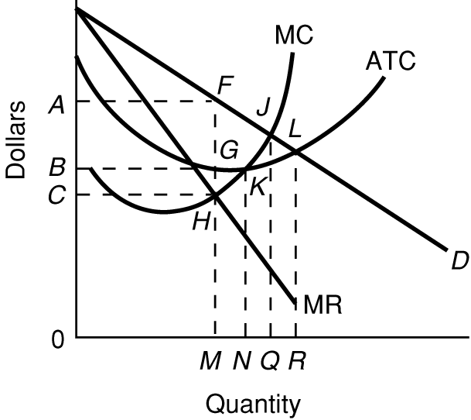
6. Use the figure above for a monopoly in long run equilibrium to answer this question. What quantity will this monopolist produce and what price will it charge?
1. quantity 0Q; price 0B
2. quantity 0M; price 0C
3. quantity 0M; price 0A
4. quantity 0n; price 0B
7. Use the figure above for a monopoly in long run equilibrium to answer this question. The allocatively efficient quantity is
1. 0M
2. 0N
3. 0Q
4. 0R
8. Use the figure above for a monopoly in long run equilibrium to answer this question. The productively efficient quantity is
1. 0M
2. 0N
3. 0Q
4. 0R
9. Use the figure above for a monopoly in long run equilibrium to answer this question. In long run equilibrium this firm will
1. produce too much.
2. produce too little.
3. produce the efficient quantity.
4. not produce anything at all.
Monopolistic Competition – Quick Quiz

1. Refer to the above diagram for a monopolistically competitive firm in short-run equilibrium. This firm will realize an economic:
1. loss of $320.
2. profit of $480.
3. profit of $280.
4. profit of $600.

2. Refer to the above diagram for a monopolistically competitive firm. If more firms were to enter the industry, then for this firm:
1. resource misallocation would become more severe.
2. the demand curve would increase.
3. equilibrium output would decline and equilibrium price would rise.
4. equilibrium output would decline and equilibrium price would fall.

3. In the short run a monopolistically competitive firm's economic profit:
1. will be maximized where price equals average total cost.
2. may be positive, zero, or negative.
3. are always positive.
4. will always be zero.

4. Refer to the above diagrams, which pertain to monopolistically competitive firms. Short-run equilibrium entailing economic loss is shown by:
1. diagram a only.
2. diagram b only.
3. diagram c only.
4. both diagrams a and c.
5. Refer to the above diagrams, which pertain to monopolistically competitive firms. A short-run equilibrium entailing economic profits is shown by:
1. diagram a only.
2. diagram b only.
3. diagram c only.
4. both diagrams b and c.
6. Refer to the above diagrams, which pertain to monopolistically competitive firms. Long-run equilibrium is shown by:
1. diagram a only.
2. diagram b only.
3. diagram c only.
4. both diagrams b and c.
7. Refer to the above diagram for a monopolistically competitive firm. Long-run equilibrium price will be:
1. above A.
2. EF.
3. A.
4. B.
8. Refer to the above diagram for a monopolistically competitive firm. Long-run equilibrium output will be:
1. greater than E.
2. E.
3. D.
4. C.
9. Long-run equilibrium for a monopolistically competitive firm where economic profits are zero results from:
1. rising marginal costs.
2. a perfectly elastic product demand curve.
3. relatively easy entry.
4. product differentiation and development.
10. Which of the following is not characteristic of long-run equilibrium under monopolistic competition?
1. price equals minimum average total cost
2. marginal cost equals marginal revenue
3. price is equal to average total cost
4. price exceeds marginal cost

11. In long-run equilibrium, the firm shown in the diagram above will:
1. earn a normal profit.
2. go bankrupt.
3. incur a loss.
4. realize an economic profit.
12. In long-run equilibrium, production for the firm shown in the diagram above is:
1. greater than would occur under pure competition.
2. less efficient than in a purely competitive market.
3. more efficient than in a purely competitive market.
4. optimally efficient.
13. When a monopolistically competitive firm is in long-run equilibrium:
1. production takes place where ATC is minimized.
2. marginal revenue equals marginal cost and price equals average total cost.
3. normal profit is zero and price equals marginal cost.
4. economic profit is zero and price equals marginal cost.

14. In the long run, new firms will enter a monopolistically competitive industry:
1. provided economies of scale are being realized.
2. even though losses are incurred in the short run.
3. until minimum average total cost is achieved.
4. until economic profits are zero.
15. If some firms leave a monopolistically competitive industry, the demand curves of the remaining firms will:
1. be unaffected.
2. shift to the left.
3. become more elastic.
4. shift to the right.
16. When a monopolistically competitive firm is in long-run equilibrium:
1. P = MC = ATC.
2. MR = MC and minimum ATC > P.
3. MR > MC and P = minimum ATC.
4. MR = MC and P > minimum ATC.

Quick Quiz -- Oligopoly – Short Run

1. The above diagram portrays:
1. pure competition.
2. collusive oligopoly.
3. noncollusive oligopoly.
4. pure monopoly.

2. Refer to the above diagram. Equilibrium output is:
1. j.
2. h.
3. g.
4. f.

3. Refer to the above diagram. Equilibrium price is:
1. e.
2. d.
3. c.
4. b.

4. Refer to the above diagram. This firm's demand and marginal revenue curves are based on the assumption that:
1. the firm has no immediate rivals.
2. rivals will match both a price increase and a price decrease.
3. rivals will match a price increase, but ignore a price decrease.
4. rivals will ignore a price increase, but match a price decrease.

5. Refer to the above diagram. In equilibrium the firm:
1. is realizing an economic profit of ad per unit.
2. should close down in the short run.
3. is incurring a loss.
4. is realizing an economic profit of bd per unit.

Oligopoly – Long Run – Quick Quiz
1. We would expect a cartel to achieve:
1. both allocative efficiency and productive efficiency.
2. allocative efficiency, but not productive efficiency.
3. productive efficiency, but not allocative efficiency.
4. neither allocative efficiency nor productive efficiency.
2. Suppose that a particular industry has a four-firm concentration ratio of 85 and a Herfindahl Index of 3,000. Most likely, this industry would achieve:
1. both productive efficiency and allocative efficiency.
2. allocative efficiency but not productive efficiency.
3. neither productive efficiency nor allocative efficiency.
4. productive efficiency but not allocative efficiency.
3. Suppose that an industry is characterized by a few firms and price leadership. We would expect that:
1. price would equal marginal cost.
2. price would equal average total cost.
3. price would exceed both marginal cost and average total cost.
4. marginal revenue would exceed marginal cost.
4. The conclusion that oligopoly is inefficient relative to the competitive ideal must be qualified because:
1. industry price leaders often select a price equal to marginal cost.
2. over time oligopolistic industries may promote more rapid product development and greater improvement of production techniques than if they were purely competitive.
3. increased output due to persuasive advertising may perfectly offset the restriction of output caused by monopoly power.
4. many oligopolists sell their products in monopolistically competitive or even purely competitive industries.

All Market Models – Long Run – Quick Quiz
The graphs below show the long run equilibrium for each of the four product market models.
1. The purely competitive market model is portrayed in the above figures by:
1. Figure A.
2. Figure B.
3. Both Figures B and D.
4. Figure C.
2. Refer to the above figures. We would expect industry entry and exit to be relatively easy in:
1. Figure A only.
2. Figure C only.
3. Both Figures A and D.
4. Both Figures B and D.
3. Refer to the above figures. Both allocative and productive efficiency are being realized in:
1. All four figures.
2. Figures B and D.
3. Figure D only.
D. Figure B only.
4. Refer to the above figures. Collusion is most likely to occur in the industry(ies) represented by:
1. Figure A.
2. Figure B.
3. Figure C.
4. Both Figures B and D.
5. Refer to the above figures. Product differentiation may be present in:
1. Figure A only.
2. Figure B only.
3. Figure C only.
4. Both Figures C and D.
6. Refer to the above figures. Government regulation of price and service is most likely to occur in:
1. Figure A only.
2. Figure D only.
3. Both Figures A and C.
4. Both Figures A and D.
7. Refer to the above figures. Long-run economic profits are most likely to occur in:
1. Figures A and B.
2. Figure B only.
3. Figure D.
4. Figures A and C.
8. Refer to the above figures. Industry entry is likely to be most difficult in:
1. Figure A.
2. Figure B.
3. Figure C.
4. Figure D.
9. Refer to the above figures. A homogeneous or standardized product is most likely to be produced in:
1. Figure A.
2. Figure B.
3. Figure C.
3. Figure D

Three Rules and Four Models

Three Rules:
How to find the profit maximizing quantity:
A firm will maximize its profit (or minimize its losses) by producing that output at which marginal revenue and marginal cost are equal provided product price is equal to or greater than average variable cost.
(1) Find the quantity where: MR=MC
(2) produce this quantity only if: AR > AVC or P > AVC
This is WHAT WE GET

How to find the productively efficient quantity:
Society will achieve productive efficiency by producing that output at which the average total cost (ATC) is at a minimum.
minimum ATC, or
MC = ATC
This is WHAT WE WANT

How to find the allocatively efficient quantity:
Society will achieve allocative efficiency by producing that output at which price and marginal cost are equal.
P=MC

Four Product Market Models:

1. Competitive Market
Characteristics:

1. Number of firms: very large numbers
2. Type of product: standardized product
3. Control over price: none, they are "price takers"
4. Ease of entry: no barriers; free entry
5. Nonprice competition: none
Examples: Agriculture
Why is the D curve horizontal?
The demand curve is perfectly price elastic giving the firm no control over the price because of the very large number of firms producing standardized (identical) products. If one firm tries to charge a higher price all customers would buy from someone else. If one firm decides to sell nothing it has no effect on the market supply because there each firm produces an insignificant amount of the total
Why does P = MR?
Because the demand curve s perfectly price elastic. Since a single firm can sell all that they produce at the equilibrium price (i.e. they do not have to lower the price to sell more) the extra revenue that they receive when they sell one more unit (the MR) is the same as the price.
Long-run equilibrium graph:
What happens if there are short run profits?
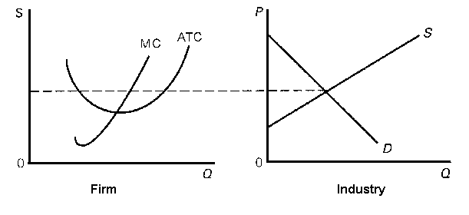
Remember, there are no barriers to entry, therefore if there are short run profits as shown in the graph on the left above, new firms will enter. When new firms enter (an increase in the number of producers) the market supply will increase (shift to the right) and cause the price to drop and they will no longer be earning profits.

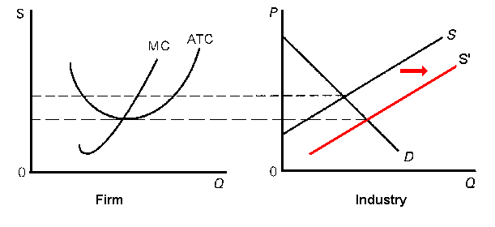
What happens if there are short run losses?
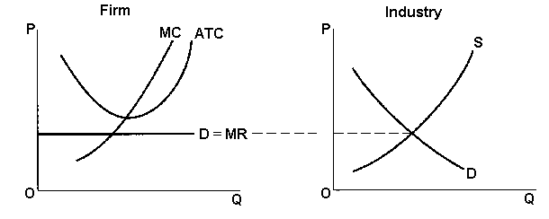
I there are short run losses as shown in the graph on the left above, firms will leave the industry. When firms leave (a decrease in the number of producers) the market supply will decrease (shift to the right) and cause the price to drop and they will no longer be earning profits.

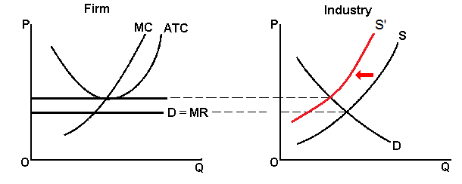

Why are there only normal profits in the long run?
Because there are no barriers to entry. If there are short run profits new firms will enter and the price will drop. If there are short run losses, firms will leave the industry and the price will rise. After all long-run adjustments are completed, product price will be exactly equal to, and production will occur at, each firm's point of minimum average total cost, and the firm will earn normal (zero) profits.
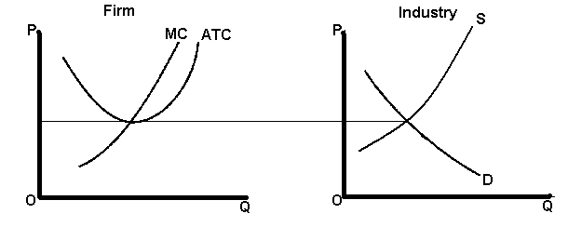
Long Run Equilibrium Graph – Pure Competition:
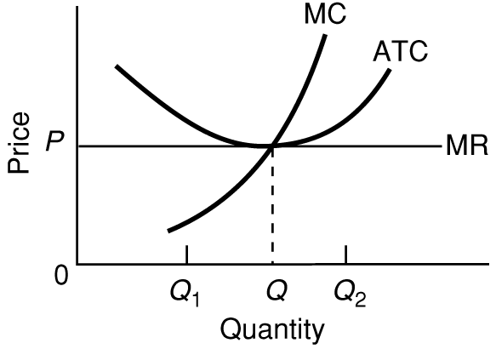
Be able to find the:
- profit maximizing quantity and price:
Quantity would be “Q” (where MR=MC) and the price would be P
- profits: none; normal profits
- allocatively efficient quantity: Q (same as the profit maximizing quantity)
- productively efficient quantity: Q (same as the profit maximizing quantity)

2. Monopoly
Characteristics:

1. Number of firms: one
2. Type of product: unique product; no close substitutes
3. Control over price: very much; considerable
4. Ease of entry: blocked
What are the barriers to entry?

A. Economies of scale constitute one major barrier. This occurs where the lowest unit costs and, therefore, lowest unit prices for consumers, depend on the existence of a small number of large firms or, in the case of a pure monopoly, only one firm. Because a very large firm with a large market share can produce at a lower ATC than if there were many firms producing a small market share

B. Legal barriers to entry into a monopolistic industry also exist in the form of patents and licenses.

C. Ownership or control of essential resources is another barrier to entry.

D. Monopolists may use pricing or other strategic barriers such as selective price-cutting and advertising.

5. Nonprice competition: mostly public relations advertising
Examples:
1. | Public utilities: gas, electric, water, cable TV, and local telephone service companies, are often pure monopolies.
2. | First Data Resources (Western Union), Wham-O (Frisbees), and the DeBeers diamond syndicate are examples of "near" monopolies.
3. | Manufacturing monopolies are virtually nonexistent in nationwide U.S. manufacturing industries.
4. | Professional sports leagues grant team monopolies to cities.
5. | Monopolies may be geographic. A small town may have only one airline, bank, etc.
Why is the demand curve downward sloping?
Monopoly demand is the industry (market) demand and is therefore downward sloping just lake we learned in the Supply and Demand chapter.

Why is MR < P ?
Price will exceed marginal revenue because non-price discriminating monopolist must lower the price to ALL CUSTOMERS in order to sell the additional unit. The added revenue will be the price of the last unit less the sum of the price cuts which must be taken on all prior units of output
Long-Run Equilibrium Graph - Monopoly
Why are there long run profits?

Because there are barriers to entry (entry is blocked).
Be able to find the:
- profit maximizing quantity and price: quantity is 0M, price is 0A
- profits: BAFG
- allocatively efficient quantity: 0Q
- productively efficient quantity: 0N

Natural Monopoly

How can you tell from this graph (see below) that this is a natural monopoly?
Because the demand curve crosses the ATC curve while the ATC is still going down. This means that one firm can produce everything that is demanded at a lower cost than if there were many firms each producing a small amount (at a higher ATC).
What are some examples of natural monopolies?

Public utilities are often natural monopolies because they have economies of scale in the extreme case where one firm is most efficient in satisfying existing demand. Therefore the government usually gives one firm the right to operate a public utility industry in exchange for government regulation of its power. If there were more than one firm it would be productively inefficient (higher average total costs) because there would be many pipes and wires going to each house.
Explain WHY it is more productively efficient for there to be only one producer. (WHY are there natural monopolies?)

SAME ANSWER AS ABOVE - Public utilities are often natural monopolies because they have economies of scale in the extreme case where one firm is most efficient in satisfying existing demand. Therefore the government usually gives one firm the right to operate a public utility industry in exchange for government regulation of its power. If there were more than one firm it would be productively inefficient (higher average total costs) because there would be many pipes and wires going to each house.

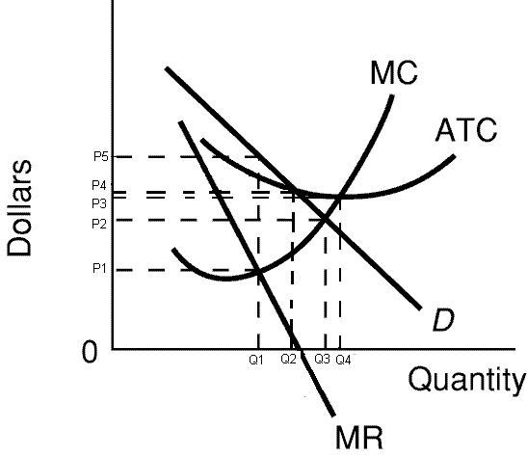
Be able to find the:
- profit maximizing quantity and price: Q1 (where MR=MC), P5
- profits: for profits see graph below
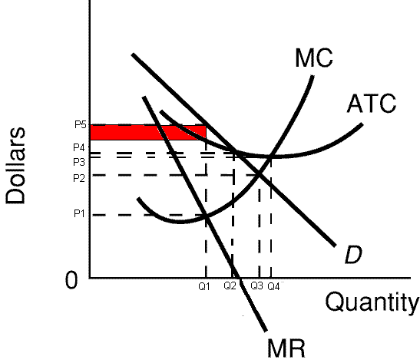
- allocatively efficient quantity: Q3 (where P=MC or D=MC)
- productively efficient quantity: Q4 (minimum ATC or where MC=ATC)
- "fair-return" price and quantity: Q2 and P4 (where D crosses the ATC)

3. Monopolistic Competition

Characteristics:

1. Number of firms: Many
2. Type of product: Differentiated
What is product differentiation and how is it achieved?

Product differentiation is a strategy in which one firm’s product is distinguished from competing products by means of its design, related services, quality, location, or other attributes (except price).

Product differentiation and other types of nonprice competition give the individual firm some degree of monopoly power that the purely competitive firm does not possess therefore it allows producers to have some control over the prices of their products.

Product differentiation may be physical (qualitative). It may include services and conditions accompanying the sale of the product. Location is another type of differentiation. Brand names and packaging lead to perceived differences and are forms of product differentiation as well.
3. Control over price: some, depending on the degree of product differentiation
4. Ease of entry: easy
5. Nonprice competition: a lot; product differentiation is a type of nonprice competition
Examples:
Retail trade, Restaurants, Manufactured Ice, Plastic Pipe, Book Publishing, Paperboard Boxes, Curtains and Draperies, Textile Machinery, Leather Goods, Lighting Fixtures, Wood Furniture, Wooden Kitchen Cabinets
Define Concentration ratio:
The percentage of the total sales of an industry made by the four (or some other number) largest sellers in the industry.
(Is the concentration ratio HIGH or LOW for monopolistically competitive industries?) LOW
Define: Herfindahl index:
A measure of the concentration and competitiveness of an industry; calculated as the sum of the squared percentage market shares of the individual firms.
SUM % market shares squared
If monopoly = 100 squared = 10,000
If 4 firms with 25% each = 25 squared + 25 squared + 25 squared + 25 squared = 2500
(Is the Herfindahl index HIGH or LOW for monopolistically competitive industries?) LOW

Long-Run Equilibrium
Why are there only normal profits in the long run?
Because there are few barriers to entry. Whenever there are no, or few, barriers to entry, firms will not be able to earn long run profits because if there are short run profits new firms will enter causing the price to g down and the profits to evaporate.

What happens if there are short run profits as shown in the graph below?
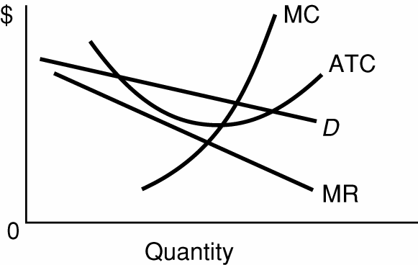

If there are short run profits, new firms would enter the industry (remember, there are few barriers to entry) and the demand curve for all of the existing firms will decrease (move ot the left).
What happens if there are short run losses as shown on the graph below?
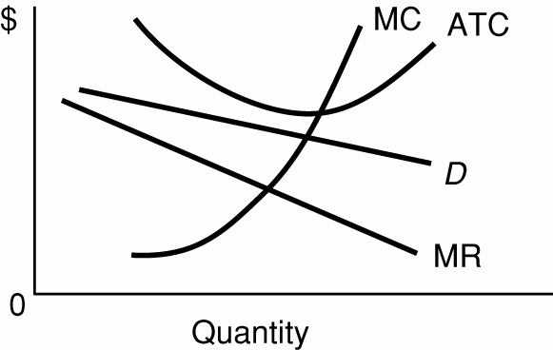

If there are short run losses, firms would leave the industry (go out of business in the ling run) and the demand curve for all of the remaining firms will increase (move to the right).

Long Run Equilibrium Graph – Monopolistic Competition:

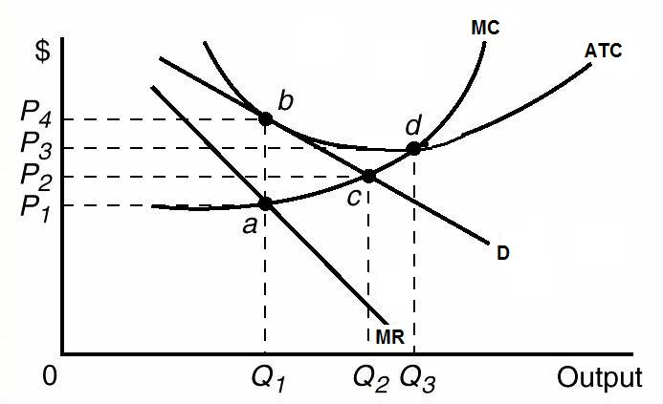
Be able to find the:
profit maximizing quantity and price:
quantity would be Q1 where MR=MC, and the price would be P4
profits: zero, or normal profits
allocatively efficient quantity: Q2 (Where P=MC or D=MC)
productively efficient quantity: Q3 (minimum ATC or where MC=ATC)

4. Oligopoly

Characteristics

- Number of firms: FEW; So few that collusion may be possible and mutual interdependence exists

What is collusion?

Collusion is a situation in which firms act together and in agreement (collude) to fix prices, divide a market, or otherwise restrict competition. In other words, they cheat and work together as if they were a monopoly.
What is mutual interdependence?
Mutual interdependence is a situation in which a change in price strategy (or in some other strategy) by one firm will affect the sales and profits of another firm (or other firms); any firm which makes such a change can expect the other rivals to react to the change
Is the concentration ratio HIGH or LOW for oligopolistic industries? HIGH
Is the Herfindahl index HIGH or LOW for oligopolistic industries? HIGH
2. Type of product:
Standardized (homogenous) OR differentiated
3. Control over price:
Since there are few firms in the industry you would expect there to be a lot of control over price, but it is limited by mutual interdependence. A firm has to be concerned about what their competitors will do if it decides to change its price.
With collusion there is much control over price (like a monopoly).
4. Ease of entry:
Entry is difficult since there are significant barriers to entry.
5. Nonprice competition:
If they have differentiated products, there is a lot of nonprice competition.

Examples:
Automobiles, cigarettes, breakfast cereal, beer, soaps and detergents, refrigerators, roasted coffee, copper, flat glass,
What are the three oligopoly pricing models?
Kinked demand (non-collusive)
Collusion and Cartels
Price Leadership
What are the assumptions behind the kinked demand curve?
The kinked demand model is based on the assumption that rivals will:
- follow a price decrease, and
- ignore a price increase.

Oligopoly Long-Run Equilibrium Graph - Kinked Demand Model
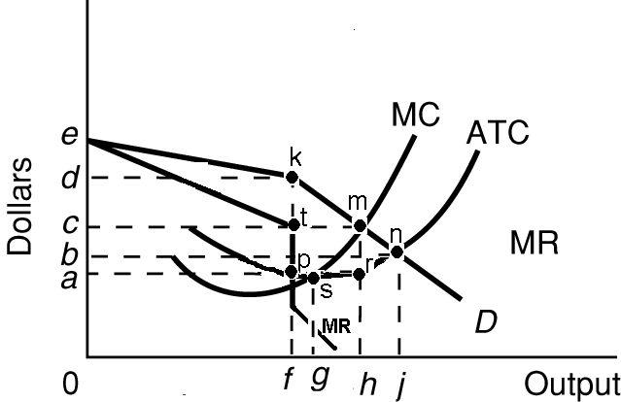

Be able to find the:
- profit maximizing quantity and price: quantity is 0f (where MR=MC) and price is 0d (from the demand [D] curve)
- profits: adkp
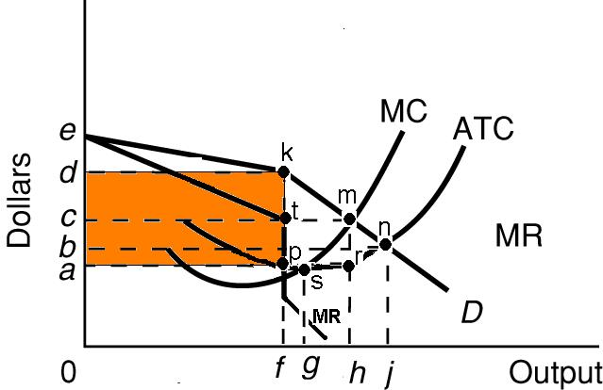
- allocatively efficient quantity: 0h
- productively efficient quantity: 0g

Oligopoly Long Run Equilibrium - Collusive Oligopoly
Define
Collusion:

Collusion is a situation in which firms act together and in agreement (collude) to fix prices, divide a market, or otherwise restrict competition. In other words, they cheat and work together as if they were a monopoly.
Cartel
A cartel is a group of producers that creates a formal written agreement specifying how much each member will produce and charge. The Organization of Petroleum Exporting Countries (OPEC) is the most significant international cartel.
overt collusion
collusion that is formal and known by all, like OPEC
covert collusion
Tacit understandings or “gentlemen’s agreements,” often made informally, are also illegal but difficult to detect.
What are the obstacles to collusion?

a. Differing demand and cost conditions among firms in the industry;

b. A large number of firms in the industry;

c. The incentive to cheat;

d. Recession and declining demand (increasing ATC);

e. The attraction of potential entry of new firms if prices are too high; and

f. Antitrust laws that prohibit collusion.
Long Run Equilibrium Graph – Collusive Oligopoly (same as Monopoly graph)
Be able to find the:
- profit maximizing quantity and price: quantity is 0M and price is 0A
- profits: BAFG
- allocatively efficient quantity: 0Q
- productively efficient quantity: 0N

