Three Rules and Four Models

Three Rules:
How to find the profit maximizing quantity:
A firm will maximize its profit (or minimize its losses) by producing that output at which marginal revenue and marginal cost are equal provided product price is equal to or greater than average variable cost.
(1) Find the quantity where: MR = MC
(2) produce this quantity only if: AR > AVC or P > AVC
This is WHAT WE GET

How to find the productively efficient quantity:
Society will achieve productive efficiency by producing that output at which the average total cost (ATC) is at a minimum.
minimum ATC, or
MC = ATC

How to find the allocatively efficient quantity:
Society will achieve allocative efficiency by producing that output at which price and marginal cost are equal.
P=MC
This is WHAT WE WANT

Four Product Market Models:

1. Competitive Market (Pure Competion)
Characteristics:

1. Number of firms:
2. Type of product:
3. Control over price:
4. Ease of entry:
5. Nonprice competition:

Examples:

Why is the D curve horizontal?

Why does P = MR?

Long-run equilibrium - Pure competition
What happens if there are short run profits?
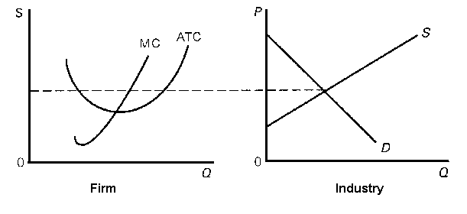
What happens if there are short run losses?
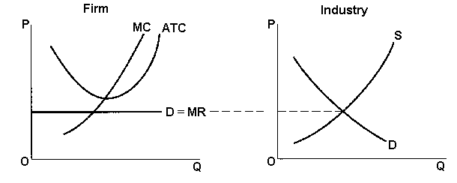
Why are there only normal profits in the long run?
Long Run Equilibrium Graph – Pure competition:
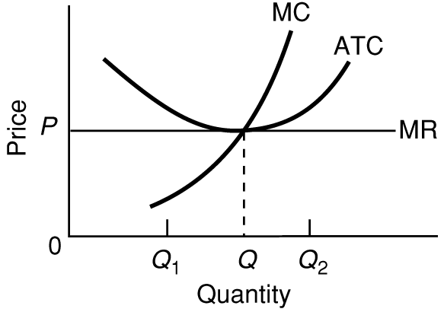
Be able to find the:
- profit maximizing quantity and price
- profits
- allocatively efficient quantity
- productively efficient quantity

2. Monopoly
Characteristics:

1. Number of firms:
2. Type of product:
3. Control over price:
4. Ease of entry:
What are the barriers to enrty?

5. Nonprice competition:

Examples:

Why is the demand curve downward sloping?

Why is MR < P ?

Long-Run Equilibrium Graph - Monopoly
Why are there long run profits?

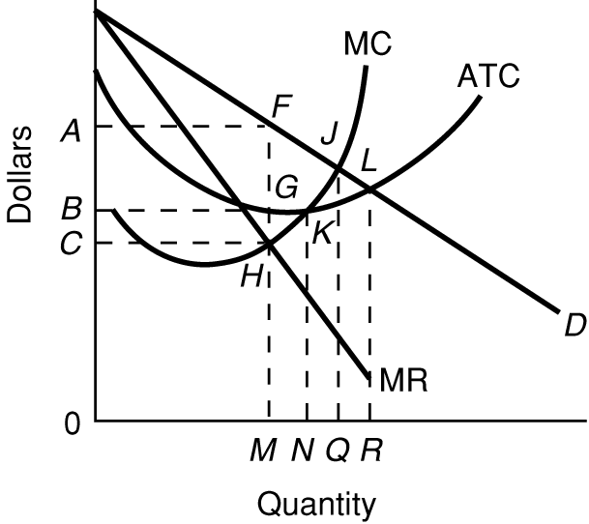
Be able to find the:
- profit maximizing quantity and price
- profits
- allocatively efficient quantity
- productively efficient quantity

Natural Monopoly

How can you tell from this graph that this is a natural monopoly?

What are some examples of natural monopolies?

Explain WHY it is more productively efficient for there to be only one producer. (WHY are there natural monopolies?)

Be able to find the:
- profit maximizing quantity, price, and profits
- allocatively efficient quantity
- productively efficient quantity
- "fair-return" or “average cost” price and quantity

3. Monopolistic Competition
Characteristics:

1. Number of firms:
2. Type of product:
What is product differentiation and how is it achieved?

3. Control over price:
4. Ease of entry:
5. Nonprice competition:
Examples:

Define:
Concentration ratio:

(Is the concentration ratio HIGH or LOW for monoplistically competitive industries?)
Herfindahl index:

(Is the Herfindahl index HIGH or LOW for monoplistically competitive industries?)
Long-Run Equilibrium – Monopolistic Competition
Why are there only normal profits in the long run?

What happens if there are short run profits?
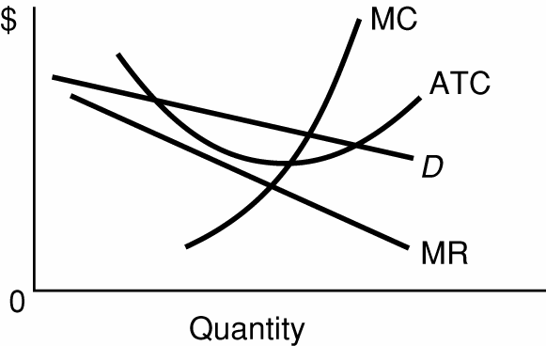

What happens if there are short run losses?
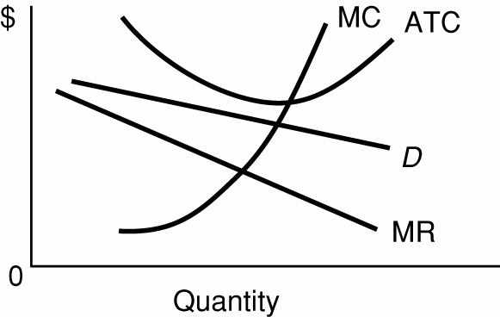
Long Run Equilibrium Graph – Monopolistic Competition:

Be able to find the:
- profit maximizing quantity and price
- profits
- allocatively efficient quantity
- productively efficient quantity

4. Oligopoly
Characteristics

- Number of firms:

What is collusion?
What is mutual interdependence?
Is the concentration ratio HIGH or LOW for oligopolistic industries?
Is the Herfindahl index HIGH or LOW for oligopolistic industries?
2. Type of product:

3. Control over price:

- Ease of entry:

- Nonprice competition:

Examples:

What are the three oligopoly pricing models?

What are the assumptions behind the kinked demand curve?

Long-Run Equilibrium – Oligopoly: Kinked Demand Model

Be able to find the:
- profit maximizing quantity and price
- profits
- allocatively efficient quantity
- productively efficient quantity

Long Run Equilibrium - Collusive Oligopoly
Define
collusion
cartel
overt collusion
covert collusion
What are the obstacles to collusion?

Long Run Equilibrium Graph – Collusive Oligopoly (same as Monopoly graph)
Be able to find the:
- profit maximizing quantity and price
- profits
- allocatively efficient quantity
- productively efficient quantity

