Three Rules and Four Models

Three Rules:
How to find the profit maximizing quantity:
A firm will maximize its profit (or minimize its losses) by producing that output at which marginal revenue and marginal cost are equal provided product price is equal to or greater than average variable cost.
(1) Find the quantity where: MR=MC
(2) produce this quantity only if: AR > AVC or P > AVC
This is WHAT WE GET

How to find the productively efficient quantity:
Society will achieve productive efficiency by producing that output at which the average total cost (ATC) is at a minimum.
minimum ATC, or
MC = ATC
This is WHAT WE WANT

How to find the allocatively efficient quantity:
Society will achieve allocative efficiency by producing that output at which price and marginal cost are equal.
P=MC

Four Product Market Models:

1. Competitive Market (Pure Competition)
Characteristics:

1. Number of firms: very large numbers
2. Type of product: standardized product
3. Control over price: none, they are "price takers"
4. Ease of entry: no barriers; free entry
5. Nonprice competition: none
Examples: Agriculture
Why is the D curve horizontal?
The demand curve is perfectly price elastic giving the firm no control over the price because of the very large number of firms producing standardized (identical) products. If one firm tries to charge a higher price all customers would buy from someone else. If one firm decides to sell nothing it has no effect on the market supply because there each firm produces an insignificant amount of the total
Why does P = MR?
Because the demand curve s perfectly price elastic. Since a single firm can sell all that they produce at the equilibrium price (i.e. they do not have to lower the price to sell more) the extra revenue that they receive when they sell one more unit (the MR) is the same as the price.
Long-run equilibrium graph:
What happens if there are short run profits?
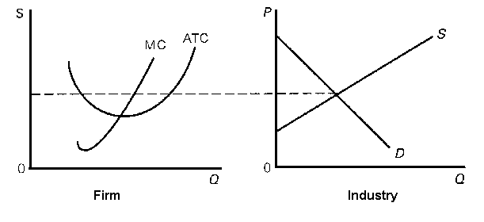
Remember, there are no barriers to entry, therefore if there are short run profits as shown in the graph on the left above, new firms will enter. When new firms enter (an increase in the number of producers) the market supply will increase (shift to the right) and cause the price to drop and they will no longer be earning profits.

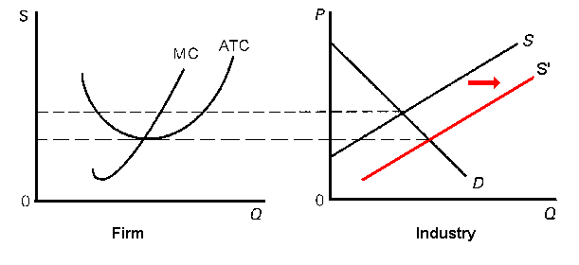
What happens if there are short run losses?
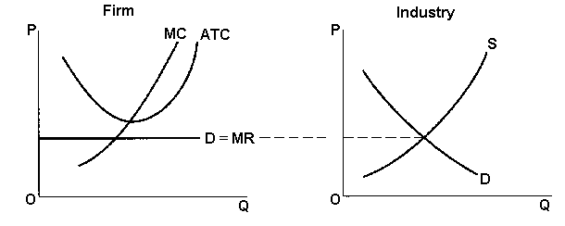
I there are short run losses as shown in the graph on the left above, firms will leave the industry. When firms leave (a decrease in the number of producers) the market supply will decrease (shift to the right) and cause the price to drop and they will no longer be earning profits.

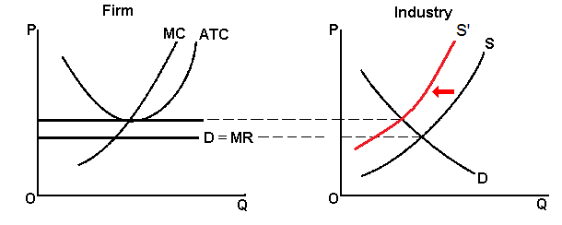

Why are there only normal profits in the long run?
Because there are no barriers to entry. If there are short run profits new firms will enter and the price will drop. If there are short run losses, firms will leave the industry and the price will rise. After all long-run adjustments are completed, product price will be exactly equal to, and production will occur at, each firm's point of minimum average total cost, and the firm will earn normal (zero) profits.
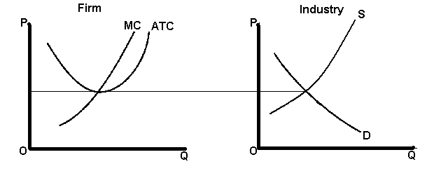
Long Run Equilibrium Graph – Pure Competition:
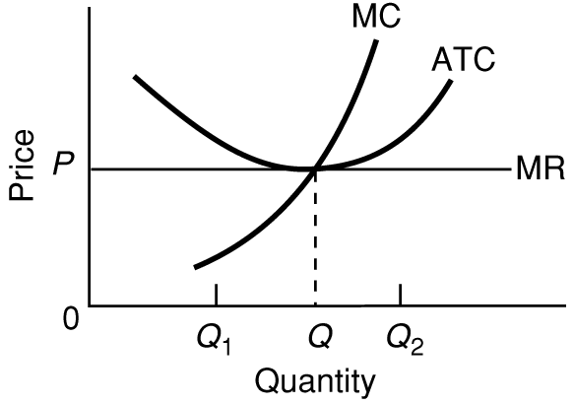
Be able to find the:
- profit maximizing quantity and price:
Quantity would be “Q” (where MR=MC) and the price would be P
- profits: none; normal profits
- allocatively efficient quantity: Q (same as the profit maximizing quantity)
- productively efficient quantity: Q (same as the profit maximizing quantity)

2. Monopoly
Characteristics:

1. Number of firms: one
2. Type of product: unique product; no close substitutes
3. Control over price: very much; considerable
4. Ease of entry: blocked
What are the barriers to entry?

A. Economies of scale constitute one major barrier. This occurs where the lowest unit costs and, therefore, lowest unit prices for consumers, depend on the existence of a small number of large firms or, in the case of a pure monopoly, only one firm. Because a very large firm with a large market share can produce at a lower ATC than if there were many firms producing a small market share

B. Legal barriers to entry into a monopolistic industry also exist in the form of patents and licenses.

C. Ownership or control of essential resources is another barrier to entry.

D. Monopolists may use pricing or other strategic barriers such as selective price-cutting and advertising.

5. Nonprice competition: mostly public relations advertising
Examples:
1. | Public utilities: gas, electric, water, cable TV, and local telephone service companies, are often pure monopolies.
2. | First Data Resources (Western Union), Wham-O (Frisbees), and the DeBeers diamond syndicate are examples of "near" monopolies.
3. | Manufacturing monopolies are virtually nonexistent in nationwide U.S. manufacturing industries.
4. | Professional sports leagues grant team monopolies to cities.
5. | Monopolies may be geographic. A small town may have only one airline, bank, etc.
Why is the demand curve downward sloping?
Monopoly demand is the industry (market) demand and is therefore downward sloping just lake we learned in the Supply and Demand chapter.

Why is MR < P ?
Price will exceed marginal revenue because non-price discriminating monopolist must lower the price to ALL CUSTOMERS in order to sell the additional unit. The added revenue will be the price of the last unit less the sum of the price cuts which must be taken on all prior units of output
Long-Run Equilibrium Graph - Monopoly
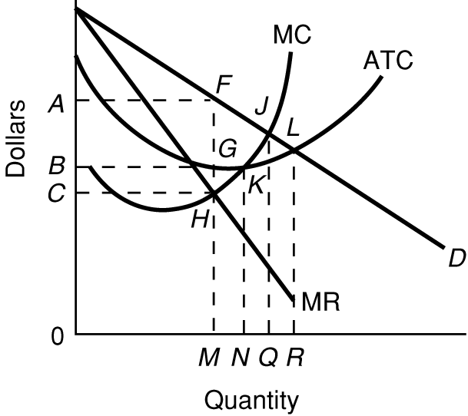
Why are there long run profits?

Because there are barriers to entry (entry is blocked).
Be able to find the:
- profit maximizing quantity and price: quantity is 0M, price is 0A
- profits: BAFG
- allocatively efficient quantity: 0Q
- productively efficient quantity: 0N

Natural Monopoly

How can you tell from this graph (see below) that this is a natural monopoly?
Because the demand curve crosses the ATC curve while the ATC is still going down. This means that one firm can produce everything that is demanded at a lower cost than if there were many firms each producing a small amount (at a higher ATC).
What are some examples of natural monopolies?

Public utilities are often natural monopolies because they have economies of scale in the extreme case where one firm is most efficient in satisfying existing demand. Therefore the government usually gives one firm the right to operate a public utility industry in exchange for government regulation of its power. If there were more than one firm it would be productively inefficient (higher average total costs) because there would be many pipes and wires going to each house.
Explain WHY it is more productively efficient for there to be only one producer. (WHY are there natural monopolies?)

SAME ANSWER AS ABOVE - Public utilities are often natural monopolies because they have economies of scale in the extreme case where one firm is most efficient in satisfying existing demand. Therefore the government usually gives one firm the right to operate a public utility industry in exchange for government regulation of its power. If there were more than one firm it would be productively inefficient (higher average total costs) because there would be many pipes and wires going to each house.

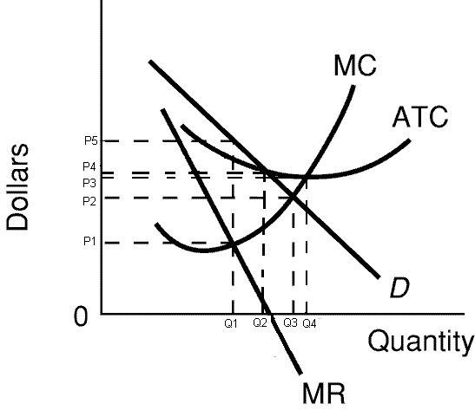
Be able to find the:
- profit maximizing quantity and price: Q1 (where MR=MC), P5
- profits: for profits see graph below
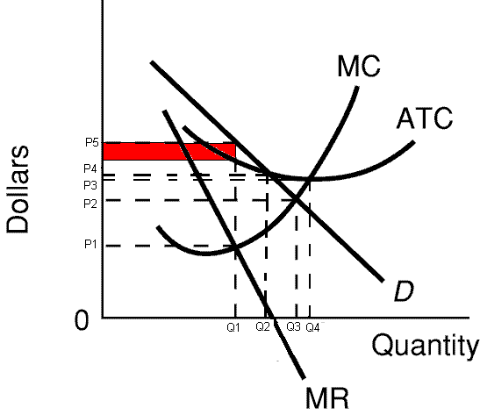
- allocatively efficient quantity: Q3 (where P=MC or D=MC)
- productively efficient quantity: Q4 (minimum ATC or where MC=ATC)
- "fair-return" or “average cost” price and quantity: Q2 and P4 (where D crosses the ATC)

3. Monopolistic Competition

Characteristics:

1. Number of firms: Many
2. Type of product: Differentiated
What is product differentiation and how is it achieved?

Product differentiation is a strategy in which one firm’s product is distinguished from competing products by means of its design, related services, quality, location, or other attributes (except price).

Product differentiation and other types of nonprice competition give the individual firm some degree of monopoly power that the purely competitive firm does not possess therefore it allows producers to have some control over the prices of their products.

Product differentiation may be physical (qualitative). It may include services and conditions accompanying the sale of the product. Location is another type of differentiation. Brand names and packaging lead to perceived differences and are forms of product differentiation as well.
3. Control over price: some, depending on the degree of product differentiation
4. Ease of entry: easy
5. Nonprice competition: a lot; product differentiation is a type of nonprice competition
Examples:
Retail trade, Restaurants, Manufactured Ice, Plastic Pipe, Book Publishing, Paperboard Boxes, Curtains and Draperies, Textile Machinery, Leather Goods, Lighting Fixtures, Wood Furniture, Wooden Kitchen Cabinets
Define Concentration ratio:
The percentage of the total sales of an industry made by the four (or some other number) largest sellers in the industry.
(Is the concentration ratio HIGH or LOW for monopolistically competitive industries?) LOW
Define: Herfindahl index:
A measure of the concentration and competitiveness of an industry; calculated as the sum of the squared percentage market shares of the individual firms.
SUM % market shares squared
If monopoly = 100 squared = 10,000
If 4 firms with 25% each = 25 squared + 25 squared + 25 squared + 25 squared = 2500
(Is the Herfindahl index HIGH or LOW for monopolistically competitive industries?) LOW

Long-Run Equilibrium – Monopolistic Competition
Why are there only normal profits in the long run?
Because there are few barriers to entry. Whenever there are no, or few, barriers to entry, firms will not be able to earn long run profits because if there are short run profits new firms will enter causing the price to g down and the profits to evaporate.

What happens if there are short run profits as shown in the graph below?
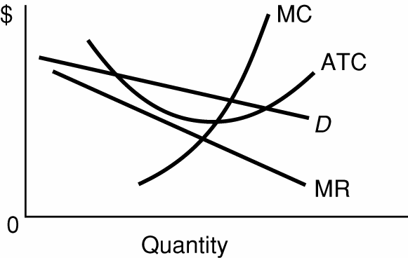

If there are short run profits, new firms would enter the industry (remember, there are few barriers to entry) and the demand curve for all of the existing firms will decrease (move ot the left).
What happens if there are short run losses as shown on the graph below?
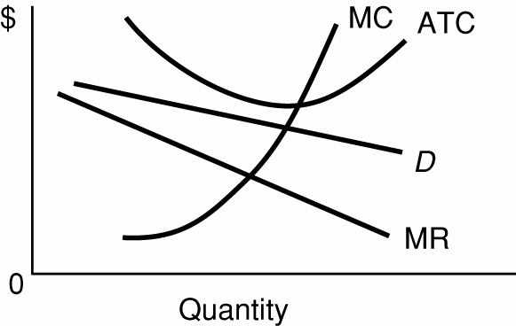

If there are short run losses, firms would leave the industry (go out of business in the ling run) and the demand curve for all of the remaining firms will increase (move to the right).

Long Run Equilibrium Graph – Monopolistic Competition:

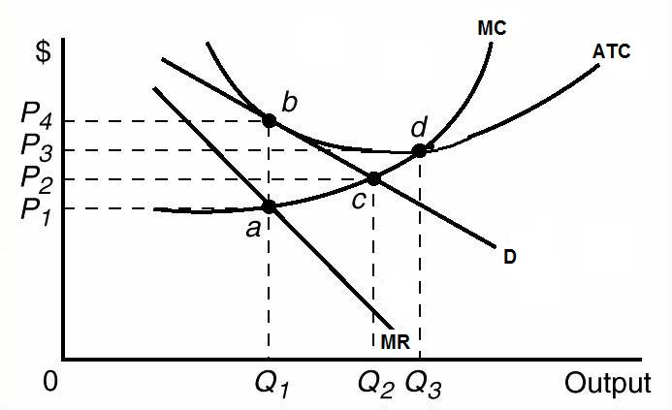
Be able to find the:
profit maximizing quantity and price:
quantity would be Q1 where MR=MC, and the price would be P4
profits: zero, or normal profits
allocatively efficient quantity: Q2 (Where P=MC or D=MC)
productively efficient quantity: Q3 (minimum ATC or where MC=ATC)

4. Oligopoly

Characteristics

- Number of firms: FEW; So few that collusion may be possible and mutual interdependence exists

What is collusion?

Collusion is a situation in which firms act together and in agreement (collude) to fix prices, divide a market, or otherwise restrict competition. In other words, they cheat and work together as if they were a monopoly.
What is mutual interdependence?
Mutual interdependence is a situation in which a change in price strategy (or in some other strategy) by one firm will affect the sales and profits of another firm (or other firms); any firm which makes such a change can expect the other rivals to react to the change
Is the concentration ratio HIGH or LOW for oligopolistic industries? HIGH
Is the Herfindahl index HIGH or LOW for oligopolistic industries? HIGH
2. Type of product:
Standardized (homogenous) OR differentiated
3. Control over price:
Since there are few firms in the industry you would expect there to be a lot of control over price, but it is limited by mutual interdependence. A firm has to be concerned about what their competitors will do if it decides to change its price.
With collusion there is much control over price (like a monopoly).
4. Ease of entry:
Entry is difficult since there are significant barriers to entry.
5. Nonprice competition:
If they have differentiated products, there is a lot of nonprice competition.

Examples:
Automobiles, cigarettes, breakfast cereal, beer, soaps and detergents, refrigerators, roasted coffee, copper, flat glass,
What are the three oligopoly pricing models?
Kinked demand (non-collusive)
Collusion and Cartels
Price Leadership
What are the assumptions behind the kinked demand curve?
The kinked demand model is based on the assumption that rivals will:
- follow a price decrease, and
- ignore a price increase.

Oligopoly Long-Run Equilibrium Graph - Kinked Demand Model
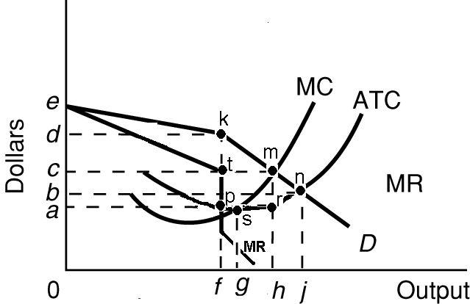

Be able to find the:
- profit maximizing quantity and price: quantity is 0f (where MR=MC) and price is 0d (from the demand [D] curve)
- profits: adkp
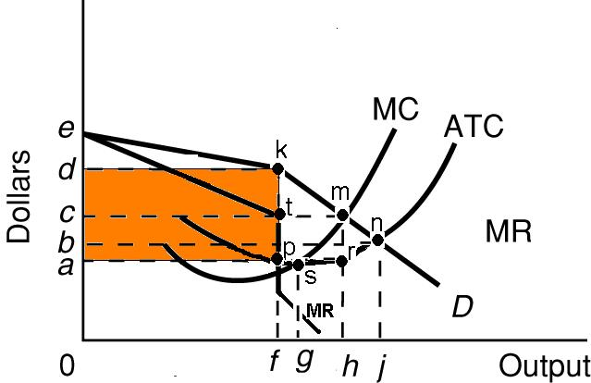
- allocatively efficient quantity: 0h
- productively efficient quantity: 0g

Oligopoly Long Run Equilibrium - Collusive Oligopoly
Define
Collusion:

Collusion is a situation in which firms act together and in agreement (collude) to fix prices, divide a market, or otherwise restrict competition. In other words, they cheat and work together as if they were a monopoly.
Cartel
A cartel is a group of producers that creates a formal written agreement specifying how much each member will produce and charge. The Organization of Petroleum Exporting Countries (OPEC) is the most significant international cartel.
overt collusion
collusion that is formal and known by all, like OPEC
covert collusion
Tacit understandings or “gentlemen’s agreements,” often made informally, are also illegal but difficult to detect.
What are the obstacles to collusion?

a. Differing demand and cost conditions among firms in the industry;

b. A large number of firms in the industry;

c. The incentive to cheat;

d. Recession and declining demand (increasing ATC);

e. The attraction of potential entry of new firms if prices are too high; and

f. Antitrust laws that prohibit collusion.
Long Run Equilibrium Graph – Collusive Oligopoly (same as Monopoly graph)
Be able to find the:
- profit maximizing quantity and price: quantity is 0M and price is 0A
- profits: BAFG
- allocatively efficient quantity: 0Q
- productively efficient quantity: 0N

