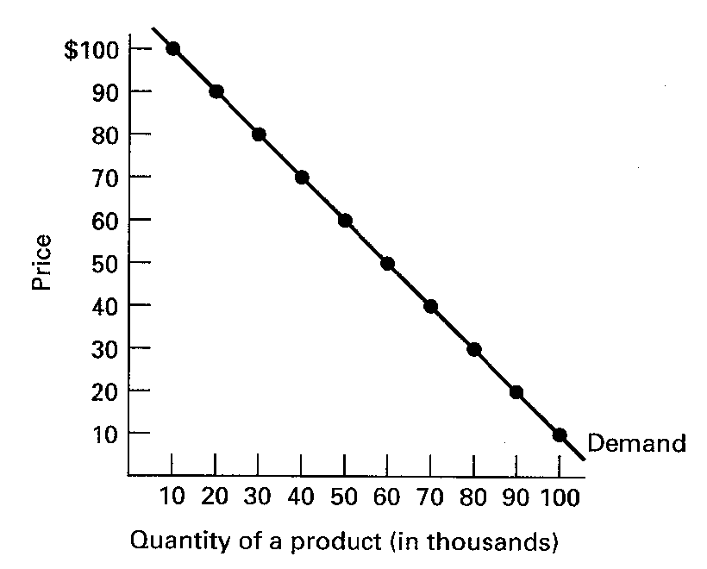
ELASTICITY WORKSHEET

1. Use the graph below for the question that follow.

Assume that the current price is $70. The seller wants to increase its revenues and has decided to increase the price to $80. Is this a good idea?

-----------------------------------------------------------------------------------------------------------
2. Based on the determinants of elasticity as discussed in the text, guess what the price elasticity of demand of the following products would be (elastic or inelastic?) and state which determinant supports your guess.

- ballpoint pens

- Crest toothpaste

- diamond rings

- sugar

- refrigerators.

3. Use the information in the table below to identify the type of cross elasticity relationship between products X and Y and whether demand is cross elastic or cross inelastic in each of the following five cases, A to E.

Percent change
Percent change in quantity Cross elasticity Cross Elastic
Cases in price of Y demanded of X type or Inelastic?

A 5 7 ______________ ____________

B –9 –6 ______________ ____________

C 5 –5 ______________ ____________

D 3 0 ______________ ____________

E –2 10 ______________ ____________

4. Use the information in the table below to identify the income elasticity type of each of the following products, A to E.

Income
Percent change Income elastic,
Percent change in quantity elasticity inelastic
Product in income demanded type or unit elastic

A 9 12 __________ __________

B –6 6 __________ __________

C 3 3 __________ __________

D 6 –3 __________ __________

E –2 –1 __________ __________

